- (2 pts) Memory leak:
  - What is memory leak?
  - Write a C/C++ function that has memory leak problem.

- (4 pts) Shallow copy: A program is used to record each student's quiz scores.
Answer the following sub-questions:
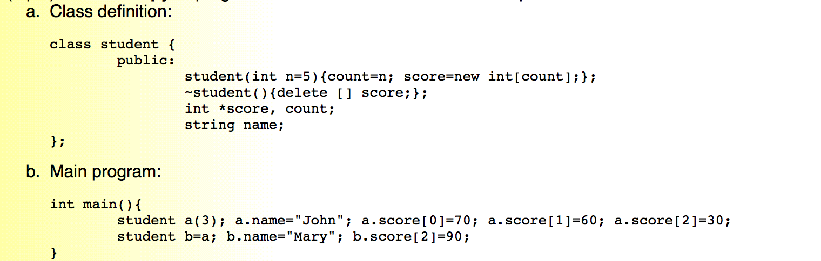
  - What are the contents of variables a and b?
  - What are the two potential problems of this program?

- (4 pts) STL vectors: Give 3 advantages and 1 disadvantage of STL vectors when compared with the standard C/C++ arrays.

- (3 pts) STL vectors: Given an STL vector x, answer the following sub-questions.
  - What does "x.reserve(25)" mean?
  - What is the difference between x[i] and x.at(i)?
  - What is the difference between x.size() and x.capacity()?

- (2 pts) Row-based vs. column-based operations: There are two ways to compute the total of elements in a traditional two-dimensional arrays in C/C++, as shown next.
  - Compute the column sum first, then compute the overall total.
  - Compute the row sum first, then compute the overall total.
In general, which one is faster? Why?

- (3 pts) Insertion sort: Show each major step of insertion sort on the sequence {7, 2, 8, 5, 6, 9, 4, 1, 3}.

- (2 pts) Binary search: There are two ways to compute the middle position during a binary search, as shown next.
  - mid=(left+right)/2
  - mid=left+(right-left)/2
What is the advantage of each method?

- (3 pts) Search complexity: What is the time complexity of linear search, binary search, and hash search,and when are they used?

- (4 pts) Multiple-key binary search: If you want to do binary search over multiple keys, what do you need to do in the following two stages:
  - Preprocessing stage
  - Search stage

- What else can we use to compute mid?

- (3 pts) Definition of big-Oh: Given functions f(n) and g(n), under what condition do we we say that f(n) is O(g(n)) (Note that g(n) is one of the basic functions, such as n^3.)

- (3 pts) Example of big-Oh: Use the definition of big Oh to explain why 5n^3+2(n+10)^2+(n+50)log(n+20) is O(n^3).

- (4 pts) Tries: Given a key sequence of {stop, steer, skip, step, top, took}, draw the trie data structure. (You need to indicate the end-of-key nodes clearly.)

- (3 pts) Binary search vs. tries: What are the complexities of tries with n keys, each with m characters?
  - Time complexity for construction
  - Time complexity for Search
  - Space complexity

- (4 pts) Associative arrays in STL: There are two implementations of associative arrays (dictionaries) in STL, including <map> and <unordered_map>. Explain at least two differences between these two implementations.

- Prove that F(n)<2^n where F(n)is the Fibonacci series

- (2 pts) Advantages of postfix notation: What are the two major advantages of using postfix notation?

- (4 pts) Infix to postfix: Use a tabular form to show how to convert the following infix notation into postfix.
f-((a+b)*c+d*e)
(Note that you need to show the contents of the stack at each step.)

- (2 pts) BFS vs. DFS: In a constraint satisfaction problem for search in a game (such as 2048 or nonograms), why we do we prefer to use DFS (depth-first search) instead of BFS (breadth-first search)?

- (2 pts) BFS vs. DFS: Is DFS more related to stacks or queues? How about BFS?

- (4 pts) Evaluation of postfix notation: Use a tabular form to evaluate the following postfix notation:
abc-d+/ea-*c*
(Note that you need to show the contents of the stack at each step.)

- (5 pts) About BT: Given a binary tree and a proper binary tree with the root located at depth 0, the height of the tree is defined as the maximum depth.
  - What is the maximum number of nodes at depth d of a binary tree?
  - What is the maximum number of nodes in a binary tree of height h?
  - If a binary tree has 25 nodes, what is its maximum height?
  - If a binary tree has 25 nodes, what is its minimum height?
  - If a proper binary tree has 35 nodes, what are the numbers of external nodes?

- (2 pts) Vector representation for BT: In order to access the tree nodes quickly, the following binary tree is stored level-by-levey in a one-dimensional array A. What are the indices for nodes L and M, respectively?
- (3 pts) Traversal of BT: Give the preorder, inorder, and postorder traversals of the following expression tree.
- (3 pts) BT from inorder and preorder sequences: Draw a binary tree with inorder sequence [a b c d e f g h i] and preorder sequence [f b a e d c h g i].
- (3 pts) BT from inorder and postorder sequences: Draw a binary tree with inorder sequence [a b c d e f g h i] and postorder sequence [b a e d g i h f c].
6(3 pts) Conversion to BT: Use the left child-right sibling representation to convert the following tree into a binary tree.

7.prove that ne=ni+1
8.Given a proper binary tree explain why is the number of nodes always odd?
If n is 51 what is the number of internal and external nodes?
9.nk is the number of nodes with k children.
Proof that n0=n2+1
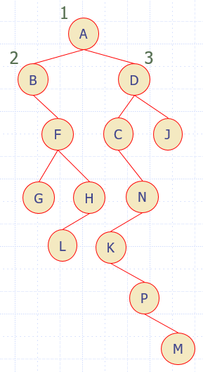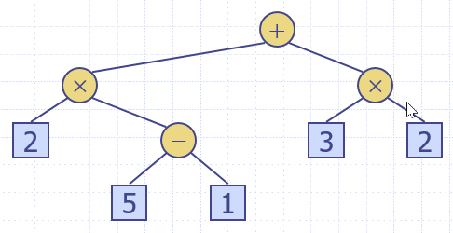
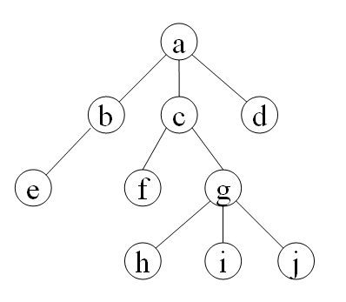

- (2 pts) About heaps: Given a heap of nn nodes, what are its minimum and maximum values of height? Why?

- (4 pts) Complexity of operations on heaps: Give the time complexity of the following operations on a min-heap of n nodes: (a) size (b) min (c) insert (d) removeMin.

- (4 pts) Heap construction in O(n): Given a vector [16 15 4 12 6 9 23 20 25 5 11 27 7 8 10], construct a min-heap from these elements based on a O(n) algorithm. Please plot the result at each step to demonstrate the algorithm clearly.

- (4 pts) Insertion and deletion in heaps: Draw a max-heap tree after each of the following operations is performed, beginning with an empty heap: insert 43, insert 31, insert 68, insert 24, delete-max, insert 51, insert 44, insert 53, insert 69, insert 71, delete-max.

- (6 pts) In-place heap sort: Given a vector of [8 5 1 3 7], how do you perform in-place heap sort? Please plot the 5 heaps (both vector and tree representations) during heap construction, and the other 5 during output, as described in class.

- (2 pts) Two components of a hash function: What are the two functions that are generally used to compose a hash function?

- (2 pts) Horner's rule: Explain the Horner's rule for efficient polynomial evaluation of p(z)=a0+a1z+a2z2+⋯+an−1zn−1.

- (2 pts) Basic compression function: What is the most commonly used compression function for a hash function?

- (2 pts) Definition of collision: What is the definition of collision in terms of the operation of a hash table?

- (4 pts) Collision handling:
  - What are the basic two methods for handling collision?
  - What is the major difference betweeen the above two methods?

- (4 pts) Linear probing: If we are using linear probing for handling collisions in a hash table, with a hash function h(x)=x mod 13 Show the hash table contents after inserting keys of 18, 41, 22, 44, 59, 32, 31, 73.

- (4 pts) Design criteria for a hash function: What are the most important two considerations in designing a hash function?

