Priority queue:像是一般queue但有權重,誰先出來有順序
Priority queue via selection sort
1.For Unsorted list
2.O(1)for insertion and O(n) in min searching
Priority queue via insertion sort
- for sorted lists
- O(n)for insertion due to sorting
Heap
1. A binary tree storing keys at its node.
2. key(v)>=key(parent(v))
if not upheap O(log(n))
3. must be a complete binary tree( at any depth the internal nodes are left to the external nodes at depth h-1)(to keep O(nlog(n)))
4. perfect binary tree 全都長滿
Removal from a heap
1.downheap
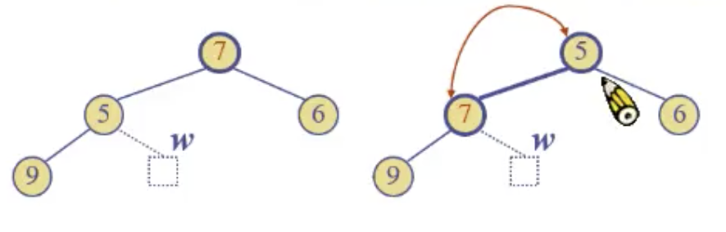
Heap sort
- O(nlog(n))
Vector based heap implementation
- 一層一層放
- left index 2i right index 2i+1
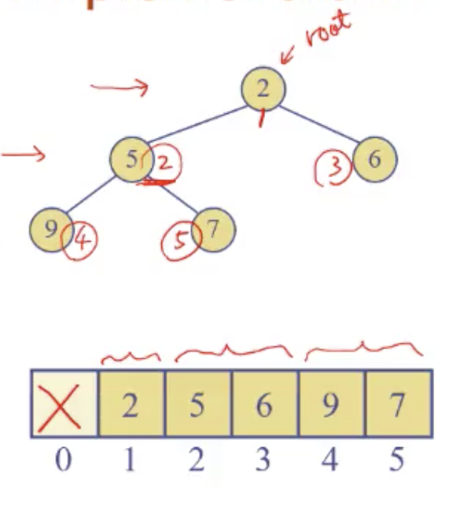

Quiz
A heap storing n keys has a height O(log(n))
2^0+2^1+…+2^(h-1)+1 (第h曾只有一個 external node)<=n<=2^0+…..+2^h
=2^h<=n<=2^(h+1)-1
log2(n+1)-1<=h<=log2(n)
Quiz2
Upheap
- if(key(v)<key(parent(v)))switch both keys
Quiz
- size,emptyO(1)
- min O(1)find the root
- insert O(log(n))
- removeMin O(log(n))
In-Place Heap-Sort
- heap construction
- output
- max heap
