- Memory leak
Occurs when you call new without a corresponding delete
- Copy constructor problems
Shared memory
Double deletion
- Assignment operator
Shared memory
Double deletion
Memory leak
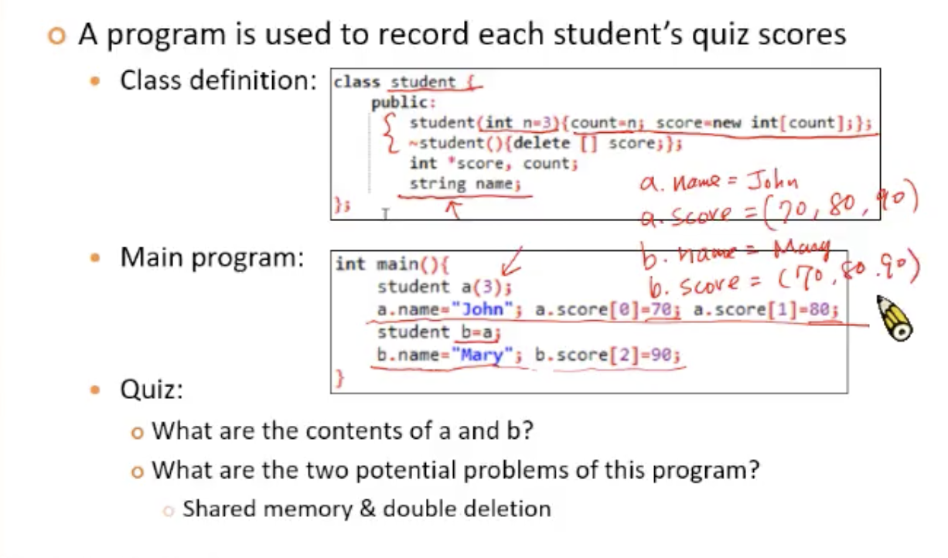
- Advantages of STL vectors
Flexible element access
Dynamic(動態) growth of arrays
Less likely to have memory leak
Built-in methods for common array operations
- Disadvantages
Not as efficient as C/C++ type arrays

6.
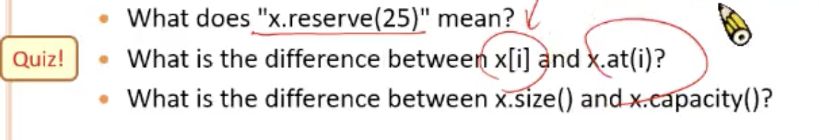
6.1 在size 25 以內不需要再要跟ＯＳ要空間
6.2 後者會做range check
6.3 前者為實際用到得空個，後者為目前vector reserve 的空間，不一定有內容物

