Analysis

Given functions f(n),g(n),we say that f(n) is O(g(n)) if there is a positive constant c and n0 such that f(n)<=cg(n)for n>0

How to prove statements

1. by giving counter examples
2. By contrapositive(若p則q=若-q則-p)
3. By math induction

Prove that F(n)<2^n where F is the Fibonacci function

Complexity in search

m=字串長度

n=number of keys

1. Binary search O(m\*log(n))
2. Trie time for insertion and search O(m)

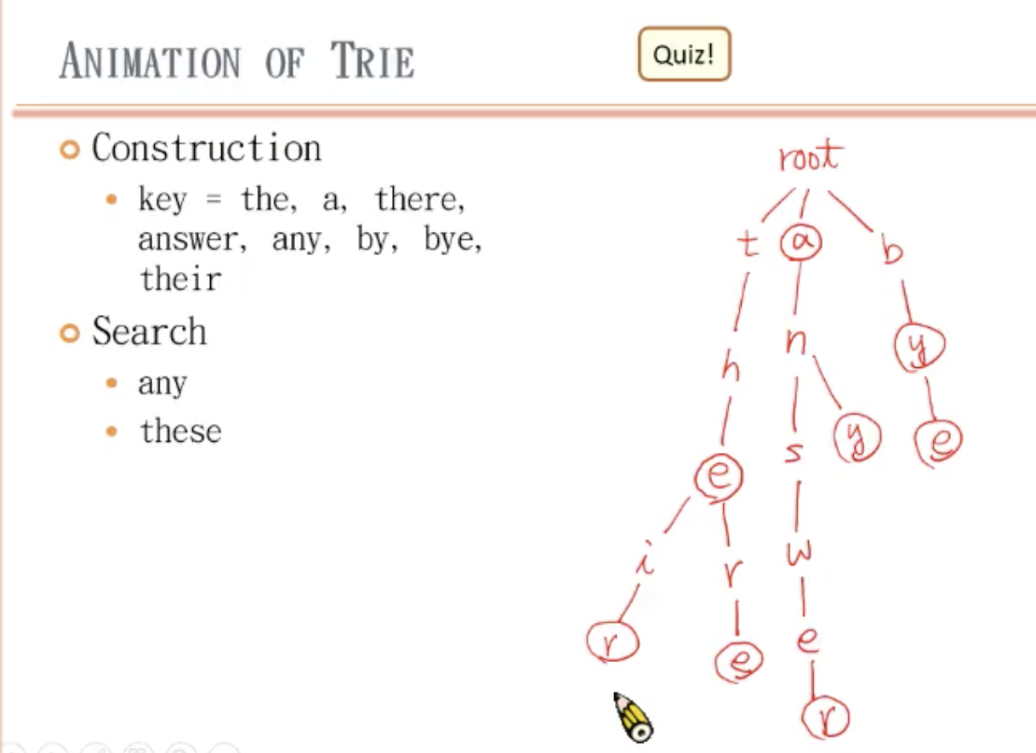

map unordered map

1. sorted keys 1.Unsorted keys
2. implementation based on trees 2.based on hash tables
3. Complexity O(log(n)) 3.O(1)