**Sub-task 1 – Create AWS Account**

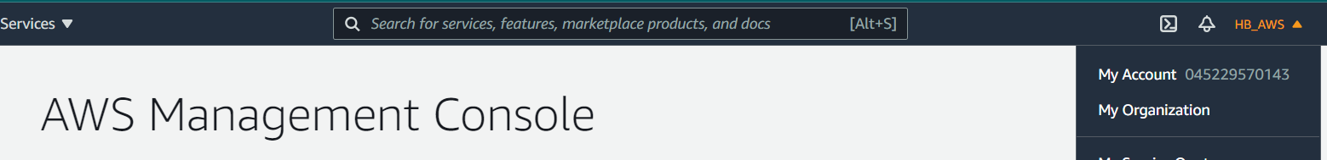

**Sub-task 2 – Secure account**

**2.1 Lock away your AWS account root user access keys**

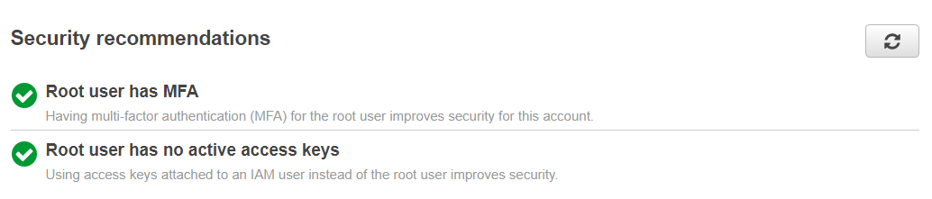

**2.2 Avoid using AWS account root user**

**Created 2 IAM Users**

* **1 for me (Administrator) to avoid using root**
* **1 for mentor (in case it is required) (The mentor user does not have rights immediately, but his rights will be changed after the first successful login.)**

**2.3 Grant least privilege (For the mentor group given view only policy)**

**2.4** **Use permissions with AWS managed policies**

**2.5 Configure a strong password policy for your users**

**Enable MFA**

**Sub-task 3 – Set Budgets/Alerts**

**3.1 Setup free tier notifications**

**3.2 Setup budget reached notifications**

**Sub-task 4 – Optional Task - Setup SCP**

**Default FullAWSAccess SCP**

**Custom SCPolicy**

