**Task #4 – S3**

**Sub-task 1 – play with versioning**

* 1. **Create an S3 bucket**

* 1. **Enable versioning for the bucket from the step 1**

**1.3. Upload 2-3 files to the bucket and get versions of at least one file.**

**1.4 Using AWS CLI, get the latest version of a specific file**



**1.5 Write a script to get the latest version of a specific file no newer than a given date**

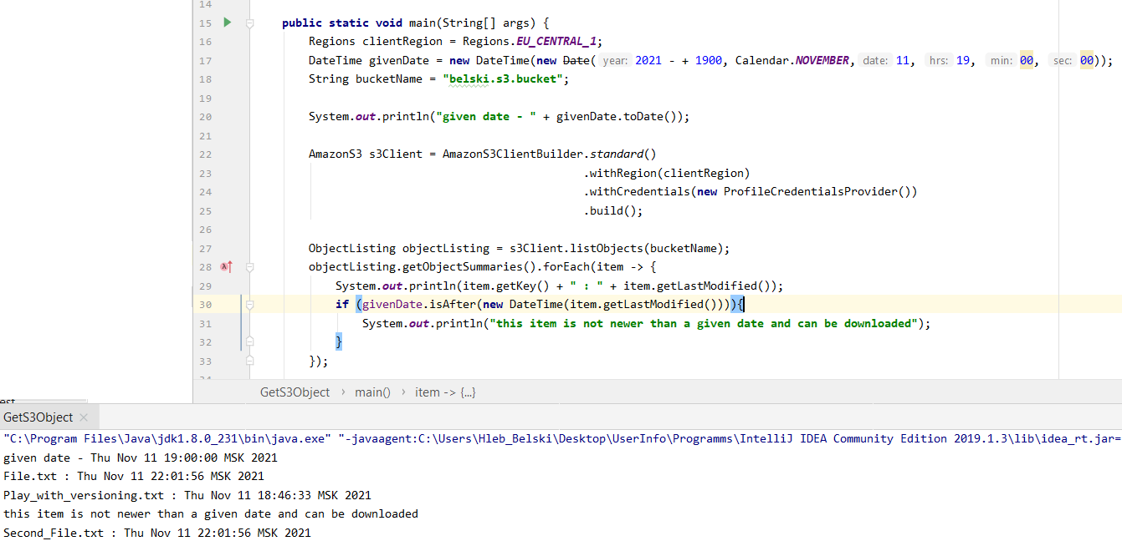

**1.6 Remove all created test files from the bucket**

**Sub-task 2 – create a static web site and enable replication**

**2.1 Enable cross-region replication for the bucket:**

1. **Create in another region another S3 bucket**

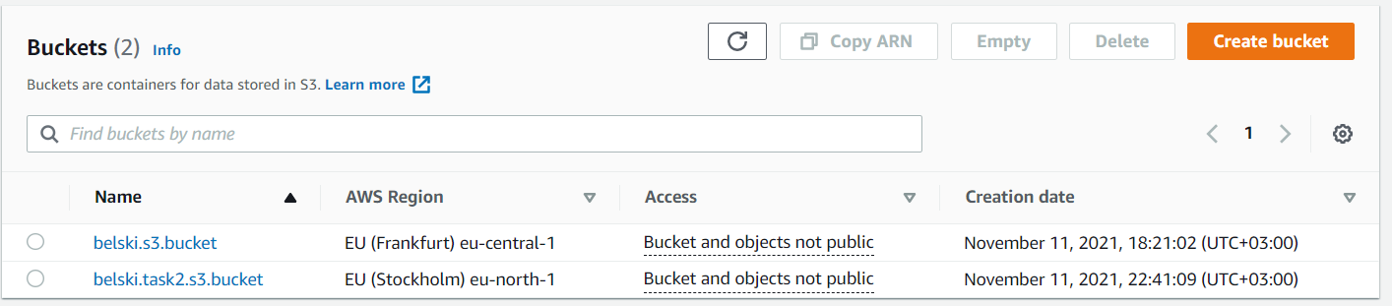

1. Graphical user interface, application

   Description automatically generated
2. Graphical user interface, text, application, email

   Description automatically generated

**2.2 Create a static web site**

**2.3 Copy the static website using AWS CLI and named**

**Profile**

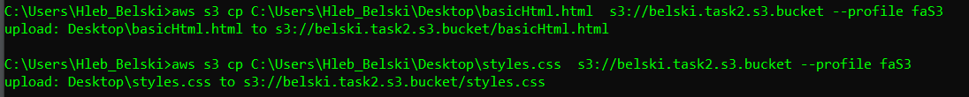

**2.4 Enable static website hosting on your S3 bucket**

**2.5 Check that the cross-region replication**

**Sub-task 3 – practice more AWS CLI hacking and play with permissions**

**3.1 Using AWS CLI list all the objects. play with the "--query" parameter to filter out only S3 object keys**

**3.2 Using different users from module 2, try to execute the following commands via AWS CLI:**

**ab) upload new file to the S3 bucket and list all the objects in the S3 bucket**

**3.4 Optional: play with the "--output" in** **"human-readable" format**

**Sub-task 4 – – think a little bit**

**4.1 Describe all the use cases for S3 you’ve seen**

* Storage for Internet.
* Backup and Disaster Recovery (Versioning).
* Analytics and get (prepared) data
* Static Website Hosting.
* Security and Compliance.
* Case: Create an S3 Bucket
* Case: Configure Options
* Case: Configure replication rules
* Java aws sdk scripting

**4.2 Describe any other S3 use cases you see reasonable**

* Manage and monitor your storage
* Data archiving
* Set file permissions (Private Local Repository \\ File Sharing)

**4.3 Optionally, visualize some of the use cases using any preferred notation**

