**Task #5 – EC2**

**Sub-task 1 – allocate EC2 resources**

* 1. **Create Linux EC2 instance**

* 1. **Configure security group for the EC2 instance so that:**

1. **allow access over HTTP/HTTPS from anywhere**
2. **allows SSH connection from your IP address only**

1. **optional task – write a script which would update the security group based on your current-IP address**

**Script**

**(work of the script)**

**1.3. Make sure Apache HTTP server is installed and running on the instance.**

**Продолжение ниже ->**

**1.4 Download the static web site created in module 3 on the instance.**

**1.5 Make sure you can view the site by accessing your EC2 instance over HTTP**

**Sub-task 2 – – automate EC2 configuration**

* 1. **Create a new EC2 instance based on any free-tier Linux AMI**

**2.2 Configure the new EC2 instance**

**a. install Apache HTTP server**

**b. download the static web site**

**2.3 Ensure that you can access the static web site**

**2.4 Create a custom AMI based on the EC2 instance**

**2.5 Delete the EC2 instance and create another**

**2.6 Make sure the web site is still available over HTTP**

**Sub-task 3 – introducing EBS basics**

**3.1 Create EBS volume and attach it to the EC2 instance from the first sub-task**

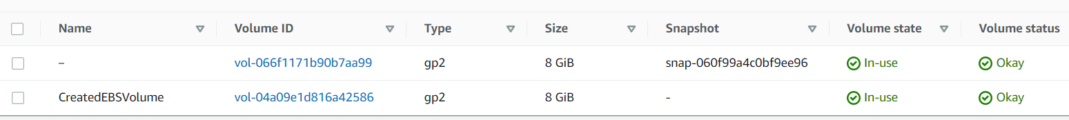

**3.2 Write any file to it and detach from the instance.**

**After detach**

**Sub-task 4 – create a load-balanced application4.1-2 In your project, create a simple web-application with one endpoint (UI page, REST)**

**4.3-4 download and deploy your web-application artifact from S3**

**4.4-5 Create an auto-scaling group and add load balancing**

