**Task #7 – Cloud Formation**

**Task 1 – Create one or more Cloud Formation templates (YAML or JSON based) which would set up a VPC similar to module 5, but simplified:**

**Sub-tusk: The VPC should have a name following this convention <ProjectName>-Network and a CIDR block of 10.0.0.0/16.**

**2. Optionally, use the Cloud Formation nesting feature to minimize the amount of template configuration duplication.**

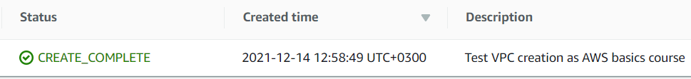

**3. Create a Cloud Formation template which creates one EC2 instance based on the AMI from module 4 in one of the custom VPC public subnets.**

**4. Optionally, make the template parameterized so that it’s possible to specify the desired subnet during stack creation.**

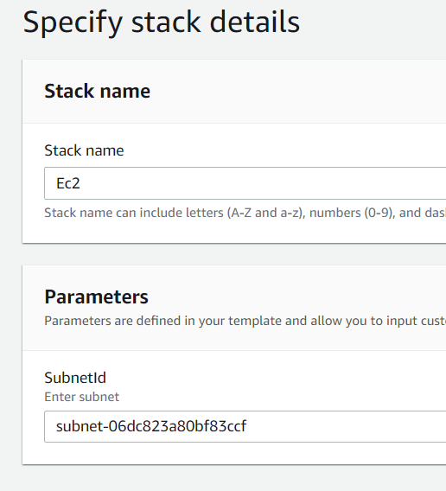

**5. Manually or using a Cloud Formation template, create one EC2 instance in one of the DB subnets and one EC2 instance in one of the public subnets.**

**Ensure that:**

1. **the public EC2 instance is accessible from outside VPC and has access to the Internet/DB subnet instance**

1. **the DB EC2 instance is not accessible from outside VPC and has not access to the Internet**

