**User’s Manual**

**Pool Access System**

**Table of contents**

1. Terms and definitions 2

2. Logging In 2

3. Main Menu 2

3.1. Find Swimmer 3

3.2. View Pool 4

3.3. Reports 5

3.4. Staff 6

4. Exit System 8

## Terms and definitions

**Pool** – a swimming pool, the primary management unit;

**Swimmer** – a single person who is a prospective, existing, or former customer of the Pool;

**Staff** – all employees including Administrators and Operators;

**Administrator (admin)** – an employee with maximum privileges. Admin, among other things, can create, update, and delete profiles of Swimmers and Staff;

**Operator** – an employee with admittance control privileges. The primary function of an Operator is to check-in/check-out Swimmers and report incidents.

## Logging In

To login into the system, the User must obtain the Employee ID and the Passport from the system’s administrator. By default, the Employee ID is a six-character string *xxxxyy*, where *xxxx* – are the first four letters of the person’s last name and *yy* – are the first two letters of the first name.

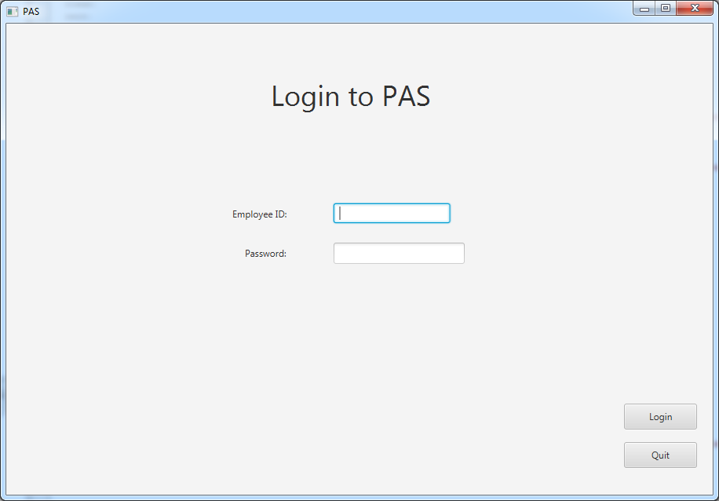

## Main Menu

The main menu has four options:

* ‘Find Swimmer’ to look-up a swimmer in the database. The User should select this option if he or she wants to register a new Swimmer, update Swimmer’s profile, or check-in/check-out a Swimmer.
* ‘View Pool’ to monitor the current status of the Pool.
* ‘Reports’ to generate various reports about past visits and swimmers’ statistics.
* ‘Staff’ to create, update, and delete the profiles of the employees.

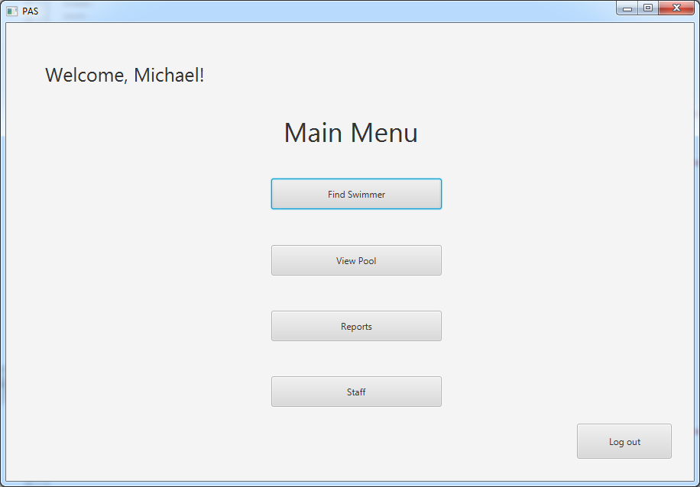

### Find Swimmer

The user can find a Swimmer by typing any fraction of the Swimmer’s name, phone, gender, date of birth, or address into the search field:

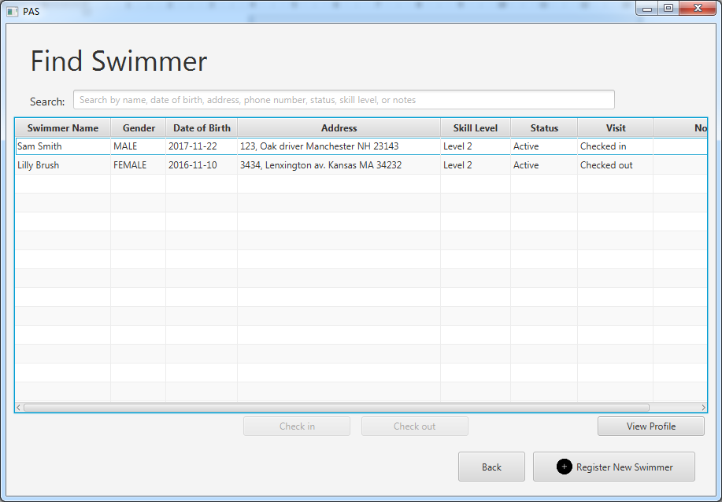

To check-in/check-out a Swimmer User has to select the Swimmer in the form.

To view the details of the Swimmer’s profile User has to press the ‘View Profile’ button. It opens the Profile of the Swimmer with detailed information about the address, emergency contact info, skill level, attendance history, and notes left by staff in the past.

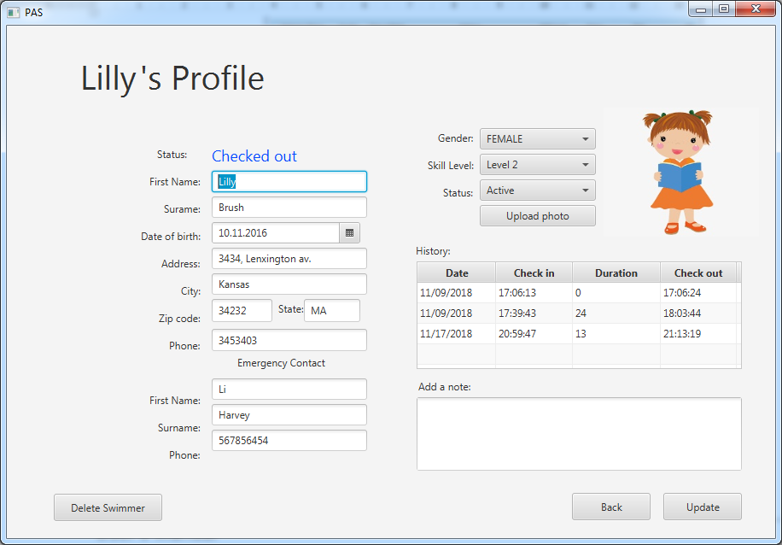

If User has Administrator privileges, he or she can create new Swimmer profile by pressing the ‘Register new Swimmer’ button:

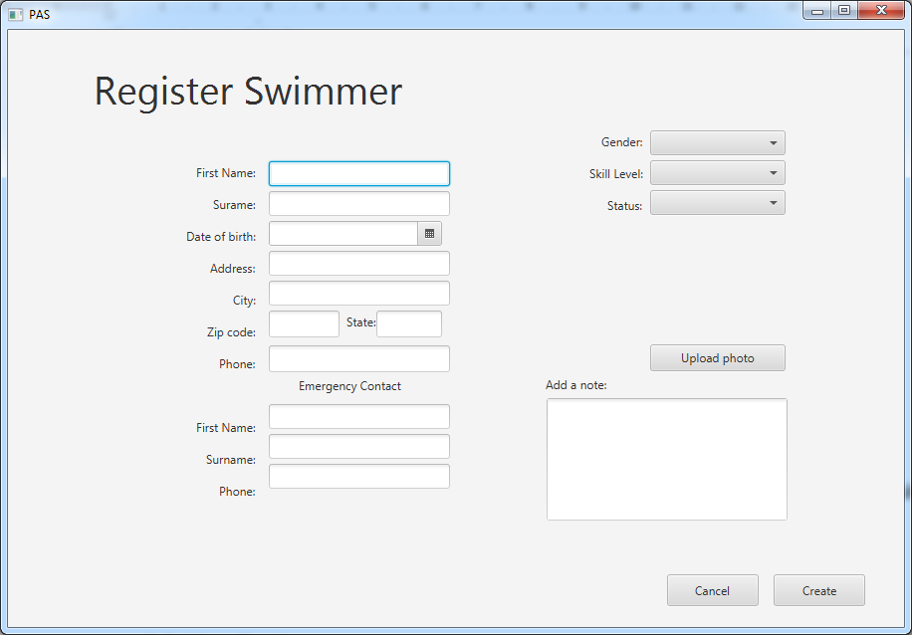

Also, Administrator can delete Swimmer’s profile. To do so, Administrator has to press ‘View profile’ button first, then press ‘Delete’ button in the lower left corner of the form.

### View Pool

This section shows the list of Swimmers in the Pool (i. e. Swimmers who have checked-in but have not checked-out yet). As in the ‘Find Swimmer’ section, User can search through the list of Swimmers by name, phone, address, gender, or date of birth:

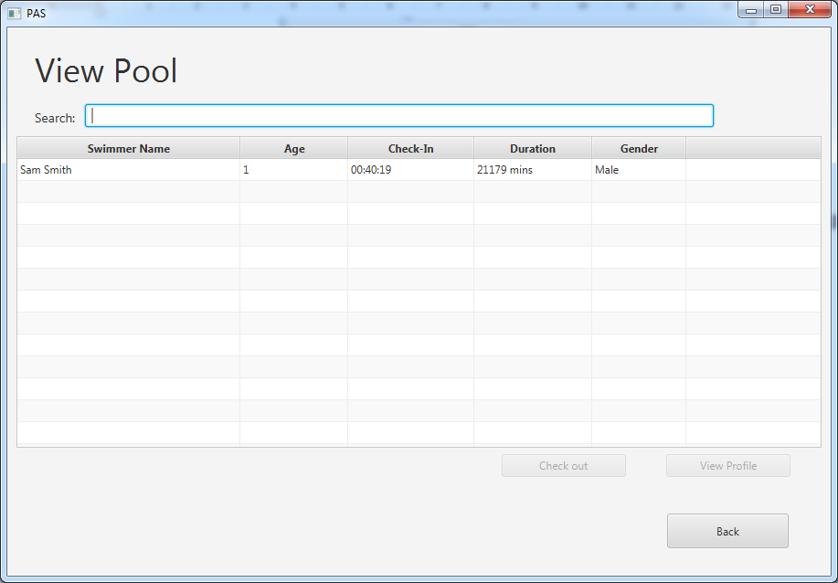

Likewise in the ‘Find Swimmer’ section, User can check-out a Swimmer or view the Swimmer’s profile once the Swimmer is selected.

### Reports

There are three types of reports available: View Visits, View Swimmers, and View Attendance. The user has to select the desired report type in the drop-down menu in the top-left corner of the window.

#### View Visits

View Visits report shows the history of Swimmer’s visit over the selected period:

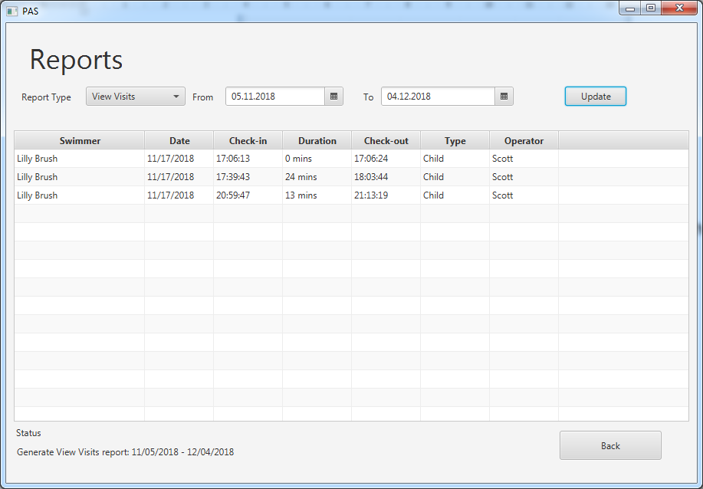

#### View Swimmers

View Swimmers report shows the statistics of attendance per Swimmer:

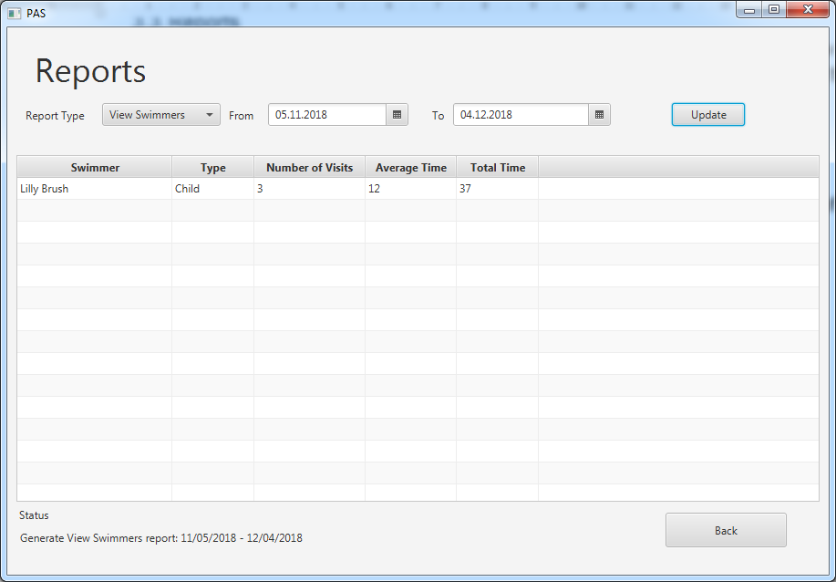

#### View Attendance

View Attendance report shows the statistics of attendance over days of the week and the working hours. It shows the total number of visits in a particular day of the week and an hour, as well as the aggregated number of visits across all weekdays and all working hours:

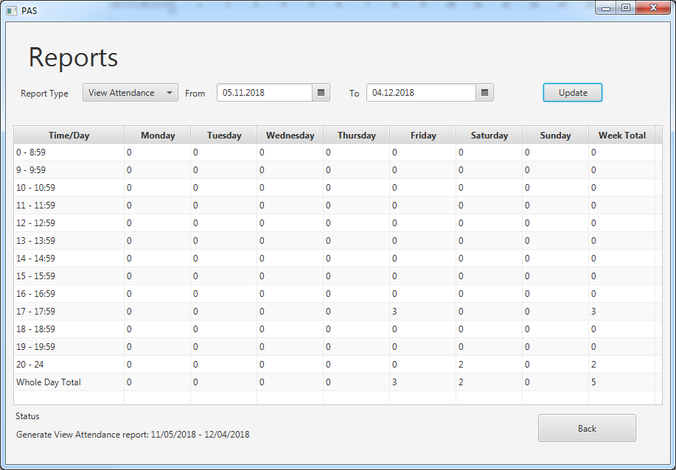

### Staff

The ‘Staff’ section is available only to Administrators. It allows Administrators to view, create, update, and delete the profiles of Employees in the system.

The user can search through the list of Employees by name, including Username (Employee ID), and in so doing, any fraction of the name would suffice:

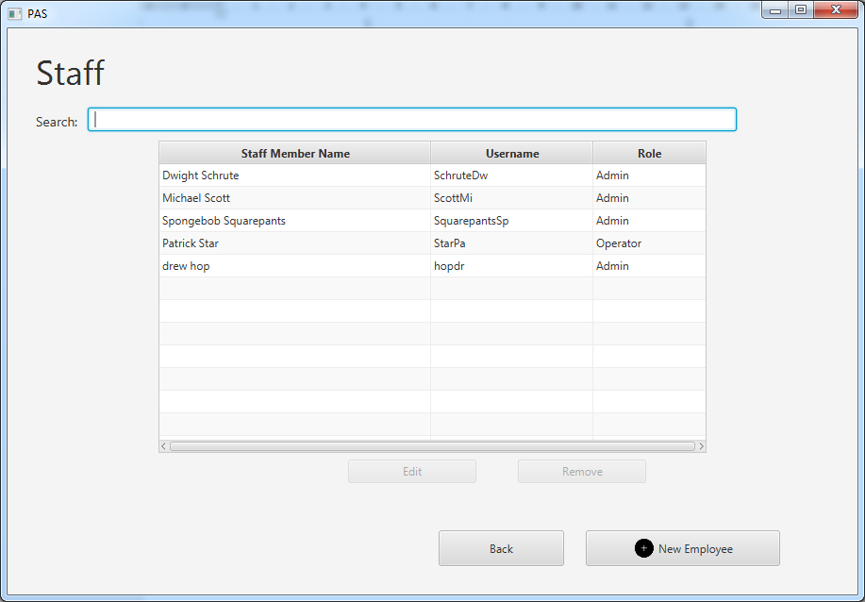

Admin can edit the profile of an Employee by pressing ‘Edit’ button (once the record is selected). To change the password, the current password must be provided:

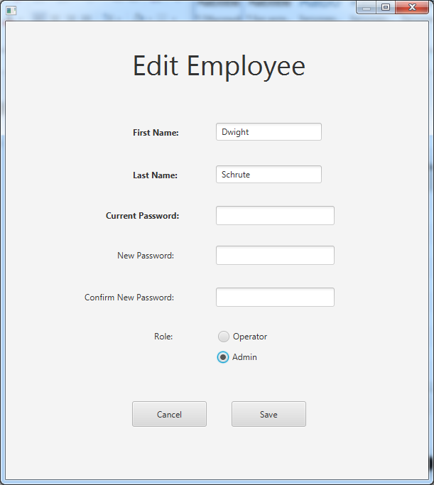

Admin can also create a new Employee profile by pressing ‘New Employee’ button. Then a new window ‘New Employee’ appears asking User to fill in the name, password, and the role of a new Employee:

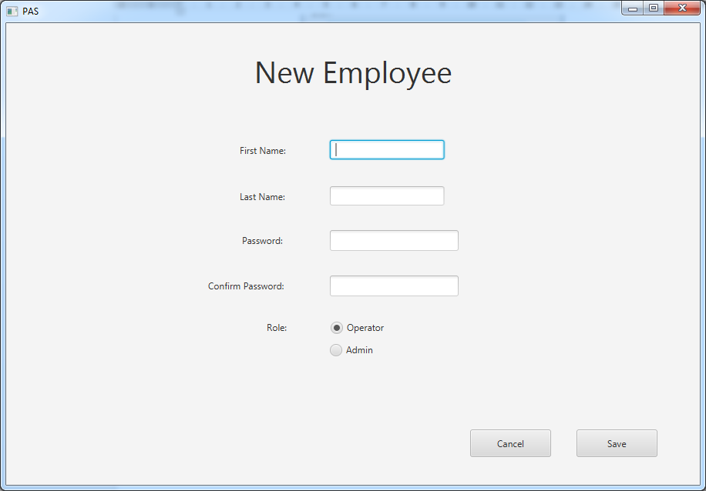

## Exit System

To Exit from the System, the User has to press ‘Log out’ button. In the new window the User has to confirm the decision to exit from the system by clicking on the ‘Confirm’ button:

