LAB-6



IT314 Software Engineering

Yuvraj Chaudhari

202101482

**Activity Diagram:**

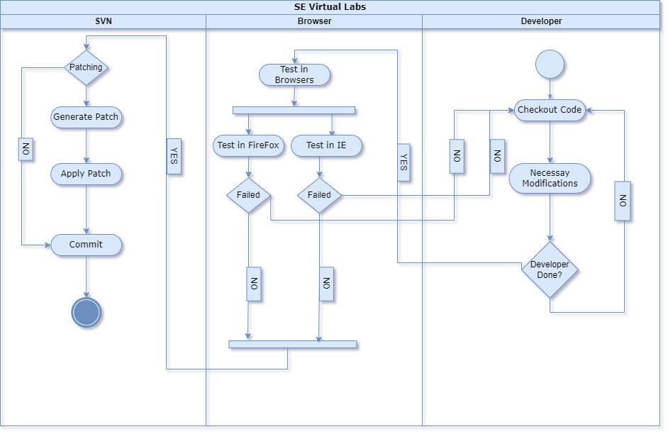

**Class Diagram:**

