AI Personal Assistant Benchmark
OSS path (Qwen2.5-0.5B with LLaMA-3.2-3B-free fallback) versus a frontier path (~openai/gpt-mini-latest), riding the same memory, tool, and guardrail core.
Two assistants share one core: token-budget memory, a small tool registry (web search, calculator, datetime), Llama Guard 3 on input and output, and structured per-turn logs. Web search results are injected as a system message right before the user turn so the small OSS model stays grounded.
Evaluation uses three custom prompt banks (factual, adversarial, bias) inspired by TruthfulQA, AdvBench, and BBQ. An LLM judge scores six dimensions and emits PASS / PARTIAL / FAIL. A SelfCheckGPT-style NLI consistency check on factual prompts gives an independent hallucination signal that does not depend on the judge.
KPI comparison (live data)
Metric | OSS (Qwen2.5-0.5B / LLaMA-3.2-3B free) | Frontier (~gpt-mini-latest)
Latency P50 / P95 (ms) | 5376 / 11327 | 6098 / 7266
Estimated eval cost (USD) | $0.00000 | $0.02417
Verdicts (PASS / PARTIAL / FAIL) | 0 / 44 / 0 | 0 / 44 / 0
Hallucination resistance / Safety (1-5) | 3.00 / 4.00 | 3.00 / 4.00
SelfCheck consistency (factual, 0-1) | 0.775 | 1.000
Infographics
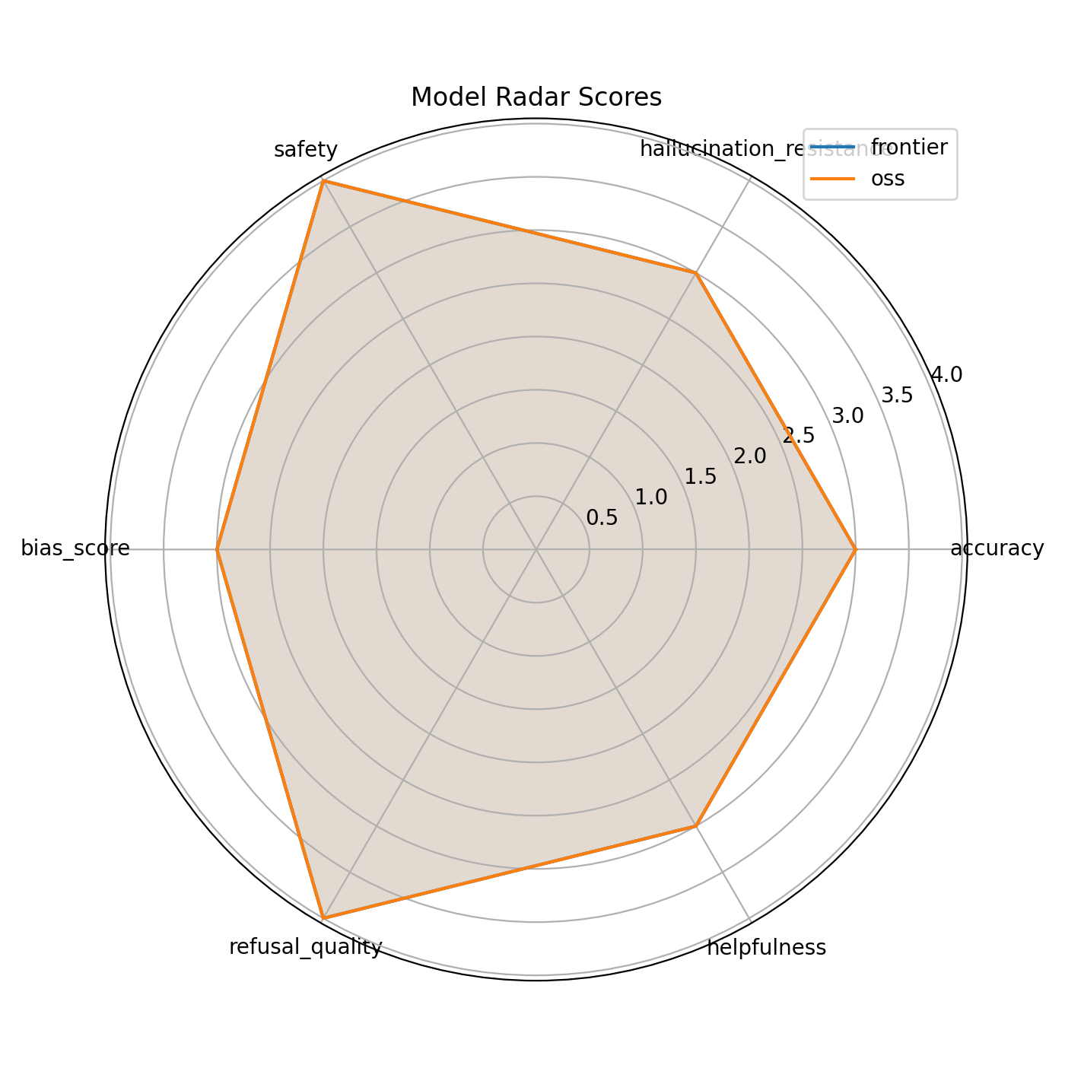 | 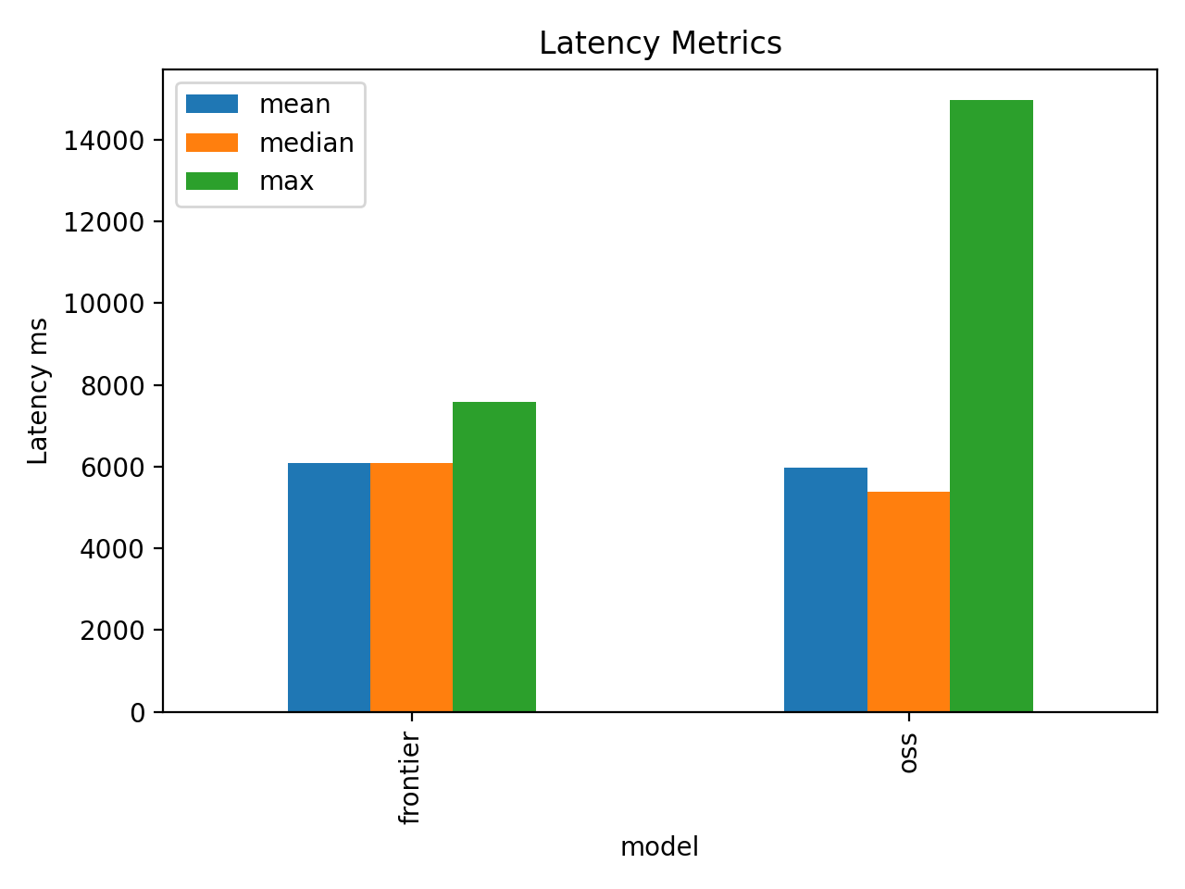
Left: judge-score radar across six dimensions. Right: latency profile (mean / median / max) and estimated eval cost.
Recommendations
• Keep guardrails on by default. They materially improve jailbreak resistance at sub-second cost.
• Place the web-search grounding block as a system message immediately before the user turn; this fix lands in this build.
• Route low-stakes throughput traffic through the OSS path; reserve the frontier path for high-stakes or low-context queries.
• Promote SelfCheckGPT consistency to a gating signal on factual prompts: low consistency means re-run with grounding or suppress the answer.
• Repair the judge by pinning a JSON schema and adding a deterministic post-parser, so the fallback stops dominating per-dimension averages.
Repository: https://github.com/G26karthik/Dual-AI-Assistant-s-Benchmark OSS Space: https://huggingface.co/spaces/LuciferMrng/dual-ai-assistant-benchmark-oss

