
DISCOVERING COMPUTERS 2018

© 2018 Cengage 版權所有， 為課本著作之延伸教材， 亦受著作權法之規範保護， 僅作為授課教學使用， 禁止列印、 影印、 未經授權重製和公開散佈

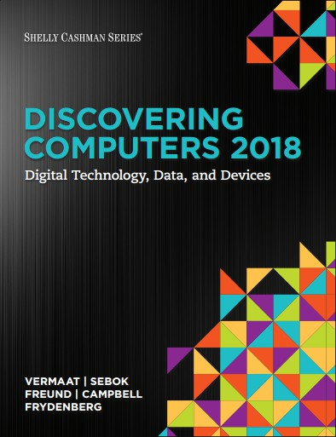
Digital Technology, Data, and Devices

Module 2 Connecting and Communicating Online:

The Internet, Website, and Media

- Discuss the evolution of the Internet.
- Briefly describe various broadband Internet connections.
- Describe the purpose of an IP address and its relationship to a domain name.
- Describe features of browsers and identify the components of a web address.
- Describe ways to compose effective search text.

IP: Internet Protocol

- Explain benefits and risks of using online social networks.
- Describe uses of various types of websites.
- Explain how the web uses graphics, animation, audio, video, and virtual reality.
- Explain how email, Internet messaging, chat rooms, online discussions, VoIP, and FTP work.
- Identify the rules of netiquette.

VoIP: voice over internet protoco FTP: pile transfer protocol

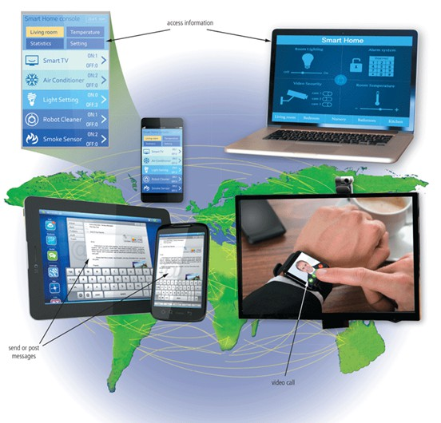
- The Internet is a worldwide collection of networks that connects millions of businesses, government agencies, educational institutions, and individuals.



- Batch processing: 1 mission at a time
- 1957 Time sharing: multiple users using a computer at a time
- 1958 DARPA (Defense Advanced Research Projects Agency)
- 1966 ARPANET: large-scale computer network

What is DARPA ?
  - Defense Advanced Research Projects Agency
  - United States Department of Defense
  - Created in February 1958
  - Internet , Computer Graphics, Parallel Computing, Flight Simulating
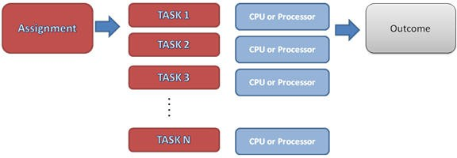


- The Internet originated as ARPANet in September 1969 and had two main goals:
- Allow scientists at different physical locations to share information and work together
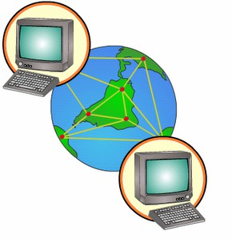
- Function even if part of the network were disabled or destroyed by a disaster

- Decentralized network




- Inter-net: connection of networks
- Other network began to go live.
- 1990 ARPANET was removed.
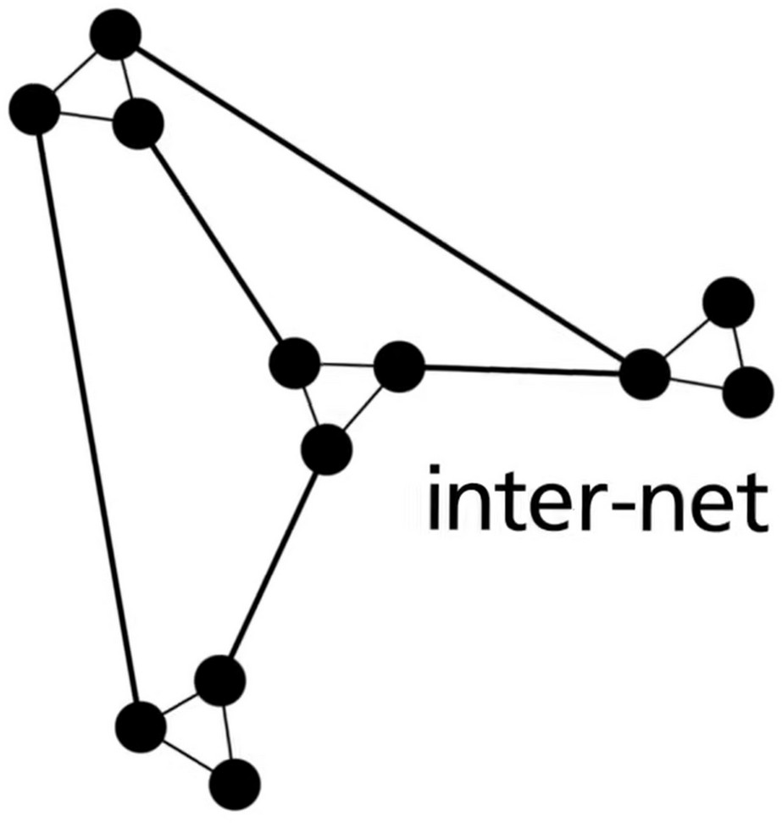

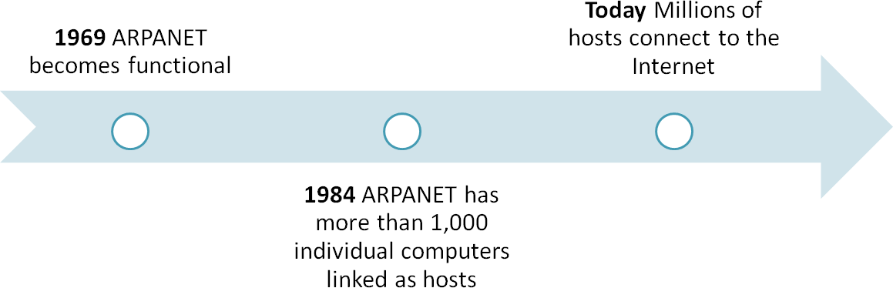

Transmission between nodes

- TCP / IP protocal
- TCP(Transmission Control Protocol) (like roads) : helps in the exchange of messages between different devices over a network
Connection-establishment process: three-way handshake
- IP(Internet Protocol) (like road signs) : a set of rules governing how data is sent and received over the internet
Every device contains a unique IP Address

FUNNY VIDEO

- https://www.youtube.com/watch?v=D61gg5RsFd A&t=23s

- Wired: With wired connections, a computer or device physically attaches via a cable or wire to a communications device
- Wireless: Computers without a communications device can use a wireless modem or other communications device that enables wireless connectivity

- Wired
- Cable Internet service
- DSL (Digital Subscriber Line)
- Fiber to the Premises (FTTP)
- Wireless
- Wi-Fi (Wireless Fidelity)
- Mobile broadband
- Fixed wireless
- Satellite Internet Service

- Broadband vs Dial-up Internet connection

 | Broadband | Dial-up
Feature | Dial-up | Broadband
Speed | Up to 56 Kbps | High (Mbps to Gbps)
Connection | Phone line required, needs to be "dialed" | Always-on, multiple types of technology
Security | IP address does not change | IP address changes every time
Applications | Basic web browsing, email | Streaming video, online gaming, video conferencing

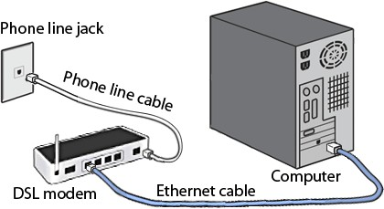
- Wired

DSL

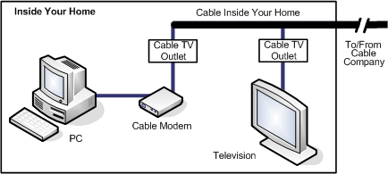
Cable Internet Service

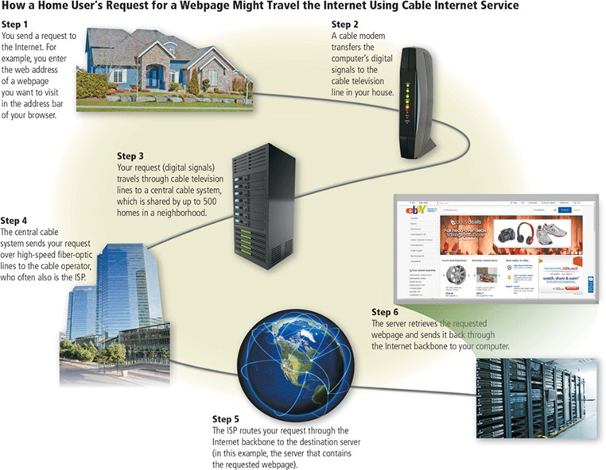
  - Wire d

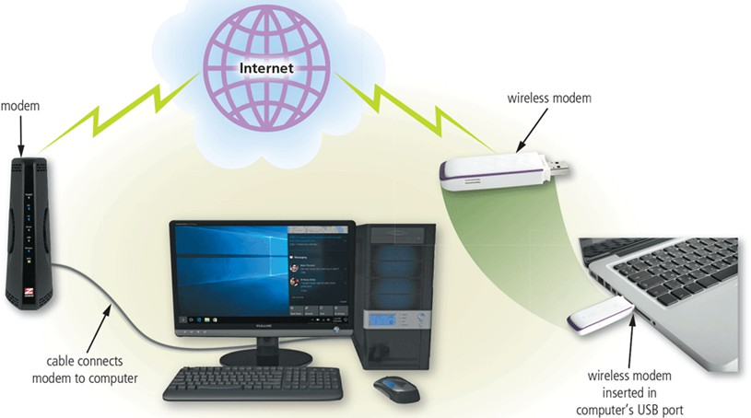
- Wireless

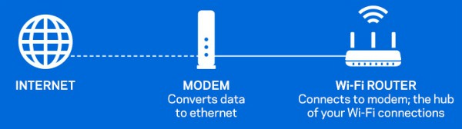

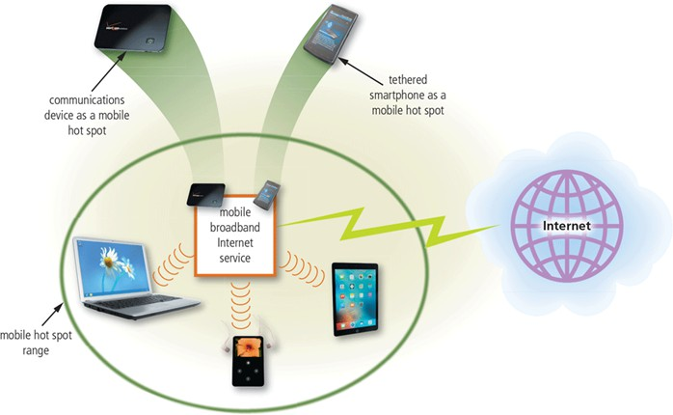
  - A hot spot is a wireless network that provides Internet connections to mobile computers and devices

    - Figure 2-3 You can create a mobile hot spot using a communications device or by tethering a smartphone.

- An Internet Service Provider (ISP) is a business that provides individuals and organizations access to the Internet free or for a fee.
- Bandwidth is a measure of the capability of a network to send and receive data, measured by how much data per unit of time a network connection can handle.


© 2018 C
duenpgliacgaete版d權, o所r有p，os為te課d本to著作a 之pu延b伸lic教ly材a，cc亦ess著ib作le權w法e之b規sit範e保, in護，wh僅o作le
© 2016 Cengage Learning®. May not be scanned, copied or
受
為授課教學使用， 禁止列
2-22
印、 影印、 未經授權重製和公開散佈
or in part.
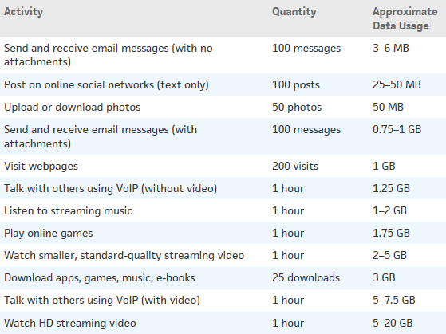

  - An IP address is a sequence of numbers that uniquely identifies the location of each computer or device connected to the Internet or any other network
  - A domain name is a text-based name that corresponds to the IP address of a server
  - A DNS (Domain Name System) server translates the domain name into its associated IP address

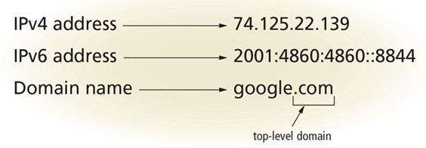
10-
base
16-
base

    - Figure 2-5 The IPv4 and IPv6 addresses, along with the domain name for Google's website.

  - 2001:0db8:0000:0000:0000:ff00:0042:8329
  - 2001:db8:0:0:0:ff00:42:8329 (omit leading 0)
  - 2001:db8::ff00:42:8329 (Double Colons for Consecutive Zeros)

  - IPv4: 2^32 ≈ 4.3 billion
  - 2024 Internet population: 5.35 billion
(https://datareportal.com/reports/digital-2024-deep-dive-the-state-of-internet-adoption)
  - IPv6: 2^128 ≈ 4.3 * 10^38
  - Sand on the Earth: 10^18 to 10^24

TLD | Intended Purpose
.biz | Businesses
.com | Commercial organizations, businesses, and companies
.edu | Educational institutions
.gov | Government agencies
.mil | Military organizations
.museum | Museums and individual museum professionals
.name | Individuals
.net | Network providers or commercial companies
.org | Nonprofit organizations
.pro | Licensed professionals
.technology | Technology information
.travel | Entities whose primary area of activity is in the travel industry
Table 2-3: Popular TLDs

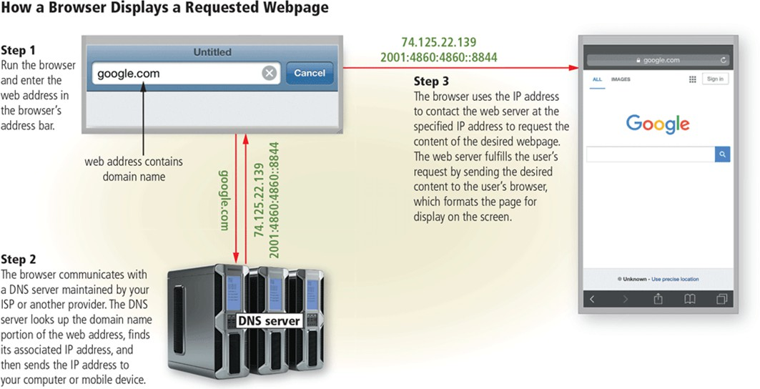
DNS: Domain Name
    - Figure 2-6 This figure show howSaeursveer’srentered domain name (google.com) uses a DNS server to display a webpage (Google, in this case).

  - Go to https://dnschecker.org/all-dns-records-of- domain.php to find IP addresses of websites
© 2018 Cengage 版權所有， 為課本著作之延伸教材， 亦受著作權法之規範保護， 僅作為授課教學使用， 禁止列印、 影印、 未經授權重製和公開散佈
2-29
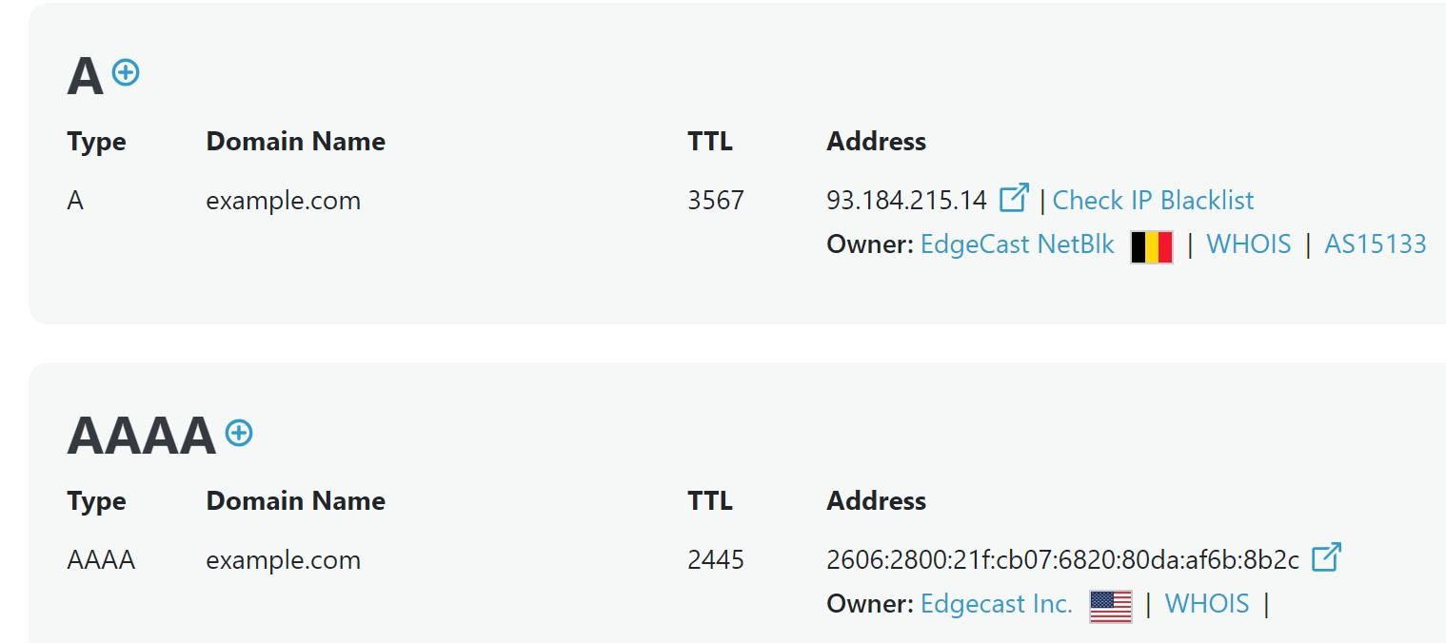
online.

  - Use `ipconfig` on windows cmd to look up your IP address.
© 2018 Cengage 版權所有， 為課本著作之延伸教材， 亦受著作權法之規範保護， 僅作為授課教學使用， 禁止列印、 影印、 未經授權重製和公開散佈
2-30
  - Go to https://api.ipify.org/ to find your IP address.
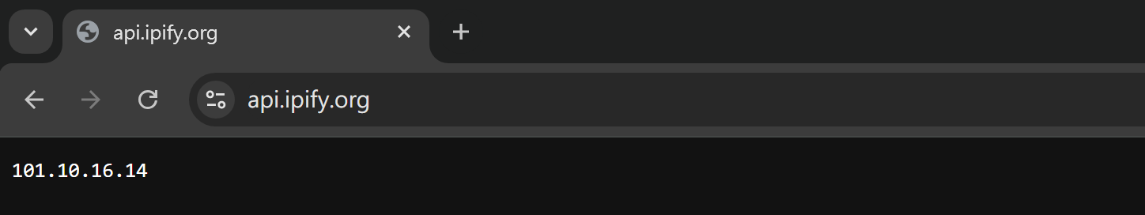
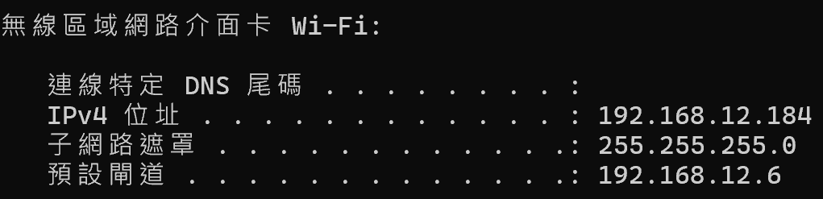
  - Why are they different?

  - It is because IPv4 addresses is exhausted.
  - NAT(Network Address Translation) is one of solutions to IPv4 exhaustion.


Intern
et
NAT
Intran
Devices such as PC,

Modem 、
et
WiFi router
smartphon e
192.168.x.x or 10.x.x.x

  - Complete website access process

DNS
server
Intern et
Intran et
Give me google’s IP
From:
192.168.87.87
Give me google’s
IP
From:
192.168.87.87
To: 1.1.1.1

IP: 1.1.1.1

Server of www.google.c om
IP: 8.8.8.8
ModemT,o: 1.1.1.1 WiFi
router

IP: 6.6.6.6

PC
IP: 192.168.87.87

  - Complete website access process

DNS
server
IP: 1.1.1.1
Server of www.google.c om
rnGivee me google’s
IP
Fr1o92mM:y6I.P6: ..68.76
.168.87
To: 1.1.1.1

IP: 8.8.8.8
Inte
t
Intern et
Intran
Give meetgoogle’s IP
M
odem,
To: 1.1.1.1
router

IP: 6.6.6.6
WiFi
From:
2.168.87.87
19

  - Complete website access process

DNS
.168.87
F1rF9or2omMm:y:61I.P.61:..61.8..167
GHiveeremyeoguooagrlee~’s
8.8IP.8.8
server
IP: 1.1.1.1

Intern Intran
et et

TToo:: 16I..16n..61..t61erne

t
Server of www.google.c om

IP: 8.8.8.8

Modem, WiFi router

IP: 6.6.6.6

  - Complete website access process
Here you are~
127.217.163.46
From: 1.1.1.1
To: 6T.o6:.6.6
192.168.87.87

DNS
server
Intern et
Intran et

IP: 1.1.1.1

Server of www.google.c om
IP: 8.8.8.8
Modem, WiFi router

IP: 6.6.6.6

PC
IP: 192.168.87.87

  - Complete website access process

Intern et
DNS
server
Intran et
Give me home
page

Give me home Herpeaygoeu are~ of goF8or.og8ml.e8.:.c8om
19F2r.o1m68: .18.71..817.1
of goForogmle.:com
192.168.87.87

IP: 1.1.1.1
ModemT, o: 8.8.8.8 WiFi
router

IP: 6.6.6.6
ToTo: 8: 6.T8.o6.8:.6.8.6
192.168.87.87 PC

IP:

IP: 8.8.8.8
Server of www.google.c om
192.168.87.87

  - Complete website access process

DNS
server

Intern et

Intran
et
Give me home
page
of google.com

IP: 1.1.1.1

Give me home
To: 8.8.8.8
192.168.87.87
From: 6.6.6.6
of goForogmle.:com
To: 8.8.8.8
From:
192.168.87.87

Server of www.google.c om
IP: 8.8.8.8

Interne t
page

Modem, WiFi router

IP: 6.6.6.6

  - Complete website access process

DNS
server
IP: 1.1H.G1eirv.ee1ymoeu haorem~e
(some page

Intern et

Intran et

Server of
page contents)
FrForommF:r:8o6.m.86.:.86..68
of google.com
192.168.87.87

Interne
t
TToo: :68.6.8.6.8.6.8
Modem, WiFi router

www.google.c om

IP: 8.8.8.8
IP: 6.6.6.6

  - Complete website access process
Intern Intran
(some page
contents)
From: 8.8.8.8
To: 6T.o6:.6.6
192.168.87.87

DNS
server IP: 1.1.1.1

IP: 8.8.8.8
et et

Modem, WiFi router
Server of www.google.c om

IP: 6.6.6.6

Here you are~

PC
IP: 192.168.87.87

  - Complete website access process
Intern et
Intran et
Modem, WiFi router

IP: 6.6.6.6

DNS
server
IP: 1.1.1.1


IP: 8.8.8.8
Here you are~ (some page
PC
To: 6T.o6:.6.6
192.168.87.87
contents)
From: 8.8.8.8
Server of www.google.c om
IP: 192.168.87.87

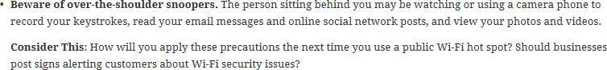



FUNNY VIDEO

  - https://www.youtube.com/watch?v=D61gg5RsFd A&t=210s

© 2018 Cengage 版權所有， 為課本著作之延伸教材， 亦受著作權法之規範保護， 僅作為授課教學使用， 禁止列
2-42

  - The World Wide Web (WWW), or web, consists of a worldwide collection of electronic documents (webpages)
  - A website is a collection of related webpages and associated items
  - A web server is a computer that delivers requested webpages to your computer or mobile device
  - HTML (Hypertext Markup Language) is a set of symbols that developers use to specify the headings, paragraphs, images, links, and other
content elements that a webpage contains

© 2018 Cengage 版權所有， 為課本著作之延伸教材， 亦受著作權法之規範保護， 僅作為授課教學使用， 禁止列
2-43

  - A browser is an application that enables users with an Internet connection to access and view webpages on a computer or mobile device
– Internet-capable mobile devices such as smartphones use a special type of browser, called a mobile browser
  - A home page is the first page that a website displays
  - Current browsers typically support tabbed browsing

© 2018 Cengage 版權所有， 為課本著作之延伸教材， 亦受著作權法之規範保護， 僅作為授課教學使用， 禁止列
2-44

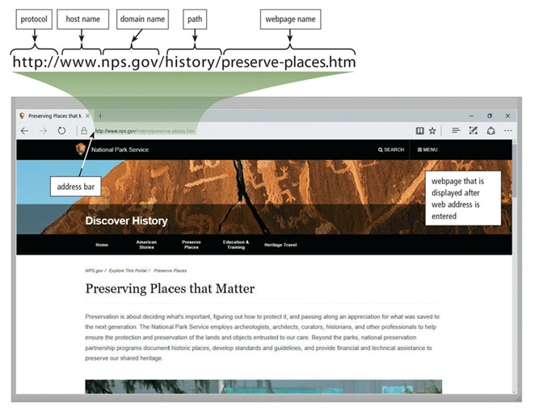
  - A webpage has a unique address, called a web address or URL (Uniform Resource Locator)

Figure 2-8 After entering http://www.nps.gov/history/preserve- places.htm in the address bar and then pressing the ENTER key or clicking the Search, Go, or similar button in a browser, the U.S. Department of the Interior National Park Service (NPS) home page shown here is displayed.

https://www.example.com:8080/folder/page.html? id=123&name=John#section2
    - Protocol
      - https ( http / ftp / ftps … )
    - Hostname
      - www.example.com
    - Port Number
      - :8080 ( default: 80 for http, 443 for https )
    - Path
      - /folder/page.html
    - Query Pramaters
      - ?id=123&name=John
    - Fragment Identifier
      - #section2

The World Wide Web (3 of 5)
© 2018 Cengage 版權所有， 為課本著作之延伸教材， 亦受著作權法之規範保護， 僅作為授課教學使用， 禁止列印、 影印、 未經授權重製和公開散佈
2-47


    - Figure 2-7 Many websites, such as the Centers for Disease Control and Prevention shown here, provide a mobile version that is designed specifically for display on a mobile browser.

    - A web app is an application stored on a web server that you access through a browser
      - Web apps usually store users’ data and information on their hosts’ servers
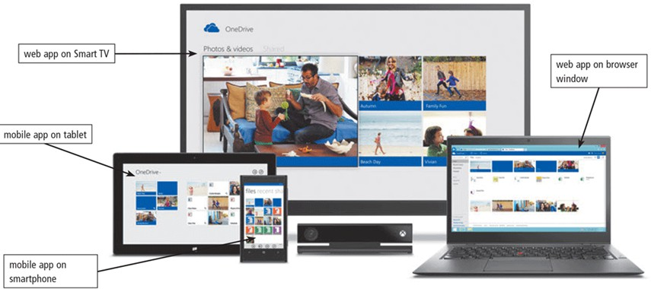
Figure 2-9 Web and mobile apps often work together, enabling you to access your content from a variety of computers and devices.

© 2018 Cengage 版權所有， 為課本著作之延伸教材， 亦受著作權法之規範保護， 僅作為授課教學使用， 禁止列印、 影印、 未經授權重製和公開散佈
2-48

  - Search engine ： is software that finds websites, webpages, images, videos, news, maps, and other information related to a specific topic

  - Subject directory ： classifies webpages in an organized set of categories, such as sports or shopping, and related subcategories

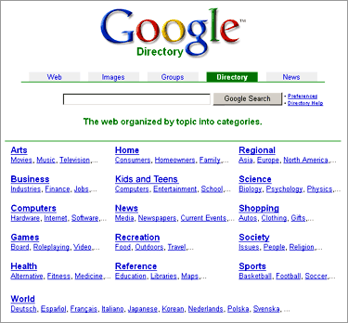
search engine

subject directory

Operator | Description | Examples | Explanation
Space or + | Display search results that include specific words. | art + music art music | Results have both words, art and music, in any order
OR | Display search results that include at least one word from a list. | dog OR puppy  dog OR puppy OR canine | Results have either the word, dog, or the word, Puppy. Results have the word, dog, or the word, puppy, or the word, canine.
* | Substitute characters in place of the asterisk. | writer* | Results include any word that begins with the text, writer (e.g., writer, writers, writer's)

Operator | Description | Examples | Explanation
_ | Exclude a word from search results. | automobile- convertible | Results include the word, automobile, but do not include the word, convertible.
“ ” | Search for an exact phrase in a certain order. | "19th century literature" | Results include the exact phrase, 19th century literature.

    - site:
    - filetype
:
    - inurl:
    - intext
:

  - There are several types of websites
- Informational and research
- Online social network, Media sharing
- Bookmarking
- Wiki and Collaboration
- Business, governmental, and organizational
- Content aggregation
- Mapping
- Retail and auctions
- Banking and Finance
- Portals

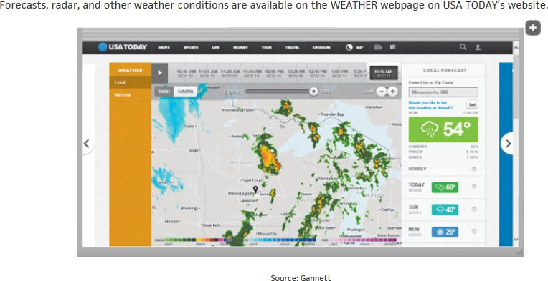

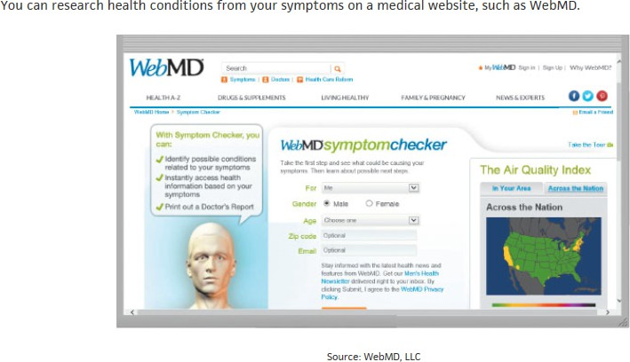

MD: Medical Doctor

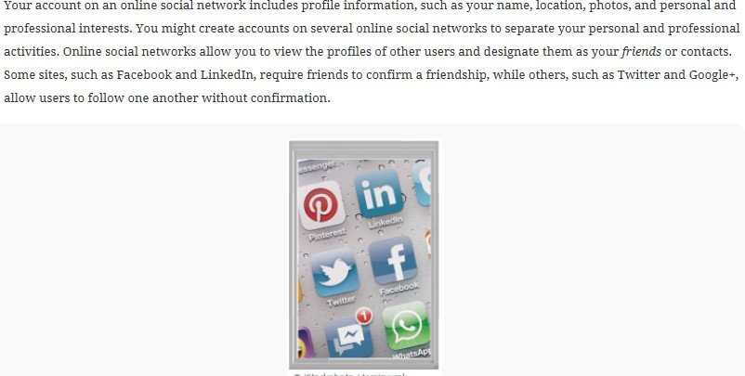
- Online social network

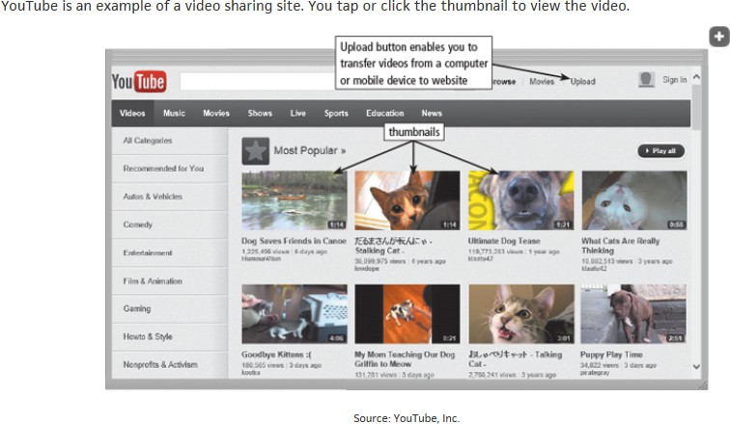

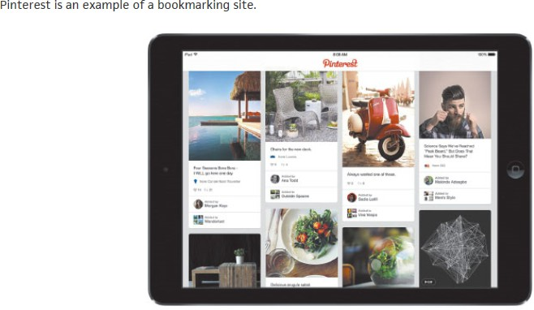

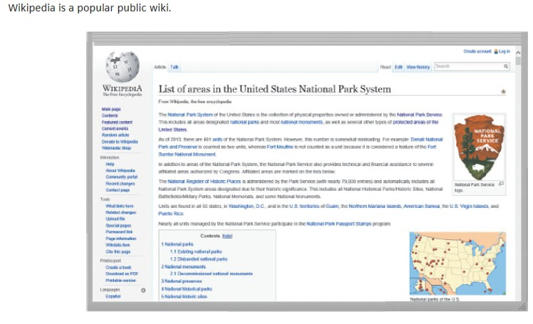
- Wiki and collaboration

- Government Agencies
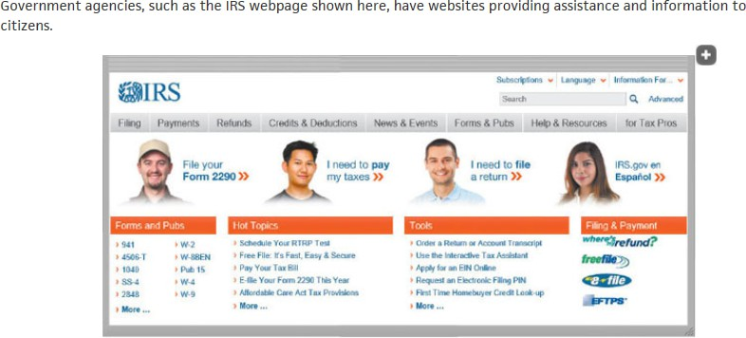
IRS: Internal Revenue Service



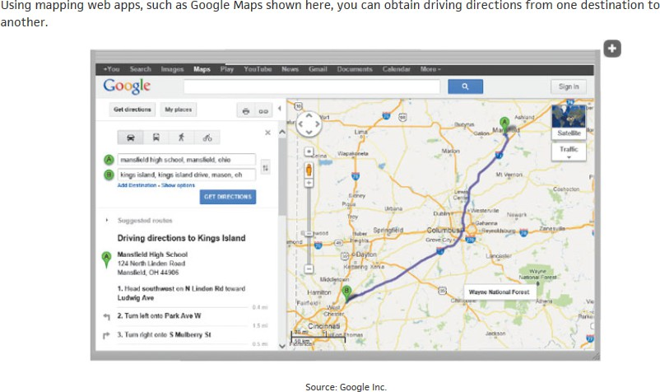

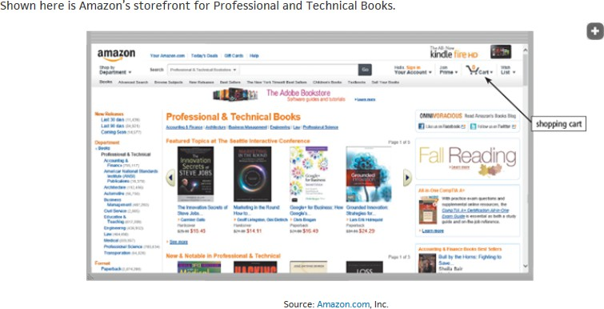

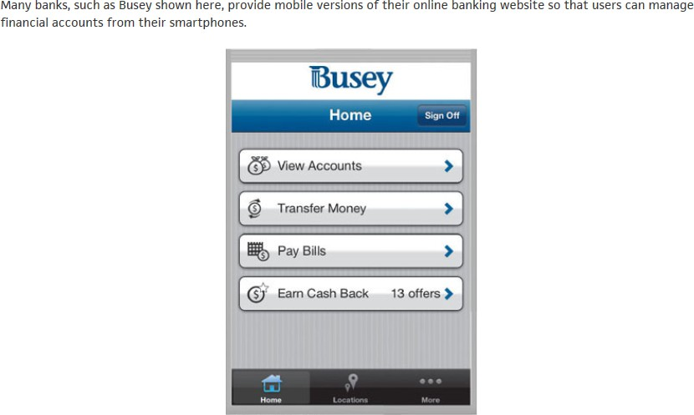

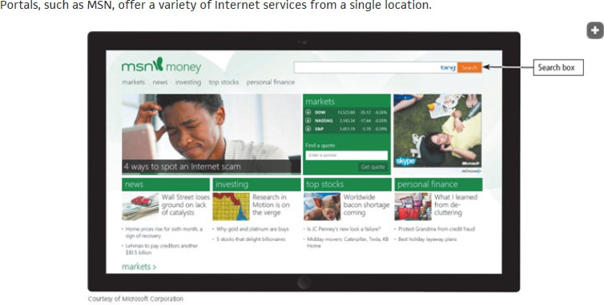
MSN: MicroSoft Network

Types of Websites (4 of 4)
- Web publishing is the creation and maintenance of websites



- Multimedia refers to any application that combines text with media
  - Graphics
  - Animation
  - Audio
  - Video
  - Virtual Reality

- Graphic: a visual representation of nontext information
- Graphic formats include BMP, GIF, JPEG, PNG, and TIFF

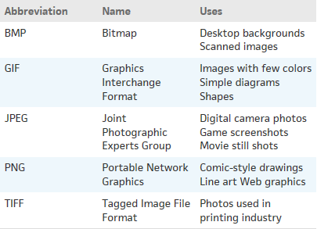

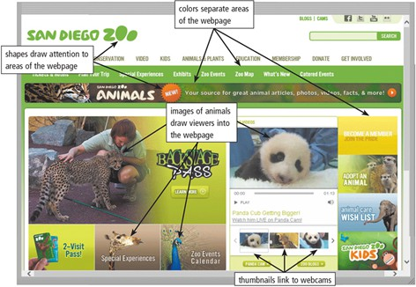

- Figure 2-22 Many webpages use colorful graphics to convey messages. For example, the variety of colors, images, shapes, and thumbnails on the San Diego Zoo webpage visually separate and draw attention to areas of the webpage, making the webpage more dynamic and enticing.


- Infographic: a visual representation of data and information, designed to communicate quickly, simplify complex concepts, or present patterns
or trends.
© 2018 Cengage 版權所有， 為課本著作之延伸教材， 亦受著作權法之規範保護， 僅作為授課教學使用， 禁止列印、 影印、 未經授權重製和公開散佈
2-71

Figure 2-23 An infographic presents complex concepts at a glance.

- Animation: the appearance of motion created by displaying a series of still images in sequence


  - Audio: includes music, speech, or any other sound
– Compressed to reduce file size
  - You listen to audio on your computer using a media player

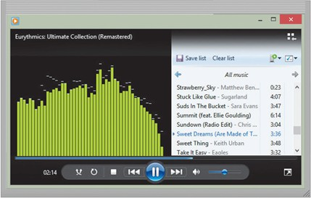
© 2018 Cengage 版權所有， 為課本著作之延伸教材， 亦受著作權法之規範保護， 僅作為授課教學使用， 禁止列印、 影印、 未經授權重製和公開散佈
2-74
Figure 2-24 Windows Media Player is a popular media player, through which you can listen to music and watch video.

Digital Media on the Web (5 of 6)
© 2018 Cengage 版權所有， 為課本著作之延伸教材， 亦受著作權法之規範保護， 僅作為授課教學使用， 禁止列印、 影印、 未經授權重製和公開散佈
2-75
- Video consists of images displayed in motion
- Virtual Reality (VR) is the use of computers to simulate a real or imagined environment that appears as a three-dimensional (3-D) space.

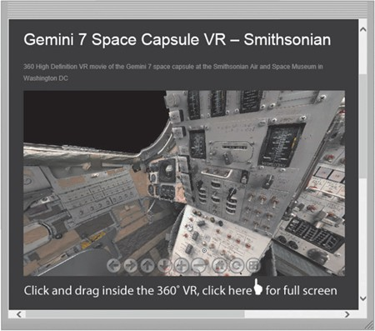

Figure 2-25 Users can explore a VR world using a touch screen or their input device. For example, users can explore the inside of the Gemini 7 space capsule, located at the Smithsonian Air and Space Museum in Washington, D.C., from their computer or mobile device. D.C.: District of Columbia
© 2018 Cengage 版權所有， 為課本著作之延伸教材， 亦受著作權法之規範保護， 僅作為授課教學使用， 禁止列印、 影印、 未經授權重製和公開散佈

2-76

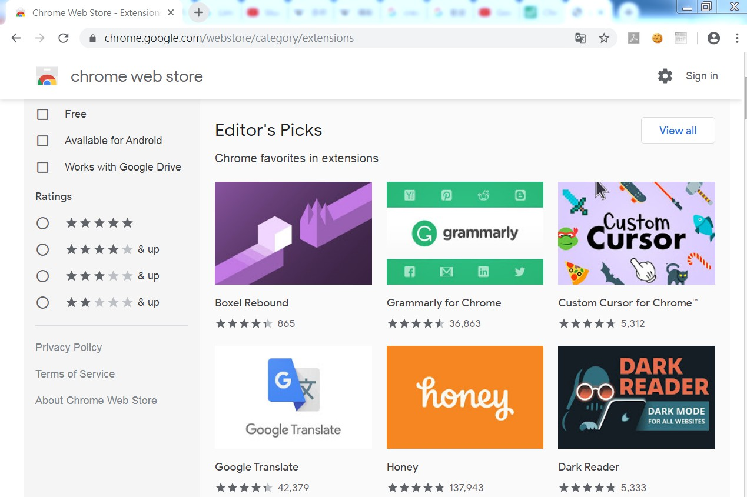
- A plug-in, or add-on, is a program that extends the capability of a browser

- A plug-in, or add-on, is a program that extends the capability of a browser


- Other Internet Service
  - Email
  - Internet Messaging
  - Chat Room
  - Online Discussion
  - VoIP(Voice over Internet Protocol)
  - FTP(File Transfer Protocol)

- Email is the transmission of messages and files via a computer network
- An email program allows you to create, send, receive, forward, store, print, and delete email messages

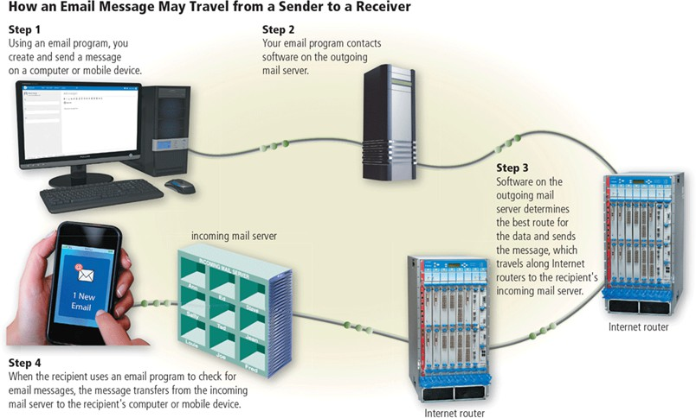
© 2018 Cengage 版權所有， 為課本著作之延伸教材， 亦受著作權法之規範保護， 僅作為授課教學使用， 禁止列印、 影印、 未經授權重製和公開散佈
2-81

Figure 2-26 This figure shows how an email message may travel from a sender to a receiver.

Other Internet Services (4 of 11)
© 2018 Cengage 版權所有， 為課本著作之延伸教材， 亦受著作權法之規範保護， 僅作為授課教學使用， 禁止列印、 影印、 未經授權重製和公開散佈
2-82
- Internet messaging services, which often occur in real-time, are communications services that notify you when one or more of your established contacts are online and then allows you to exchange messages or files or join a private chat room with them

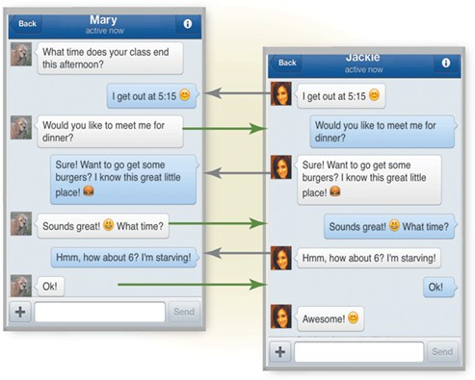
Figure 2-28 With Internet messaging services, you and the person(s) with whom you are conversing are online at the same time. The conversation appears on all parties' screens at the same time. Shown here is Facebook messenger.

© 2018 Cengage 版權所有， 為課本著作之延伸教材， 亦受著作權法之規範保護， 僅作為授課教學使用， 禁止列印、 影印、 未經授權重製和公開散佈
2-83

Other Internet Services (6 of 11)
© 2018 Cengage 版權所有， 為課本著作之延伸教材， 亦受著作權法之規範保護， 僅作為授課教學使用， 禁止列印、 影印、 未經授權重製和公開散佈
2-84

- A chat is a real-time typed conversation that takes place on a computer or mobile device with many other online users
- A chat room is a website or application that permits users to chat with others who are online at the same time

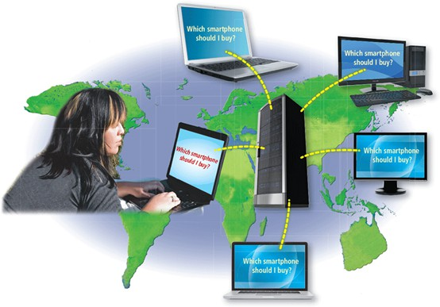
typed.
© 2018 Cengage 版權所有， 為課本著作之延伸教材， 亦受著作權法之規範保護， 僅作為授課教學使用， 禁止列印、 影印、 未經授權重製和公開散佈
2-85
Figure 2-29 As you type, others in the same chat room see what you have

- An online discussion is an online area in which users have written discussions about a particular subject
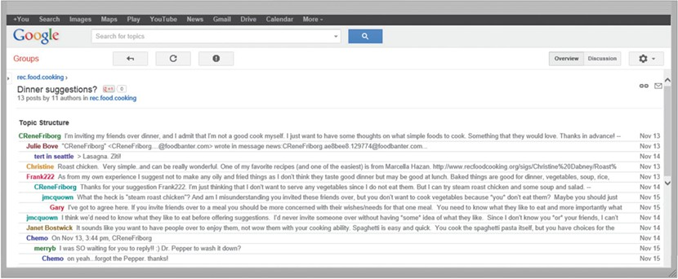

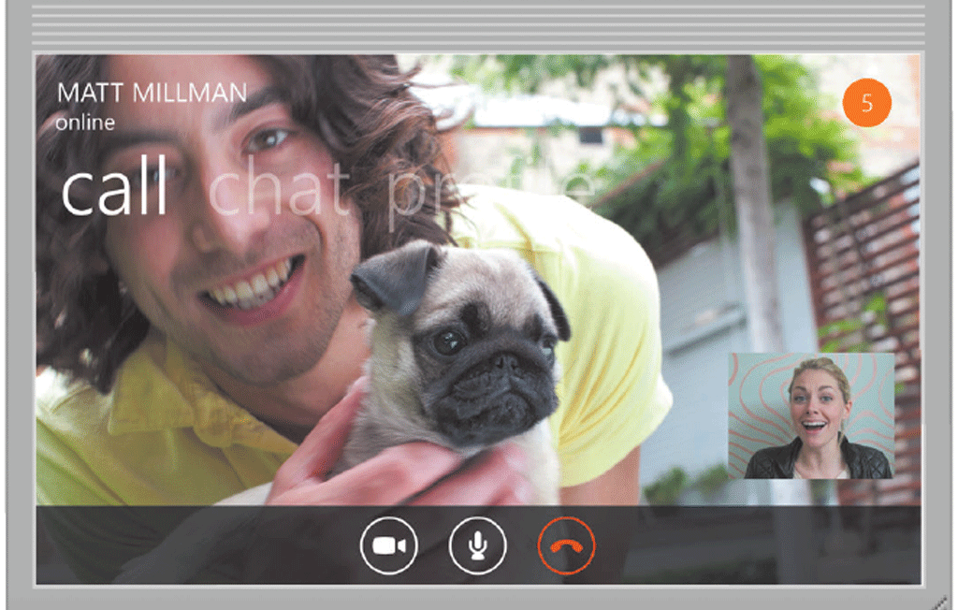
VoIP (Voice over Internet Protocol) enables users to speak to other users via their Internet connection
.

Source: Microsoft

- FTP (File Transfer Protocol) is an Internet standard that permits file uploading and downloading to and from other computers on the Internet
- Many operating systems include FTP capabilities
- An FTP server is a computer that allows users to upload and/or download files using FTP
2024cs

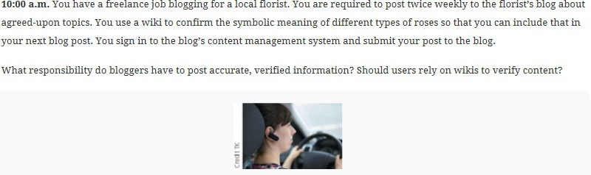

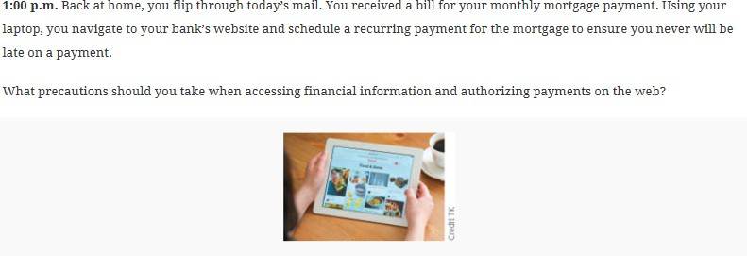

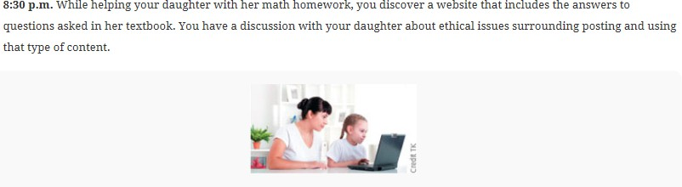

Netiquette
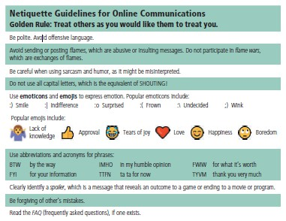
- Netiquette is the code of acceptable Internet behavior users should follow while on th
e Internet

Figure 2-31 Some of the rules of netiquette, with respect to online communications. Source: Microsoft

FUNNY VIDEO

- https://www.youtube.com/watch?v=D61gg5RsFd A&t=360s

Summary

- Evolution of the Internet
- The web
- Various types of websites and media
- Other services available on the Internet
- Netiquette

- 1. Steps of publishing a website?
- 2. How many bits make up IPv4 and IPv6 addresses?
- 3. What is web address also called?
- 4. What converts domain name to IP address?
- 5. What is the difference between WWW and the Internet

- Answer:
- 1.Plan Design Create Host Maintain
- 2. 32 128
- 3. URL
- 4. DNS server
- 5. The internet is a global network of computers all connected together. The world wide web is a collection of webpages found on this global network of computers

Project due Sep.
- Find and list the server IP addresses of your top ten most frequently used websites.
- For example:
– example.com - 93.184.215.14 and 2606:2800:21f:cb07:6820:80da:af6b:8b2c
– github.com - 20.27.177.113
– pixiv.net - 210.140.92.181
– google.com - 142.251.42.238 and 2404:6800:4012:2::200e
– one.one.one.one - 1.1.1.1 and 1.0.0.1 and 2606:4700:4700::1111 and 2606:4700:4700::1001

