**2048**

***Crypto***

**Challenge:**

Question: Our team has intercepted a message that has been encrypted. Can you decipher it?

SkJTV1kzRFBGUVFHMjZKQU5aUVcyWkpBTkZaU0FTTE9ORlRXNklDTk41WEhJMzNaTUVXQ0E2TFBPVVFHVzJMTU5SU1dJSUROUEVRR01ZTFVOQlNYRUxCQU9CWkdLNERCT0pTU0E1RFBFQlNHU1pKTw==

**Approach:**

On first look it kinda looks like base64 so we check it in the cipher identifier tool, and as expected:

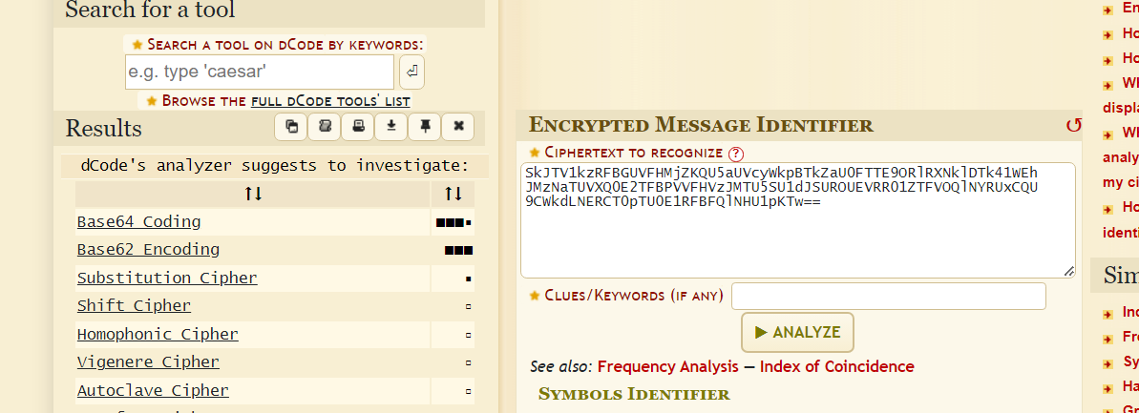

We decode it from base64 and get “*JBSWY3DPFQQG26JANZQW2ZJANFZSASLONFTW6ICNN5XHI33ZMEWCA6LPOUQGW2LMNRSWIIDNPEQGMYLUNBSXELBAOBZGK4DBOJSSA5DPEBSGSZJO”*

…..well, that does not look like the answer they are expecting (Stupid me tried and lost one attempt there)

Maybe it's multiple layers encoded?

We check it again against the cipher identifier and…

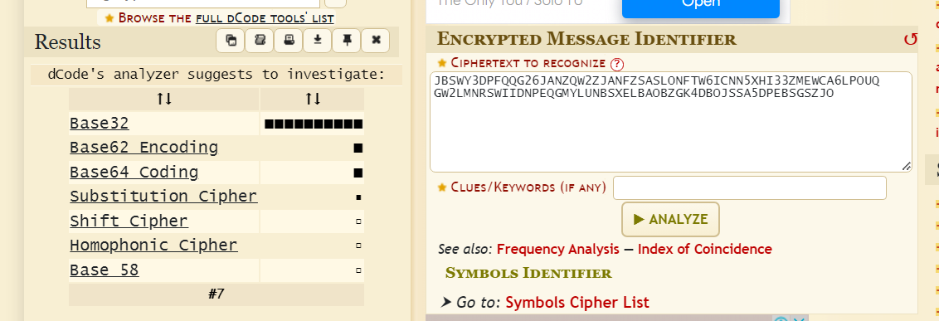

Well, that looks quite promising, we decode it through base32 and finally get what we were looking for (the flag ofc!)

**Flag: Hello, my name is Inigo Montoya, you killed my father, prepare to die.**

Congrats!!

Happy Hacking!