**Waterfall**

***Crypto***

**Challenge:**

Can you decode the hidden message?

Attached - waterfall.wav

**Approach:**

This question, not that difficult, took me HOURSS!!!

Just because i was looking in the wrong direction.

Well, first of all, obviously, opening it up on notepad….that gets me nothing. :(

I tried what not, noise cancellation, maybe some low frequency morse code? , binwalk, stegseek, some other not so famous steg tools.

Never forget this rule:

ALWAYS check audio files through an audio tool!!! UGHH

Downloaded Audacity, opened up the image, fidgeted through a few options and landed up on the spectrogram view, and there it was, literally 10 mins!! JESUS CHRIST!

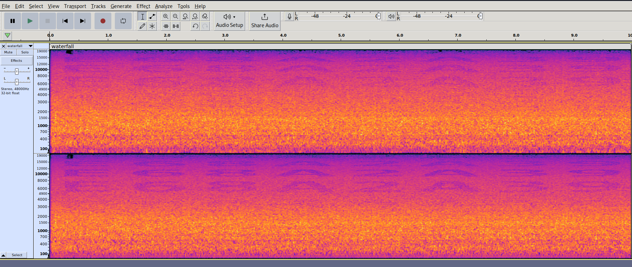

**Flag: E68A2A39**

Congrats!!

Happy Hacking!