**Dark_Web_Dump**

***OSINT***

**Challenge:**

Welcome to challenge 1 in the Track the Hacker Series, a multi-step challenge. You are simulating an attack path as the hacker to take over GlitterCo!

For this challenge, d34th dumped some data onto GhostTown in a thread about Dark Web Dumps. Use this information to track down the person’s username and password that he left out on the public web! This will require a bit of social media and other websites to track these credentials down, think you can hack it?

Submit the flag as flag{username:password} (case sensitive).

**Approach:**

Upon reconning through the forum, we find the link to the Google drive named “Hacked Stuff” and found this note (more of a confession letter?) to someone named Lucy. It read:

Dear Lucy,

How do I tell you that I love your sister and not you? You just can't slap the bass like a real

bass player. Oh man, this will never work she won't be able to handle the heart break. Alas, my

love will go on....I guess I will just keep stalking you on Twitter if Elon doesn’'t get it shut down.

Love

OpticSeltzer69

Well now we know he was stalking her on X and his X handle is OpticSeltzer69, we open up X and find his profile there and a post about a TicTacToe game he made that he posted on his github. Through this get into his github account and find 2 more repositories under his name. In the repository of BrownGlitter we found the code and a line in it, where he had hardcoded his username and password in the program:

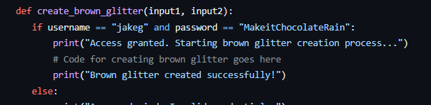

Hence our flag:

**Flag: flag{jakeg:MakeitChocolateRain}**

Congrats!!

Happy Hacking!