This is a test document that contains text

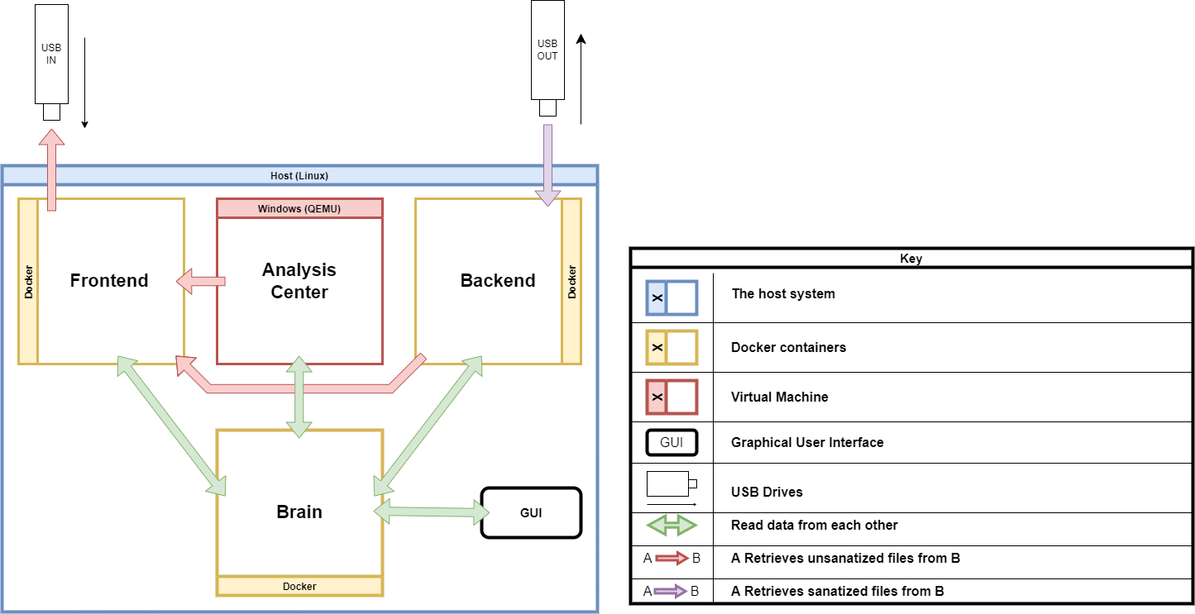

As well as a png image !

|  |  |
| --- | --- |
| And | I Can |
| Conserve | Tabs containing |
| Images too ! | Hey there  And text as well ! |

* 1
* 2
* 3
* 4

And even a text area!

1. I
2. II
3. III
4. IV

On multiple pages !