This is a test document that contains text
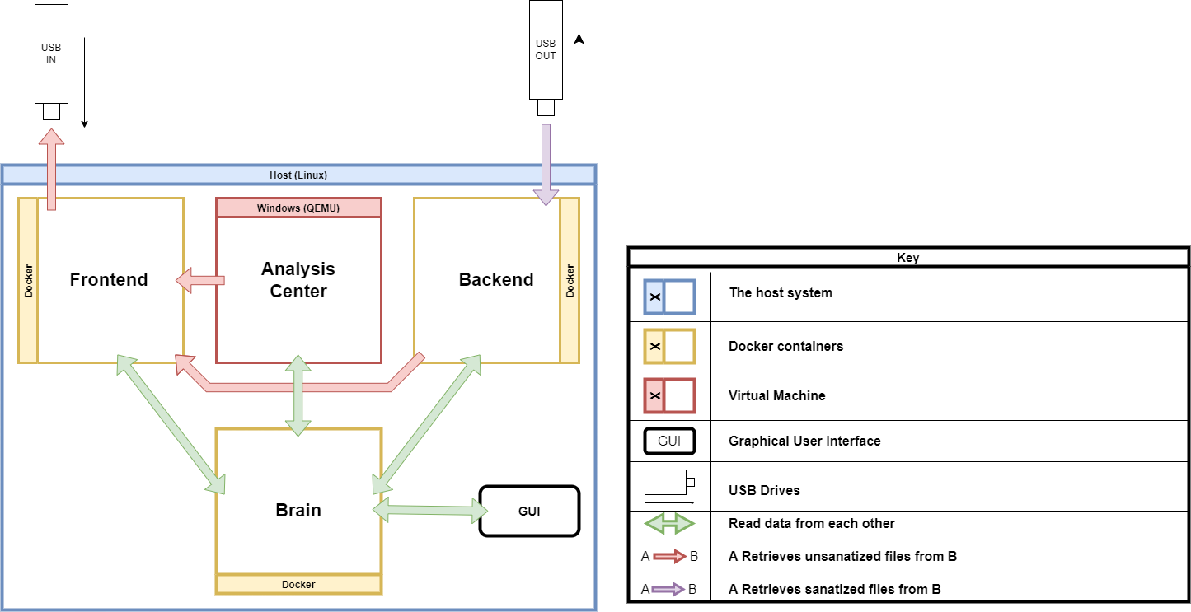
As well as a png image !

And | I Can
Conserve | Tabs containing
Images too ! | 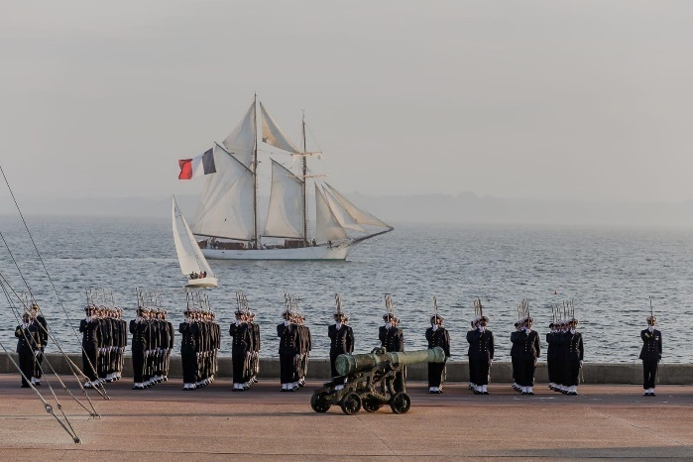  Hey there  And text as well !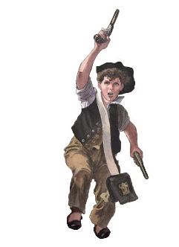

- 1
- 2
- 3
- 4
And even a text area!

- I
- II
- III
- IV

On multiple pages !
This text is relly just here to take some space.
I really want to demonstrate that this software works !!

Hope you like it, it took some time to develop….

