Crownfield Eye Hospital Database Development Report
Individual Report for CPU4:103 Database Development
Student | G77307 - Gabriel-Adrian Bunea
Assessment | Collaborative database build with individual report
Database | MySQL 8.0 prototype using synthetic records
Submission date | 9 November 2026
Word count 1383 excluding references captions code and tables

1 Introduction
This project converts the Crownfield Eye Hospital case from a wide spreadsheet record into a working MySQL database. The starting record repeated patient, clinician, clinic and medicine details, so a small change could leave different rows saying different things. My aim was to implement a version that could be rebuilt from ordered scripts and then tested with visible results. All names and clinical details in the database are fictional and the system is only a coursework prototype.
My part concentrated on implementation and testing. I matched the queries to the final column names, loaded the sample records, and checked the aggregate, joins, subquery, procedure and trigger in MySQL Workbench. I also prepared the role permissions, encryption example and rollback tests. I kept the files numbered because a script that runs alone is less useful than a repository another student can rebuild.

2 Analysis and Design
The clearest problem in the source was duplicated data. A patient postcode, clinician name or clinic location appeared again for each visit. Medicines also appeared as repeating columns inside one record. This creates an update anomaly when only one copy changes, an insertion anomaly when a medicine has no visit yet, and a deletion anomaly when removing a visit also removes the last copy of another fact. Separating the subjects removes that dependence on repeated text. This is the redundancy problem described by the relational model (Codd, 1970).
I treated patient_ref as the stable public reference and used numeric keys inside the database. Every appointment belongs to one patient, clinician and clinic. A visit can have several diagnosis rows and several prescriptions, but it can have only one optional follow-up plan. Prescription items hold the medicine, dose, route, frequency and duration. These assumptions match the foreign keys and the optionality shown in the ER diagram.
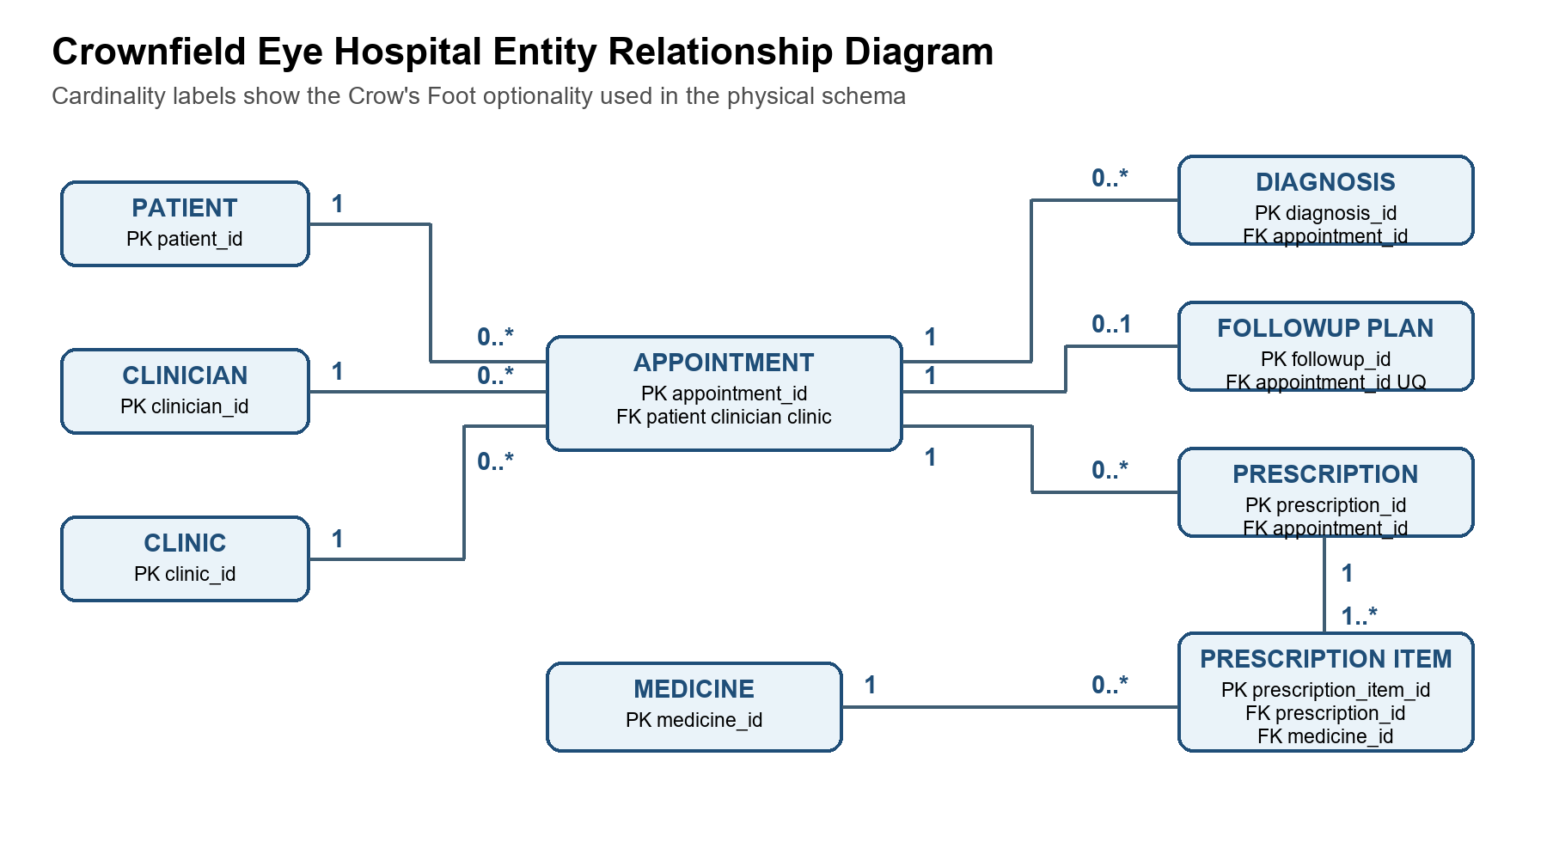
Figure 1. Crow's Foot entity relationship diagram for the implemented schema
The UNF record contained a repeating group for medicines. In 1NF I changed the repeating values into separate atomic rows. In 2NF I placed item details with the complete prescription-item key instead of leaving them with an appointment. In 3NF I separated patient, clinician, clinic and medicine descriptions from the appointment facts. The result follows the normalisation approach described by Connolly and Begg (2015) and avoids storing descriptive facts in several places.
The main design issue I checked was consistency between the logical model and the SQL. The early material mixed names such as date, appointment_date and followup_date. I used one name for each field and corrected the follow-up query so that patient data is reached through appointment instead of comparing unrelated identifiers.
Stage | Change made | Reason
UNF | Wide visit record with repeating medicines | Shows the original anomalies
1NF | One value in each field and repeating items split | Removes repeating groups
2NF | Line-item facts depend on the complete item key | Removes partial dependency
3NF | Patient, clinician, clinic and medicine stored separately | Removes transitive dependency

3 Implementation and Testing
I created eleven tables in MySQL 8.0. Primary keys identify the records and foreign keys connect the appointment to its patient, clinician and clinic. UNIQUE protects patient references and appointment slots. NOT NULL, DEFAULT and CHECK or ENUM rules cover required fields and allowed statuses. I used RESTRICT for parent rows that should not disappear while appointments still refer to them, and CASCADE for dependent clinical rows. This agrees with the purpose of foreign keys in the MySQL manual (Oracle, 2026a).
The schema and data scripts completed in the documented order. The checks returned 12 patients, 10 clinicians, 10 clinics, 10 medicines and 12 appointments. The related tables returned 11 diagnoses, 10 follow-up plans, 12 prescriptions and 20 prescription items. I also ran an UPDATE and a DELETE inside transactions. The changed result appeared before ROLLBACK, and the original value or row count returned after it, so the tests did not damage the sample dataset.
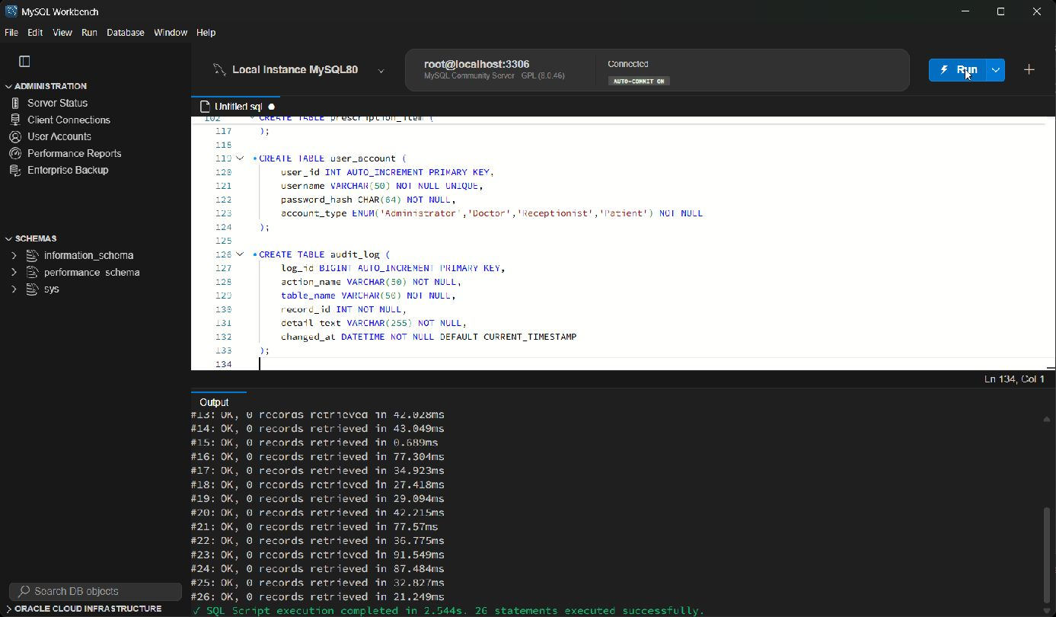
Figure 2. Successful schema execution in MySQL Workbench Full screen
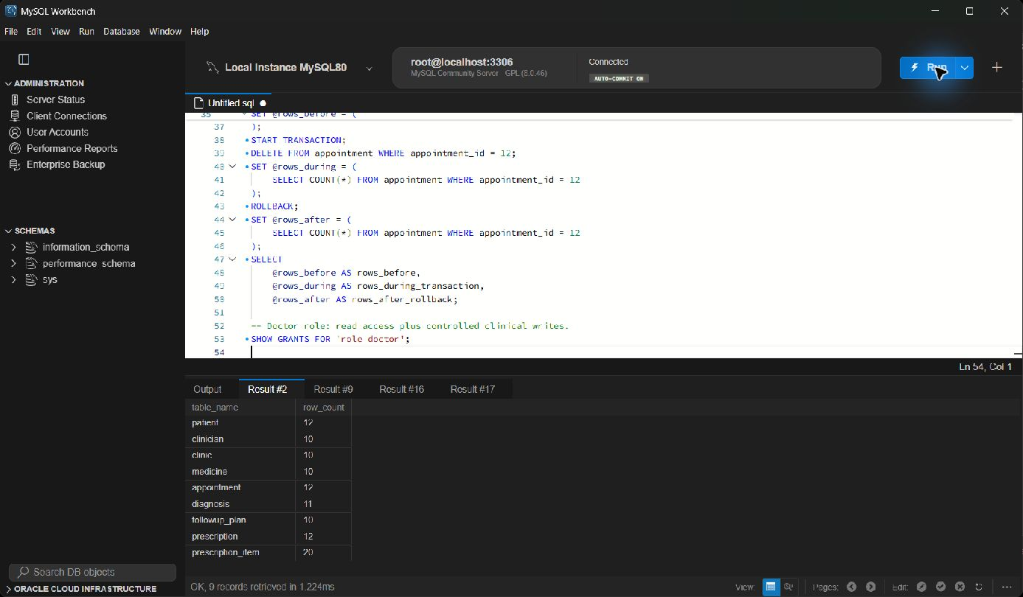
Figure 3. Record count test for the main tables Full screen
Test | Expected result | Observed result
Schema build | Tables and constraints created | Pass
Record counts | At least 10 rows in each main table | Pass
Valid follow-up | Future date accepted with Pending status | Pass
Controlled update | Change visible before rollback | Pass
Controlled delete | Delete visible before rollback | Pass

4 Individual SQL
I checked every feature in three steps: the SQL had to execute, the result had to agree with the sample records, and the evidence had to show the statement and result together. My four direct queries examine clinician workload, complete visit details, appointments missing follow-up work and intervals above the average. The procedure and trigger provide the two reusable database features required by the brief.

Query 1 Aggregate appointments by clinician
Question answered Which clinicians handled at least two appointments
SELECT c.full_name, COUNT(a.appointment_id) AS total_appointments
FROM clinician c JOIN appointment a ON a.clinician_id = c.clinician_id
GROUP BY c.clinician_id, c.full_name
HAVING COUNT(a.appointment_id) >= 2;
This aggregate groups visits by clinician and filters the grouped result with HAVING. The test returned Dr Maya Shah with five appointments and Dr Leo Grant and Dr Priya Nair with two each. The counts agree with the appointment data, so the result demonstrates both aggregation and a condition applied after grouping.
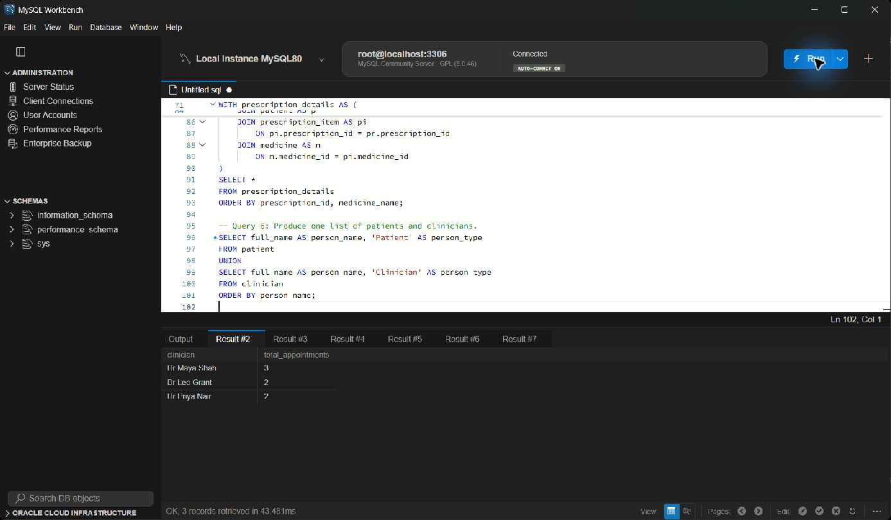
Figure 4. Query 1 Aggregate appointments by clinician execution evidence Full screen

Query 2 Inner join across clinical tables
Question answered Which patient attended each appointment and who treated them
SELECT a.appointment_id, p.patient_ref, p.full_name, c.full_name,
cl.clinic_name, a.appointment_date, d.diagnosis_text
FROM appointment a JOIN patient p ON p.patient_id = a.patient_id
JOIN clinician c ON c.clinician_id = a.clinician_id
JOIN clinic cl ON cl.clinic_id = a.clinic_id
JOIN diagnosis d ON d.appointment_id = a.appointment_id;
The INNER JOIN follows foreign keys through appointment to patient, clinician, clinic and diagnosis. Only visits with all required joined rows appear, and the test returned eleven linked consultation records. This is useful for a clinical visit summary and proves that the keys connect the five tables without a direct or invented relationship.
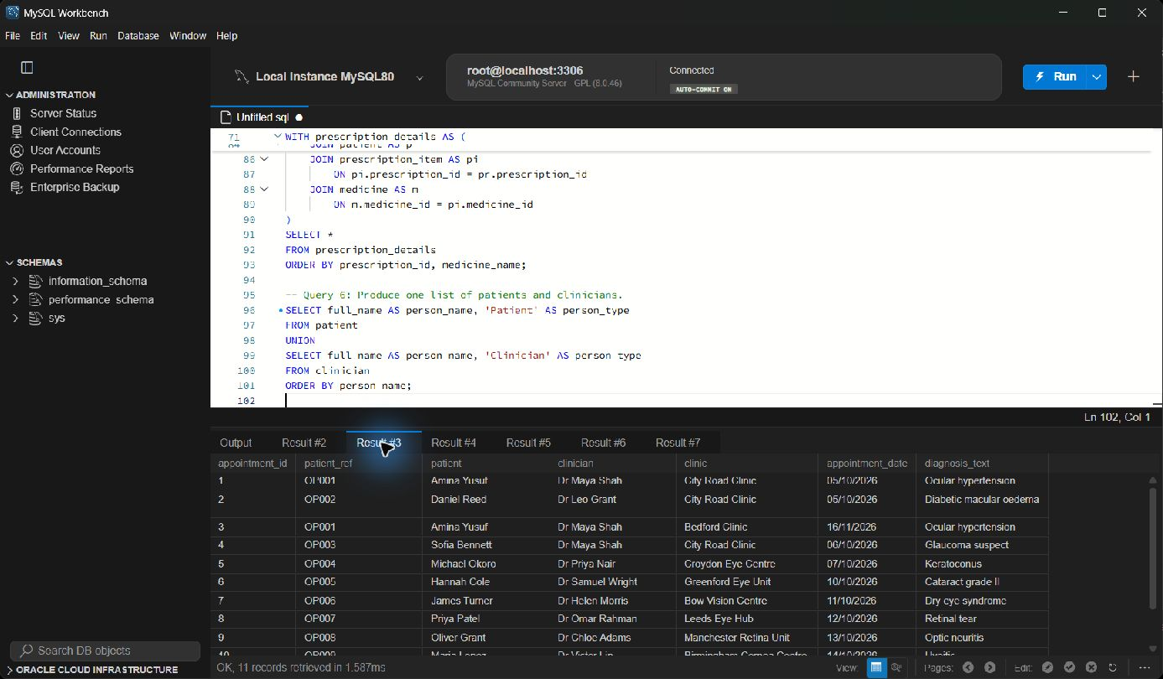
Figure 5. Query 2 Inner join across clinical tables execution evidence Full screen

Query 3 Left join for missing follow up
Question answered Which appointments do not yet have a follow up plan
SELECT a.appointment_id, p.patient_ref, p.full_name, a.appointment_date
FROM appointment a JOIN patient p ON p.patient_id = a.patient_id
LEFT JOIN followup_plan f ON f.appointment_id = a.appointment_id
WHERE f.followup_id IS NULL;
A LEFT JOIN keeps every appointment even when no follow-up row exists. Filtering for a NULL followup_id returned appointments 11 and 12. An INNER JOIN would hide these records, so this result is evidence that the optional relationship is represented correctly and can be used to find work that is still outstanding.
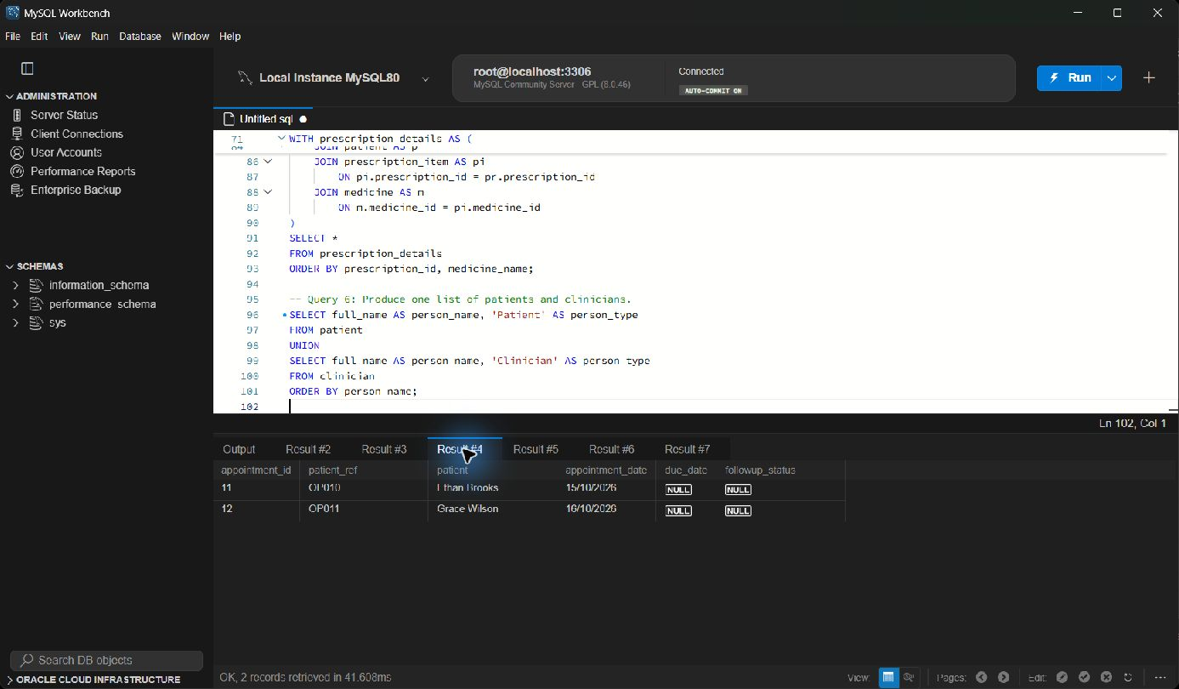
Figure 6. Query 3 Left join for missing follow up execution evidence Full screen

Query 4 Subquery above average follow up interval
Question answered Which follow up intervals are longer than the average
SELECT p.patient_ref, p.full_name, DATEDIFF(f.due_date,a.appointment_date) AS days
FROM followup_plan f JOIN appointment a ON a.appointment_id=f.appointment_id
JOIN patient p ON p.patient_id=a.patient_id
WHERE DATEDIFF(f.due_date,a.appointment_date) >
(SELECT AVG(DATEDIFF(f2.due_date,a2.appointment_date))
FROM followup_plan f2 JOIN appointment a2 ON a2.appointment_id=f2.appointment_id);
The inner query calculates one average follow-up interval and the outer query compares each plan with it. Four records were above the average, including intervals of 183, 140, 98 and 84 days. The patient join is made through appointment, which corrects the earlier version that compared unrelated patient and appointment identifiers.
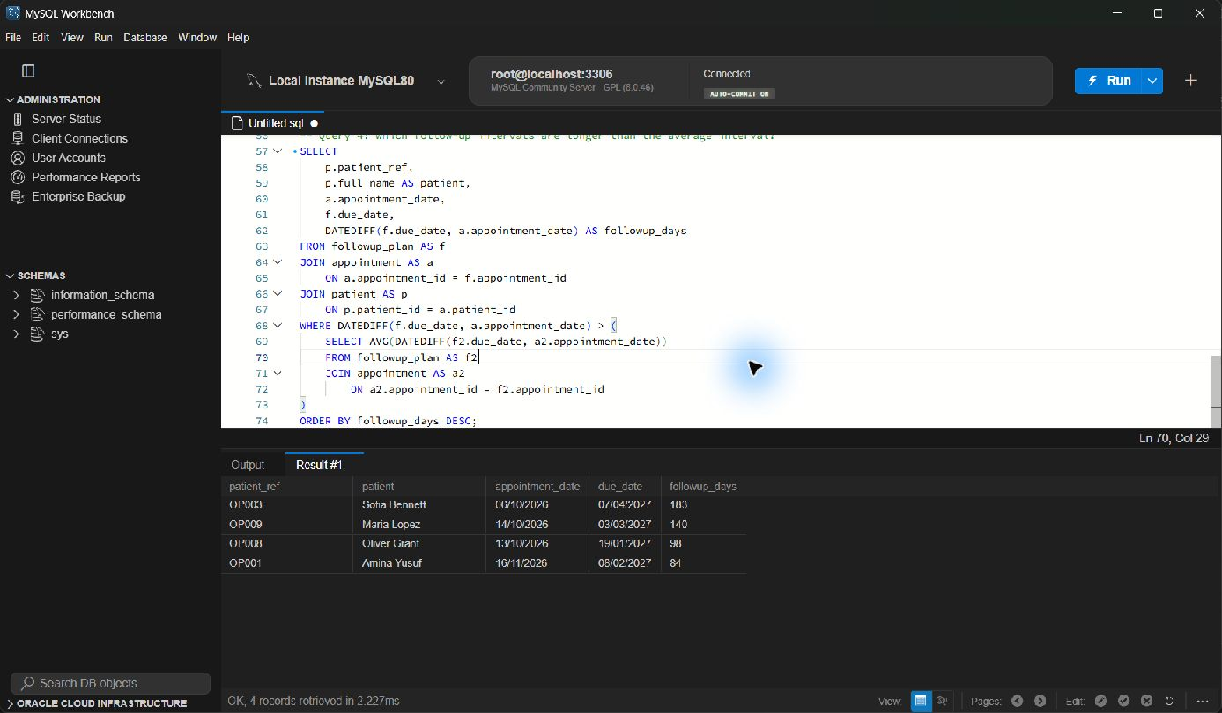
Figure 7. Query 4 Subquery above average follow up interval execution evidence Full screen

Query 5 Stored procedure with an input parameter
Question answered What is the appointment history for one patient reference
CREATE PROCEDURE gabriel_patient_history(IN p_patient_ref VARCHAR(10))
BEGIN
SELECT ... FROM patient p JOIN appointment a ON a.patient_id=p.patient_id ...
WHERE p.patient_ref = p_patient_ref;
END;
CALL gabriel_patient_history('OP001');
The procedure accepts a patient reference instead of fixing one patient in the SQL. Calling it with OP001 returned both appointments for Amina Yusuf in date order with clinician, clinic and diagnosis details. The parameter makes the feature reusable, while the join path and returned rows show that it reads the expected patient's history.
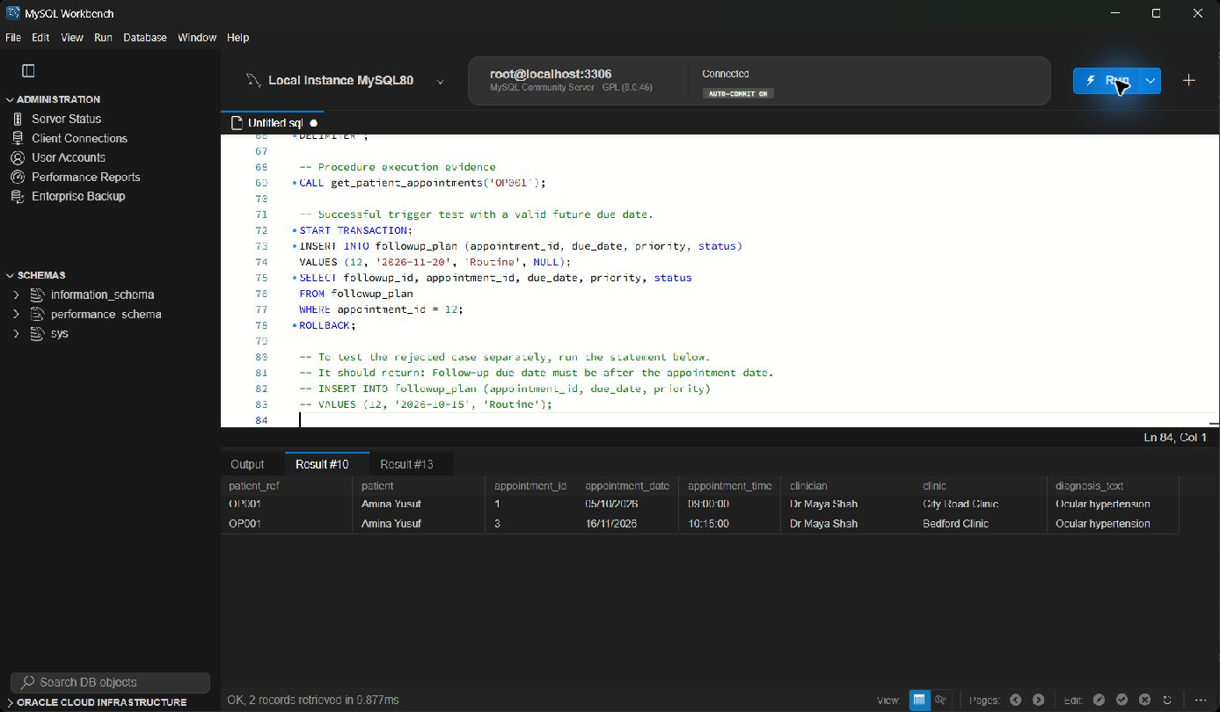
Figure 8. Query 5 Stored procedure with an input parameter execution evidence Full screen

Query 6 Trigger for follow up dates
Question answered How does the database stop an invalid follow up date
CREATE TRIGGER trg_gabriel_followup_date BEFORE INSERT ON followup_plan
FOR EACH ROW BEGIN
IF NEW.due_date <= v_appointment_date THEN
SIGNAL SQLSTATE '45000' SET MESSAGE_TEXT =
'Follow-up due date must be after the appointment date';
END IF;
END;
The trigger reads the linked appointment date before a follow-up is inserted. It rejects a due date on or before the visit and sets a missing status to Pending for a valid row. The evidence shows a valid insert for appointment 12 with the default status. The test was wrapped in a transaction and rolled back so the original sample data remained unchanged.
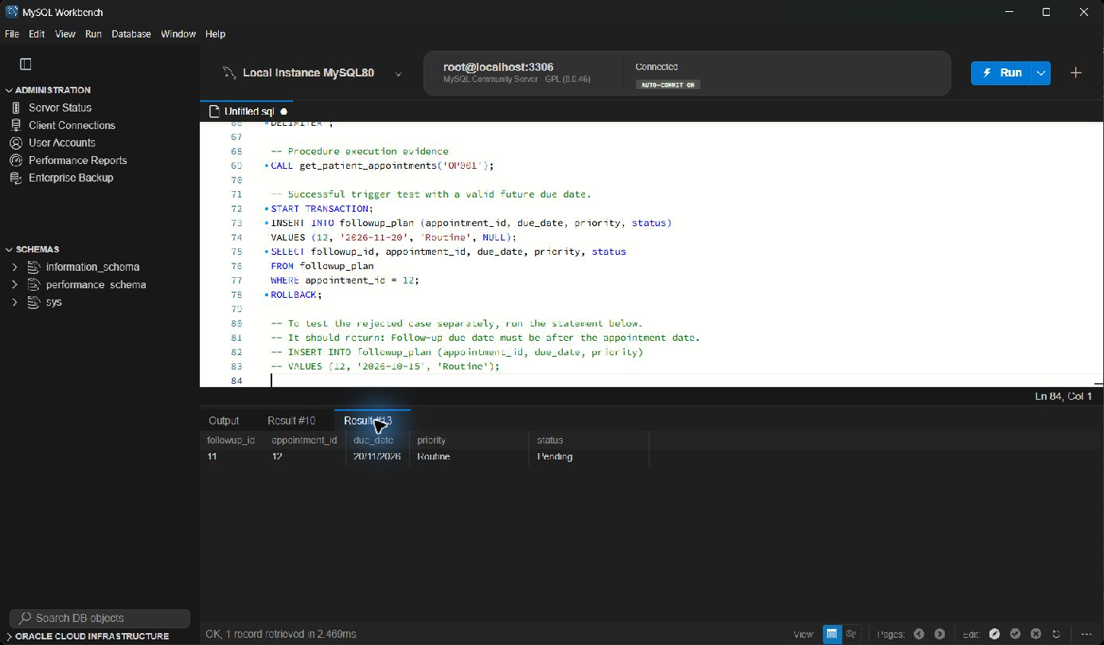
Figure 9. Query 6 Trigger for follow up dates execution evidence Full screen

5 Security and Transactions
I created separate administrator, doctor, receptionist and patient roles. The administrator role manages only this project database. Doctors can read the data and maintain clinical records. Receptionists can maintain patient and appointment information, while the patient demonstration role can only read a limited view. MySQL roles group privileges so that the same access rules can be assigned consistently (Oracle, 2026b). The matrix therefore follows least privilege rather than giving every account full access.
Role | Main permissions | Purpose
Administrator | Project database administration | Build and maintain the prototype
Doctor | SELECT plus clinical INSERT and UPDATE | Record diagnoses, follow-up and prescriptions
Receptionist | Patient and appointment maintenance | Manage bookings and demographics
Patient | Read-only demonstration access | Prevent direct data changes

The user_account table stores SHA-256 hashes instead of the original passwords. I used AES_ENCRYPT on fictional postcodes and decrypted two values to prove the example worked. A prepared statement binds the patient reference separately from the SQL text. This is the important protection against SQL injection described by OWASP Foundation (2026). The encryption key in the script is only for demonstration; a live hospital would keep keys outside the repository and control them separately.
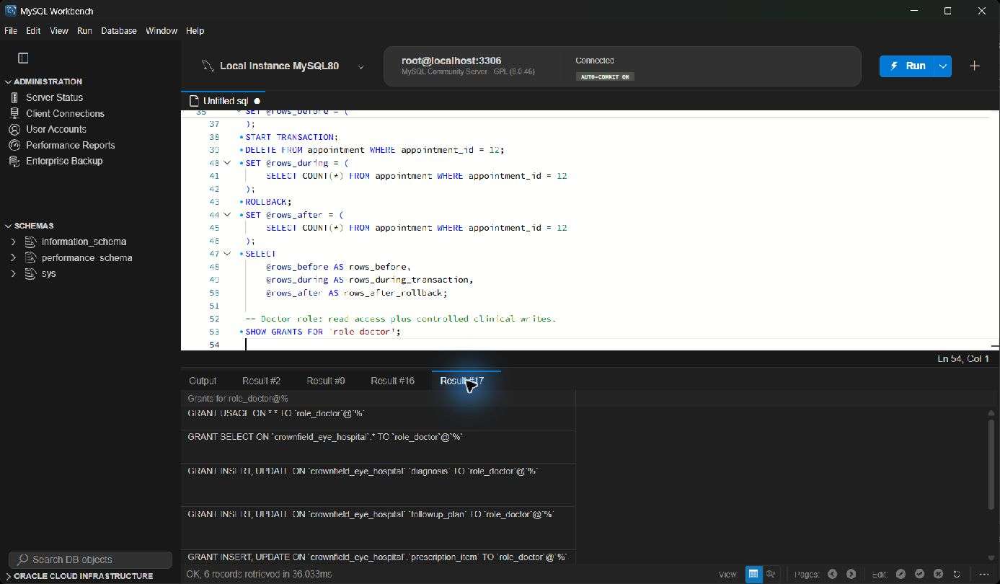
Figure 10. Doctor role grants in MySQL Workbench Full screen
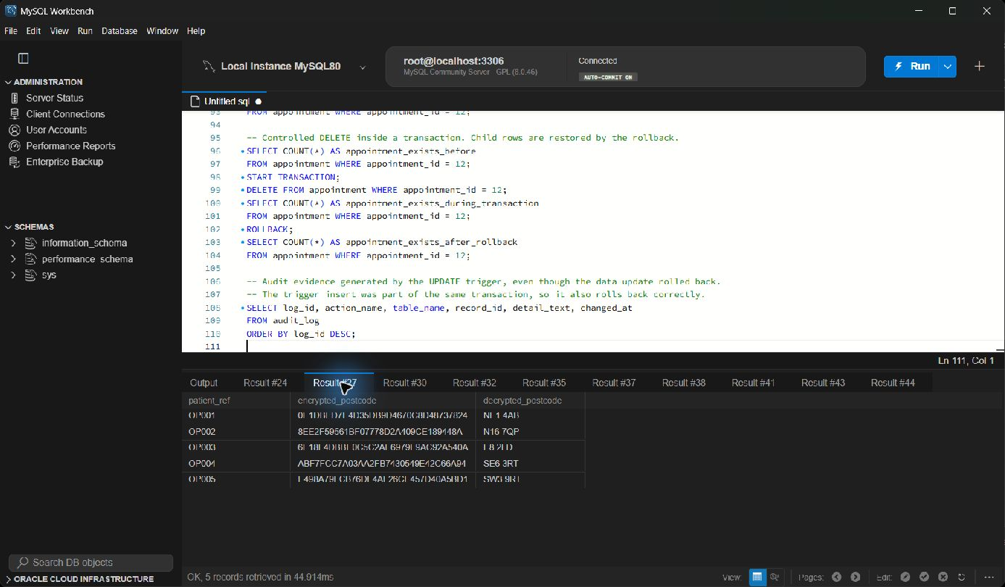
Figure 11. Hashing and encryption demonstration Full screen
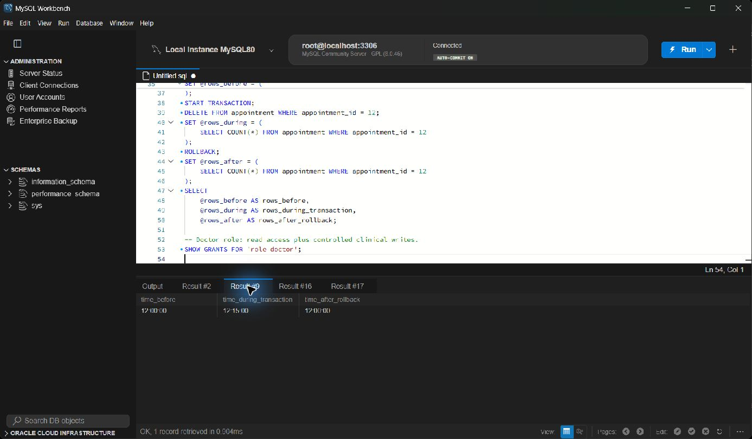
Figure 12. Controlled update and rollback evidence Full screen
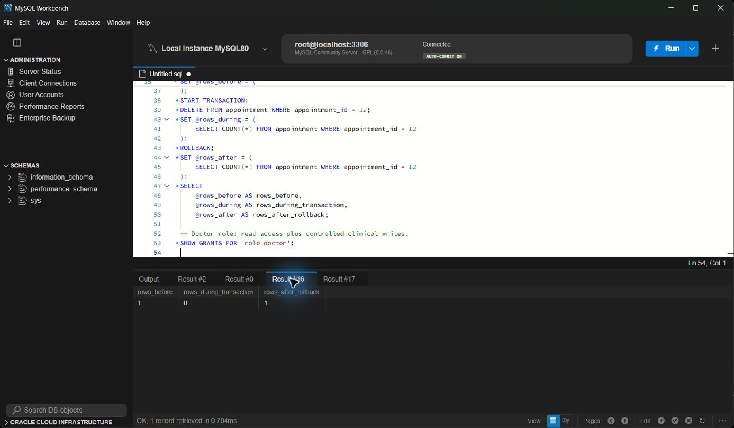
Figure 13. Controlled delete and rollback evidence Full screen

6 Evaluation and Reflection
The final database is easier to test than the original spreadsheet because each fact has a defined table and the relationships are checked by the database. The aggregate highlights clinician workload, the LEFT JOIN finds missing follow-up plans, and the procedure returns one patient's history without editing the query. The follow-up trigger blocks a date on or before the appointment. These features demonstrate useful behaviour rather than only showing CREATE TABLE statements.
The main challenge in my part was that some original slides described columns that were not in the implemented schema. This made a query look correct while it could not run. I solved it by using the schema as the single reference, then rerunning each feature. This helped me meet LO2 through tested retrieval and LO3 through roles, constraints and transactions. I met LO1 by checking that the physical tables still represented the agreed model.
Testing exposed mistakes that were easy to miss when reading the SQL. The first follow-up query tried to compare identifiers from different tables, and some material used date or followup_date when the schema used appointment_date and due_date. I used the schema as the reference, corrected the join path through appointment, and reran the queries. I also learned that a useful screenshot needs the SQL, result grid and successful status, otherwise it proves much less.
The prototype is suitable for coursework evidence but it is not a live clinical system. Patient access is read-only in the role demonstration, but true access to only one patient's rows would need an application layer or a separate row-filtering design. The encryption example also uses synthetic data and a demonstration key; production key management is outside this project.

7 References
Codd, E.F. (1970) 'A relational model of data for large shared data banks', Communications of the ACM, 13(6), pp. 377-387. doi: 10.1145/362384.362685.
Connolly, T. and Begg, C. (2015) Database Systems A Practical Approach to Design Implementation and Management. 6th edn. Harlow: Pearson Education.
Oracle (2026a) MySQL 8.0 Reference Manual Foreign Key Constraints. Available at: https://dev.mysql.com/doc/refman/8.0/en/constraint-foreign-key.html (Accessed: 3 November 2026).
Oracle (2026b) MySQL 8.0 Reference Manual Using Roles. Available at: https://dev.mysql.com/doc/refman/8.0/en/roles.html (Accessed: 3 November 2026).
OWASP Foundation (2026) SQL Injection Prevention Cheat Sheet. Available at: https://cheatsheetseries.owasp.org/cheatsheets/SQL_Injection_Prevention_Cheat_Sheet.html (Accessed: 3 November 2026).

