**LAB# Service Endpoints and Securing Storage**

**Task 1: Screenshot of creating a virtual network**

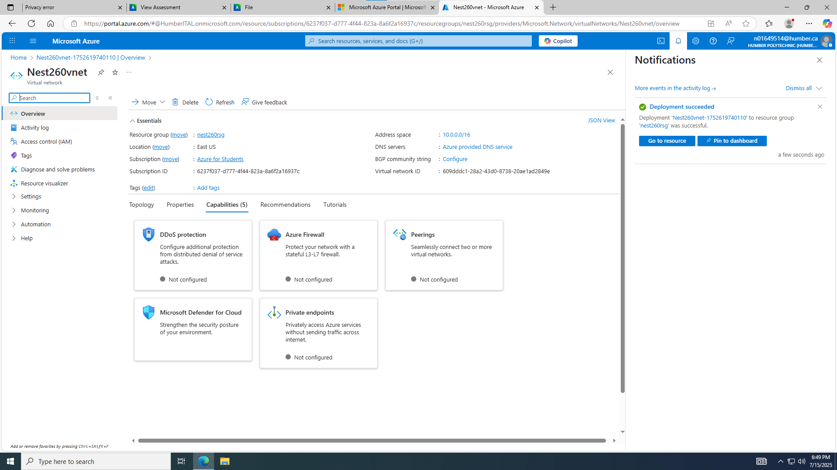

**Task 2: Screenshot of created virtual network:**

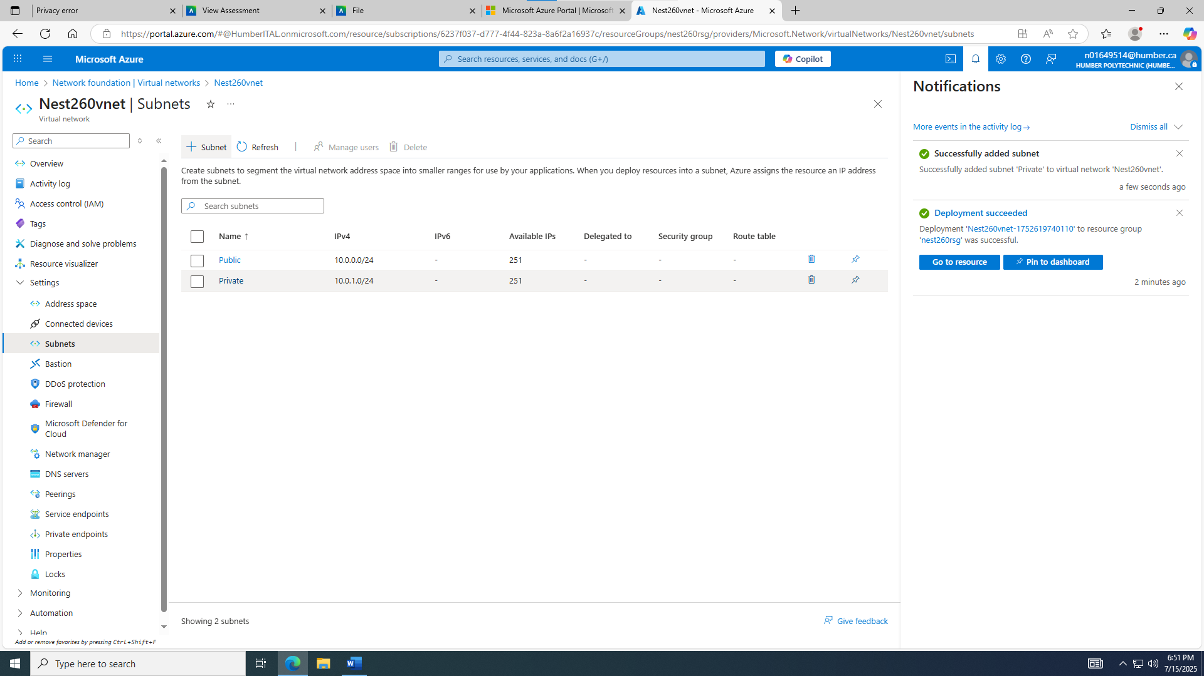

**Task 3: Screenshot of created network security group (myNsgPrivate):**

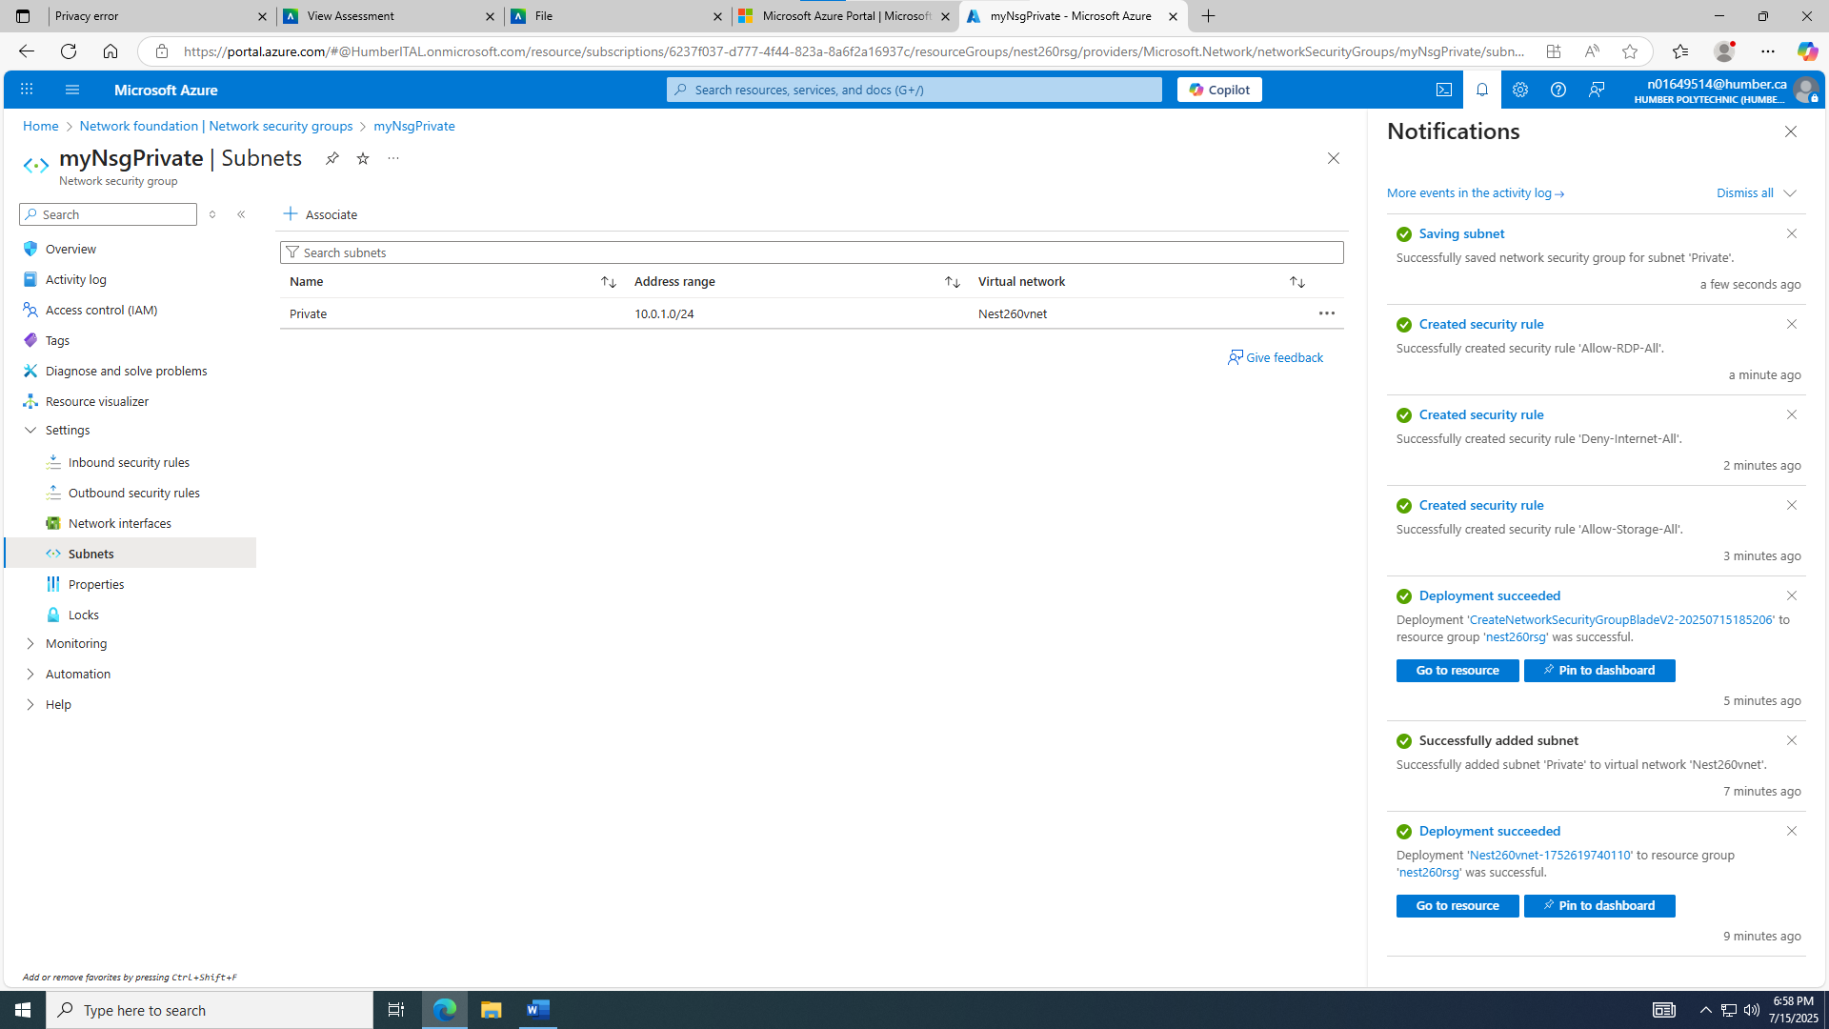

**Task 4: Screenshot of created network security group (myNsgPublic):**

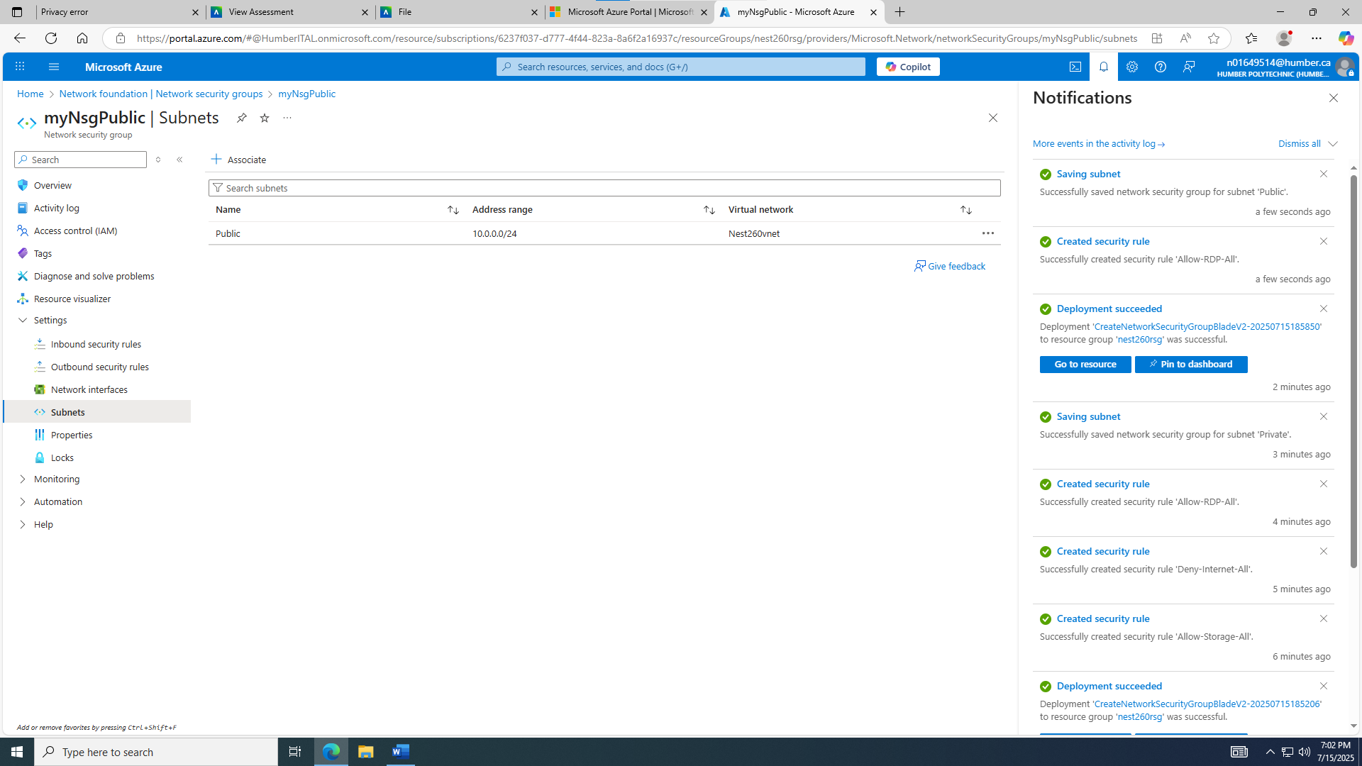

**Task 5: Screenshot of created storage:**

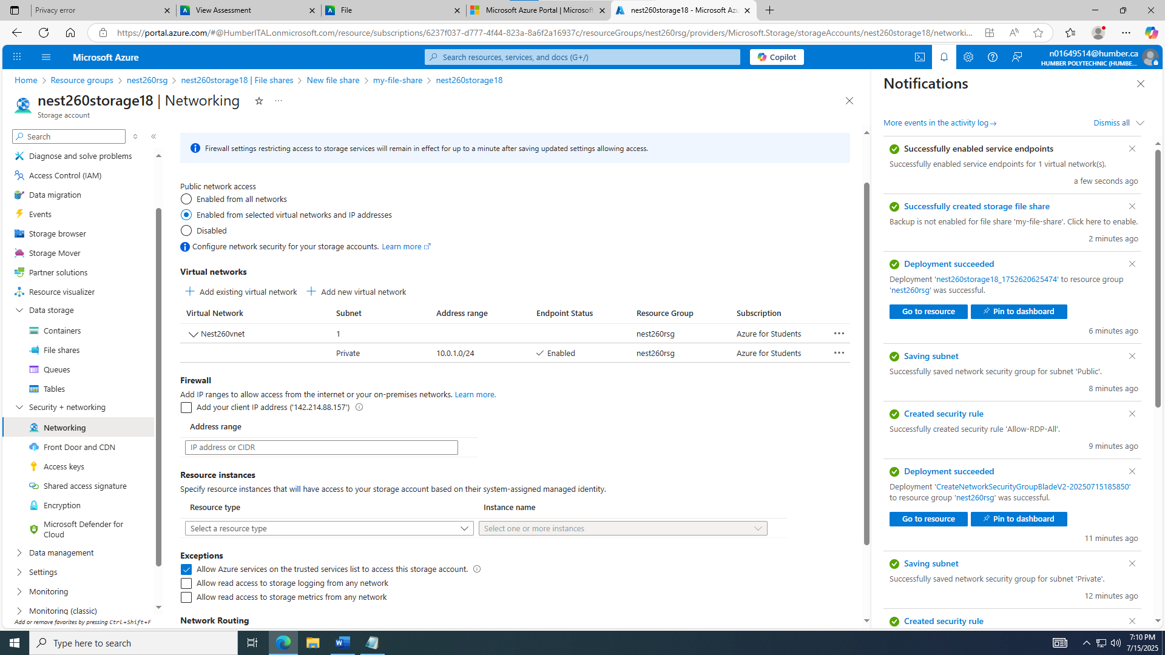

**Task 6: Screenshot of successfully created virtual machines:**

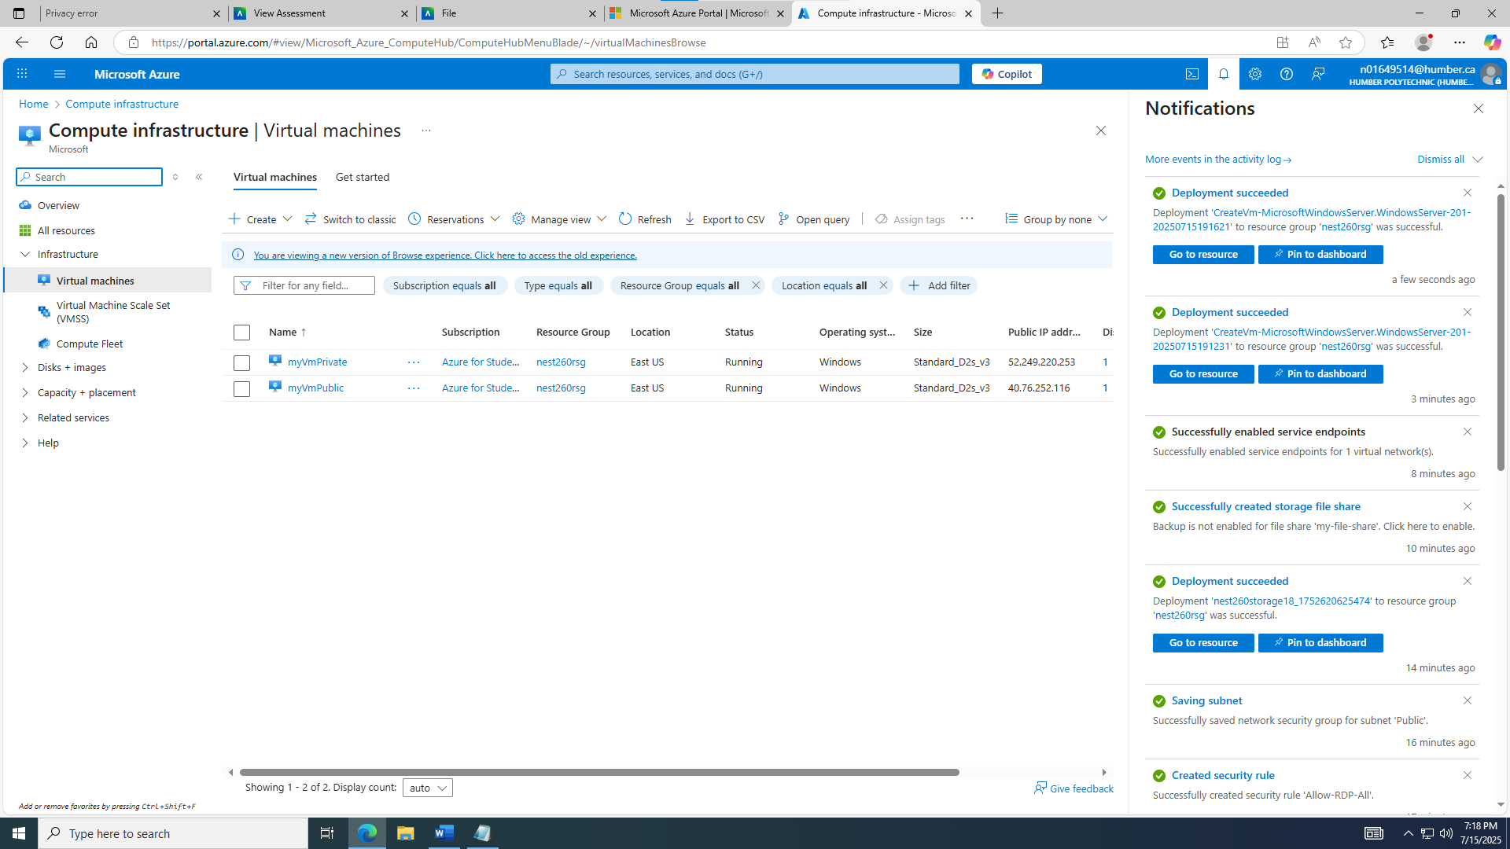

**Task 7: myVmPrivate remote desktop with failed www.bing.com:**

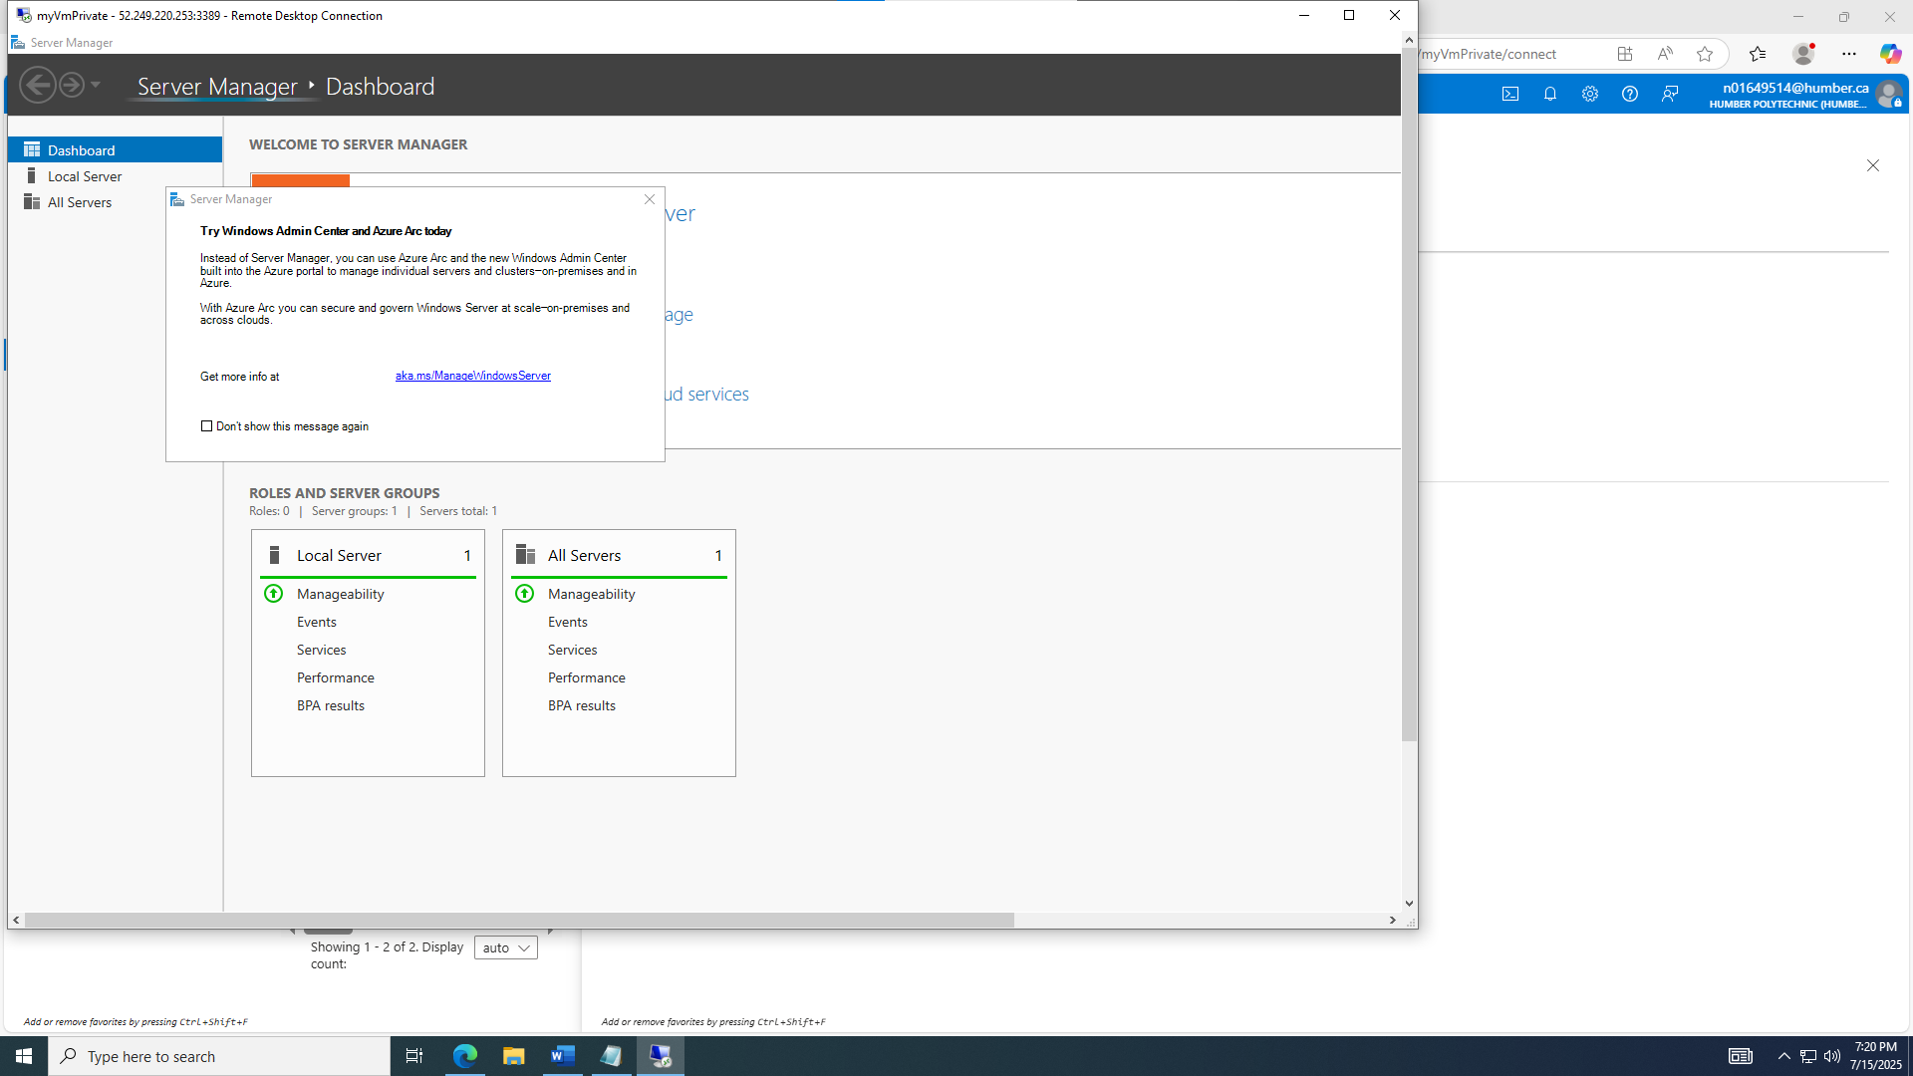

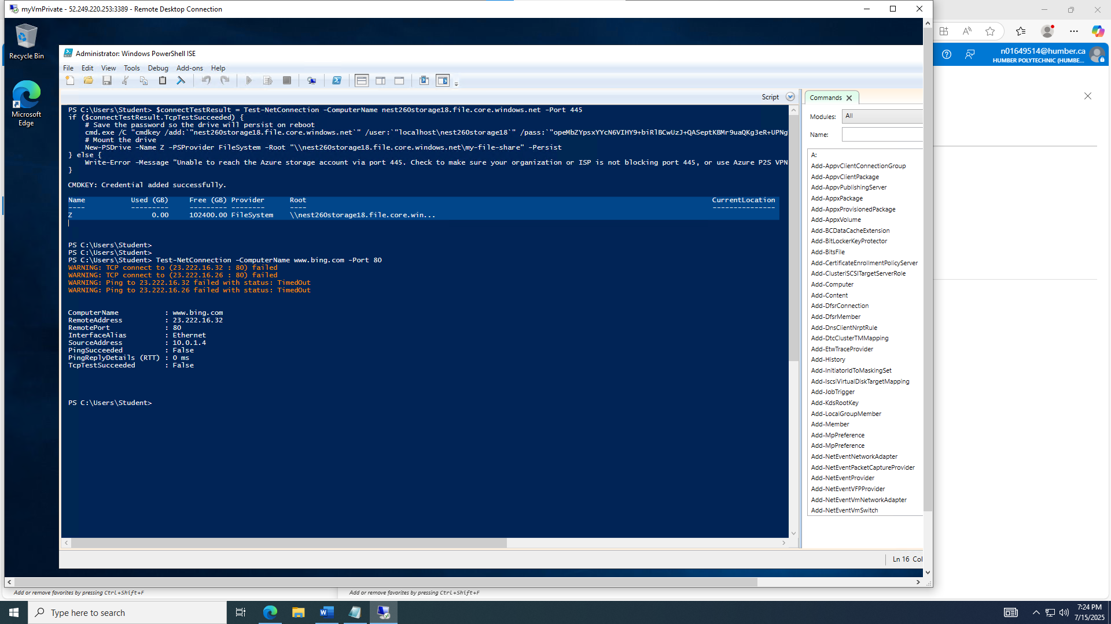

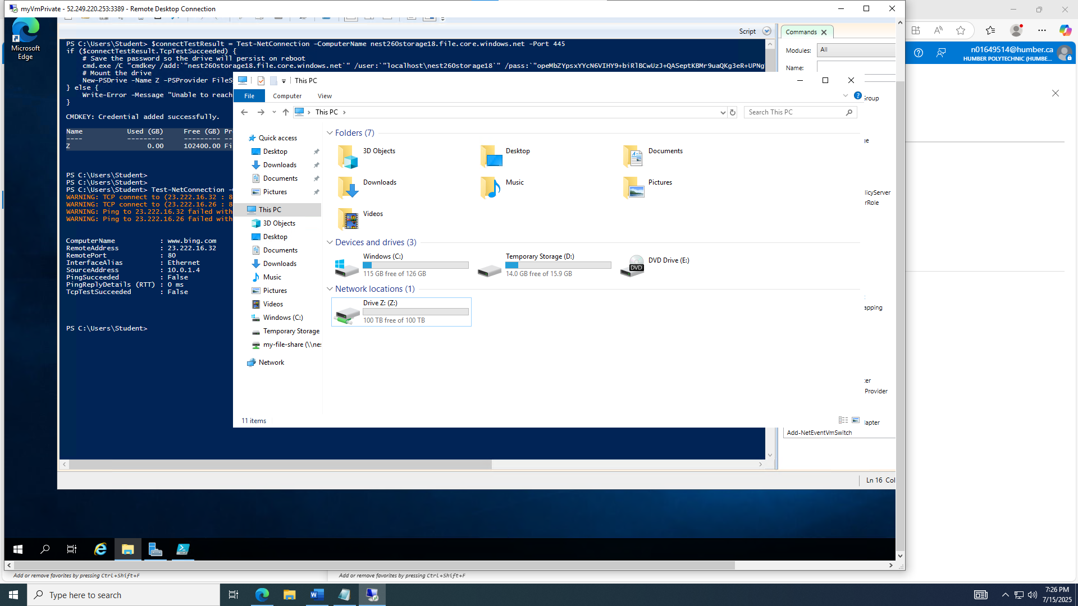

**Task 8: myVmPublic remote desktop with successful www.bing.com:**

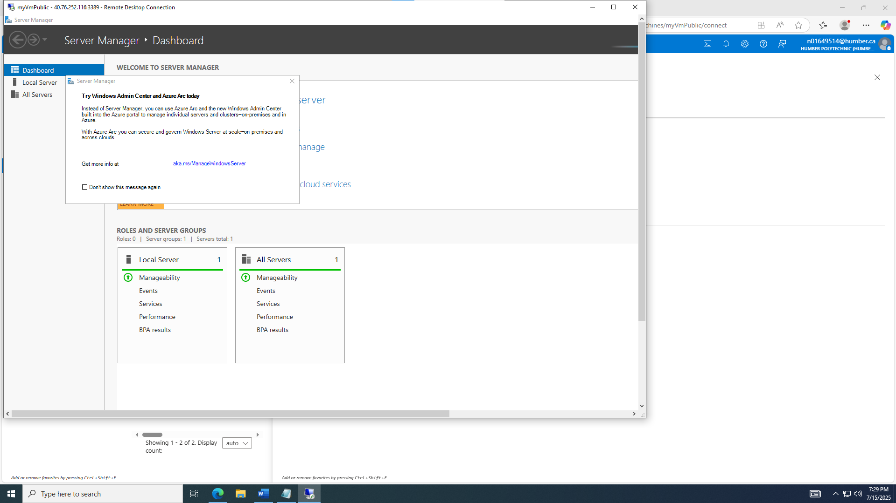

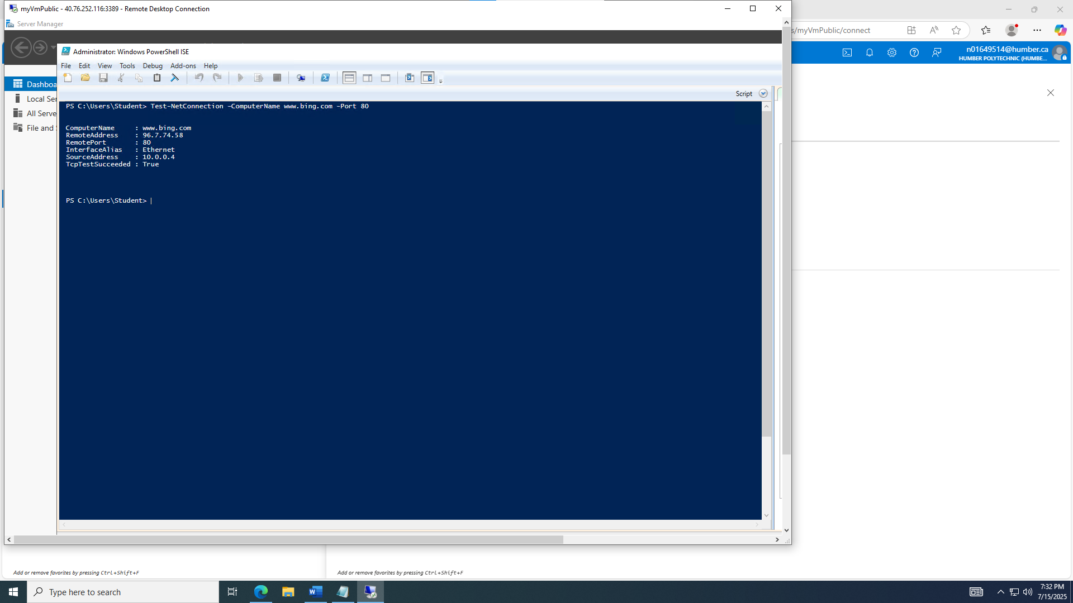

**Screenshot of Clearing Up resources:**

