EXECUTIVE SUMMARY
Sales Trend and Time-Based Performance Analysis
Afficionado Coffee Roasters | Astoria · Hell's Kitchen · Lower Manhattan
Reporting period | Transactions analysed | Revenue covered | Prepared by | Date
1 Jan – 30 Jun 2025 (181 days) | 149,116 | $698,812 | Golu Kumar (Internship ID UMID22062699466) | September 2026

Purpose
This summary reports the findings of a quantitative study of when sales occur at Afficionado Coffee Roasters' three retail locations, and sets out the operational decisions those findings support. The study analysed every transaction recorded over the first half of 2025. It is intended for stakeholders responsible for oversight of operating performance, staffing cost and trading hours; the full methodology, statistical tests and supporting evidence are set out in the accompanying research paper, and an interactive dashboard allows all figures to be examined under any filter.

Headline position
Indicator | Value | Reading
Revenue, six months | $698,812 | Across three stores, 181 trading days
Growth, January to June | +103.8% | Revenue more than doubled over the period
Source of that growth | Transaction volume | Volume per day +111%; average ticket flat at $4.69
Strongest to weakest day gap | 3.4% | Not statistically significant — days are equivalent
Share of revenue, 08:00–10:00 | 36.7% | Three hours carry over a third of all trade
Revenue spread between stores | 2.8% | Totals nearly identical; demand patterns are not
Identified staffing efficiency | 40.7% | Reduction in required barista-hours (see Recommendation 1)

The central finding
• Demand at Afficionado is governed by the hour of the day, not the day of the week.
• Which day it is has no measurable effect on sales — the best and worst days differ by 3.4%, and weekends perform within 0.2% of weekdays.
• What hour it is has a very large effect — the 10:00 hour runs at three times the volume of the quietest trading hour, and the morning carries 55.6% of all revenue.
• Staffing and trading hours should therefore be planned against the clock, not the calendar.

Principal findings
1. The business is growing strongly, and on volume alone. Revenue rose from $81,678 in January to $166,486 in June. Transactions per day rose 111% while the average amount each customer spends did not move ($4.72 to $4.71). The chain is serving far more people rather than charging them more, which means the limit on further growth is how many customers can be served per hour — counter space, equipment and staff — and not price. February's apparent 6.8% dip is a calendar effect only: February has three fewer trading days, and revenue per trading day rose 3.2%.
2. Day of week does not drive sales. Thursday is nominally the strongest day and Wednesday the weakest, but the difference is 3.4% — well inside normal daily variation. A formal statistical test finds no difference between the seven days whatsoever, and the same result holds when each store is tested separately. The widely held assumption that weekends are the strongest trading days does not hold at any Afficionado location.
3. Time of day drives sales decisively. Demand climbs from opening to a firm peak at 10:00, halves at 11:00, then holds almost perfectly flat for seven hours before tapering to close. The 08:00–10:00 window produces 36.7% of all revenue in 20% of the trading day. This shape repeats on all seven days of the week and has stayed constant while volume doubled — it is a structural feature of the business, not a temporary pattern.
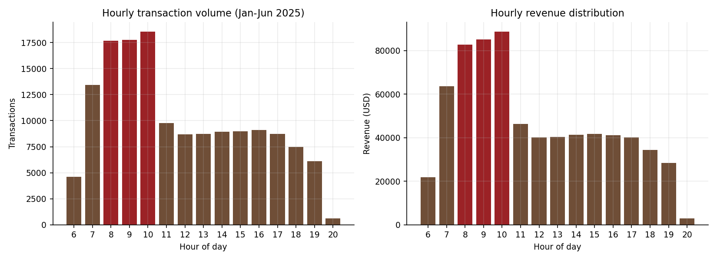
Hourly transaction volume and revenue. The morning peak hours are highlighted.
4. The three stores post near-identical totals but behave quite differently. Revenue varies by only 2.8% across the estate, which makes them look interchangeable. They are not. Lower Manhattan earns 62.6% of its revenue before noon and is effectively empty by early evening — a commuter store. Astoria earns only 45.2% in the morning and 21.0% in the evening, with its strongest days on Saturday and Sunday — a neighbourhood store. Hell's Kitchen sits between the two but carries the sharpest morning peak in the chain, and therefore the greatest risk of queues and lost customers at the busiest hour.
Store | Trading hours | Morning share | Evening share | Character
Lower Manhattan | 06:00 – 20:00 | 62.6% | 8.3% | Commuter / business district
Hell's Kitchen | 06:00 – 20:00 | 59.0% | 16.1% | Hybrid; sharpest peak, highest revenue
Astoria | 07:00 – 19:00 | 45.2% | 21.0% | Residential; flattest demand
Share of each store's own revenue. Morning = 06:00–11:00; Evening = 17:00–21:00.

Recommendations
# | Recommendation | Basis | Expected effect
1 | Move to hour-varying rosters: heavy 07:00–10:00, lean and constant 11:00–17:00. Do not vary headcount by day of week. | 10:00 runs at 3× the quietest trading hour; no measurable day-of-week effect | 40.7% fewer barista-hours required while still covering the busiest day in ten
2 | Review Lower Manhattan's evening trading hours; trial an 18:00 or 19:00 close for four weeks. | Records 0.26% of its daily transactions at 19:00 — about one per hour | Releases up to two staffed hours per day for negligible revenue loss
3 | Trial extending Astoria's close from 19:00 to 20:00. | Still transacting 7.1% of its daily volume in its final hour | Captures demand the current closing time may be truncating
4 | Move deliveries, stock counts, cleaning, training and handovers into 11:00–17:00. | Seven consecutive hours of flat, low demand | Protects the peak; no revenue cost to the displaced activity
5 | Invest in throughput at Hell's Kitchen (second till, pre-order pickup, pre-batched morning prep). | Sharpest peak concentration in the chain | Reduces queue risk at the chain's tightest capacity point
6 | Place take-home goods (retail beans, loose tea, merchandise) for the morning customer; run promotions only in the 11:00–17:00 window. | Take-home goods run at 1.9× their normal revenue share before noon | Lifts basket value in the morning; adds demand only where capacity is idle
7 | Re-run the demand model quarterly. | Volume doubling while the demand shape stays constant | Roster shape remains valid; only its scale needs refreshing

Basis of the staffing recommendation
Recommendation 1 is derived by converting observed transaction load into the number of staff required on the floor in each hour. The model is calibrated on June 2025 — the most recent month — rather than a six-month average, because rosters are forward-looking and an average would under-staff a business growing at this rate. Headcount is sized to cover the busiest day in ten, not an average day, so the roster holds under normal peaks. The comparison below is against staffing flat at peak level all day, which is the pattern the current uniform roster most closely resembles.
Store | Demand-based barista-hours per day | Flat peak-level staffing | Reduction
Astoria | 32 | 52 | 38.5%
Hell's Kitchen | 37 | 60 | 38.3%
Lower Manhattan | 33 | 60 | 45.0%
Chain total | 102 | 172 | 40.7%
Assumes 25 transactions served per barista-hour. This figure is a planning norm and should be recalibrated against Afficionado's own measured service times; the dashboard allows it to be adjusted and the model re-run instantly.

Assurance and limitations
- The dataset required no cleaning: 149,116 rows with no missing values, no duplicate transaction identifiers, and no invalid quantities, prices or timestamps.
- The source file did not contain a calendar date. The trading calendar was reconstructed from the chronological structure of the transaction ledger, independently producing exactly 181 continuous trading days for each of the three stores. The findings on hours, store comparison and growth do not depend on this reconstruction at all.
- Six months of data spanning winter into summer cannot separate genuine growth from seasonal uplift. The +103.8% figure is the observed change over the period and should not be read as an annual growth rate. A second year of data would resolve this.
- The 40.7% figure is a reduction in required staff-hours, not a verified cash saving; converting it requires wage rates and current rosters, which were not available for this study.
- Transactions cannot be linked to individual customers, so the study cannot distinguish new customers from more frequent visits by existing ones.

Supporting material
- Research paper — full methodology, statistical testing, eight figures and ten tables of supporting evidence.
- Interactive dashboard (Streamlit) — all analyses reproducible under any combination of store, day, hour range, date range and product category, including an adjustable staffing planner.
- Analysis code and validated dataset — every figure in this summary is reproducible from the source workbook by running three scripts.

