Sales Trend and Time-Based Performance Analysis
Afficionado Coffee Roasters
A quantitative study of temporal demand patterns across three retail locations
149,116 transactions | 3 stores | 1 January – 30 June 2025
Research Paper
Exploratory Data Analysis, Insights and Operational Recommendations
Prepared by: Golu Kumar
Internship ID: UMID22062699466
Unified Mentor — Data Analytics Capstone Project
September 2026

Contents
1. Abstract | 3
2. Introduction and Background | 3
2.1 Problem statement | 3
2.2 Objectives | 3
3. Dataset Description | 4
4. Analytical Methodology | 4
4.1 Data ingestion and validation | 4
4.2 Calendar reconstruction | 5
4.3 Temporal feature engineering | 5
5. Results | 6
5.1 Portfolio overview | 6
5.2 Sales trend across the period | 6
5.3 Day-of-week performance | 8
5.4 Time-of-day demand | 9
5.5 Cross-location comparison | 11
5.6 Product mix across the trading day | 13
6. Discussion: why these patterns occur | 14
7. Recommendations | 14
7.1 Staff scheduling | 14
7.2 Operating hours | 15
7.3 Store-specific operational focus | 15
7.4 Merchandising | 15
8. Limitations | 16
9. Streamlit Dashboard | 16
10. Conclusion | 16
Appendix A — Reproducibility | 18

1. Abstract
This paper analyses 149,116 point-of-sale transactions recorded at three Afficionado Coffee Roasters outlets — Astoria, Hell's Kitchen and Lower Manhattan — over the 181 trading days from 1 January to 30 June 2025, representing $698,812.33 in revenue and 214,470 units sold. The objective is to replace intuition-led operational decisions with quantitative evidence about when sales occur.
Three findings dominate. First, the business is growing rapidly and the growth is entirely volume-driven: revenue rose from $81,678 in January to $166,486 in June (+103.8%), while the average ticket stayed flat at roughly $4.69, meaning the increase comes from 111% more transactions per day rather than higher spend per customer. Second, day of week is not a meaningful driver of demand. The gap between the strongest and weakest weekday is only 3.4%, weekend days perform within 0.3% of weekdays, and a one-way ANOVA cannot reject the hypothesis that all seven days are equal (F = 0.04, p = 0.9998). Third, hour of day is overwhelmingly the dominant driver: the 08:00–10:00 window alone generates 36.7% of all revenue, the 10:00 hour is the single busiest across all three stores, and hourly variation is highly significant (F = 98.5, p < 10⁻²⁰⁰).
The three stores are near-identical in total revenue (2.8% spread) yet differ sharply in demand shape: Lower Manhattan earns 62.6% of its revenue before noon and is effectively empty after 18:00, while Astoria earns only 45.2% in the morning and 21.0% in the evening. This divergence is a commuter-versus-residential signature and implies that a single chain-wide roster and a single set of opening hours are both misallocations.
A demand-based staffing model calibrated on June 2025 demand at a 25-transaction-per-barista-hour service rate shows that matching headcount to the hourly demand curve — rather than staffing flat at peak level — reduces required barista-hours by 40.7% while still covering the 90th-percentile day. The paper closes with location-specific recommendations on rosters, trading hours and product placement, and is accompanied by an interactive Streamlit dashboard that reproduces every analysis under user-selected filters.

2. Introduction and Background
In specialty coffee retail, when a sale occurs matters as much as what is sold. Labour is the single largest controllable cost in a café, and it is bought in hourly blocks, whereas demand arrives in a sharply non-uniform curve across the trading day. Any mismatch between the two is expensive in both directions: overstaffing during slow hours burns wage cost with no revenue attached, while understaffing during a rush produces queues, walk-outs and an inconsistent customer experience that erodes repeat visits.
Retail managers commonly navigate this with heuristics — "mornings are busy", "weekends are our best days" — that are plausible, cheap to hold, and frequently wrong. Heuristics also fail to travel: a rule learned in one location is applied to another with a completely different catchment. Converting transaction-level data into a quantified demand curve replaces these heuristics with evidence that can be scheduled against, budgeted against, and audited.

2.1 Problem statement
Afficionado Coffee Roasters holds transaction-level data but lacks a consolidated view of sales trends over time, a clear identification of peak and off-peak days, and hourly demand insight across its store locations. Operational decisions are therefore reactive and experience-driven rather than data-driven.

2.2 Objectives
Primary objectives:
- Identify overall sales trends across the 2025 observation period.
- Determine the busiest and slowest days of the week.
- Identify peak transaction hours.
Secondary objectives:
- Compare temporal demand patterns across store locations.
- Support staff scheduling and operational planning.
- Provide evidence-based explanations for the observed patterns.

3. Dataset Description
The source file is a single-sheet Excel workbook, Afficionado_Coffee_Roasters.xlsx, containing 149,116 transaction rows and 11 columns.
Column | Description | Observed range / values
transaction_id | Unique identifier per transaction | 1 – 149,456
year | Transaction year | 2025 (single value)
transaction_time | Time of transaction (HH:MM:SS) | 06:00:00 – 20:59:32
transaction_qty | Quantity purchased | 1 – 8
unit_price | Price per unit (USD) | $0.80 – $45.00
store_id | Store identifier | 3, 5, 8
store_location | Physical store location | Astoria, Hell's Kitchen, Lower Manhattan
product_id | Unique product identifier | 1 – 87
product_category | Broad product group | 9 categories
product_type | Variant within the category | 29 types
product_detail | Detailed attributes (flavour, blend, size) | 80 details
Table 1. Source data dictionary with observed ranges.

4. Analytical Methodology

4.1 Data ingestion and validation
The workbook was loaded in full and subjected to a validation battery before any analysis. The dataset is exceptionally clean:
Validation check | Result | Verdict
Rows loaded | 149,116 | Complete
Missing values (all columns) | 0 | Pass
Duplicate transaction IDs | 0 | Pass
Fully duplicated rows | 0 | Pass
Non-positive quantities | 0 | Pass
Non-positive unit prices | 0 | Pass
Invalid / unparseable timestamps | 0 | Pass
Distinct years present | 1 (2025) | As specified
Table 2. Data quality validation results. No rows were dropped or imputed.
Note that transaction_id reaches 149,456 while only 149,116 rows are present. The 340 absent identifiers are consistent with voided or cancelled tickets at the point of sale; they introduce no duplication or ordering defect and were left as-is.

4.2 Calendar reconstruction
The supplied file carries year and transaction_time but no calendar date column. Taken literally, this makes three of the stated objectives — daily revenue trends, weekly aggregation and day-of-week performance — impossible to compute. Rather than abandon them, the calendar was reconstructed from the structure of the ledger itself.
The transactions are written in chronological order within each store: transaction_time increases monotonically through a trading day, then resets when the store closes and reopens the following morning. Every point at which the time steps backwards is therefore a day boundary. Counting those boundaries and assigning a sequential day index produced the following, all of which were verified programmatically:
- Each of the three stores yields exactly 181 trading days — the same count, independently derived.
- The day index is monotonically non-decreasing in transaction_id across the entire file, confirming the ledger is globally, not merely locally, chronological.
- Every store trades on every one of the 181 days; there are no gaps in the calendar.
A continuous 181-day calendar beginning 1 January 2025 ends on 30 June 2025 (31 + 28 + 31 + 30 + 31 + 30 = 181; 2025 is not a leap year). The reconstructed period is therefore the first half of calendar 2025, and all dates in this paper follow from that mapping.

Methodological caveat
• The reconstruction fixes the sequence of days with certainty; the anchoring of that sequence to 1 January 2025 rests on the year field and on the 181-day span matching January–June exactly.
• Should the true start date differ, every finding about hours, store comparison, trend direction and magnitude is unaffected. Only the assignment of weekday labels would rotate — and since the analysis finds no significant day-of-week effect, even that conclusion is robust to a rotation.

4.3 Temporal feature engineering
The following fields were derived from the validated data:
- revenue = transaction_qty × unit_price (transaction-level monetary value).
- hour — hour of day, 0–23.
- day_of_week and is_weekend (Saturday and Sunday).
- week_of_year (ISO) and month, for aggregation.
- time_bucket — Morning (06–11), Afternoon (12–16), Evening (17–21), Late hours (22–05).
Analysis then proceeded through five stages: sales-trend analysis, day-of-week performance, time-of-day demand, cross-location comparison, and a derived staffing model. Statistical significance of the day-of-week and hour-of-day effects was tested with one-way ANOVA on daily and hourly aggregates respectively.

5. Results

5.1 Portfolio overview
Metric | Value
Observation period | 1 Jan – 30 Jun 2025 (181 days)
Total transactions | 149,116
Total revenue | $698,812.33
Total units sold | 214,470
Average transactions per day (chain) | 823.8
Average revenue per day (chain) | $3,860.84
Average ticket value | $4.69
Average units per transaction | 1.44
Daily revenue volatility (coefficient of variation) | 30.8%
Table 3. Headline performance metrics, all stores combined.

5.2 Sales trend across the period
Revenue grew strongly and persistently. A linear fit to daily revenue gives a slope of +$20.84 per day, implying roughly $146 of additional daily revenue every week. Monthly revenue more than doubled over the six months.
Month | Revenue | Transactions | Trading days | Revenue / day | MoM %
January | $81,677.74 | 17,314 | 31 | $2,634.77 | —
February | $76,145.19 | 16,359 | 28 | $2,719.47 | −6.8%
March | $98,834.68 | 21,229 | 31 | $3,188.22 | +29.8%
April | $118,941.08 | 25,335 | 30 | $3,964.70 | +20.3%
May | $156,727.76 | 33,527 | 31 | $5,055.73 | +31.8%
June | $166,485.88 | 35,352 | 30 | $5,549.53 | +6.2%
Table 4. Monthly revenue. February's apparent decline is a calendar artefact — on a per-trading-day basis February grew 3.2% over January.
The February dip is the only interruption, and it is not a real one: February has three fewer trading days than January, and revenue per trading day actually rose 3.2%. This is a standing reason to monitor revenue per trading day alongside monthly totals.
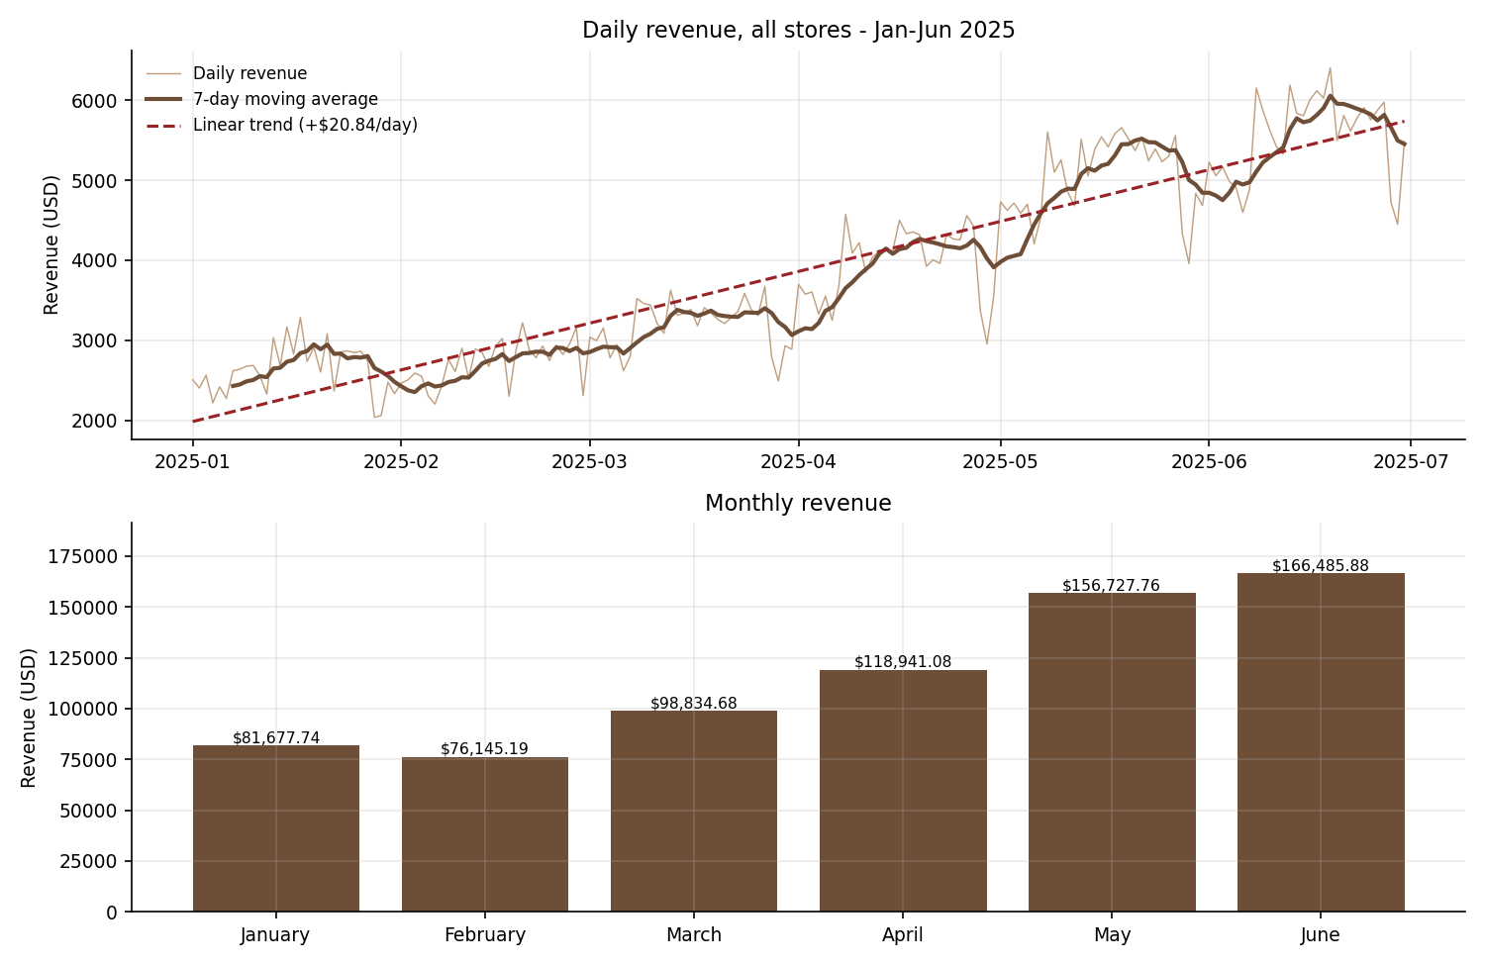
Figure 1. Daily revenue with 7-day moving average and fitted trend (top); monthly revenue (bottom).
Decomposing the growth shows it is entirely a volume story. Transactions per day rose 111% from January to June, while the average ticket moved by −0.2% (from $4.72 to $4.71). Afficionado is serving far more customers, not extracting more from each one. The implication for operations is direct: the binding constraint on growth is throughput capacity — counter, equipment and staff — not price.
Growth is also remarkably uniform. Every hour of the trading day grew between 103% and 124% from January to June, and all three stores grew within a 3.4-point band of each other (Astoria +101.7%, Hell's Kitchen +104.7%, Lower Manhattan +105.1%). The shape of the demand curve is therefore stable; only its scale is changing. This matters for planning: a roster shape derived today remains valid as volume grows, requiring only proportional scaling.
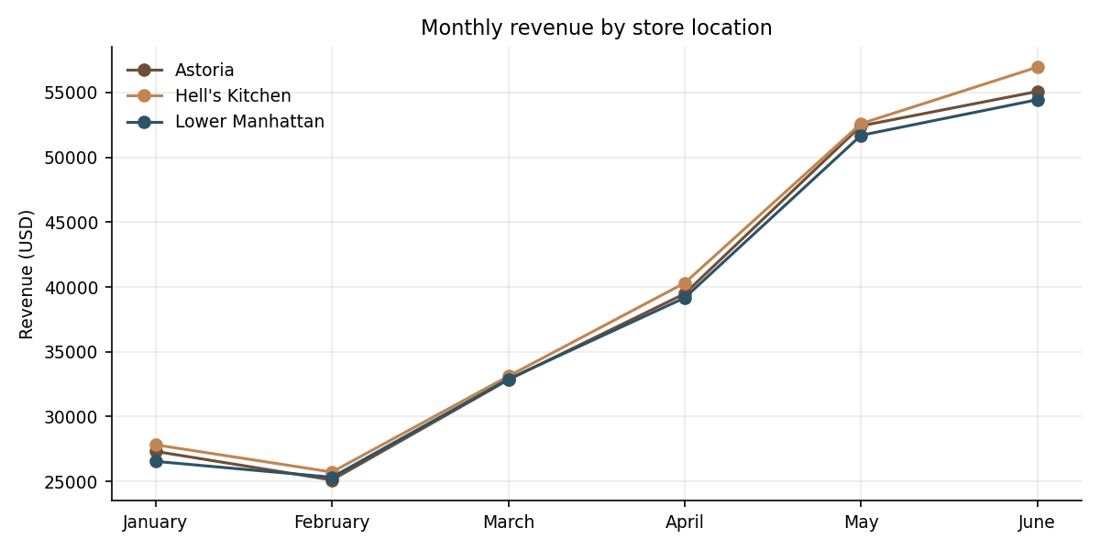
Figure 2. Monthly revenue by store location. The three trajectories are nearly parallel.

5.3 Day-of-week performance
Day of week turns out to be a weak driver of demand — a finding that directly contradicts the common retail assumption that weekends dominate.
Day | Avg revenue | Avg transactions | Avg ticket | Share of revenue
Thursday | $3,910.66 | 832.4 | $4.70 | 14.55%
Monday | $3,898.96 | 834.7 | $4.67 | 14.51%
Tuesday | $3,875.78 | 820.4 | $4.72 | 13.87%
Sunday | $3,875.68 | 832.9 | $4.65 | 14.42%
Saturday | $3,858.21 | 819.6 | $4.71 | 14.35%
Friday | $3,825.23 | 815.5 | $4.69 | 14.23%
Wednesday | $3,781.94 | 811.4 | $4.66 | 14.07%
Table 5. Day-of-week performance, ranked by average daily revenue. Tuesday's revenue share is lower only because the period contains 25 Tuesdays against 26 of every other day.
Thursday is nominally the busiest day and Wednesday the slowest, but the gap between them is just 3.4% — smaller than the day-to-day noise, whose coefficient of variation is 30.8%. A one-way ANOVA across the seven days returns F = 0.035 with p = 0.9998: there is no detectable difference between days. The same test run separately on each store gives p = 0.988, 0.999 and 0.989 respectively, so the null result is not an artefact of pooling.
The weekday–weekend comparison is equally flat. Weekdays average $3,858.38 per day and weekends $3,866.95, a difference of 0.2%. Average ticket is likewise indistinguishable ($4.69 weekday, $4.68 weekend).
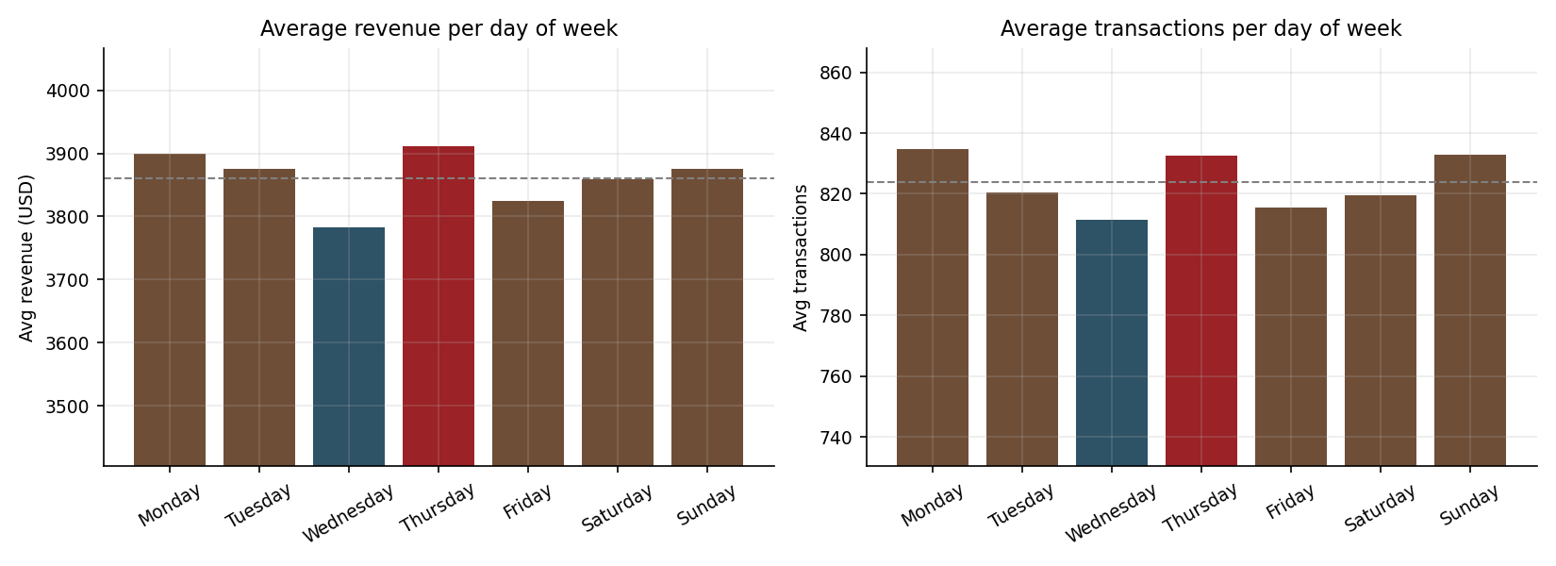
Figure 3. Average revenue and transactions by day of week. Note the suppressed y-axis origin — the visual spread exaggerates a 3.4% range.
Insight 1 — Day of week is not a scheduling lever
• Best-to-worst day gap is 3.4%; ANOVA p = 0.9998 across all seven days.
• Weekend revenue is within 0.2% of weekday revenue.
• Practical consequence: varying headcount by day of week would chase noise. Rosters should be built on a single day-shape and varied by hour, not by day.

5.4 Time-of-day demand
Hour of day is the dominant temporal driver. The same ANOVA applied across hours returns F = 98.5 with p < 10⁻²⁰⁰ — the contrast with the day-of-week result could hardly be sharper.
Hour | Transactions | Revenue | Share of revenue | Avg txns / day
06:00 | 4,594 | $21,900.27 | 3.1% | 25.4
07:00 | 13,428 | $63,526.47 | 9.1% | 74.2
08:00 | 17,654 | $82,699.87 | 11.8% | 97.5
09:00 | 17,764 | $85,169.53 | 12.2% | 98.1
10:00 | 18,545 | $88,673.39 | 12.7% | 102.5
11:00 | 9,766 | $46,319.14 | 6.6% | 54.0
12:00 | 8,708 | $40,192.79 | 5.8% | 48.1
13:00 | 8,714 | $40,367.45 | 5.8% | 48.1
14:00 | 8,933 | $41,304.74 | 5.9% | 49.4
15:00 | 8,979 | $41,733.10 | 6.0% | 49.6
16:00 | 9,093 | $41,122.75 | 5.9% | 50.2
17:00 | 8,745 | $40,134.31 | 5.7% | 48.3
18:00 | 7,498 | $34,286.20 | 4.9% | 41.4
19:00 | 6,092 | $28,446.68 | 4.1% | 33.7
20:00 | 603 | $2,935.64 | 0.4% | 3.3
Table 6. Hourly demand, all stores. 20:00 is a partial hour observed at two stores only.
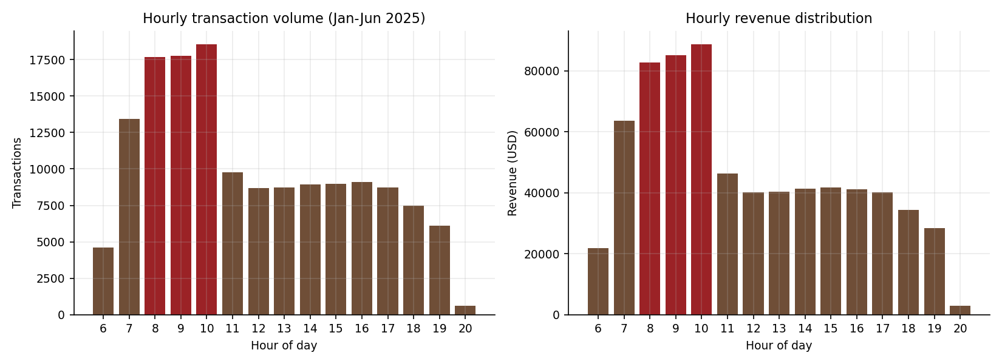
Figure 4. Hourly transaction volume and revenue distribution. The morning peak is highlighted.
The curve has a clear and consistent shape:
- Morning rush (07:00–10:00): demand climbs steeply from opening and peaks at 10:00. The three-hour window 08:00–10:00 carries 36.7% of all revenue in just 20% of the trading day.
- Midday plateau (11:00–17:00): demand drops by roughly half and then stays almost perfectly flat — hourly transactions vary only between 48 and 54 per day across seven consecutive hours.
- Evening taper (18:00–20:00): a gradual decline rather than a second peak. There is no evening rush at chain level.
- Late hours (22:00–05:00): zero transactions. No store trades in this window.
At 10:00 the chain handles 3.0 times the transaction volume of 19:00, and 2.1 times the flat midday plateau. Revenue distributes across time buckets as Morning 55.6%, Afternoon 29.3% and Evening 15.1%, with Late hours at zero. The average ticket is notably stable across hours ($4.52–$4.87), so the hourly revenue curve is a pure volume curve — the same conclusion reached for the growth trend.
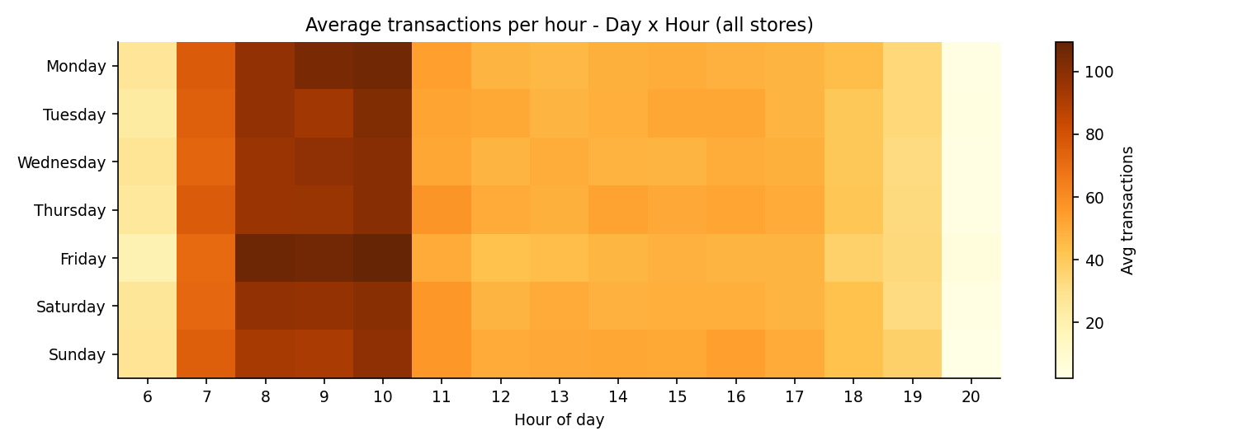
Figure 5. Average transactions by day and hour. The vertical morning band is uniform across all seven days — visual confirmation that the hour effect dominates and the day effect is absent.
Insight 2 — Hour of day is the operational lever
• 08:00–10:00 generates 36.7% of revenue in 20% of trading hours; 10:00 is the single peak hour at every store.
• Peak hour runs at 3.0× the volume of the quietest full trading hour and 2.1× the midday plateau.
• Morning bucket (06–11) accounts for 55.6% of all revenue.
• The morning band is present on all seven days — the pattern is structural, not weekday-specific.

5.5 Cross-location comparison
On aggregate totals, the three stores look interchangeable — total revenue spans only 2.8% from lowest to highest. Judged on temporal shape, they are three different businesses.
Store | Revenue | Share | Transactions | Avg ticket | Peak hour
Hell's Kitchen | $236,511.17 | 33.8% | 50,735 | $4.66 | 10:00
Astoria | $232,243.91 | 33.2% | 50,599 | $4.59 | 10:00
Lower Manhattan | $230,057.25 | 32.9% | 47,782 | $4.81 | 10:00
Table 7. Store-level aggregates. Near-identical totals conceal materially different demand curves.
Store | Operating window | Morning 06–11 | Afternoon 12–16 | Evening 17–21
Lower Manhattan | 06:00 – 20:00 | 62.6% | 29.2% | 8.3%
Hell's Kitchen | 06:00 – 20:00 | 59.0% | 25.0% | 16.1%
Astoria | 07:00 – 19:00 | 45.2% | 33.8% | 21.0%
Table 8. Share of each store's own revenue by time bucket. The spread in evening share is 2.5-fold.
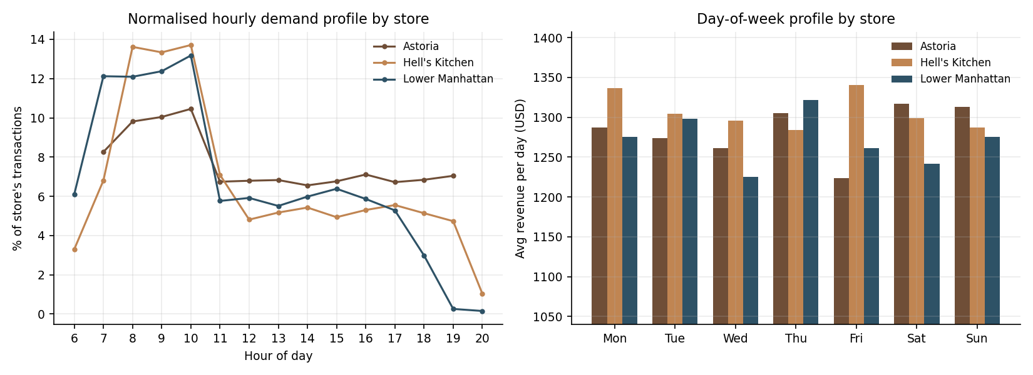
Figure 6. Normalised hourly demand profile by store (left) and day-of-week profile by store (right).
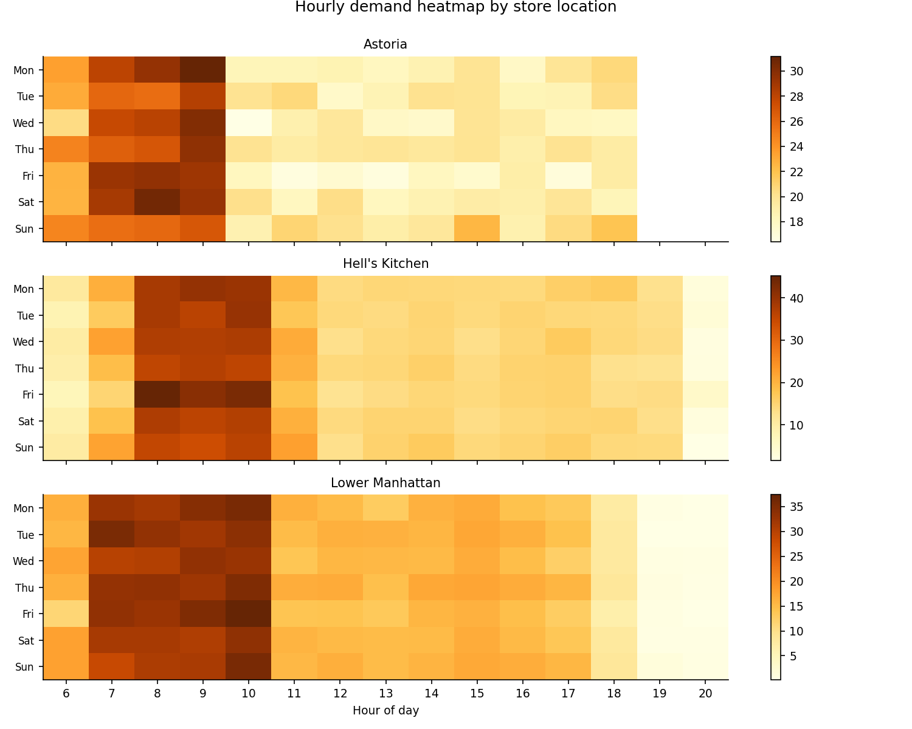
Figure 7. Per-store day × hour heatmaps. Lower Manhattan's demand collapses after 18:00; Astoria's persists to close.
Three distinct signatures emerge:
Lower Manhattan — commuter / business district. Opens at 06:00 and front-loads hard: 62.6% of revenue before noon, and by 19:00 the store is transacting at 0.26% of its daily volume — approximately one transaction per hour in June. It also carries the highest average ticket ($4.81), consistent with a professional catchment buying larger or premium formats. The trading day effectively ends around 18:00.
Hell's Kitchen — hybrid, sharpest peak. Has the most concentrated morning spike of the three: 13.6–13.7% of its daily transactions in each of the 08:00, 09:00 and 10:00 hours, against Astoria's 9.8–10.5%. It retains a meaningful evening (16.1%) and is the chain's top revenue store. It carries the heaviest peak-load burden and therefore the greatest queue risk.
Astoria — residential / neighbourhood. The flattest profile in the chain, with no hour exceeding 10.5% of its daily volume. It earns 21.0% of revenue in the evening — more than twice Lower Manhattan's share — and its Saturday and Sunday are its two strongest days, the only store where a weekend tilt is visible at all. It also has the shortest operating window (07:00–19:00) and the lowest average ticket ($4.59), indicating frequent small purchases rather than commuter bulk.
Insight 3 — Same totals, different businesses
• All three stores peak at 10:00, but morning share ranges from 45.2% (Astoria) to 62.6% (Lower Manhattan).
• Evening share ranges 8.3% to 21.0% — a 2.5-fold spread.
• Lower Manhattan trades to 20:00 while earning 0.26% of its transactions at 19:00; Astoria closes at 19:00 while still earning 7.1% of its transactions in that hour.
• Consequence: chain-wide rosters and chain-wide opening hours are both misallocations, in opposite directions at opposite ends of the chain.

5.6 Product mix across the trading day
Although product analysis is secondary to the temporal brief, category mix shifts measurably by time of day and carries a merchandising implication.
Category | Revenue | Share | Morning mix | Afternoon mix | Evening mix
Coffee | $269,952.45 | 38.6% | 37.2% | 40.6% | 40.0%
Tea | $196,405.95 | 28.1% | 26.9% | 29.4% | 29.9%
Bakery | $82,315.64 | 11.8% | 12.4% | 11.1% | 10.8%
Drinking Chocolate | $72,416.00 | 10.4% | 9.8% | 10.9% | 11.3%
Coffee beans | $40,085.25 | 5.7% | 7.3% | 3.8% | 3.8%
Branded | $13,607.00 | 1.9% | 2.2% | 1.6% | 1.6%
Loose Tea | $11,213.60 | 1.6% | 1.9% | 1.2% | 1.3%
Flavours | $8,408.80 | 1.2% | 1.5% | 0.8% | 0.8%
Packaged Chocolate | $4,407.64 | 0.6% | 0.8% | 0.5% | 0.5%
Table 9. Revenue by product category, with each category's share of the revenue in each time bucket.
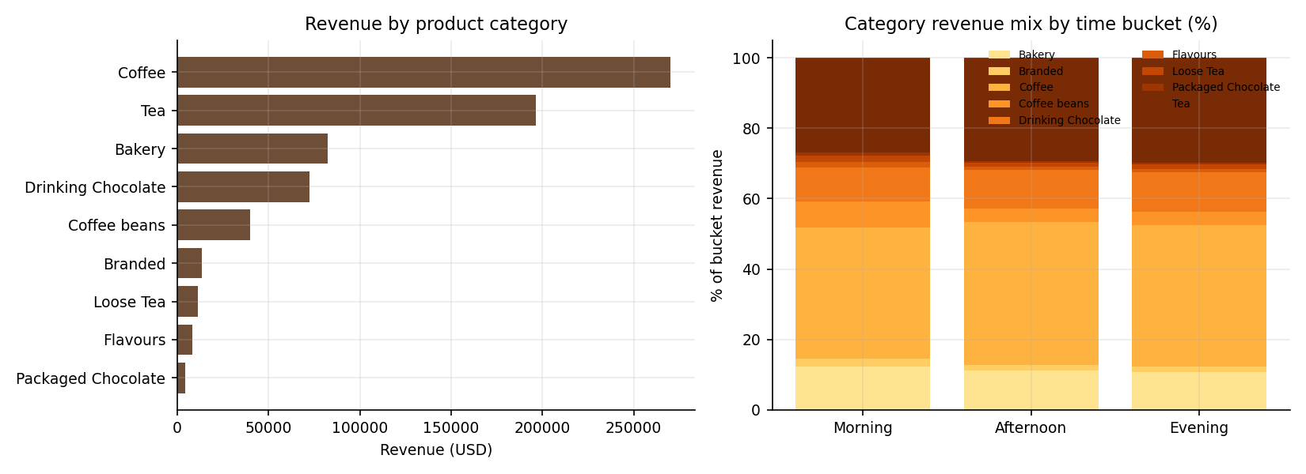
Figure 8. Revenue by product category (left) and category mix by time bucket (right).
The clearest signal is in take-home goods. Retail bags of coffee beans account for 7.3% of morning revenue but only 3.8% in the afternoon and evening — a 1.9× concentration. Loose tea, branded merchandise and flavour syrups follow the same pattern. Customers buy take-home product on the morning visit, not the afternoon one. Bakery is likewise a morning item (12.4% versus 10.8% in the evening), while brewed beverages take a slightly larger share later in the day.

6. Discussion: why these patterns occur
Coffee is a routine, not an occasion. The absence of a day-of-week effect is the most counter-intuitive result and has a straightforward behavioural explanation. Purchases driven by habit — the commute coffee, the mid-morning break — recur at the same clock time every day and are largely indifferent to which day it is. Categories that do show strong weekly cycles (restaurant dining, cinema, apparel) are discretionary occasions planned around leisure time. Afficionado's demand is a daily ritual, so it is anchored to the hour hand, not the calendar.
The morning peak is a commuting artefact. The 07:00–10:00 climb and the 10:00 peak align with the arrival pattern of a working population plus the mid-morning break that follows it. The sharpness of the peak varies with how commuter-dependent each catchment is, which is precisely what the store comparison shows: Lower Manhattan, a business district, front-loads most; Astoria, residential, spreads demand across the day and holds it into the evening when residents return home.
Growth without ticket inflation indicates customer acquisition. A flat average ticket alongside a 111% rise in daily transactions rules out price increases and larger baskets as drivers. The growth is new visits — either new customers or greater frequency from existing ones. Some portion is likely seasonal: the period runs from mid-winter into summer in New York, and foot traffic rises with the weather. Six months of data spanning a single seasonal upswing cannot separate structural growth from seasonality; a second year of data is needed to do so, and this is stated as a limitation rather than assumed away.
The midday plateau is a genuine flat, not a trough. Seven consecutive hours (11:00–17:00) sit within a 48–54 transaction-per-day band. This is unusually stable and operationally convenient: a single staffing level covers the entire midday block without adjustment, and the marginal cost of a given promotional hour in that window is identical to any other.

7. Recommendations

7.1 Staff scheduling
A staffing model was derived by converting observed transaction load into required baristas. Two deliberate choices were made. First, the model is calibrated on June 2025 rather than the six-month average: rosters are forward-looking, and a period average would under-staff a business growing at this rate. Second, headcount is sized on the 90th-percentile day rather than the mean day, so the roster holds on nine days out of ten. A service rate of 25 transactions per barista-hour is assumed — roughly 2.4 minutes per transaction including preparation — and should be recalibrated against Afficionado's own measured service times.
Hour | Astoria | Hell's Kitchen | Lower Manhattan
06:00 | closed | 2 | 3
07:00 | 3 | 3 | 3
08:00 | 3 | 4 | 3
09:00 | 4 | 4 | 3
10:00 | 4 | 4 | 4
11:00 – 17:00 | 2 | 2 | 2
18:00 | 2 | 2 | 1
19:00 | 2 | 2 | 1
20:00 | closed | 2 | 1
Barista-hours per day | 32 | 37 | 33
Flat peak-level staffing | 52 | 60 | 60
Reduction | 38.5% | 38.3% | 45.0%
Table 10. Recommended baristas on the floor by hour, calibrated on June 2025 demand at the 90th-percentile day and 25 transactions per barista-hour.
- Adopt an hour-varying roster with a heavy 07:00–10:00 block and a lean, constant midday block. Across the chain this requires 102 barista-hours per day against 172 under flat peak-level staffing — a 40.7% reduction while still covering the 90th-percentile day.
- Do not vary headcount by day of week. The evidence shows no day-of-week effect; a day-varying roster would add scheduling complexity and staff churn in exchange for chasing statistical noise.
- Schedule all non-customer-facing work — deliveries, stock counts, deep cleaning, training, one-to-ones — into the 11:00–17:00 plateau, and never into 07:00–10:00.
- Set shift changeovers away from the peak. A handover at 10:00 costs the busiest hour of the day; 11:00 or 14:00 costs almost nothing.
- Re-run the model quarterly. Volume is growing 100%+ annually while the demand shape stays constant, so the roster shape holds but its scale must be refreshed.

7.2 Operating hours
- Review Lower Manhattan's evening hours. The store trades until 20:00 while recording 0.26% of its transactions at 19:00 — about one transaction per hour in June — and 0.16% at 20:00. Closing at 18:00 or 19:00 would forfeit a negligible share of revenue and release two staffed hours per day. Trial the change for four weeks and measure the revenue actually lost before making it permanent.
- Consider extending Astoria's evening. Astoria closes at 19:00 yet still transacts 7.1% of its daily volume in the 19:00 hour — its demand is still live at close, which suggests the current closing time is truncating available revenue rather than responding to its absence. A 20:00 close, trialled and measured, is the natural test.
- Consider a 06:00 open at Astoria only if a commuter base can be evidenced. The other two stores earn 3.3% and 6.1% of transactions in the 06:00 hour; Astoria's residential profile makes a comparable return unlikely, so this is the weakest of the three hours recommendations.

7.3 Store-specific operational focus
- Hell's Kitchen — engineer for throughput. It carries the sharpest peak in the chain and therefore the greatest queue risk. Mobile or pre-order pickup, a second till, and pre-batched morning preparation target the exact hours where capacity binds.
- Lower Manhattan — optimise for speed and take-home value. Highest average ticket and the most commuter-dependent profile: prioritise grab-and-go formats, pre-packed bakery and fast checkout in the 06:00–10:00 window, and reallocate evening labour to the morning.
- Astoria — build on the afternoon and evening. The only store with a meaningful evening and a weekend tilt. It is the natural site for afternoon promotions, loyalty offers, seating-led dwell time and any community or events programming; such initiatives would be wasted at Lower Manhattan.

7.4 Merchandising
- Position retail coffee beans, loose tea and branded merchandise for the morning customer. Take-home goods run at 1.9× their normal revenue share before noon; counter placement, signage and staff prompts should concentrate there.
- Use the 11:00–17:00 plateau for demand-shifting promotions. It is the only block where added demand carries no queueing cost, because staffing is already at floor level and capacity is idle.
- Protect the peak from discounting. Promotions in the 08:00–10:00 window discount demand that would arrive regardless and add load to the chain's binding constraint.

8. Limitations
- Calendar anchoring. The sequence of 181 trading days is established with certainty from the ledger structure, but its anchoring to 1 January 2025 is inferred from the year field and the exact 181-day match to January–June. Weekday labels would rotate if the true start date differed; no other finding would change, and the day-of-week conclusion is a null result that a rotation cannot overturn.
- Single-season window. Six months covering winter into summer cannot separate structural growth from seasonal upswing. The +103.8% figure should be read as observed change over the period, not as an annualised growth rate.
- No customer identifier. Transactions cannot be linked to customers, so it is impossible to distinguish new-customer acquisition from increased visit frequency, or to measure retention.
- No cost or labour data. The staffing model translates demand into required barista-hours; converting that into monetary savings requires wage rates and current rosters, which were not supplied. The 40.7% figure is a reduction in required hours, not a verified cost saving.
- Service rate is an assumption. The 25-transactions-per-barista-hour figure is a planning norm, not a measured value for Afficionado. The Streamlit dashboard exposes it as an adjustable parameter for exactly this reason.
- No external variables. Weather, local events, holidays, marketing activity and competitor behaviour are absent from the dataset and may explain part of both the trend and the daily volatility.

9. Streamlit Dashboard
The accompanying Streamlit application (app.py) makes every analysis in this paper interactive. It is organised into six tabs — Sales trend, Day of week, Hourly demand, Location comparison, Staffing planner, and Data & method — and all charts respond to a shared filter set in the sidebar: store location, day of week, hour range, date range, product category, and a metric toggle between revenue, quantity and transactions.
The Staffing planner tab is the operational core: managers can set the service rate, choose the calibration month and select the percentile day to size against, and the recommended roster and the barista-hours saving recalculate live. The Data & method tab reproduces the validation battery and documents the calendar reconstruction, so any reader can audit the basis of the analysis. Filtered data can be exported to CSV from within the app.
Run with: streamlit run app.py

10. Conclusion
Afficionado Coffee Roasters' demand is governed by the clock, not the calendar. Across 149,116 transactions and 181 trading days, the day of the week explains essentially nothing about how much the chain sells — the best and worst days differ by 3.4%, and a formal test cannot distinguish them at all. The hour of the day explains a great deal: three morning hours carry more than a third of all revenue, demand halves at 11:00 and then sits flat for seven hours, and the pattern repeats identically on all seven days.
The chain's three stores post nearly identical totals while behaving quite differently in time. Lower Manhattan is a commuter store that is essentially finished by early evening; Astoria is a neighbourhood store with the chain's flattest profile and strongest evening; Hell's Kitchen is a hybrid carrying the sharpest peak and the greatest queue risk. A single chain-wide roster and a single set of trading hours therefore mis-serve both ends of the estate simultaneously.
These findings convert directly into action: build rosters that vary by hour and not by day, size them on recent rather than average demand, review trading hours at the two stores where they visibly diverge from demand, and tailor merchandising to each store's temporal signature. Matching staffing to the demand curve alone releases 40.7% of currently required barista-hours while still covering the ninety-percent day. The business is growing at over 100% across the period on volume alone, which makes throughput — not price, and not the calendar — the constraint that matters and the one these recommendations are designed to relieve.

Appendix A — Reproducibility
File | Purpose
src/prepare_data.py | Ingestion, validation battery, calendar reconstruction, feature engineering
src/analysis.py | All aggregations, statistical tests and figures reported in this paper
src/staffing_model.py | Demand-based staffing model (Table 10)
app.py | Streamlit dashboard
data/coffee_clean.csv | Validated dataset with 12 derived temporal fields
data/results.json | Machine-readable output of every metric quoted here
figures/ | All eight figures at 150 dpi
Table A1. Project artefacts. Executing the three scripts in order reproduces every number in this paper from the source workbook.
Environment: Python 3.12 with pandas, numpy, scipy, matplotlib, streamlit and plotly. Statistical tests use scipy.stats.f_oneway. All monetary figures are in USD and unrounded totals are carried through intermediate calculations; only displayed values are rounded.

