SmartRepair API
Computer Repair Booking and Ticket Management System
Milestone 4 & 5 Documentation
Group members: Gurnoor Singh, Muhammad Noaman Mushtaq, Sona Jasmin
Repository: https://github.com/G97-Studi/Smart_API

1. System Overview
SmartRepair API is a full-stack web application for a computer repair shop. It lets staff record customers, track the devices those customers bring in, and manage repair tickets from intake through completion.
Who it's for: front-desk / repair-shop staff who need a single system to look up a customer, see what devices they've brought in, and track the status of each repair job — replacing ad-hoc spreadsheets or paper tickets.

Core entities
- Customers — people who own devices being repaired
- Devices — a device a customer brought in (linked to one customer)
- Repair Tickets — a repair job for a device (linked to one customer and one device), with status, priority, and estimated cost

Milestone 4 vs. Milestone 5
- Milestone 4: extended the Milestone 3 backend with full CRUD (POST, PUT, DELETE) across all three resources.
- Milestone 5: added a login-protected React frontend that consumes the full API, JWT-based authentication, and a small AI-powered assistant for writing issue descriptions.

2. Backend Architecture

Technology stack
- Runtime / language: Node.js, TypeScript
- Framework: Express
- Database: MySQL, accessed via the mysql2/promise connection pool
- Authentication: jsonwebtoken (JWT), bcryptjs (password hashing)
- Other: cors, dotenv

Folder structure
src/
db.ts MySQL connection pool
index.ts Express app, middleware, route registration
middleware/
auth.ts authenticateToken - verifies JWT
rateLimiter.ts loginRateLimiter - caps login attempts per IP
routes/ authRoutes, customerRoutes, deviceRoutes, ticketRoutes, aiRoutes
controllers/ request/response handling, validation, status codes
models/ parameterized SQL, one function per operation

Database schema
MySQL was chosen because the data is inherently relational (customers own devices, devices generate repair tickets), which maps cleanly onto primary/foreign keys and JOINs.

Users
Column | Type | Notes
user_id | INT | Primary key, auto-increment
full_name | VARCHAR(255)
email | VARCHAR(255) | Unique
password_hash | VARCHAR(255) | bcrypt hash — plain-text password is never stored
created_at | DATETIME | Defaults to current timestamp

Customers
Column | Type | Notes
customer_id | INT | Primary key, auto-increment
full_name | VARCHAR(255)
email | VARCHAR(255)
phone | VARCHAR(50)
address | VARCHAR(255)
created_at | DATETIME | Defaults to current timestamp

Devices
Column | Type | Notes
device_id | INT | Primary key, auto-increment
customer_id | INT | Foreign key -> Customers.customer_id, ON DELETE CASCADE
device_type | VARCHAR(50) | e.g. Laptop, Phone, Tablet
brand / model | VARCHAR(100)
serial_number | VARCHAR(100)
issue_description | TEXT

RepairTickets
Column | Type | Notes
ticket_id | INT | Primary key, auto-increment
customer_id | INT | Foreign key -> Customers.customer_id
device_id | INT | Foreign key -> Devices.device_id
issue | TEXT
status | VARCHAR(50) | Pending / In Progress / Completed
priority | VARCHAR(20) | Low / Medium / High
estimated_cost | DECIMAL(10,2)
created_at / updated_at | DATETIME

Relationships: one customer -> many devices; one customer -> many tickets; one device -> many tickets. All foreign keys cascade on delete.

API endpoints
All routes below except /auth/* and GET / require Authorization: Bearer <token>.
Method | Path | Request body | Response
POST | /auth/register | full_name, email, password | 201 created user / 400 invalid or duplicate
POST | /auth/login | email, password | 200 { token, user } / 401 invalid / 429 too many attempts
POST | /auth/logout | - | 200 confirmation
GET | /customers | - | 200 array of customers
POST | /customers | full_name, email, phone, address | 201 created / 400 missing fields
PUT | /customers/:id | same as POST | 200 updated / 404 not found
DELETE | /customers/:id | - | 200 confirmation / 404 not found
GET | /devices | - | 200 array, joined with customer name
POST | /devices | customer_id, device_type, brand, model, serial_number, issue_description | 201 created / 400
PUT | /devices/:id | same as POST | 200 updated / 404
DELETE | /devices/:id | - | 200 / 404
GET | /tickets | - | 200 array, joined with customer + device info
POST | /tickets | customer_id, device_id, issue, status, priority, estimated_cost | 201 / 400
PUT | /tickets/:id | same as POST | 200 / 404
DELETE | /tickets/:id | - | 200 / 404
POST | /ai/suggest | rawInput | 200 { suggestion, source }

Every SQL query is parameterized (? placeholders) — no string concatenation of user input, which prevents SQL injection.

3. Frontend Architecture
The frontend is a React + TypeScript single-page application built with Vite, living in the frontend/ folder. Navigation uses React Router; moving between pages never triggers a full page reload.

Component tree
App
AuthProvider (context: token, user, login(), logout())
Navbar (shown only when authenticated)
Routes
LoginPage (public)
ProtectedRoute (redirects to /login if not authenticated)
CustomersPage (list + create form + inline edit + delete)
DevicesPage (list + create form + inline edit + delete + AI assistant)
TicketsPage (list + create form + inline edit + delete + AI assistant)

Responsibilities
Component | Responsibility
AuthContext | Holds the JWT + current user in React state; exposes login()/logout(); persists the token to sessionStorage
ProtectedRoute | Route guard — renders child routes only if a token is present, otherwise redirects to /login
api/client.ts | Shared fetch wrapper; attaches the Authorization header to every request; throws a typed ApiError on non-2xx so pages can show real error messages
CustomersPage / DevicesPage / TicketsPage | One page per resource: table view (GET), create form (POST), inline edit (PUT), delete button (DELETE)
AIDescriptionAssistant | Small reusable component (used in Devices and Tickets forms) that calls POST /ai/suggest and lets the user accept the suggested text

AI-powered component
The AI Description Assistant lets staff type an informal description of a problem (e.g. "customer says laptop won't turn on") and get back a clean, professional issue description, without leaving the page. The frontend calls the backend's /ai/suggest endpoint, which calls the Anthropic API; the API key lives only on the backend. If no key is configured, the endpoint falls back to a simple rule-based rewrite so the feature still works during a demo.

4. Authentication Flow

Registration
- Client sends full_name, email, password to POST /auth/register.
- Server validates the email format and enforces a minimum 8-character password.
- Server hashes the password with bcrypt (10 salt rounds) and stores only the hash — the plain-text password is never written to the database or logged.

Login
- Client sends email, password to POST /auth/login.
- A rate limiter blocks further attempts from the same IP after 5 failures in 15 minutes (429 Too Many Requests).
- Server looks up the user by email and compares the password against the stored hash with bcrypt.compare.
- On success, the server signs a JWT (HS256) containing { user_id, email }, valid for 2 hours, using a secret stored in JWT_SECRET (.env, never committed).
- The token is returned to the client along with basic user info.

Using the token
- The frontend stores the token in React state (AuthContext) and in sessionStorage, so a page refresh doesn't log the user out.
- Every subsequent API call attaches Authorization: Bearer <token>.
- The authenticateToken middleware runs before every protected route handler: it verifies the JWT's signature and expiry, and rejects the request (401 missing / 403 invalid or expired) before any controller or database code runs.

Protected routes (frontend)
- ProtectedRoute wraps every CRUD page. If there's no token in AuthContext, the user is redirected to /login instead of the page rendering.

Logout
- JWTs are stateless, so there is no server-side session to destroy. Logout clears the token from React state and sessionStorage; POST /auth/logout exists as a documented, explicit endpoint the client calls as part of that flow.

Token storage trade-offs
sessionStorage was chosen over localStorage: both are readable by JavaScript on the page (so both are vulnerable if the app ever has an XSS bug), but sessionStorage is scoped to a single tab and is cleared when the tab closes, which is a smaller window of exposure. The most secure option — an httpOnly cookie, which JavaScript can't read at all — was not used here, to keep the JWT flow explicit and easy to demonstrate/explain live; it's the correct next step for a production version of this app.

Other security practices
- Passwords: hashed with bcrypt, never logged or stored in plain text.
- Rate limiting: login attempts capped per IP (see rateLimiter.ts).
- Input validation: email format and minimum password length checked server-side before touching the database; all SQL uses parameterized queries.
- Generic auth errors: login returns the same 401 message whether the email doesn't exist or the password is wrong, so the API doesn't reveal which one failed.

5. Wireframes
Digital wireframes of each main screen in the SPA:

Login
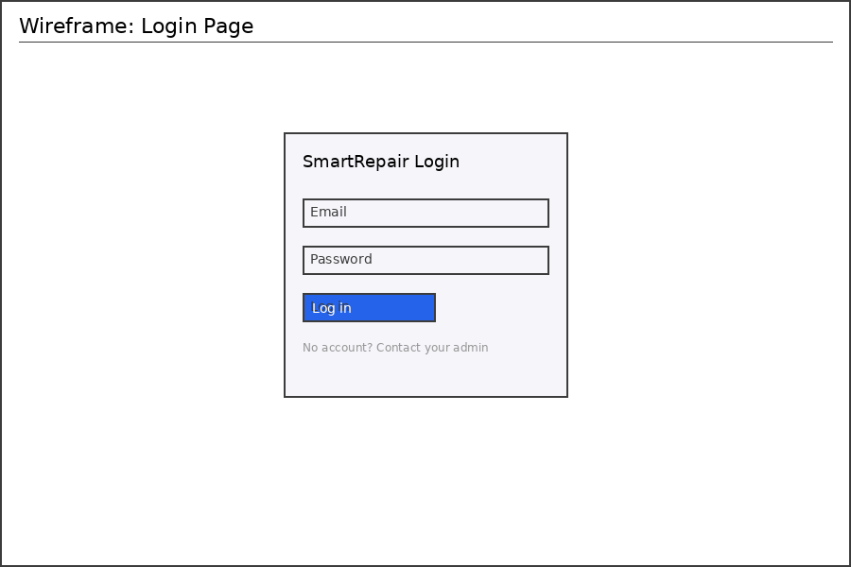

Customers
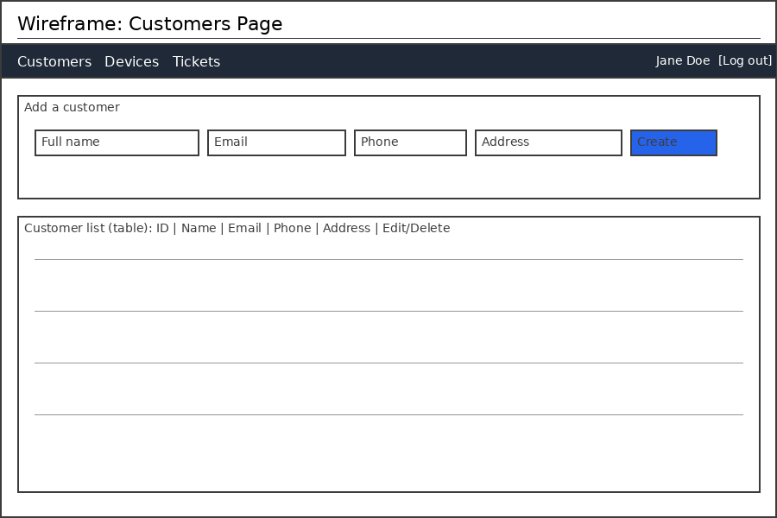

Devices
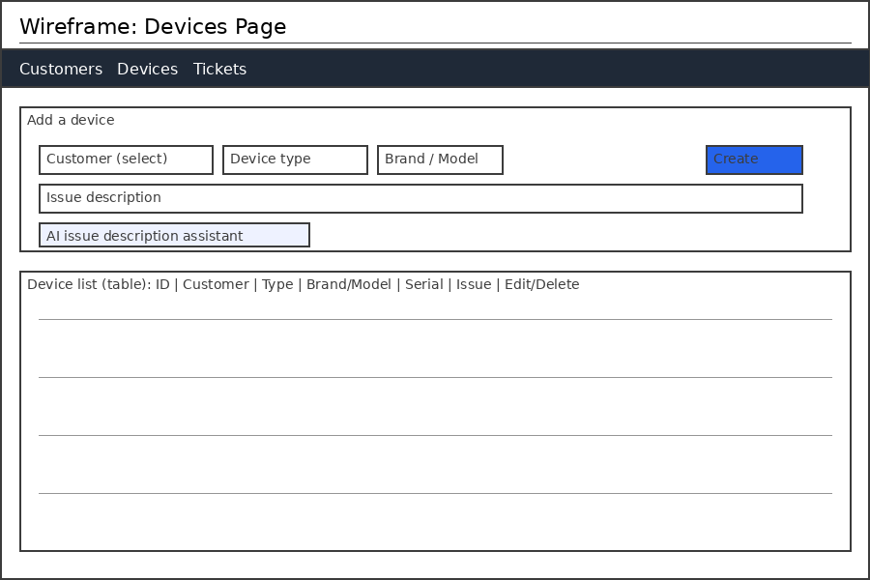

Repair Tickets
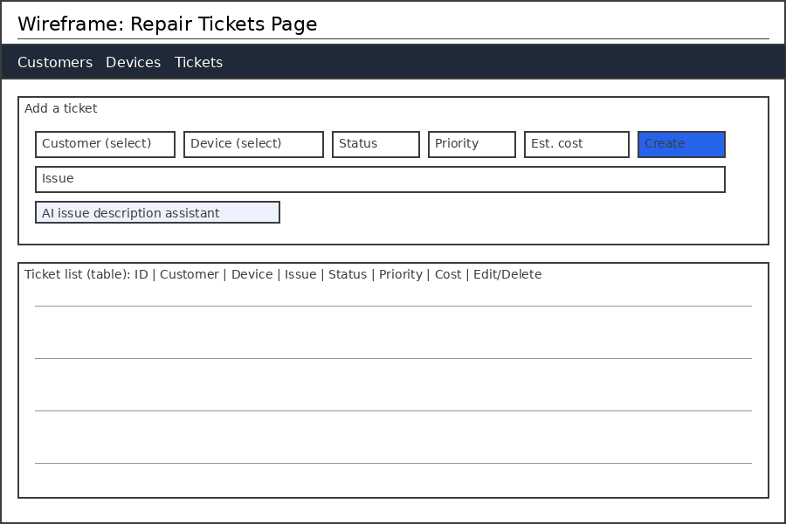

6. GitHub Repository & Reflection

Repository
https://github.com/G97-Studi/Smart_API

Work division
(Draft — please confirm/edit with your teammates before submitting; this reflects what's documented in the repo README and this session's work, not a claim about anyone else's contribution.)
Member | Milestone 2 | Milestone 3/4 | Milestone 5
Gurnoor Singh | Database design, ER diagram, table design | - | -
Muhammad Noaman Mushtaq | API route planning, Express architecture planning | - | -
Sona Jasmin | Frontend wireframes / UI planning | Express/TypeScript setup, MySQL connection (db.ts), Milestone 4 CRUD endpoints | JWT auth (register/login/logout), password hashing, protected routes, React SPA (frontend/), AI issue-description assistant

Reflection
(Draft starting point — personalize before submitting.)
Milestone 5 extended the backend built in Milestones 3 and 4 with a real authentication layer and a usable frontend, turning the project from an API that only responded to curl/Postman into an application a repair shop could actually use. The main technical challenges were keeping the JWT flow simple enough to explain clearly in a live demo while still following real security practices (hashed passwords, rate-limited login, protected routes on both the frontend and backend), and deciding where the token should live on the client given the trade-offs between localStorage, sessionStorage, and httpOnly cookies.

