My First RMarkdown

Your Name

2025-03-31

url <- "C:/capstone/father.son.csv"  
df <- read.csv(url)  
  
head(df)

## fheight sheight  
## 1 65.04851 59.77827  
## 2 63.25094 63.21404  
## 3 64.95532 63.34242  
## 4 65.75250 62.79238  
## 5 61.13723 64.28113  
## 6 63.02254 64.24221

## 데이터 요약

| 분류 | 키 평균 |
| --- | --- |
| 아빠 | 67.68710 |
| 아들 | 68.68407 |

## 평균 공식

$E=mc^{2}$

summary(df)

## fheight sheight   
## Min. :59.01 Min. :58.51   
## 1st Qu.:65.79 1st Qu.:66.93   
## Median :67.77 Median :68.62   
## Mean :67.69 Mean :68.68   
## 3rd Qu.:69.60 3rd Qu.:70.47   
## Max. :75.43 Max. :78.36

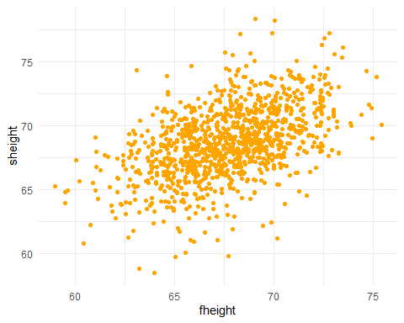

library(knitr)  
kable(head(mtcars))

|  | mpg | cyl | disp | hp | drat | wt | qsec | vs | am | gear | carb |
| --- | --- | --- | --- | --- | --- | --- | --- | --- | --- | --- | --- |
| Mazda RX4 | 21.0 | 6 | 160 | 110 | 3.90 | 2.620 | 16.46 | 0 | 1 | 4 | 4 |
| Mazda RX4 Wag | 21.0 | 6 | 160 | 110 | 3.90 | 2.875 | 17.02 | 0 | 1 | 4 | 4 |
| Datsun 710 | 22.8 | 4 | 108 | 93 | 3.85 | 2.320 | 18.61 | 1 | 1 | 4 | 1 |
| Hornet 4 Drive | 21.4 | 6 | 258 | 110 | 3.08 | 3.215 | 19.44 | 1 | 0 | 3 | 1 |
| Hornet Sportabout | 18.7 | 8 | 360 | 175 | 3.15 | 3.440 | 17.02 | 0 | 0 | 3 | 2 |
| Valiant | 18.1 | 6 | 225 | 105 | 2.76 | 3.460 | 20.22 | 1 | 0 | 3 | 1 |