ARP Spoofing for Sniffing and Man-in-the-middle Attacks

This lab was developed for the Labtainer framework by the Naval Postgraduate School, Center for Cybersecurity and Cyber Operations under National Science Foundation Award No. 1438893. This work is in the public domain, and cannot be copyrighted.

# Overview

This exercise explores the use of ARP spoofing as a means to sniff local network traffic. Modern Local Area Networks (LANs) use ethernet switches, which prevent passive sniffing of network traffic between other components. This lab assumes you have separately learned about the ARP protocol. ARP spoofing is a technique by which the attacker sends spoofed ARP messages into the LAN, with a goal of causing traffic meant for one IP address to be routed to the attacker’s computer instead. The attacker’s computer then forwards the traffic to the intended destination. This puts the attacker into the middle of the traffic exchange, hence the name ”Man in the Middle” attack.

# Lab Environmnet

This lab runs in the Labtainer framework, available at [http://my.nps.edu/web/c3o/labtainers.](http://my.nps.edu/web/c3o/labtainers) That site in- cludes links to a pre-built virtual machine that has Labtainers installed, however Labtainers can be run on any Linux host that supports Docker containers.

From your labtainer-student directory start the lab using:

labtainer arp-spoof

Links to this lab manual and to an empty lab report will be displayed. If you create your lab report on a separate system, be sure to copy it back to the specified location on your Linux system.

# Network Configuration

This lab includes four networked computers as shown in Figure 1, which illustrates the intended flow of traffic between the user computer and the Webserver via the Gateway.

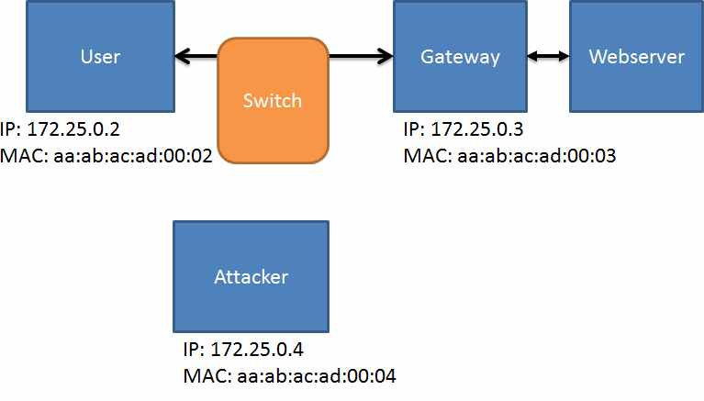

Figure 1: Intended traffic from between User and Webserver

# Lab Tasks

In this lab, you will use the arpspoof tool to convice the User computer that traffic destined for Gateway should instead be sent to the Attacker computer – and convince the Gateway that traffic destined for the User should be sent to the Attacker computer, as illustrated in Figure2

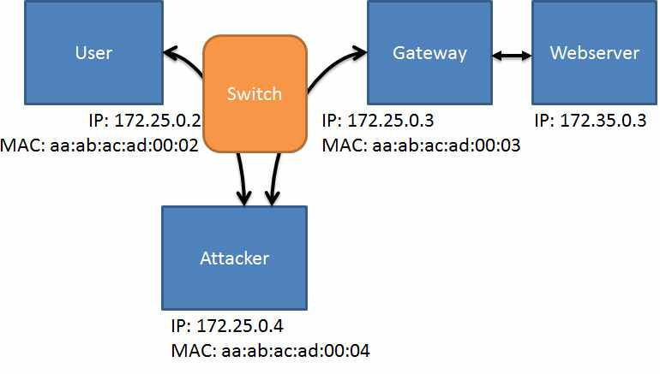

Figure 2: Man-in-the-middle attack via ARP Spoofing

The arpspoof tool is installed on the Attacker computer, as is Wireshark. The Attacker computer is configured to forward IP packets that is receives which are destined for elsewhere. You can confirm this

with this command, which should reflect a value of ’1’:

sysctl net.ipv4.conf.all.forwarding

## Task 1: Sniff the LAN from the Attacker

Before you engage in ARP spoofing, first look at network traffic as seen by the Attacker. Start Wireshark on the Attacker computer, selecting the ”eth0” interface:

wireshark -ki eth0

On the User computer, use wget to retrieve a web page from the Webserver:

wget <address of Webserver>

Observe the Wireshark display. Do you see either the web query or the response?

## Task 2: Spoof the ARP cache on the User and Gateway Computers

Use the arpspoof tool on the Attacker computer to perform your ARP spoofing. Note you must target both the User and Gateway computers. It is easiest to start the arpspoof program in two different virtual terminals connected to the attacker (you may have wondered why you were given three Attacker terminals).

sudo arpspoof -t <User IP> <gateway IP> sudo arpspoof -t <gateway IP> <User IP>

After your ARP spoofing has commenced you should see your spoofed ARP traffic in Wireshark. Now return to the User computer and refetch the web page using wget command. You should see TCP traffic in your Wireshark display. In Wireshark, stop the capture, (red button), and use ”File / Save” to save the traffic into a file named sniff.pcapng in your HOME directory, (/home/ubuntu).

# Submission

After finishing the lab, go to the terminal on your Linux system that was used to start the lab and type:

stoplab arp-spoof

When you stop the lab, the system will display a path to the zipped lab results on your Linux system. Provide that file to your instructor, e.g., via the Sakai site.