Homework 4

Information

Name | UNI
Zhewen Guo | zg2567

Goals
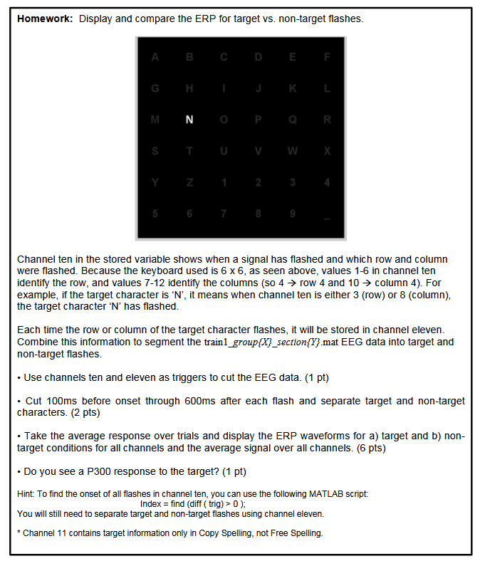
Figure 1. Screenshot of Requirements

Task 1: Cut the EEG Data
EEG data contains 11 channels. The first channel contains runtime information. The following 8 channels show the values of EEG signals from Fz, Cz, P3, Pz, P4, PO7, Oz, and PO8. Channel 10 decodes the position of the flashed signal. The values of Channel 10 range from 1 to 12 and last for 4 sample points when a row or column of letters is flashed. Channel 11 outputs a pulse signal (last for 4 sample points) whenever the target letter flashes.
As shown in Figure 2, target flash appears when channel 11 outputs 1. And when Channel 10 outputs a non-zero value while Channel 11 outputs 0, it means there is a non-target flash. (Full code in Appendix 1or ‘trigger_alignment.m’)
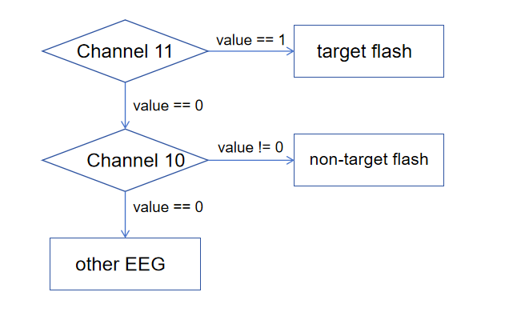
Figure 2. Flowchart of data segmentation

Task 2&3: Capture ERP of target and non-target characters.
After saving data from task 1, we could keep previous 26 sample points (100ms) and subsequent 154 sample points (600ms) of target and non-target flash. ( For Task 2: check ‘ERP_calculate.m’ in folder ‘Code’ or Appendix 2 for how to detect the onset point and cut the data by Matlab)
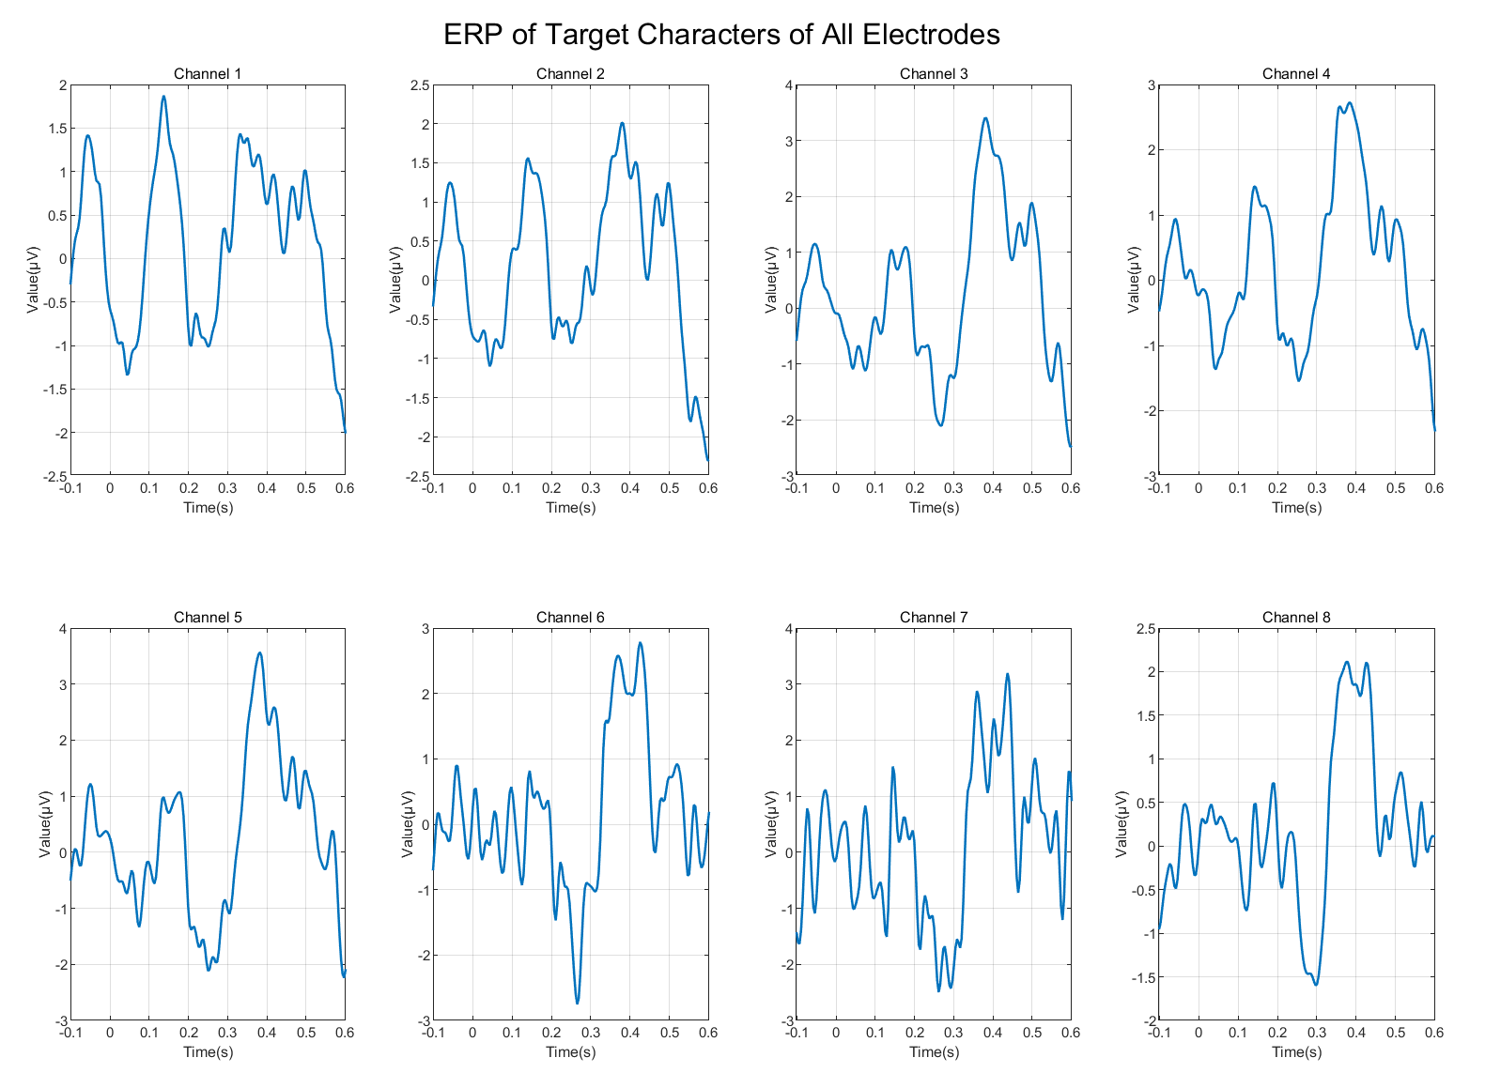
Figure 3. ERP of target character of all electrodes
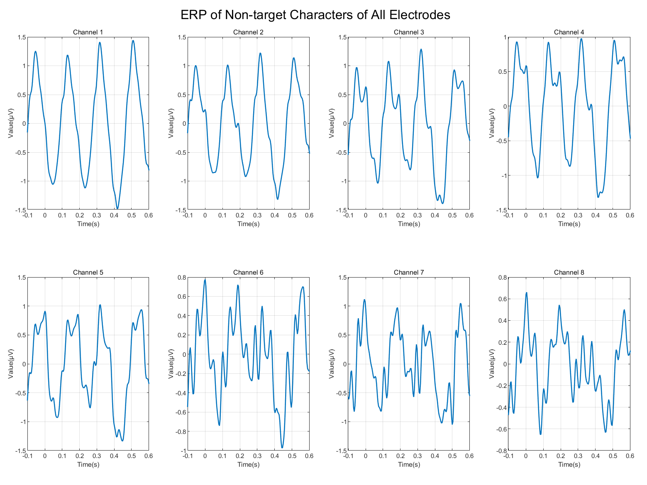
Figure 4. ERP of non-target character of all electrodes
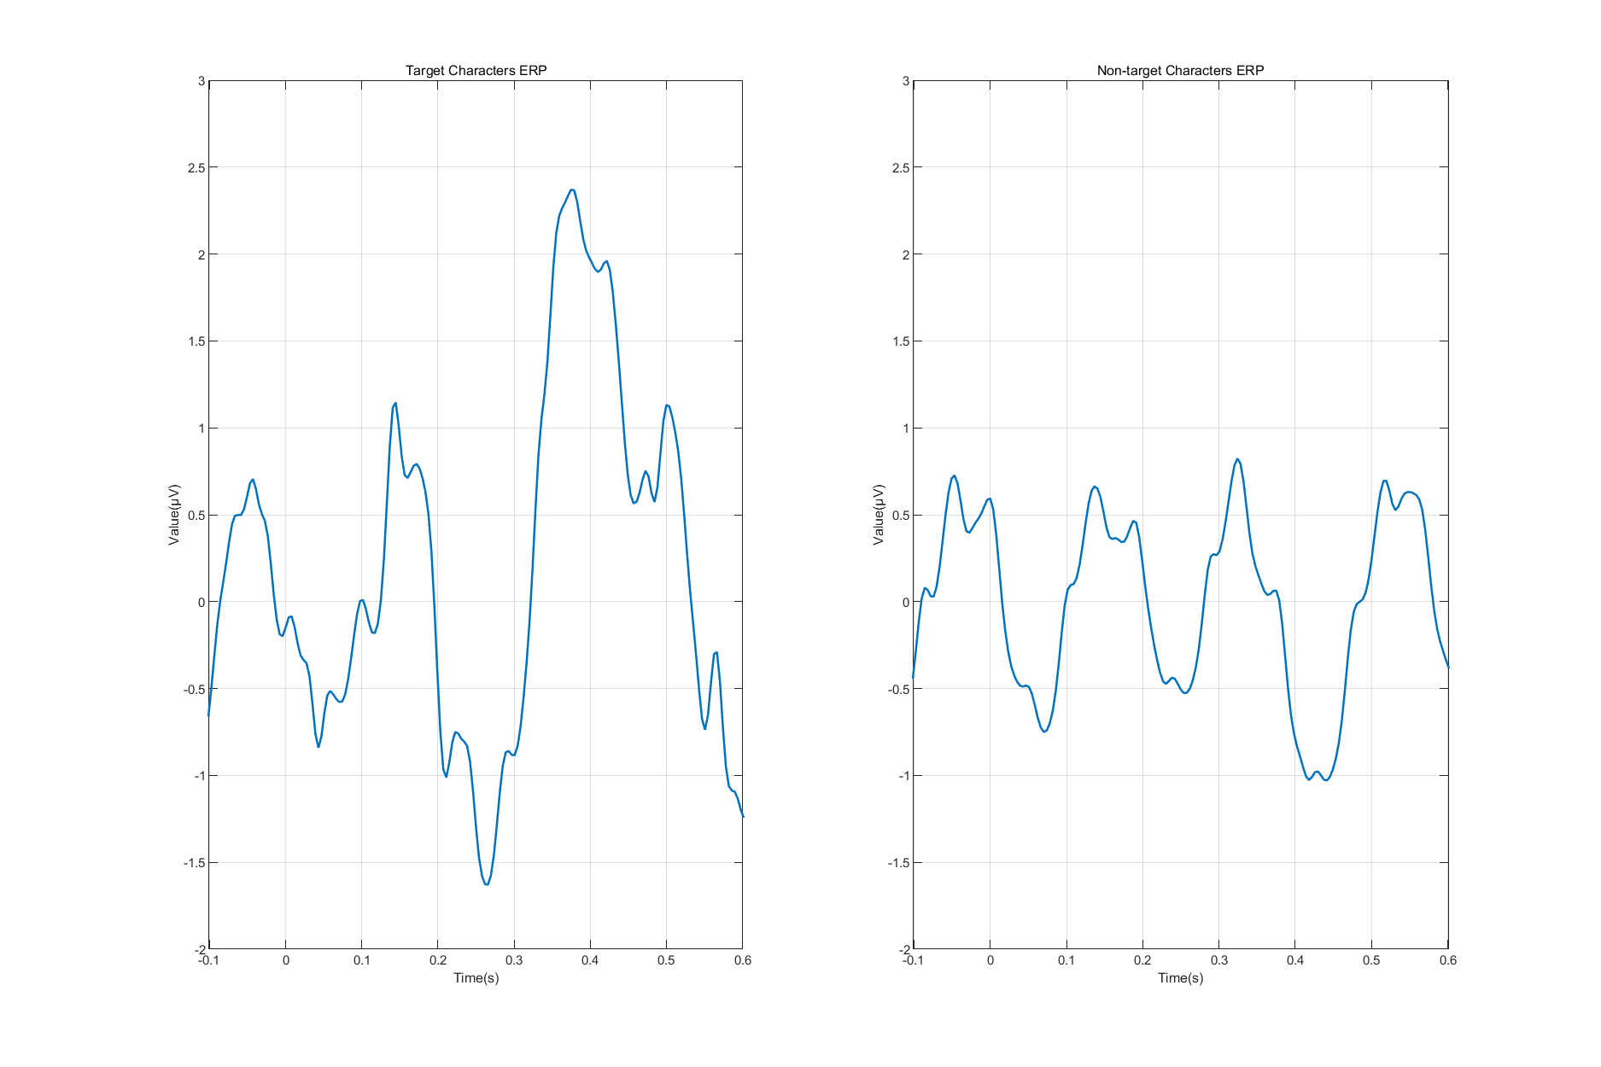
Figure 5. Average ERP signal over all channels
Figure 3 (target flash) and Figure 4 (non-target flash) exhibit the ERP signals of all 8 electrodes. Figure 5 display the average ERP waveforms for target (left) and non-target flash(right) over all channels.

Task 4: P300 Detection
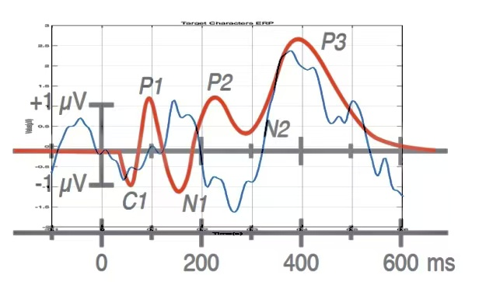
Figure 6. Target flash ERP signal (blue) vs. Standard ERP signal (red)
Figure 6 shows the comparison of the mean ERP (blue) in this experiment and a standard ERP (red). P3 means P300 component. It is evident that there is a apparent P300 component to the target in the average ERP data.

Appendix 1
function [m, n] = trigger_alignment(trigger, target)
m = zeros(1, length(trigger)); %non-target
n = zeros(1, length(trigger)); %target
k = 0;
j = 0;
for i = 2:length(trigger)
if target(i) == 1 && target(i-1) == 0
k = k + 1;
n(k) = i;
else
if trigger(i) ~= 0 && trigger(i-1) == 0
j = j + 1;
m(j) = i;
end
end
end
fprintf("find %d target pulse\n", k);
fprintf("find %d non-target pulse\n", j);
n = n(1:k);
m = m(1:j);
end

Appendix 2
function y = ERP_calculate(trigger, signal)
%signal ==> 8*n
before_sample = 26; % 0.1s * 256 (sample rate)
after_sample = 154; % 0.6s * 256 (sample rate)

y = zeros(size(signal,1),before_sample+after_sample+1);

for i = 1:size(signal,1)
temp_raw = data_capture(trigger, signal(i,:), before_sample, after_sample);
temp_mean = mean(temp_raw,1);
y(i,:) = temp_mean;
end
end

