Homework 5

Information

Name | UNI
Zhewen Guo | zg2567

Goals
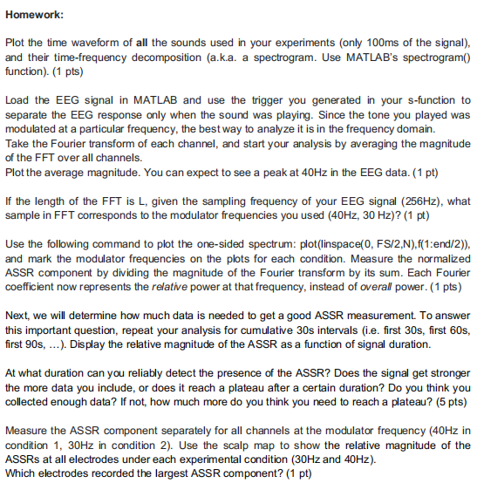
Figure 1. screenshot of requirements

Task 1: Plot the sounds waveform in time and frequency domain
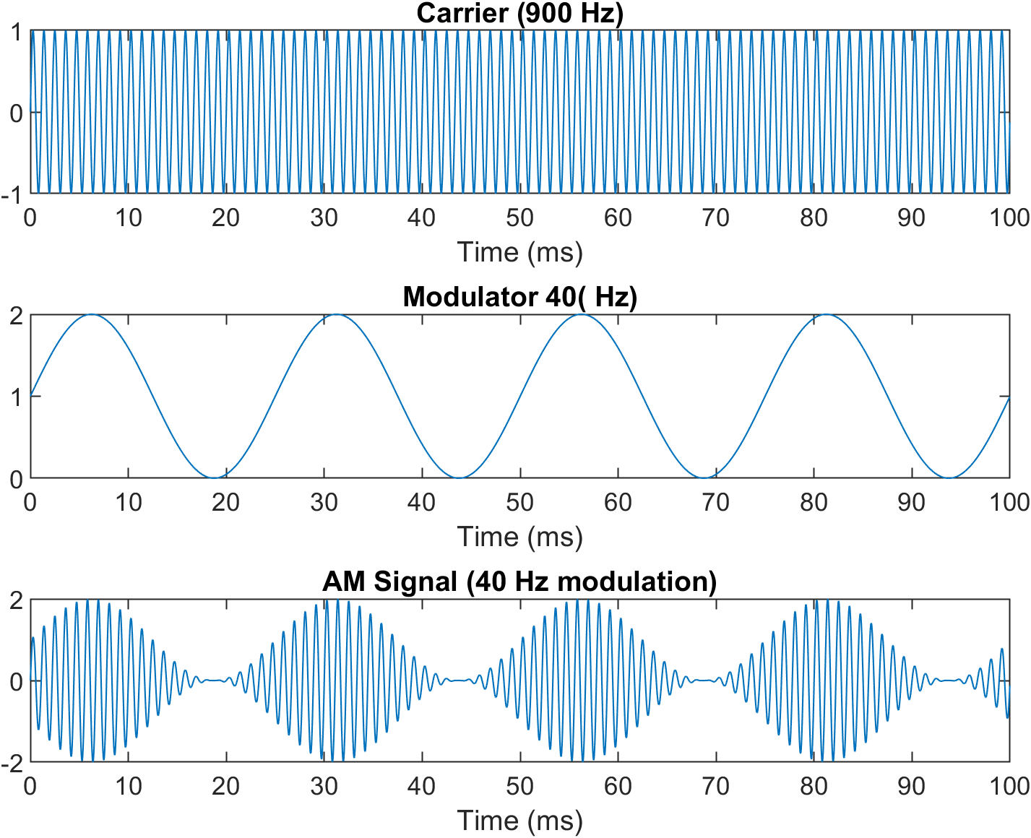
Figure 2. time domain (message frequency 40Hz)
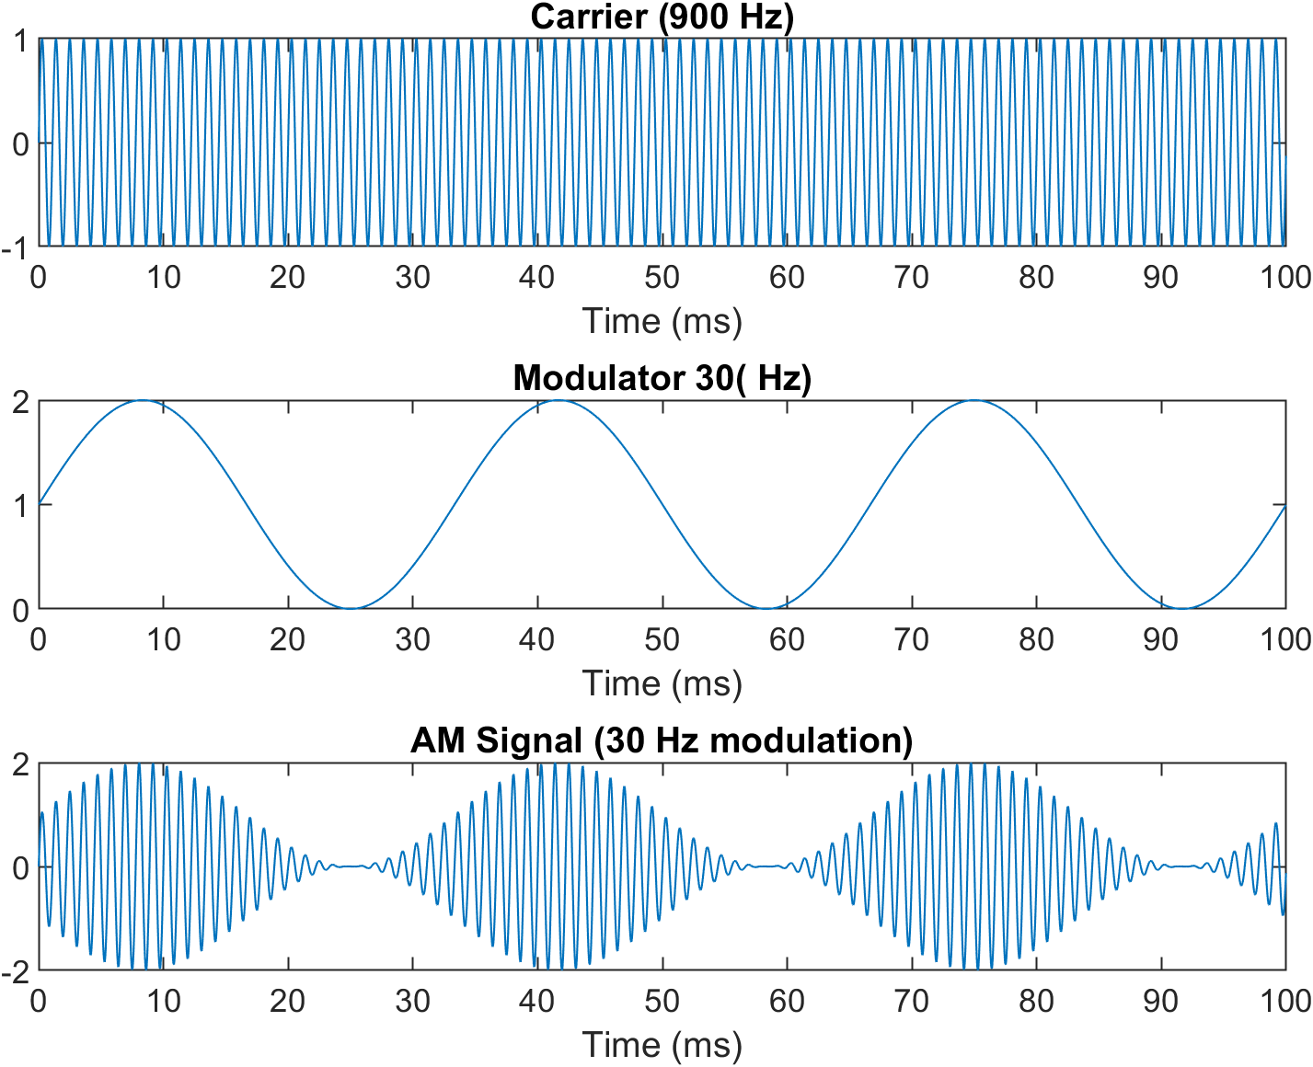
Figure 3. time domain (message frequency 30Hz)

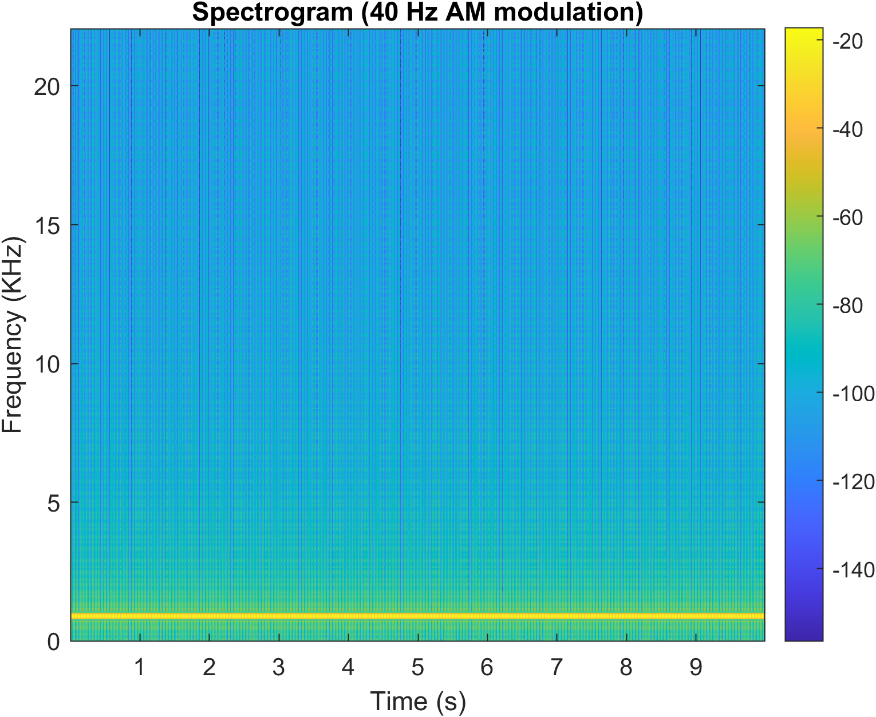
Figure 4. frequency domain (message frequency 40Hz)
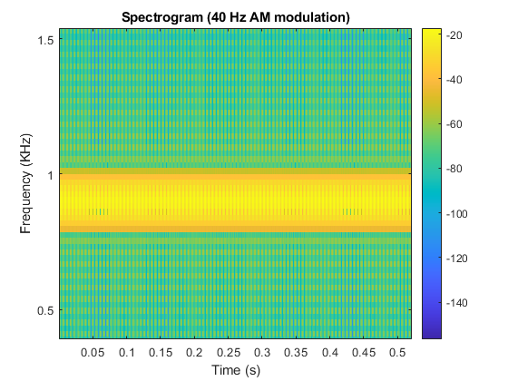
Figure 5. scaled frequency domain (message frequency 40Hz)
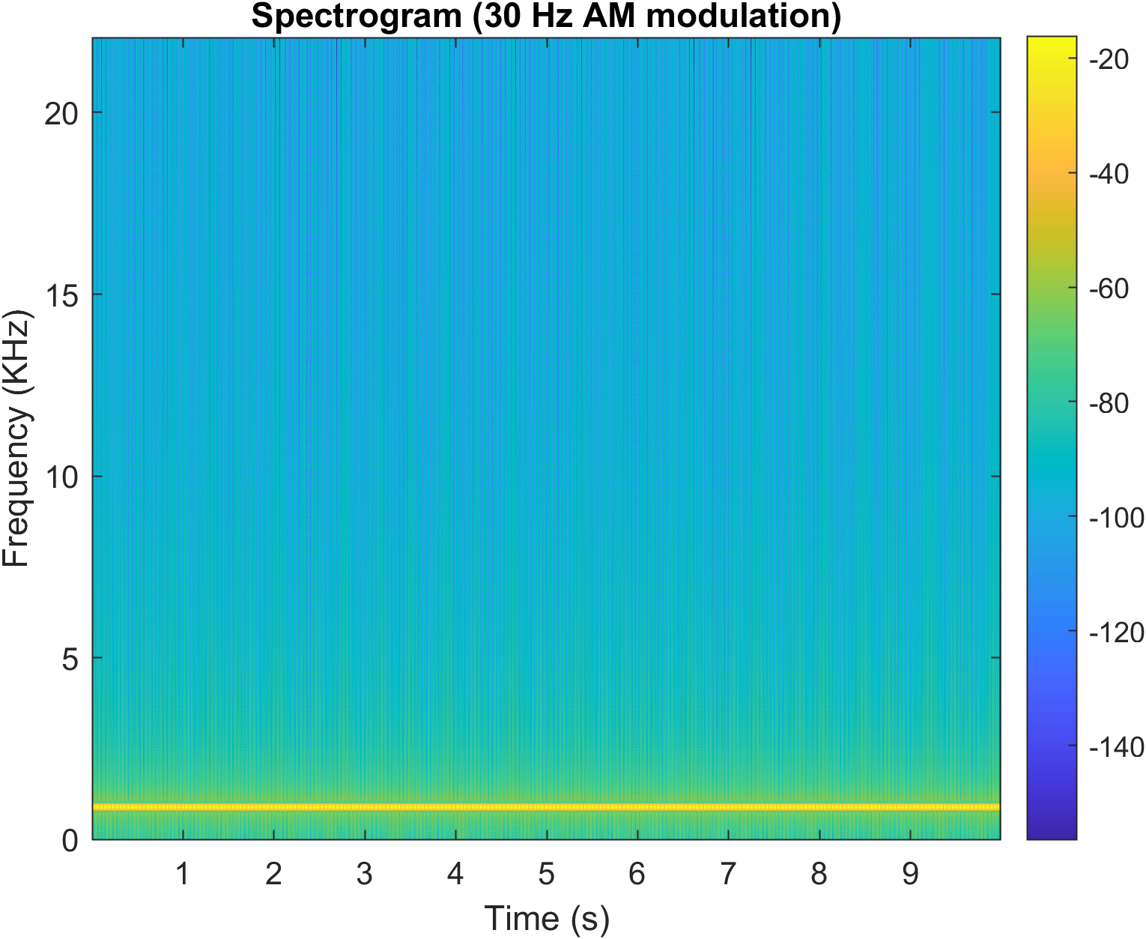
Figure 6. frequency domain (message frequency 30Hz)
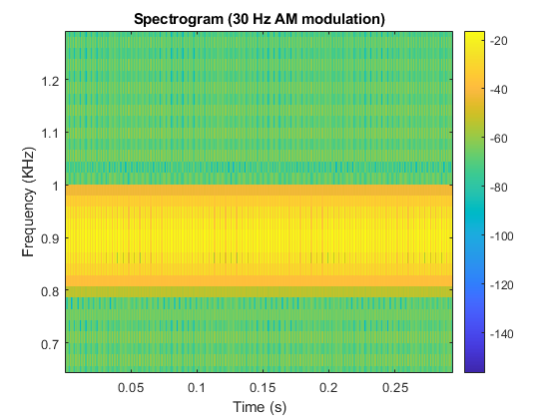
Figure 7. scaled frequency domain (message frequency 30Hz)

Task 2: Plot the average magnitude
Figure 8 shows the FFT results: the first and third subplots exhibit the average amplitude-frequency responses across all 7 electrodes and the second and fourth subplots exhibit the phase-frequency responses. It’s evident that there is a clear 40Hz component in data1 and 30Hz component in data2.
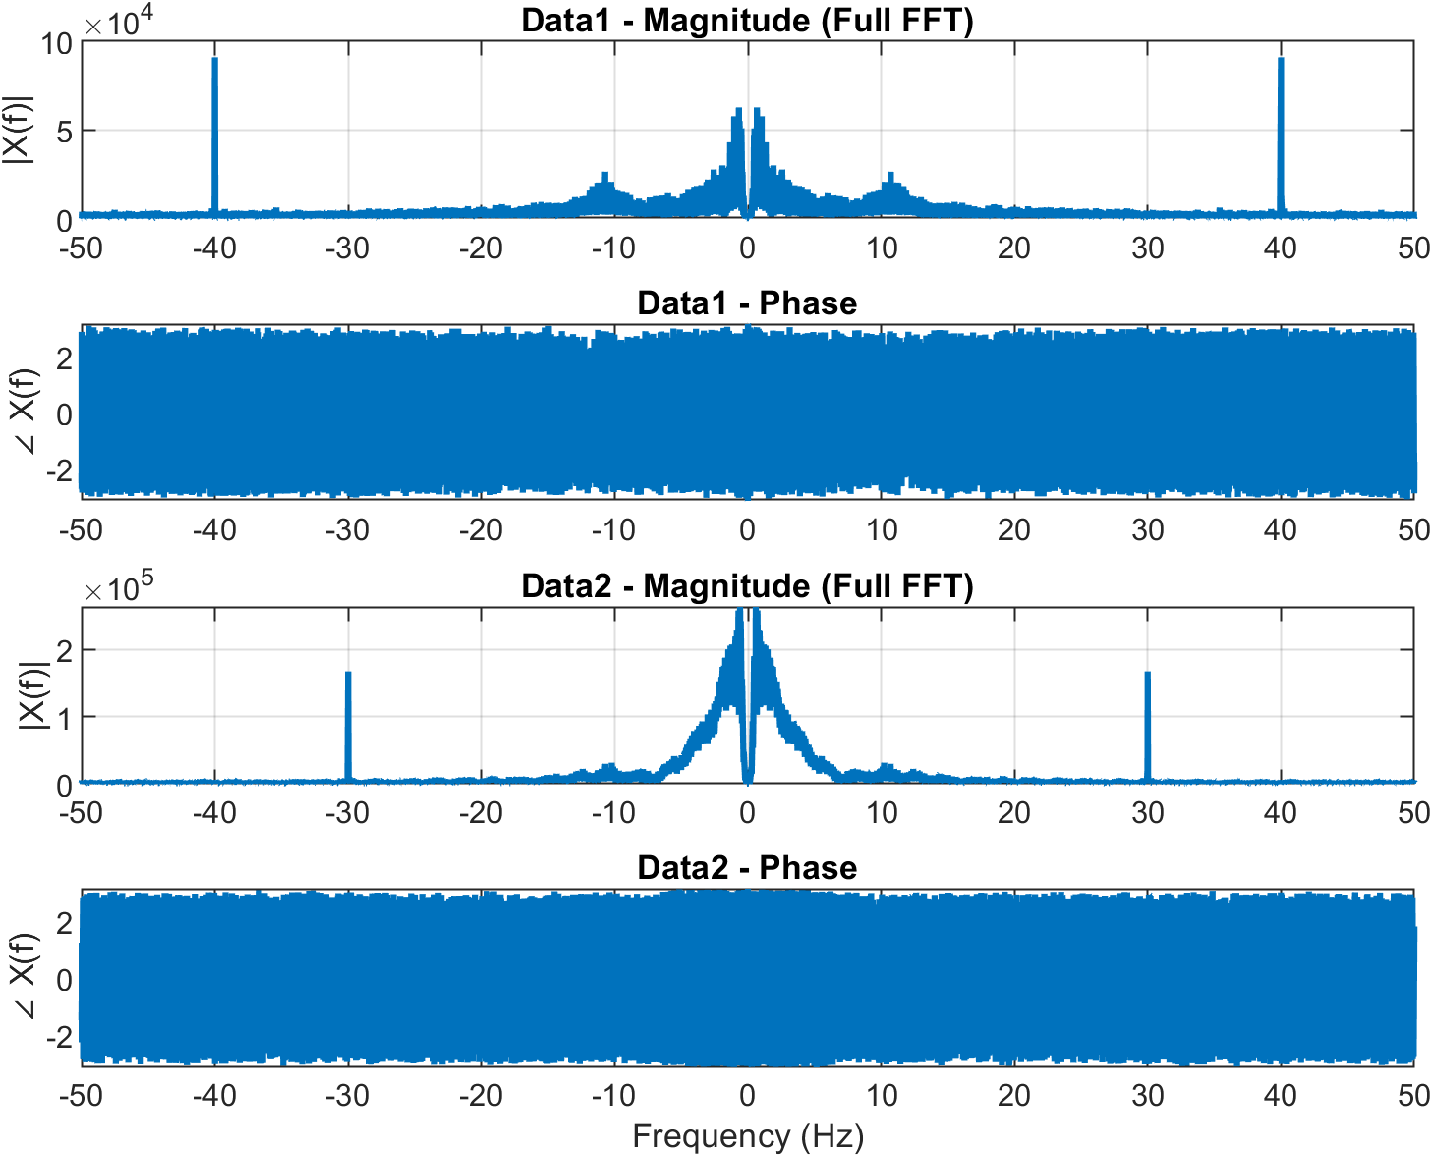
Figure 8. average magnitude

Task 3: Calculation the sample
For an FFT of length L and sampling frequency f_{s} , the sample index k corresponding to a frequency f is:
$$k=\frac{f∙L}{f_{s}}$$
Thus:
$$\left\{\begin{aligned}k_{40}=\frac{5L}{32} \\ k_{30}=\frac{15L}{128}\end{aligned}\right.$$

Task 4: Plot the one-sided spectrum
Figure 9 shows the one-sided spectrum of both trials: the blue line shows the average one-sided amplitude-frequency response when the message frequency is 40Hz and the orange line shows the result of 30Hz message frequency.
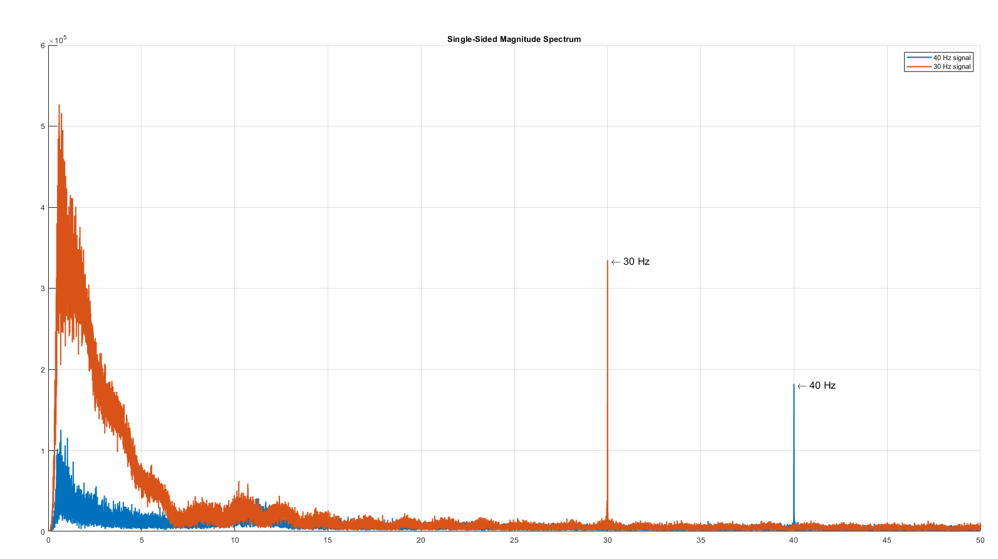
Figure 9. one-sided spectrum

Task 5: Display the relative magnitude
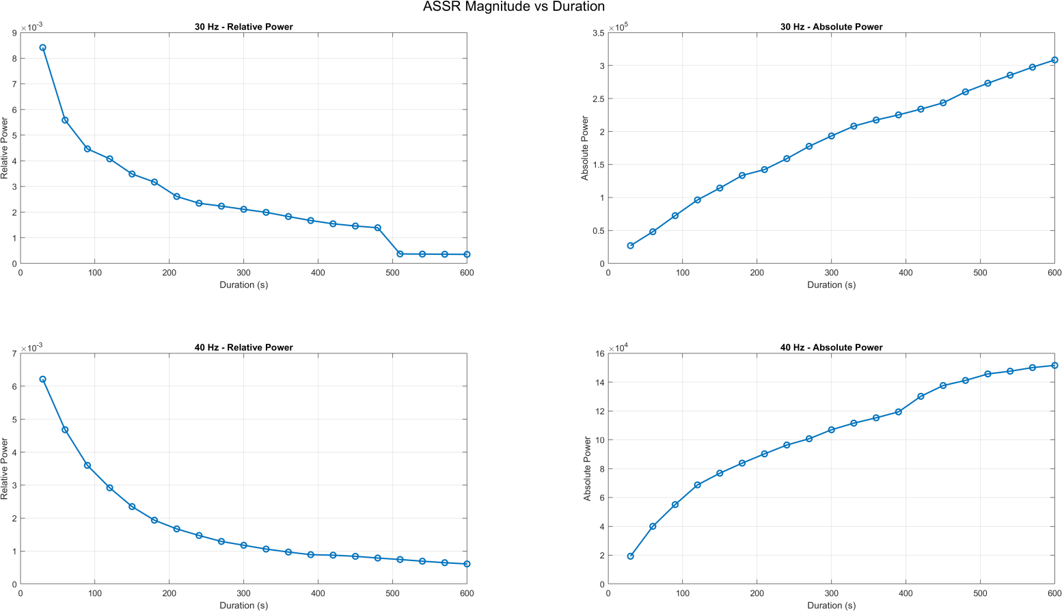
Figure 10. ASSR magnitude vs duration
Figure 10 shows the relative power (left) and absolute power (right). Although the absolute powers of 30 Hz and 40 Hz increase as the time interval grows, the relative powers decrease. A possible reason is that a longer time-domain sequence causes a higher-resolution frequency spectrum. As the resolution improves, more frequency components surrounding the target frequency are separated out, so the energy of the target frequency becomes less dominant relative to the whole spectrum.
To tackle with the impact caused by resolution, Welch’s method is used to compute the power spectrum, from which we extract the power at the target modulation frequency. The surrounding frequency samples serve as the noise floor, and the SNR is calculated in dB. Finally, the SNR values are plotted in Figure 11.
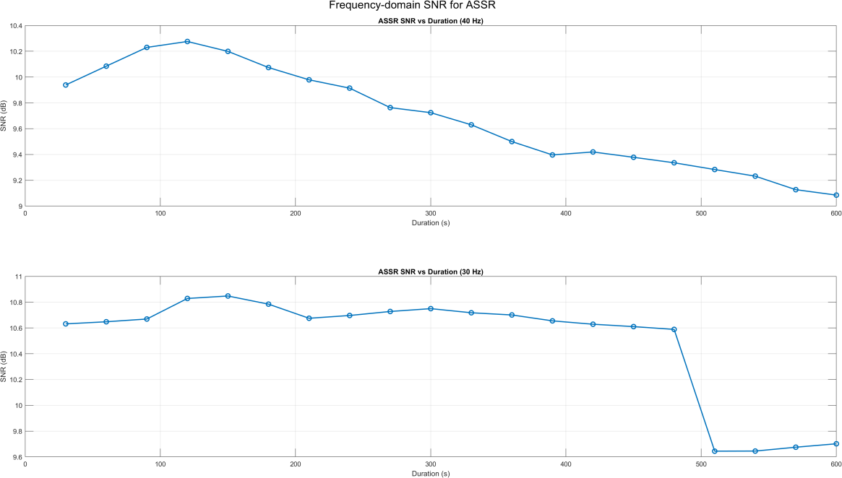
Figure 11. ASSR SNR compared to surrounding samples

According to the results, the SNR of data1 (40Hz) reaches its peak at 120s and gradually drop from 120s to 600s. However the the SNR of data2 (30Hz) peaks at150s and stays at a plateau before a sudden plunge at 510s. Based on this behavior, it appears that sufficient data have already been collected for reliable ASSR detection.

Task 6: Scalp map
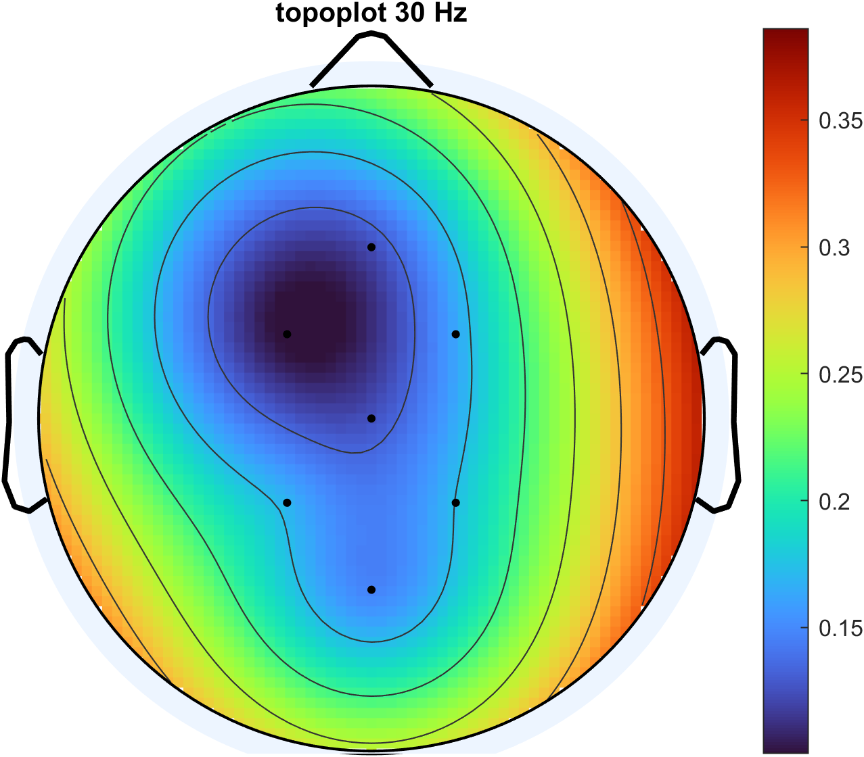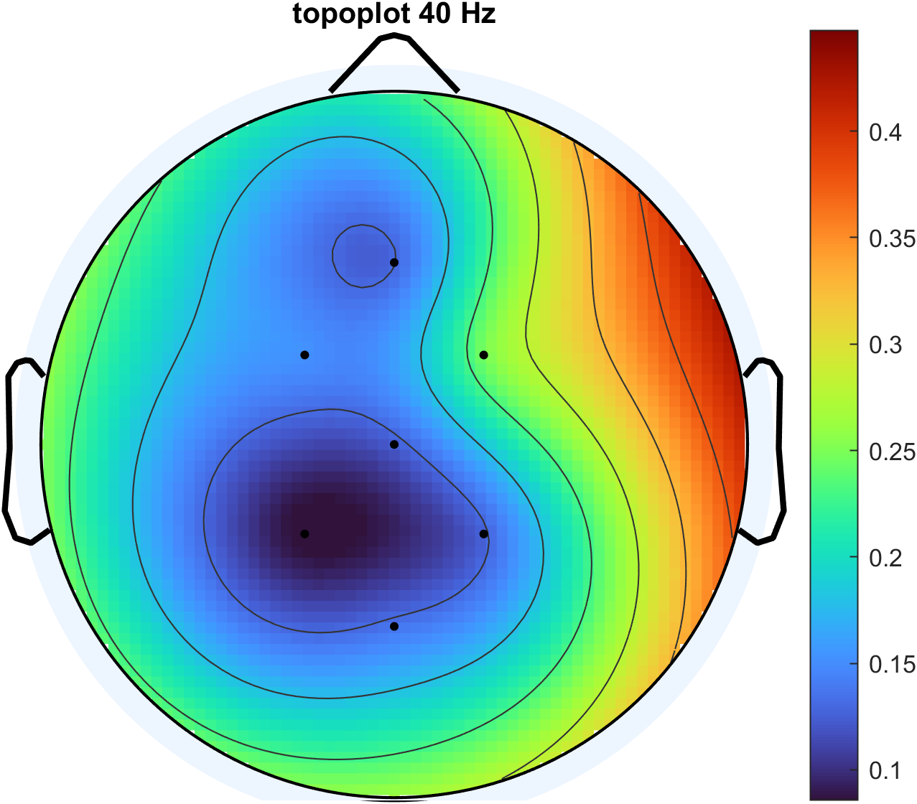
Figure 12. scalp map (left: 40Hz, right: 30Hz)
Figure 12 use the scalp map to show the relative magnitude of the ASSRs at all electrodes under each experimental condition(left: 40Hz, right: 30Hz). According to the subplots, CP2 and FC2 (right brain) recorded the largest ASSR component.

