Homework 2

Information

Name | UNI
Zhewen Guo | zg2567

Goals
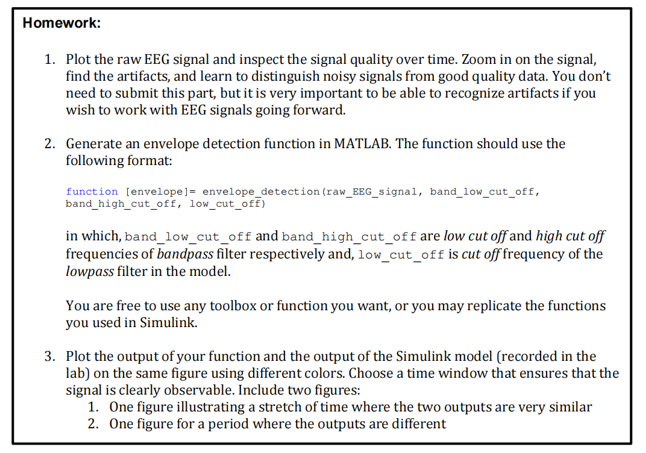
Figure 1. Screenshot of Requirements

Task 2: Generate an envelope detection function in MATLAB.
According to the process during the lab (Figure 2), the raw signals should be filtered with a band-pass filter to capture waves at a target frequency (i.g., 8-12 Hz for alpha component). Then an Absolute Value block was utilized as a rectifier. After that, we used a low-pass filter and Mean block to get the average envelope of the signals.
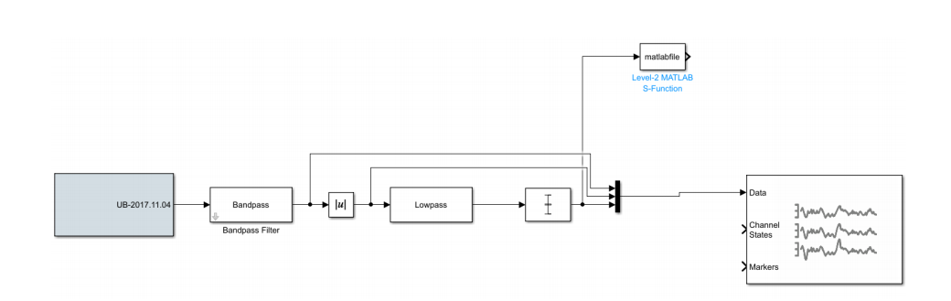
Figure 2. Data process in Simulink

To achieve a similar result, two Butterworth filters are applied to extract alpha signals and envelopes of signals. (Refer to Appendix 1 for full code).

Task 3: Plot the output of both your function and Simulink model.
To calculate the most similar and the most distinct part of two outputs, a sliding window ( length = 500, step = 1) is created to calculate the sum of differences (Refer to Appendix 1 for full code).

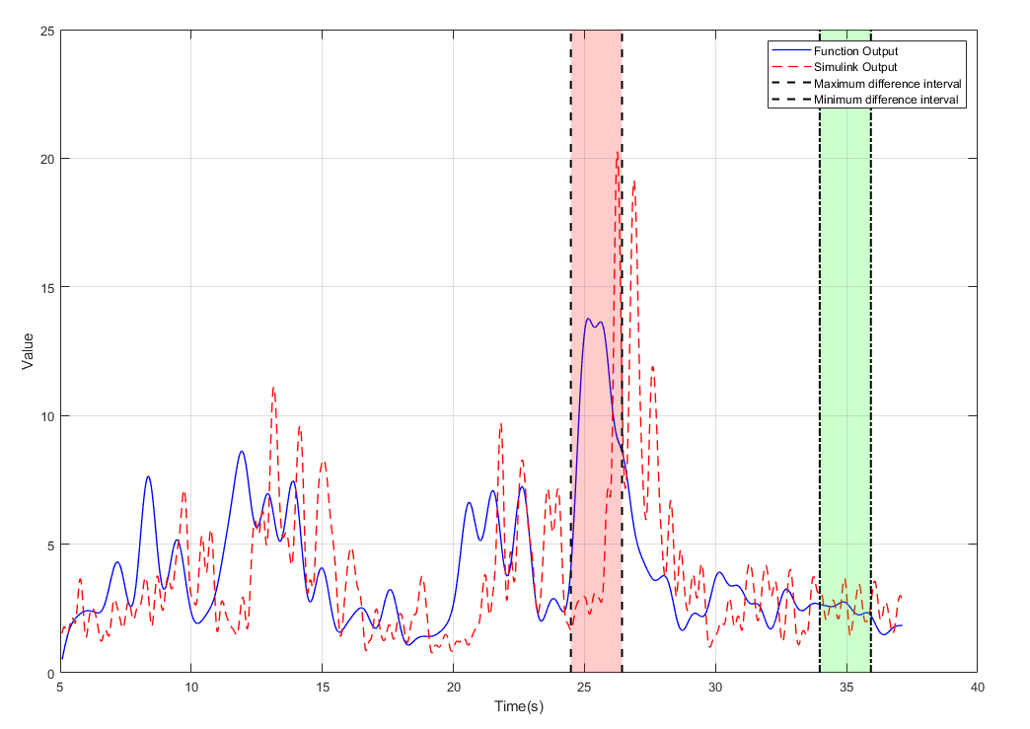
Figure 3. Exhibition of Function Output and Simulink Output
According to the Figure 3, the blue line shows the function output, while the red line demonstrates the result of Simulink. Besides, the red bar covers the range where two outputs reach the most significant difference and the signals in green bar have the highest similarity.
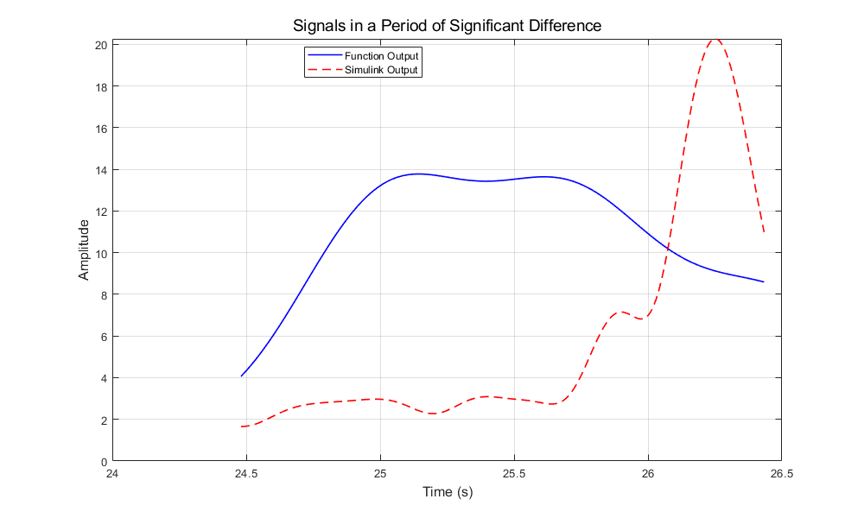
Figure 4. Signals in a Period of Significant Difference
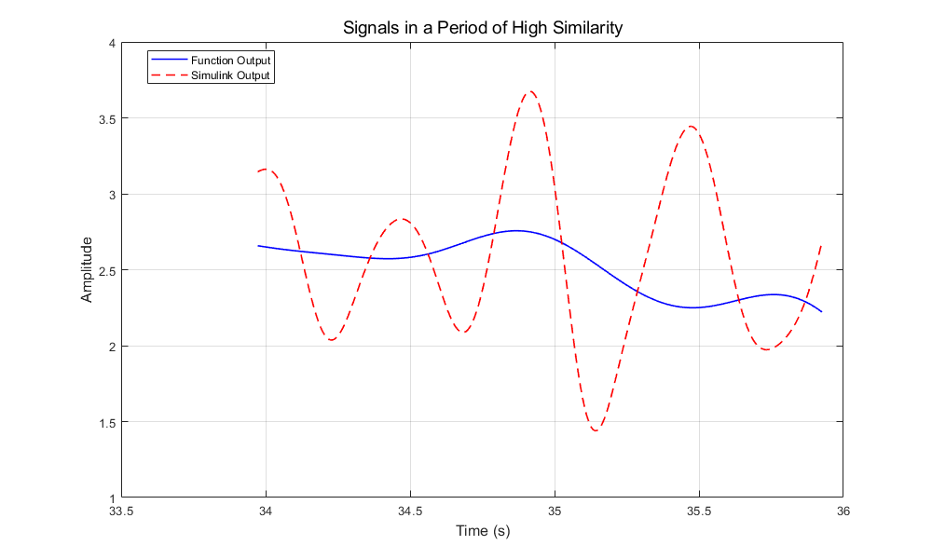
Figure 5. Signals in a Period of High Similarity
However there seems to be an evident phase delay between these two outputs that the processed signal of Simulink is slightly slower, which may lead to a error conclusion. Thus, I tried to manually align the two data sets by delaying the Simulink data sets by 350 sample points, which is approximate 1.36 second. Figure 6-8 display the result.
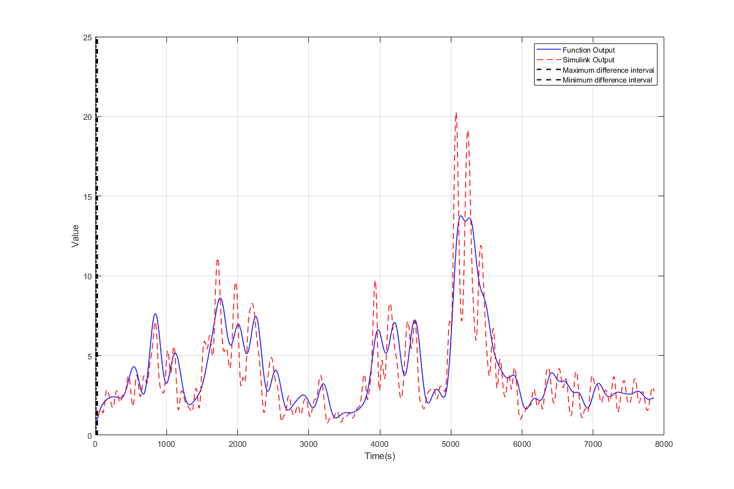
Figure 6. Exhibition of Function Output and Simulink Output After Alignment
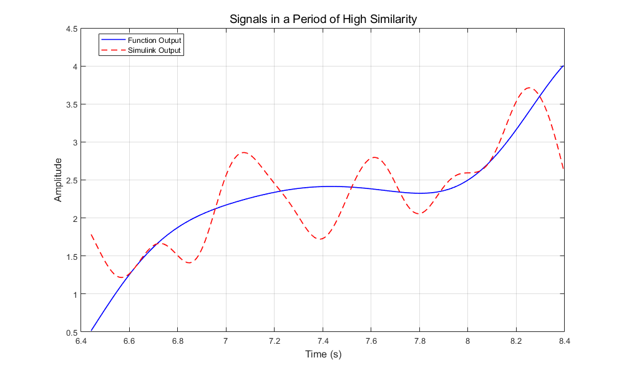
Figure 8. Signals in a Period of High Similarity After Alignment

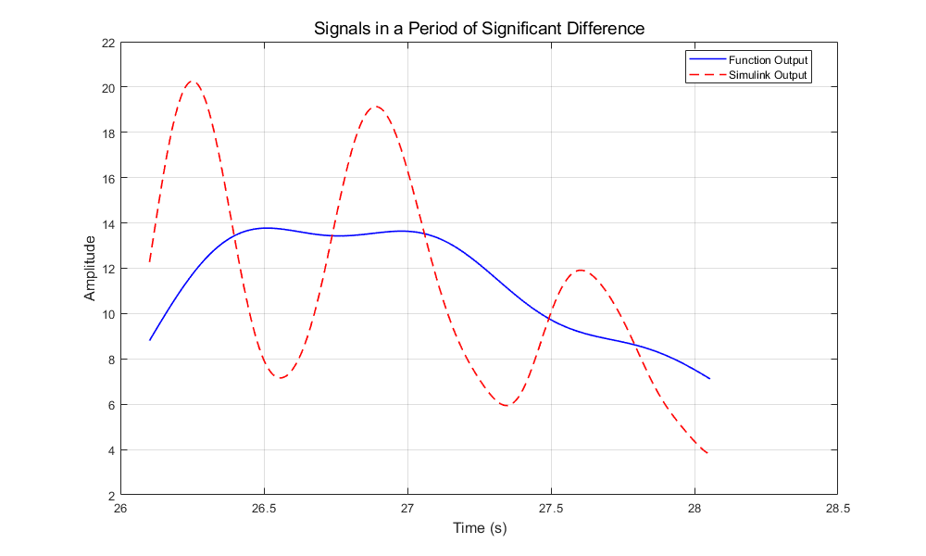
Figure 9. Signals in a Period of Significant Difference After Alignment

Appendix 1:
function [envelope] = envelope_detection(raw_EEG_signal, band_low_cut_off, band_high_cut_off, low_cut_off)
Fs = 256;
N_bandpass = 4;
N_lowpass = 4;
signal_length = length(raw_EEG_signal);
y_time = (0:signal_length-1) / Fs;

% bandpass
[b_band, a_band] = butter(N_bandpass, [band_low_cut_off/(Fs/2), band_high_cut_off/(Fs/2)], 'bandpass');
% filterd signal
filtered_signal = filtfilt(b_band, a_band, raw_EEG_signal);
%analytic_signal = hilbert(filtered_signal);

%raw_envelope = abs(imag(analytic_signal));
raw_envelope = abs(filtered_signal);
[b_low, a_low] = butter(N_lowpass, low_cut_off/(Fs/2), 'low');

envelope = filtfilt(b_low, a_low, raw_envelope);

end

Appendix 2:
clc;clear;

Fs = 256;
raw_data = load('F:/Desktop/4090-BCI/HW/HW_2_zg2567/Data/raw_data.mat');
lab_data = load('F:/Desktop/4090-BCI/HW/HW_2_zg2567/Data/mean_data.mat');
addpath('F:/Desktop/4090-BCI/HW/HW_2_zg2567/Code')

time_sample = raw_data.y(1:1, 1300:end);

raw_signal = raw_data.y(2:6, 1300:end);
lab_signal = lab_data.y(2:2,1300:end);

envelopes = zeros(size(raw_signal));
disp(size(time_sample));

for i = 1:5
envelopes(i, :) = envelope_detection(raw_signal(i, :), 8, 13, 1);
end
envelope_mean = mean(envelopes, 1);

function_output = envelope_mean;
simulink_output = lab_signal;

total_length = length(function_output);
t_total = (0:total_length-1) / Fs;

length_window = 500;
len = length(time_sample);

min_sum = Inf;
min_idx = 1;
max_sum = -Inf;
max_idx = 1;

for i = 1:(len - length_window)
diff_window = abs(function_output(i:i+length_window) - simulink_output(i:i+length_window));
sum_diff = sum(diff_window);
if sum_diff < min_sum
min_sum = sum_diff;
min_idx = i;
end
if sum_diff > max_sum
max_sum = sum_diff;
max_idx = i;
end
end
fprintf("max_index: %d \n", max_idx);
fprintf("min_index: %d \n", min_idx);
figure('Position', [100, 100, 1200, 800]);
plot(time_sample, function_output, 'b-', 'LineWidth', 1, 'DisplayName', 'Function Output');
hold on;
plot(time_sample, simulink_output, 'r--', 'LineWidth', 1, 'DisplayName', 'Simulink Output');

y_lim = ylim;
y_min = y_lim(1);
y_max = y_lim(2);

start_t_max = time_sample(max_idx);
end_t_max = time_sample(max_idx + length_window);
rectangle('Position', [start_t_max, y_min, end_t_max - start_t_max, y_max - y_min], ...
'FaceColor', 'red', ...
'EdgeColor', 'none', ...
'FaceAlpha', 0.2);

plot([start_t_max, start_t_max], [y_min, y_max], 'k--', 'LineWidth', 1.5);
plot([end_t_max, end_t_max], [y_min, y_max], 'k--', 'LineWidth', 1.5);

start_t_min = time_sample(min_idx);
end_t_min = time_sample(min_idx + length_window);
rectangle('Position', [start_t_min, y_min, end_t_min - start_t_min, y_max - y_min], ...
'FaceColor', 'green', ...
'EdgeColor', 'none', ...
'FaceAlpha', 0.2);

diff_simu = simulink_output(diff_start_idx:diff_end_idx);

figure('Position', [100, 100, 1000, 600]);
plot(similar_time, similar_func, 'b-', 'LineWidth', 1.2, 'DisplayName', 'Function Output');
hold on;
plot(similar_time, similar_simu, 'r--', 'LineWidth', 1.2, 'DisplayName', 'Simulink Output');

title('Signals in a Period of High Similarity', 'FontSize', 14);
xlabel('Time (s)', 'FontSize', 12);
ylabel('Amplitude', 'FontSize', 12);
legend('Location', 'best');
grid on;
box on;
hold off;

figure('Position', [200, 200, 1000, 600]);
plot(diff_time, diff_func, 'b-', 'LineWidth', 1.2, 'DisplayName', 'Function Output');
hold on;
plot(diff_time, diff_simu, 'r--', 'LineWidth', 1.2, 'DisplayName', 'Simulink Output');

title('Signals in a Period of Significant Difference', 'FontSize', 14);
xlabel('Time (s)', 'FontSize', 12);
ylabel('Amplitude', 'FontSize', 12);
legend('Location', 'best');
grid on;
box on;
hold off;

plot([start_t_min, start_t_min], [y_min, y_max], 'k-.', 'LineWidth', 1.5);
plot([end_t_min, end_t_min], [y_min, y_max], 'k-.', 'LineWidth', 1.5);

% add label and legend
xlabel('Time(s)');
ylabel('Value');
legend('Function Output', 'Simulink Output', 'Maximum difference interval', 'Minimum difference interval');
grid on;
hold off;

% extract similar data
similar_start_idx = min_idx;
similar_end_idx = min_idx + length_window;
similar_time = time_sample(similar_start_idx:similar_end_idx);
similar_func = function_output(similar_start_idx:similar_end_idx);
similar_simu = simulink_output(similar_start_idx:similar_end_idx);

% extract distinct data
diff_start_idx = max_idx;
diff_end_idx = max_idx + length_window;
diff_time = time_sample(diff_start_idx:diff_end_idx);
diff_func = function_output(diff_start_idx:diff_end_idx);
diff_simu = simulink_output(diff_start_idx:diff_end_idx);

figure('Position', [100, 100, 1000, 600]);
plot(similar_time, similar_func, 'b-', 'LineWidth', 1.2, 'DisplayName', 'Function Output');
hold on;
plot(similar_time, similar_simu, 'r--', 'LineWidth', 1.2, 'DisplayName', 'Simulink Output');

title('Signals in a Period of High Similarity', 'FontSize', 14);
xlabel('Time (s)', 'FontSize', 12);
ylabel('Amplitude', 'FontSize', 12);
legend('Location', 'best');
grid on;
box on;
hold off;

figure('Position', [200, 200, 1000, 600]);
plot(diff_time, diff_func, 'b-', 'LineWidth', 1.2, 'DisplayName', 'Function Output');
hold on;
plot(diff_time, diff_simu, 'r--', 'LineWidth', 1.2, 'DisplayName', 'Simulink Output');

title('Signals in a Period of Significant Difference', 'FontSize', 14);
xlabel('Time (s)', 'FontSize', 12);
ylabel('Amplitude', 'FontSize', 12);
legend('Location', 'best');
grid on;
box on;
hold off;

