Homework 3

Information

Name | UNI
Zhewen Guo | zg2567

Goals
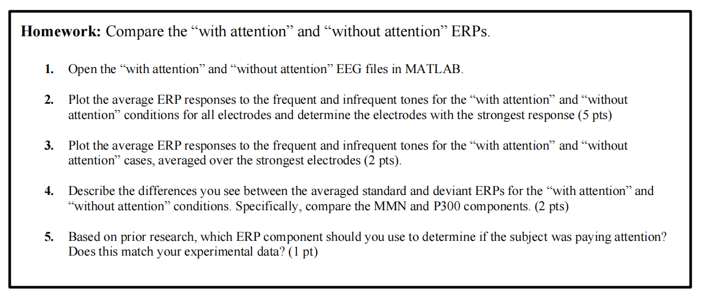
Figure 1. Screenshot of Requirements

Task 2: Plot Average ERP response
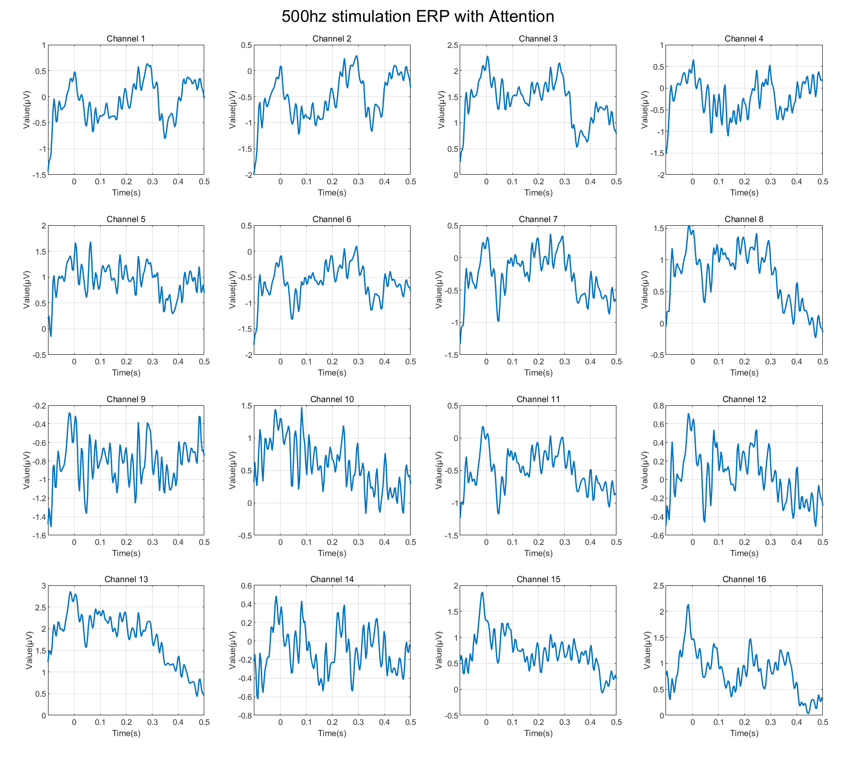
Figure 2. 500hz stimulation ERP with Attention
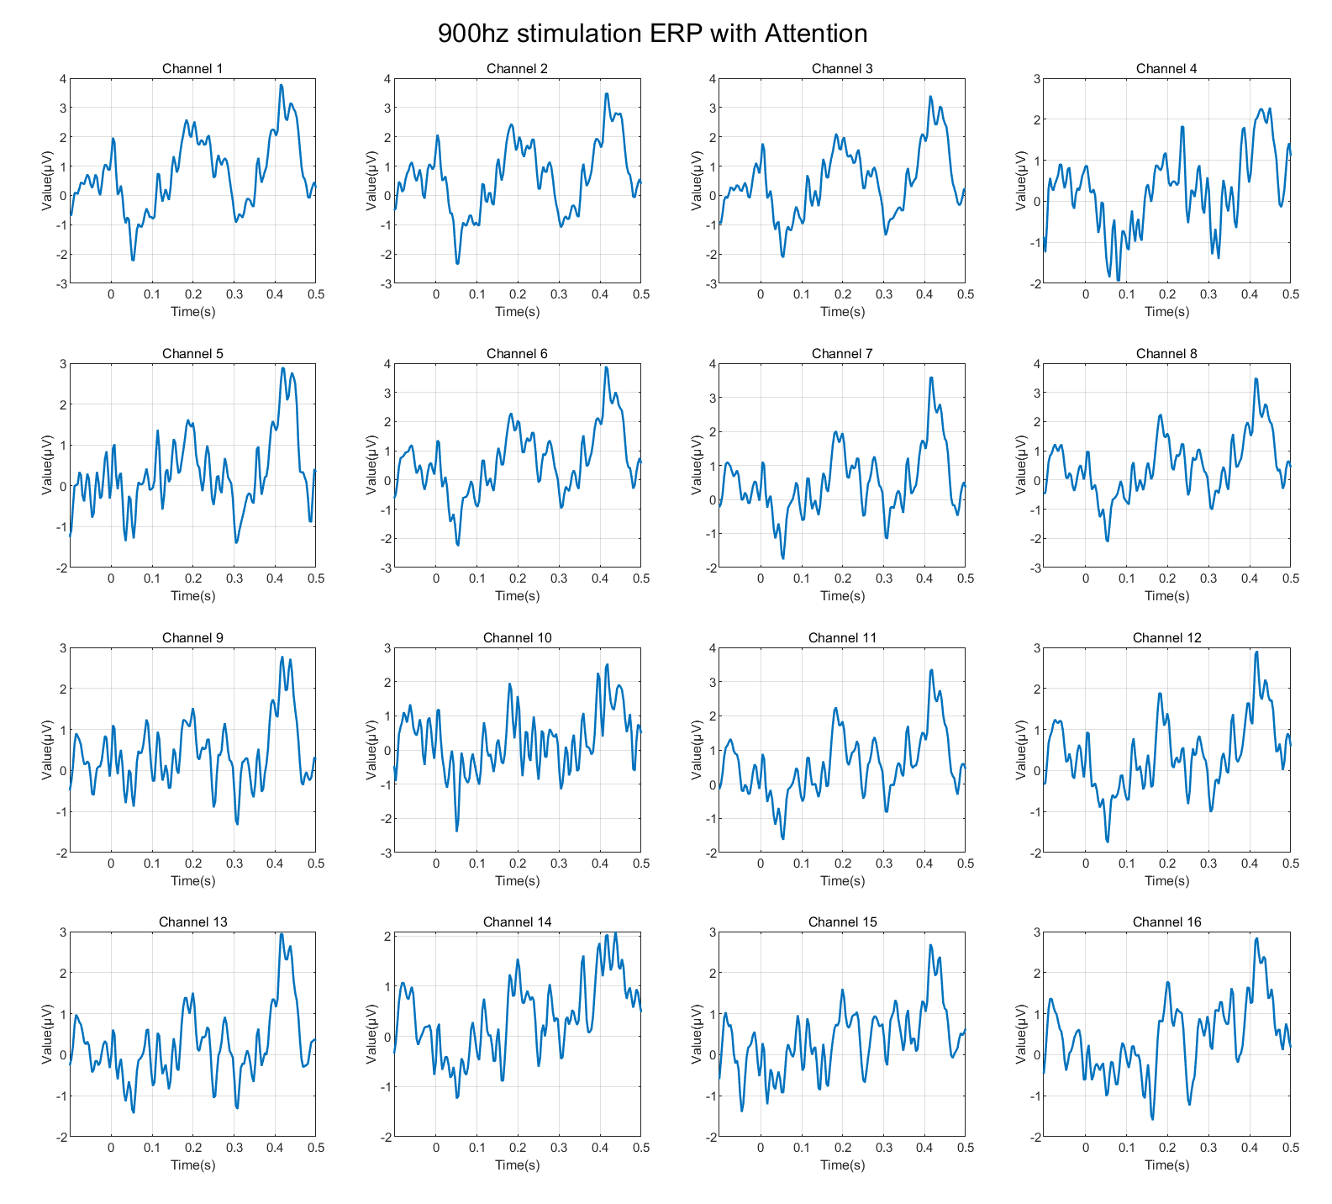
Figure 3. 900hz stimulation ERP with Attention
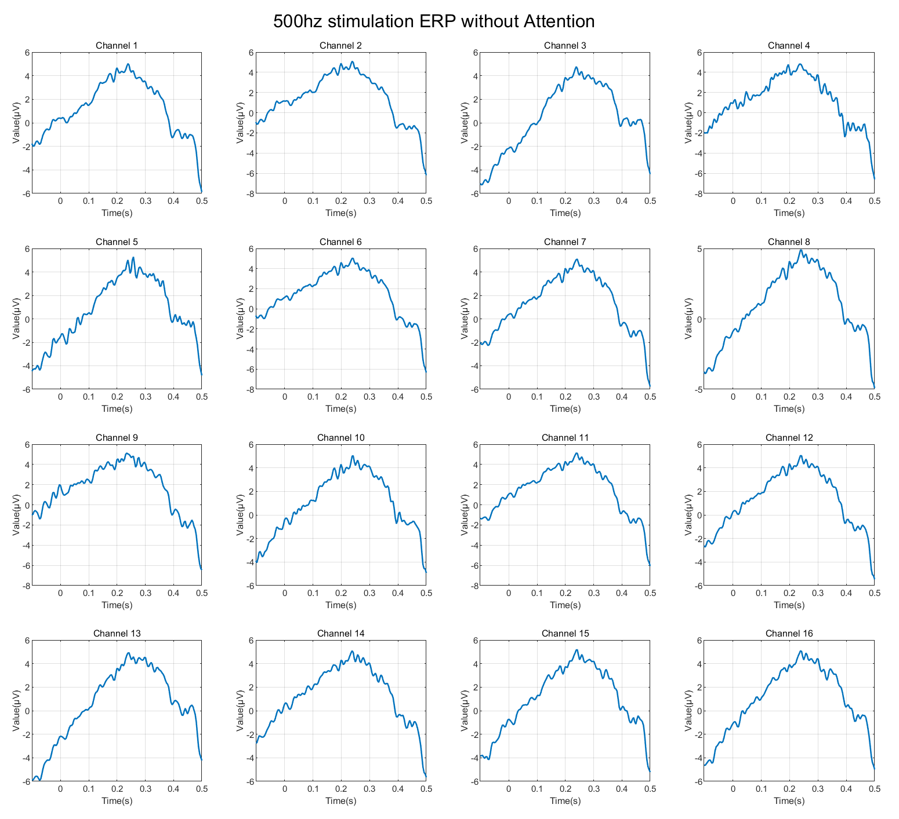
Figure 4. 500hz stimulation ERP without Attention
(The quality is bad and a further discussion will be provided later in this chapter)
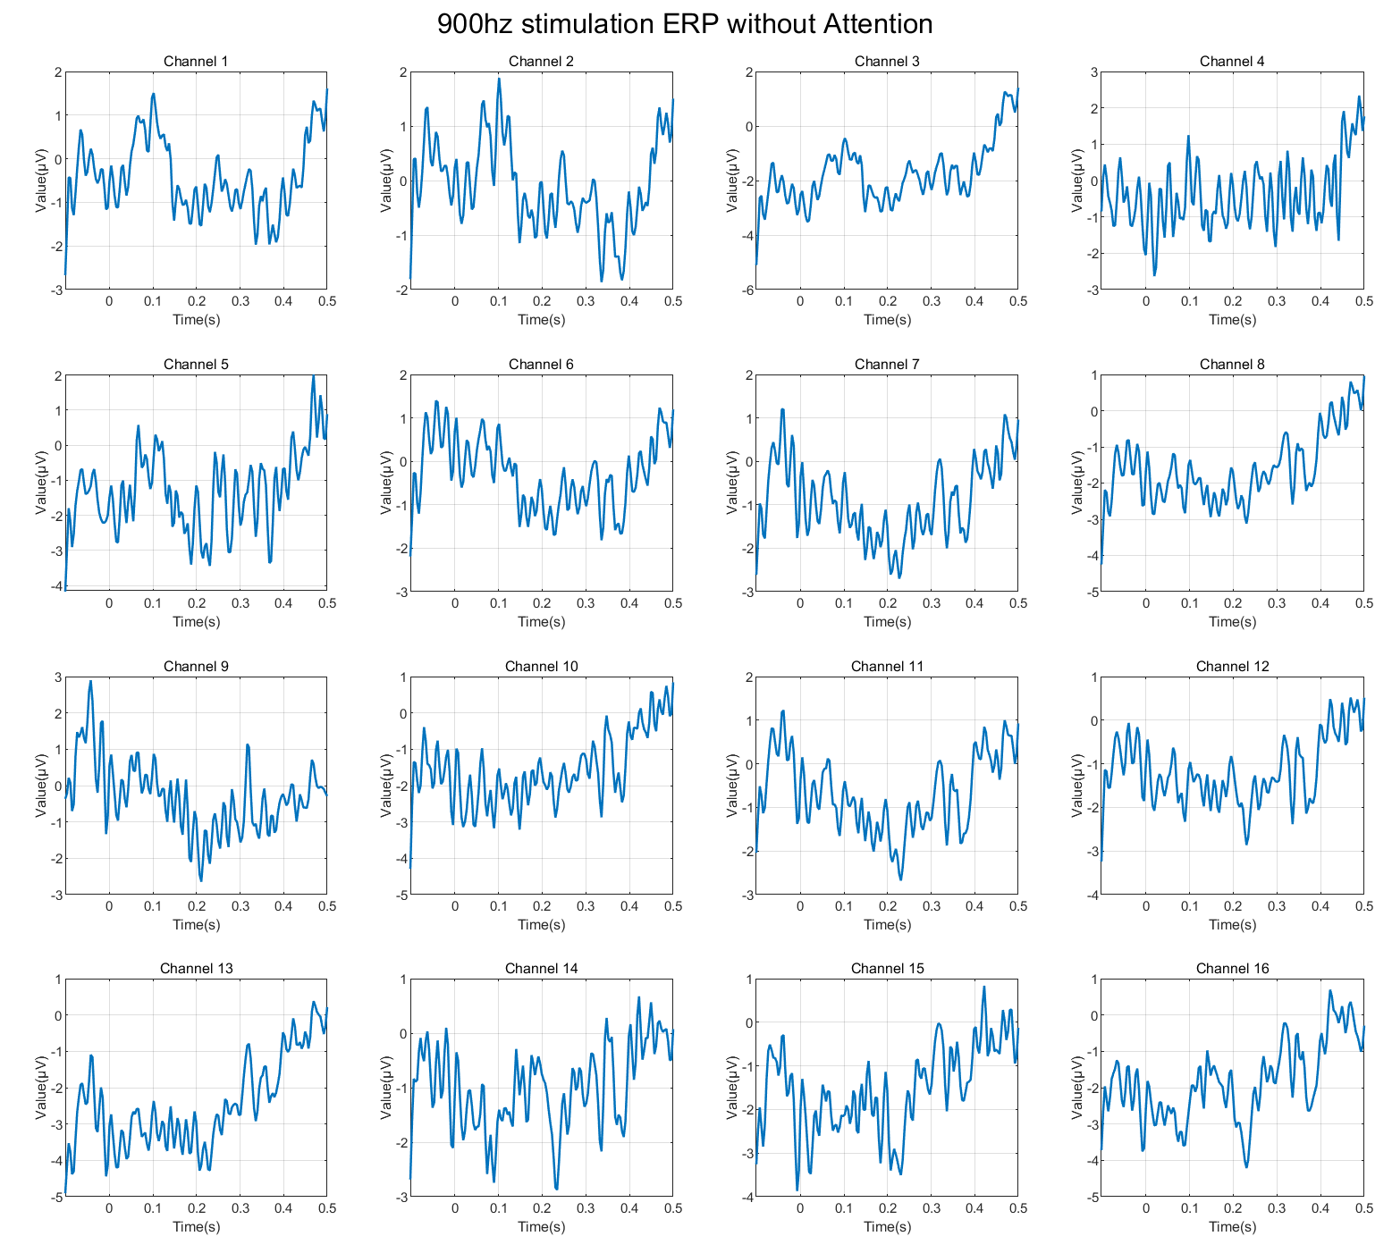
Figure 5. 900hz stimulation ERP without Attention
According to Figure 3, it is evident that Channels 6 and 11 exhibit the strongest responses to infrequent tones. The comparisons between the standard ERP responses and the signals from Channels 6 and 11 are shown in Figures 6 and 7 (the x- and y-axis labels have been aligned).
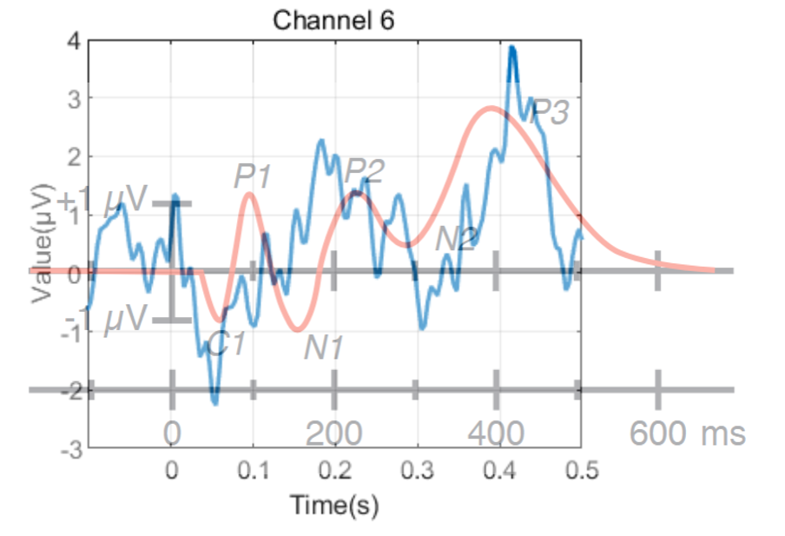
Figure 6. Standard ERP vs. Signals in Channel 6
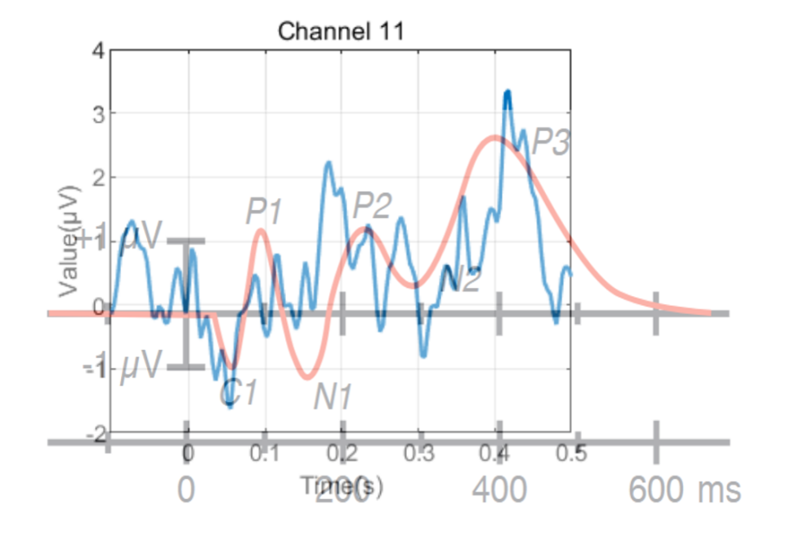
Figure 7. Standard ERP vs. Signals in Channel 11
The signal in Figure 4 appears very unusual and highly similar, which differs from typical EEG signals. This may be due to the introduction of noise and artifacts. Besides, the problem may also lie in artifacts caused by the subject (myself), who coughed and swallowed saliva multiple times during the experiment, potentially leading to significant EMG artifacts. In addition, frequent blinking during the test may have caused EOG artifacts.
Thus, I tried to utilize ICA to detect and remove the artifacts and only extracted the middle segment (remove the first 3000 sample points in each channel) of the signal for the ERP detection. Here are the results:
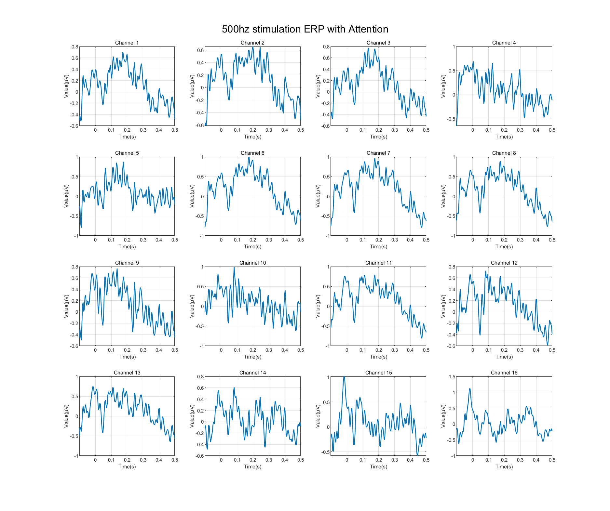
Figure 8. 500hz stimulation ERP with Attention (After ICA)
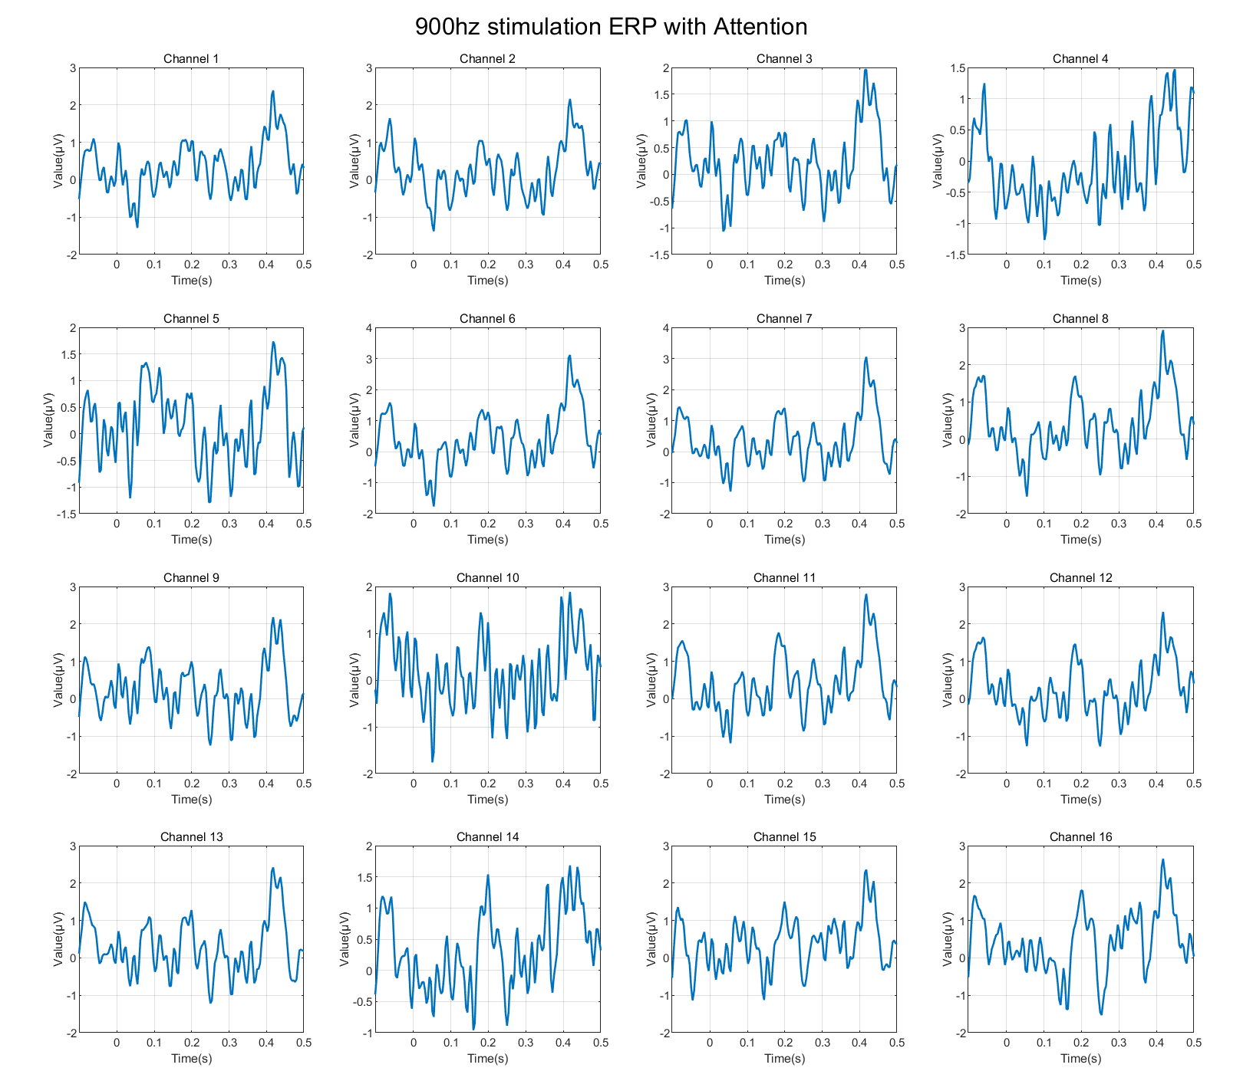
Figure 9. 900hz stimulation ERP with Attention (After ICA)
Figure 10. 500hz stimulation ERP without Attention (After ICA)
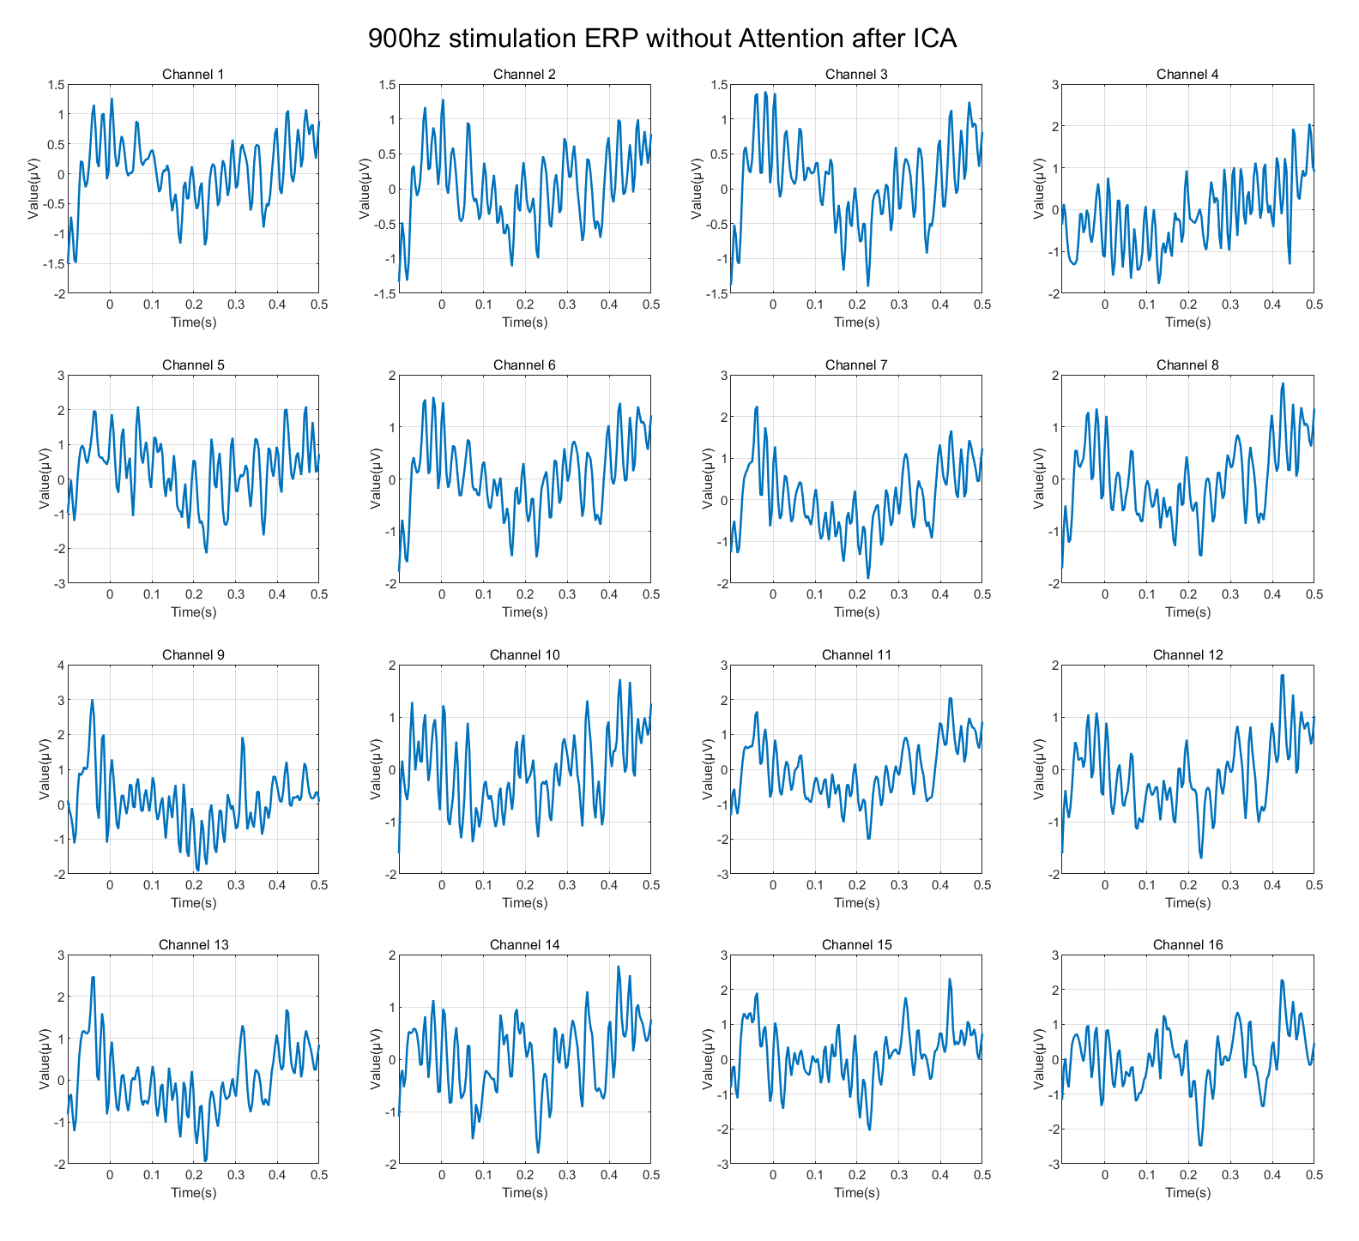
Figure 11. 500hz stimulation ERP without Attention (After ICA)
Task 3: Plot the average ERP responses over the strongest electrodes
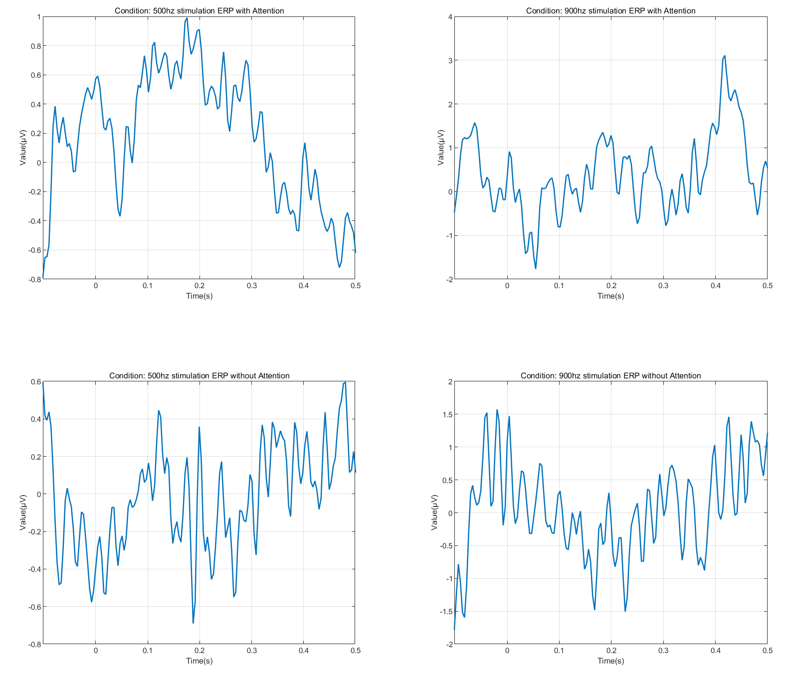
Figure 12. The Average ERP Responses over Channel 6 (Cz)
Figures 12 illustrates the averaged ERP responses under different experimental conditions. Each subplot corresponds to a specific combination of stimulus frequency (500 Hz or 900 Hz) and attention state (with or without attention). The two subplots on the top show the ERP responses when the subject was fully attentive to the experiment, whereas the subplots on the bottom display the responses recorded without attention. In addition, the subplots on the left represent the responses to the standard stimulation (500 Hz), while those on the right depict the responses to the deviant stimulation (900 Hz).

Task 4: Describe the differences between standard and deviant ERP
Figures 13 illustrates the comparison about ERP responses under different stimulation condition. The figure the left represents that the subject was fully attentive to the test while the one on the right means the non-attentive experimental condition. Red lines depict ERP responses of deviant stimulation while blue lines display ERP responses of regular stimulation.
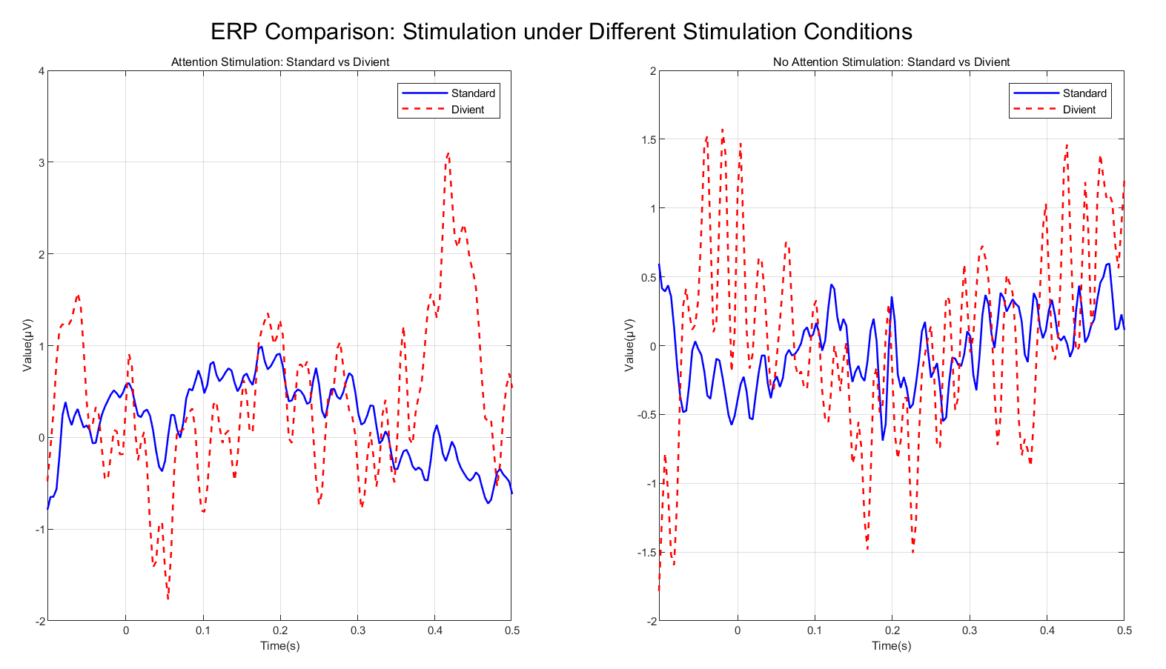
Figure 13. Comparison of Different Conditions
According to the literature and schematic diagram (Figure14), the mismatch negativity (MMN) refers to a negative deflection observed when an occasional deviant stimulus appears within a sequence of repetitive standard stimuli. The MMN typically occurs within 50 ms after the onset of the deviant stimulus, with a peak latency between 100 and 250 ms, and is most prominent at the midline of the central scalp area. Since the deviant stimulus occurs infrequently and differs only slightly from the standard stimulus, it is considered a variation of the standard stimulus within the series of standard and deviant stimuli. Therefore, this component is referred to as the MMN.
The P300 is a positive wave that appears approximately 300 ms after the presentation of a deviant stimulus. It is elicited by infrequent deviant stimuli that randomly occur among standard stimuli, reflecting the brain’s process of detecting these differences.
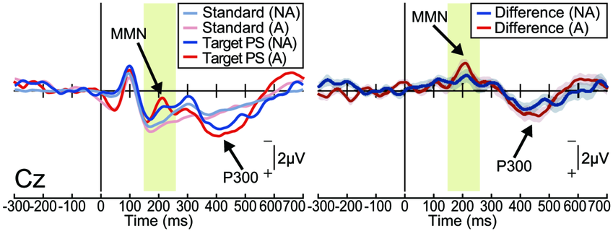
Figure 14. MMN vs. P300 (Note: The waveform is inverted.)
As shown in Figure 15, clear P300 and MMN components emerge approximately 300 ms and 200 ms after the stimulus under the attentive condition. In contrast, the waveform obtained under the non-attentive condition appears highly irregular, with no distinct components observed.
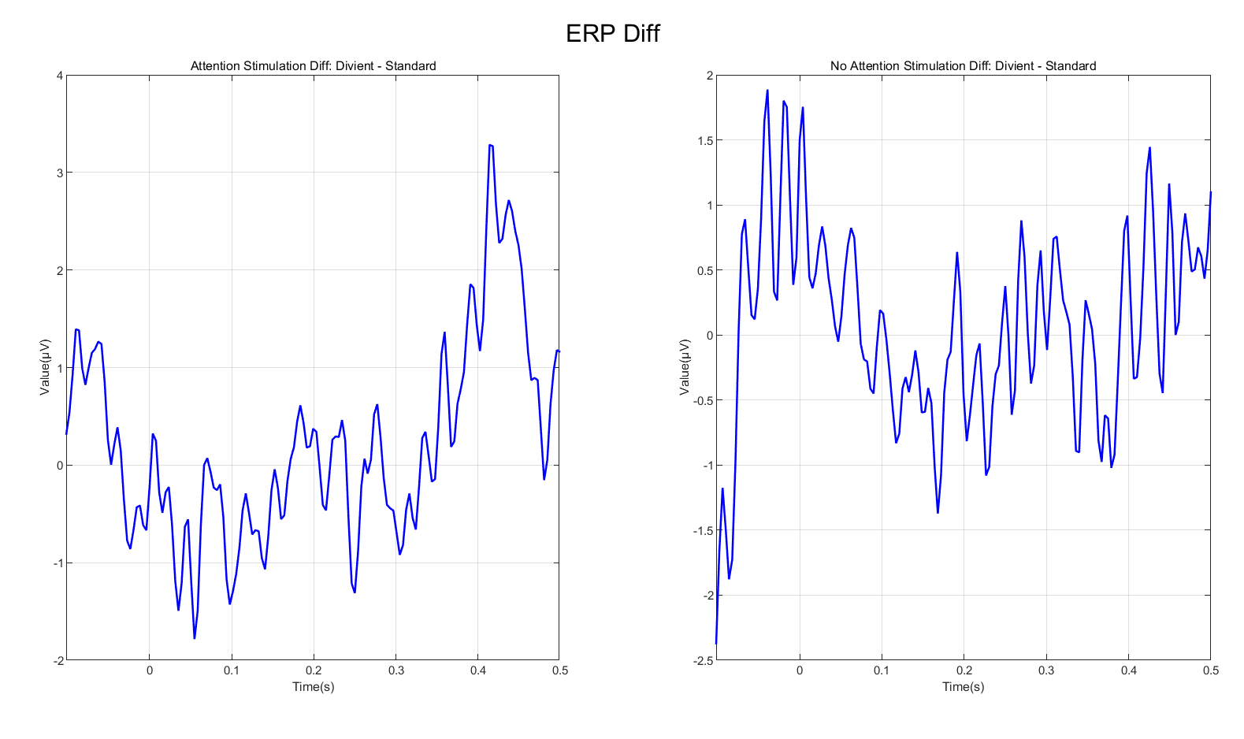
Figure 15. Differences between standard and deviant ERP
（Left - Attention, Right - No Attention)
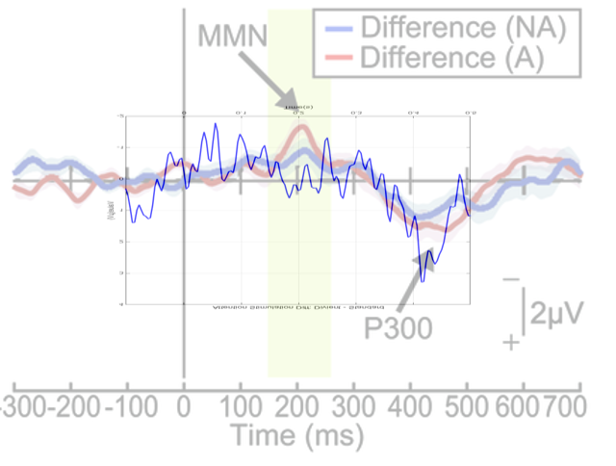
Figure 16. Differences between standard and my MMN and P300
(the x- and y-axis labels have been aligned).

Task 5: Conclusion
P300 component should be used to determine whether the subject was paying attention. In my experimental data, the P300 component is clearly visible under the “with attention” condition, but absent or much smaller under the “without attention” condition, which matches the expected result from prior research.

