Homework 1

Information

Name | UNI
Zhewen Guo | zg2567

Goals
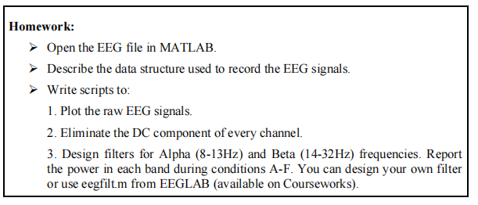
Figure 1. Screenshot of Requirements

Task 1 & 2: Open the EEG file in MATLAB & Describe the data structure used to record the EEG signals
To load the EEG file in Matlab , I use load('Lab2_Experiment1.mat') to get access of P_C_S, which is a well-structured data including 91 significant fields in the EEG data structure (Refer to Appendix 1 for details).
Among all the fields it contains, we should particularly focus on P_C_S.data, which contains EEG signals from all activated channels during the measurement. P_C_S.samplingfrequency is also important, as it records the sampling rate of the experiment and helps in constructing the time axis for subsequent processing.
Following codes could be used to check the structure of the core signal data.
>> signal_data = P_C_S.data;
>> disp(['Data Dimension: ', num2str(size(signal_data))]);

Data Dimension: 1 49312 4

Task 3: Write scripts
Step 1: Plot the raw EEG signals
The EEG signals could be simply drawn utilizing the plot(time, data) function. (Refer to Appendix 2 for full codes).
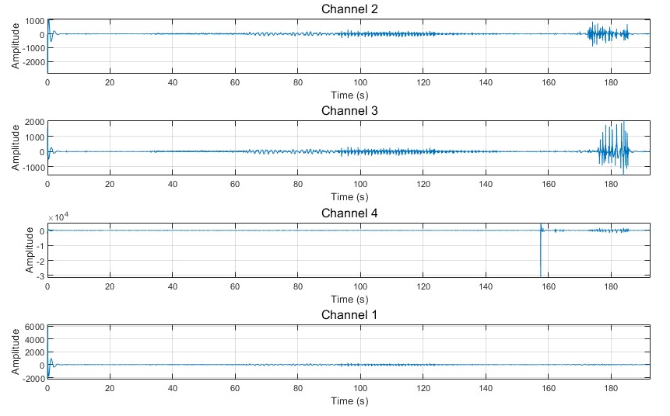
Figure 2. Plot the raw EEG signals

Step 2: Eliminate the DC component of every channel
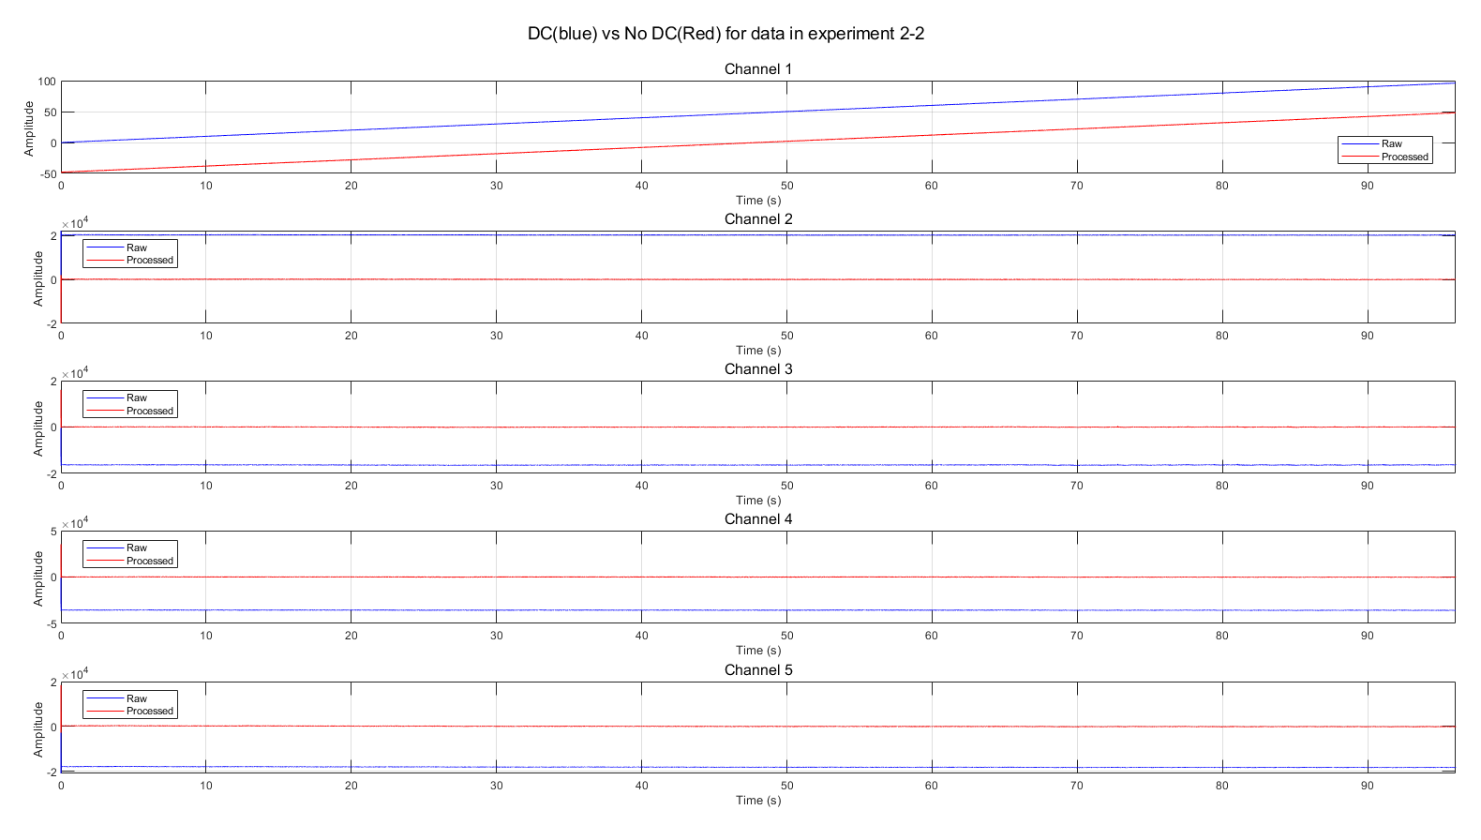
Figure 3. Eliminate the DC component of every channel

In order to remove the DC component from each channel, we should subtract the mean value of each channel from the signal. This works due to the idea of Fourier transform in which a signal with no DC component has a zero mean.
However, I notice that data from experiment 1 does not have DC component, since a band-pass filter at 0.5Hz to 60Hz has been applied during the measurement. Thus I choose to pick data from experiment 2-2 (switch off the notch and band-pass filter for all channels) to demonstrate the result of DC elimination (Refer to Appendix 3 for full codes).
From figure 3, we could observe that processed signals (red) satisfy x-axis symmetry after removing the DC component, while raw signals (blue) tend to exhibit obvious offsets.

Step 3: Design filters for Alpha (8-13Hz) and Beta (14-32Hz) frequencies.
Since I have already captured the digital signal of the EEG signals, I decide to utilize FFT to convert the time-domain EEG signal into the frequency domain. Specifically, I only retain the component at target frequency band and simply remove all the other component. The processed signal is then reconstructed via the inverse Fourier transform (Refer to Appendix 4 for self-defined filter for digital signal).
Here are the spectrum plots of filters for alpha wave (Figure 4) and beta wave (Figure 5). It is obvious that the filter solely retains signals at target frequency band (8-13 Hz) when dealing with alpha wave. While for beta wave, the band-pass frequency is 14-32 Hz.
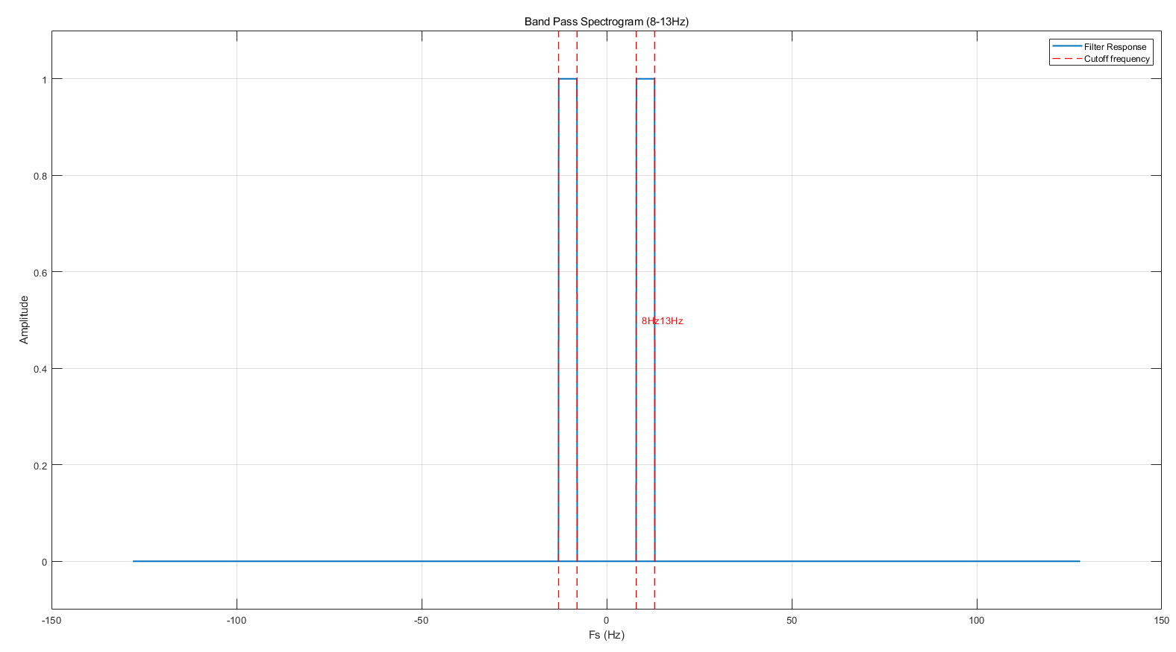
Figure 4. Band-pass Filter for Alpha Wave

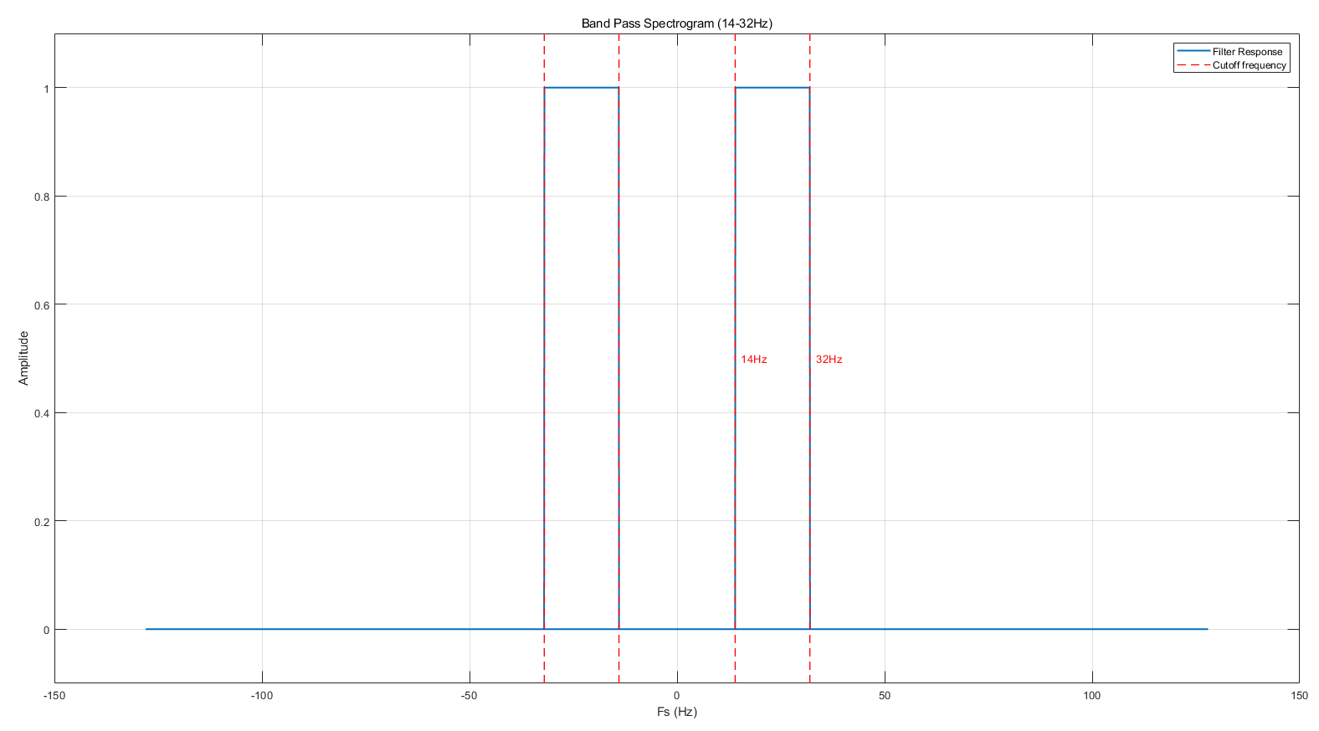
Figure 5. Band-pass Filter for Beta Wave
I apply the filter to all six conditions of the subject, and here are the results.
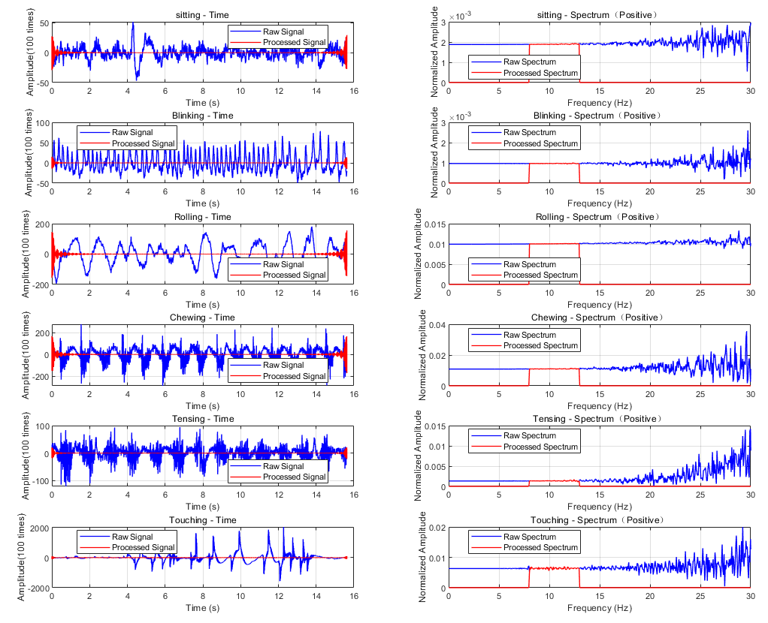
Figure 6. Alpha Wave in all 6 conditions
Figure 6 shows the time-domain signals and spectrum plots of all six conditions (sitting silently, blinking, rolling eyes, chewing, tensing neck and touching the electrodes). The graphs on the left exhibit the original signals (blue) and filtered signals (red) scaled up by a factor of 100. On the right, there are six spectrum plots showing the FFT results of each test. Similarly, blue lines show raw spectrum while the red show filtered spectrum.
From the graphs on the left (time-domain signals), even though the processed signal was amplified by a factor of 100, it is still difficult to observe the alpha wave. The reason is simple and clear according to the graphs on the right, the amplitude of the alpha wave is naturally smaller than that of the higher-frequency components.
However, the question remains as to why it is so difficult for us to detect alpha waves in this test. According to the literature, it is known that alpha waves are strongest during eyes-closed resting states and are significantly reduced when the eyes are open or attention is focused. This explains why the alpha wave component observed in the condition B-F was relatively low. As for the condition A, when the subject was sitting silently, it is still hard for us to recognize any alpha wave, which may have been due to the noisy experimental environment.

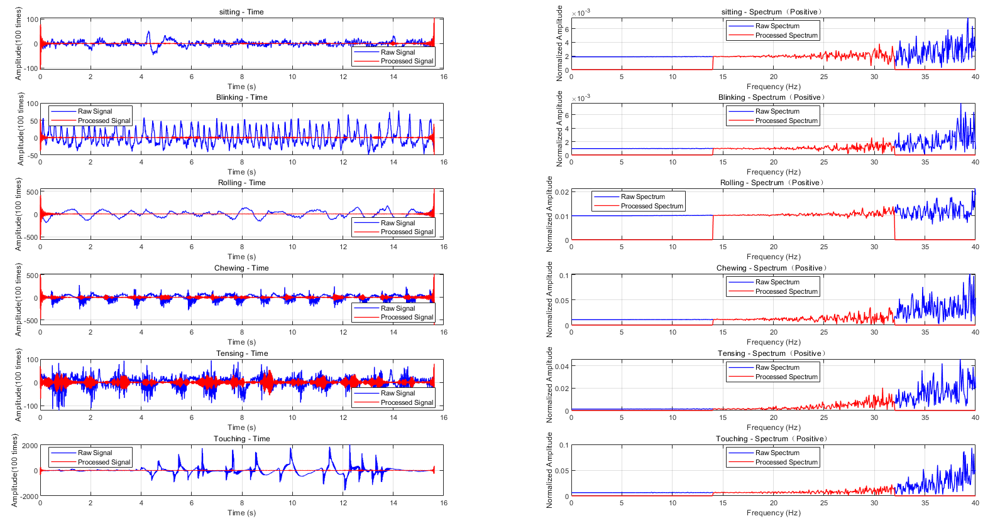
Figure 7. Beta Wave in all 6 conditions
The results shown in Figure 7 are markedly different, as apparent beta waves are detected when the subject is chewing and tensing the neck muscles. From the spectrum plots, it is clear that the signals contain more components of beta waves than alpha waves, which explains why the filtered signals appear more prominent in this test.
However, why are the results of chewing and tensing much clearer than others? By definition, beta waves are usually related to clear consciousness, focused attention, active thinking, and alertness. They are also linked to states of anxiety, tension, or excitement. Some other materials show that beta waves are also associated with the preparation, maintenance and termination of movement. Muscle control is a intensive movement demanding concentration and active thinking, which may explain the question. Besides, the main frequency range of MEG signals lies between 20 and 100 Hz. Thus, the results may partly be attributed to the properties of MEG.

Step 4: Report the power in each band during conditions A-F.
To quantify the specific proportion of alpha wave and beta wave, I calculate the power in each band based on the formula:
$$P = {\sum{{\left|x\left[n\right]\right|}^{2}}}/N$$
P is the average power of the digital signal, calculated as the sum of the squared magnitudes of all N samples, divided by the number of samples N.
Due to the significant distortion that occurs on both sides of the digital signal after IFFT caused by Spectral Truncation and Boundary Effects, only the stable part of the signal is intercepted here for calculation. Here are the results:

Condition | Power of Alpha Wave | Power of Beta Wave
Sitting | 0.000007 | 0.000129
Blinking | 0.000002 | 0.000154
Rolling | 0.000203 | 0.000610
Chewing | 0.000247 | 0.037455
Tensing | 0.000006 | 0.011831
Touching | 0.000111 | 0.018463
Figure 8. Power of stable signals

Appendix 1:
>> disp(fieldnames(P_C_S));

{'version' }
{'channels' }
{'channelname' }
{'lowpass' }
{'highpass' }
{'notch' }
{'unit' }
{'numberchannels' }
{'amplifiername' }
{'sens' }
{'data' }
{'samplingfrequency' }
{'subjectlastname' }
{'subjectfirstname' }
{'subjectid' }
{'subjectbirthday' }
{'subjectdiagnosis' }
{'subjectmedication' }
{'subjectcomment' }
{'subjecthand' }
{'subjectsex' }
{'subjectage' }
{'companyname' }
{'companyinstitute' }
{'companydepartment' }
{'companyinvestigator' }
{'companyoperator' }
{'companycopyright' }
{'companyyear' }
{'companylogo' }
{'sessionnumber' }
{'sessiontime' }
{'sessiondate' }
{'sessionstudyname' }
{'sessioncomment' }
{'paradigmname' }
{'paradigmrun' }
{'paradigmcondition' }
{'paradigmisi' }
{'paradigmcomment' }
{'paradigminfo' }
{'daqboard' }

{'daqresolution' }
{'daqboardname' }
{'daqchannels' }
{'daqsamplingfrequency' }
{'physicalvalue' }
{'matlabvalue' }
{'channeltype' }
{'attribute' }
{'attributename' }
{'attributecolor' }
{'marker' }
{'markername' }
{'markercolor' }
{'channelattribute' }
{'channelattributename' }
{'channelattributecolor'}
{'filename' }
{'videofile' }
{'workdata' }
{'trialnumber' }
{'pretrigger' }
{'posttrigger' }
{'xposition' }
{'yposition' }
{'zposition' }
{'montagename' }
{'trialexclude' }
{'channelexclude' }
{'channelscaling' }
{'positivenegative' }
{'displayseconds' }
{'displaychannels' }
{'displaytrials' }
{'gotosecond' }
{'gotochannel' }
{'gototrial' }
{'physicalunit' }
{'scalingsens' }
{'scalingunit' }
{'epochingselect' }
{'epochingname' }
{'epochingcolor' }
{'analizingdata' }
{'editcommentnumber' }
{'comment' }

{'vruler_value1' }
{'vruler_value2' }
{'hruler_value1' }
{'hruler_value2' }

Appendix 2:
eeg_data = P_C_S.data;
fs = P_C_S.samplingfrequency;
num_channels = size(eeg_data, 3);
% recreate time based on the sample and fs
time = (0 : size(eeg_data, 2)-1) / fs;

figure('Name', 'Raw EEG Signals', 'Position', [100 100 1000 600]);

for i = 1 : num_channels
% create image for each channel
subplot(num_channels, 1, i);
plot(time, squeeze(eeg_data(1, :, i)));
title(['Channel ' num2str(P_C_S.channels(i))], 'FontSize', 12);
xlabel('Time (s)', 'FontSize', 10);
ylabel('Amplitude', 'FontSize', 10);
grid on;
box on;
xlim([time(1) time(end)]);
end

figure('Name', 'Raw EEG Signals sample point based', 'Position', [100 100 1000 600]);

for i = 1 : num_channels
% create image for each channel
subplot(num_channels, 1, i);
sample_size = (0:size(eeg_data, 2)-1);
plot(sample_size, squeeze(eeg_data(1, :, i)));
title(['Channel ' num2str(P_C_S.channels(i))], 'FontSize', 12);
xlabel('Time (s)', 'FontSize', 10);
ylabel('Amplitude', 'FontSize', 10);
grid on;
box on;
xlim([time(1) time(end)]);
end

Appendix 3:
load('Lab2_Experiment 2_2.mat');
eeg_data = P_C_S.data;
[num_trails, num_samples, num_channels] = size(eeg_data);
eeg_data_dc_removed = eeg_data;
for i = 1:num_trails
for j = 1:num_channels
single_data = squeeze(eeg_data(i, :, j));
dc_component = mean(single_data);
eeg_data_dc_removed(i, :, j) = single_data - dc_component;
end
end

% save processed data
P_C_S_dc_removed = P_C_S;
P_C_S_dc_removed.data = eeg_data_dc_removed;
P_C_S_dc_removed.comment = [P_C_S.comment '; DC eliminated'];

fs = P_C_S.samplingfrequency;
time = (0:num_samples-1) / fs;
unit = P_C_S.unit;
disp(P_C_S.data(3));
figure('Name', 'DC(blue) vs No DC(Red)', 'Position', [100 100 1200 200*(num_channels)]);

for j = 1:num_channels
subplot(num_channels, 1, j);
% plot original signals
plot(time, squeeze(eeg_data(1, :, j)), 'b', 'LineWidth', 0.6);
hold on;
% plot processed signals
plot(time, squeeze(eeg_data_dc_removed(1, :, j)), 'r', 'LineWidth', 0.8);
% set labels
title(['Channel ' num2str(P_C_S_dc_removed.channels(j))], 'FontSize', 12);
xlabel('Time (s)', 'FontName', 'Arial', 'FontSize', 10);
ylabel(['Amplitude '], 'FontName', 'Arial', 'FontSize', 10);

legend({'Raw', 'Processed'}, 'FontName', 'Arial', 'FontSize', 8, 'Location', 'best');
grid on;
box on;
xlim([time(1) time(end)]);
hold off;
end

sgtitle('DC(blue) vs No DC(Red) for data in experiment 2-2', 'FontName', 'Arial', 'FontSize', 14);

Appendix 4:
function [x_filtered, f, X, X_filtered] = eegfft_bandpass(x, Fs, f_low, f_high)
N = length(x);
X = fft(x);
f = (0:N-1) * (Fs / N);
f = f - Fs/2;

mask = (abs(f) >= f_low) & (abs(f) <= f_high);
X_filtered = X .* mask;

x_filtered = real(ifft(X_filtered));
end

