Homework 6

Information

Name | UNI
Zhewen Guo | zg2567

Goals
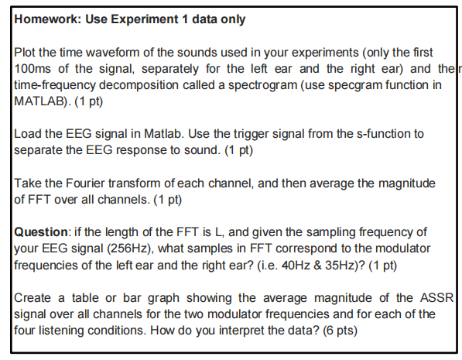
Figure 1. screenshot of requirements

Task 1: Plot the sounds waveform in time and frequency domain
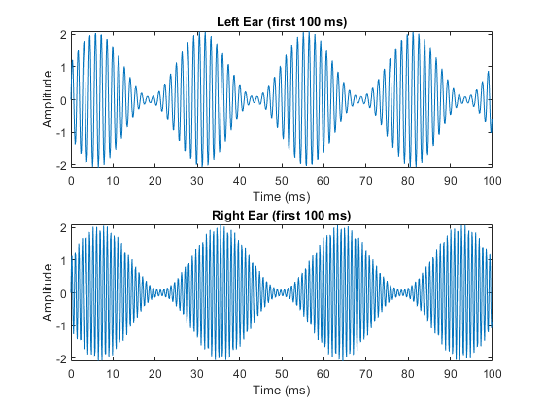
Figure 2. time domain
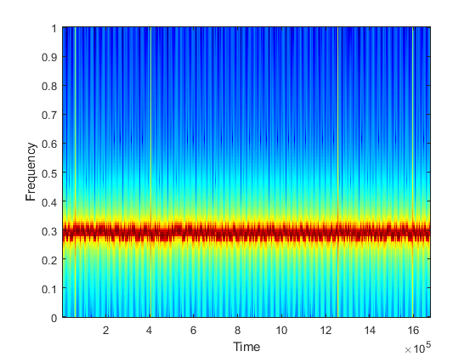
Figure 3. frequency domain

Task 2&3: Separate the EEG response and calculate FFT
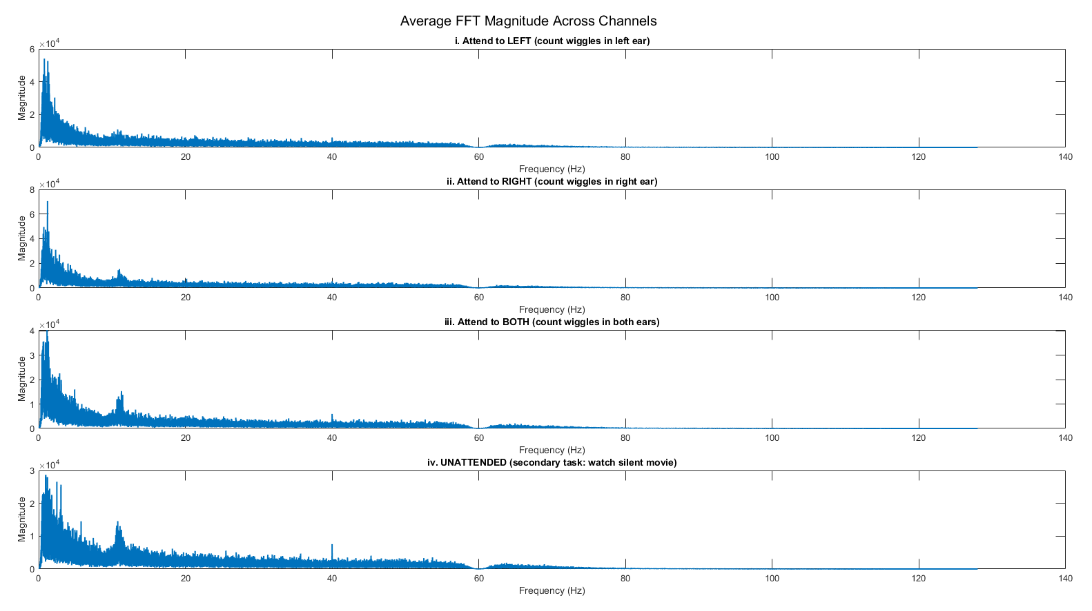
Figure 4. average FFT magnitude across channels

Task 4: Calculation the sample
For an FFT of length L and sampling frequency f_{s} , the sample index k corresponding to a frequency f is:
$$k=\frac{f∙L}{f_{s}}$$
Thus:
$$\left\{\begin{aligned}k_{40}=\frac{5L}{32} \\ k_{35}=\frac{35L}{256}\end{aligned}\right.$$

Task 5: Evaluate the results
According to the Figure 5, the ASSR average magnitude at 40Hz is greater than 35Hz in all attention conditions, because it has been shown that the amplitude of the measured brain signal peaks when the sound is modulated at about 40Hz. However, the expected attentional enhancement effect was not clearly observed. In particular, the unattended condition showed even stronger responses than the attended conditions. This suggests that the neural markers of selective auditory attention may have been masked by background EEG noise or variability in task engagement across trials.
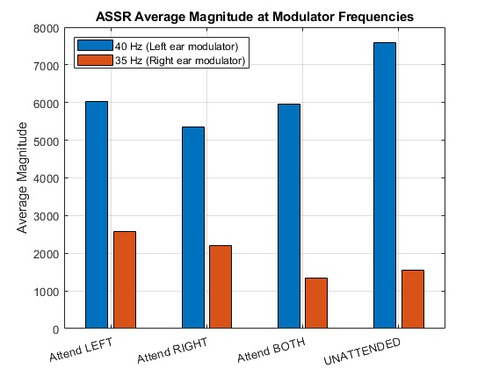
Figure 5. ASSR average magnitude at modulator frequencies

