Homework 7

Information

Name | UNI
Zhewen Guo | zg2567

Goals
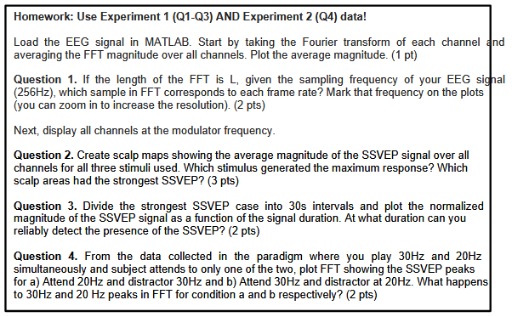
Figure 1. screenshot of requirements

Task 1: Plot the FFT results
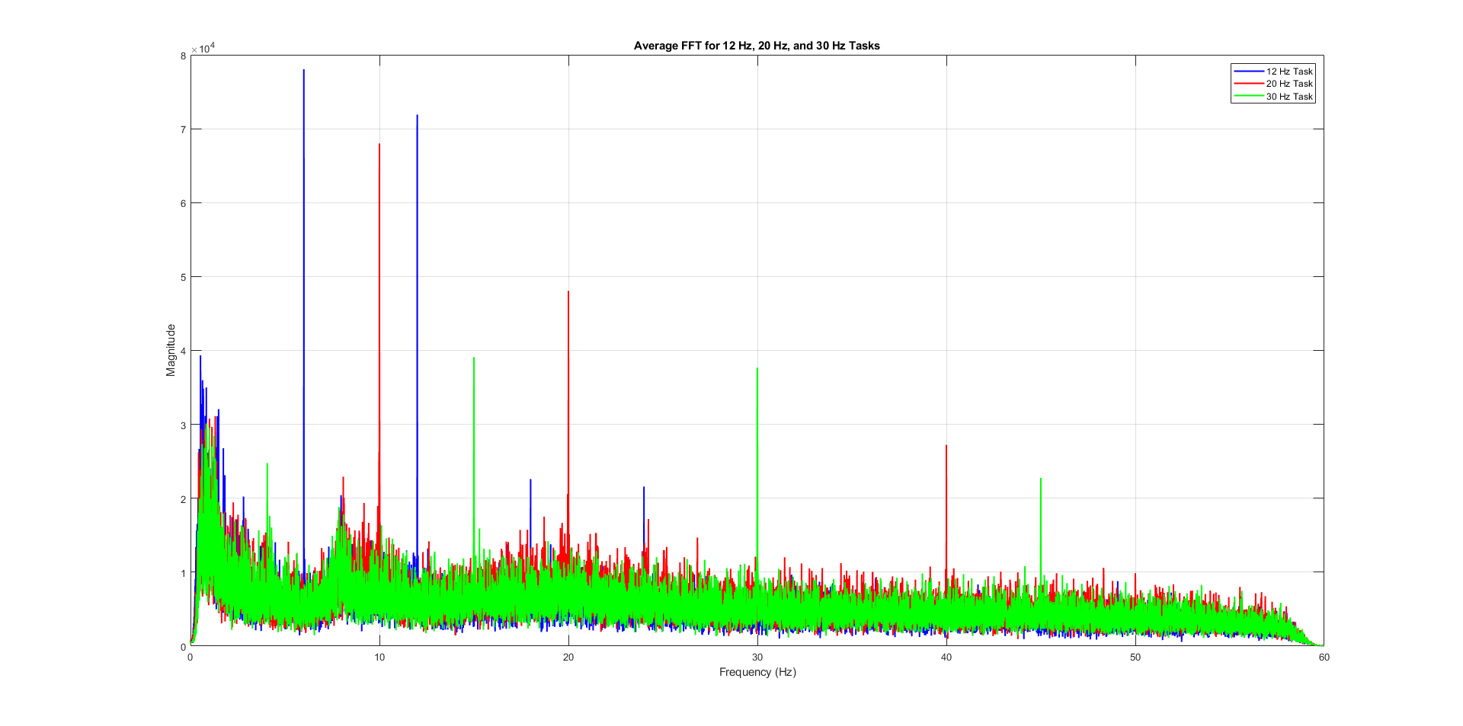
Figure 2. the average FFT magnitude
Task 2: Plot the FFT results
For an FFT of length L and sampling frequency f_{s} , the sample index k corresponding to a frequency f is:
$$k=\frac{f∙L}{f_{s}}$$
Besides, since frame rate 12 means that each frame (black or white) is shown for 1/12 second. Hence the frequency of the visual stimuli (how many full cycles per second) is 6Hz. Thus:
$$\left\{\begin{aligned}k_{12Hz Video}=\frac{3L}{128} \\ k_{20Hz Video}=\frac{5L}{128} \\ k_{30Hz Video}=\frac{15L}{256}\end{aligned}\right.$$

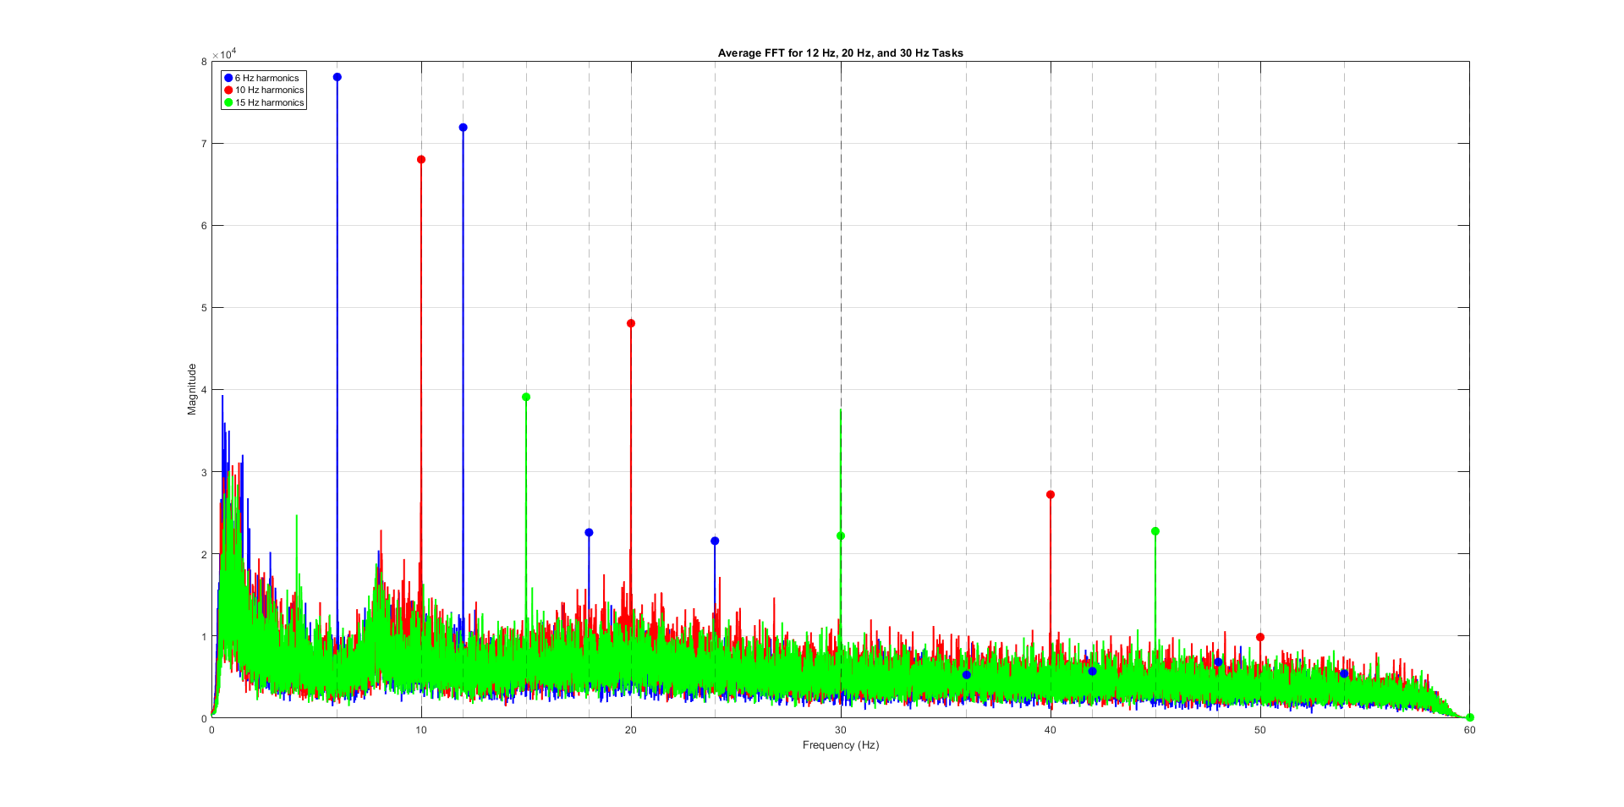
Figure 3. mark target frequency on the plots
Task 3: Separate the EEG response and calculate FFT
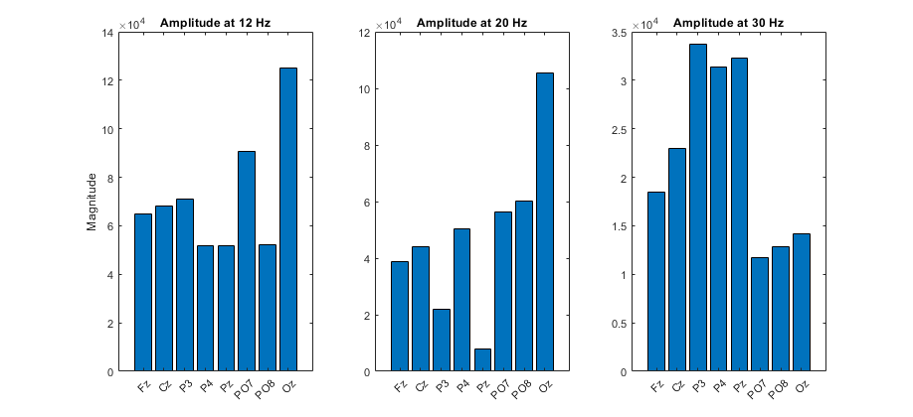
Figure 4. channels at the modulator frequency
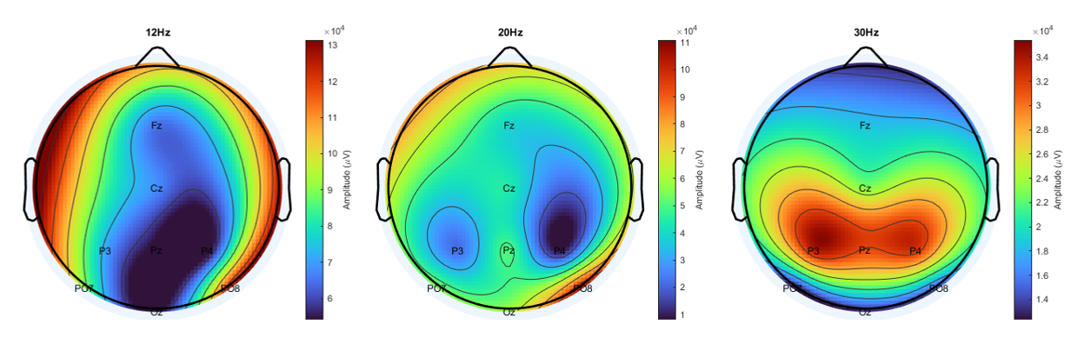
Figure 5. scalp maps of mean SSVEP

According to Figures 4 and 5, Oz exhibits the strongest response at stimulus frequencies of 12 Hz and 20 Hz. However, when the stimulus increases to 30 Hz, the overall responses become higher, with Cz, P3, and P4 showing the strongest SSVEP.

Task 4: Calculation the sample
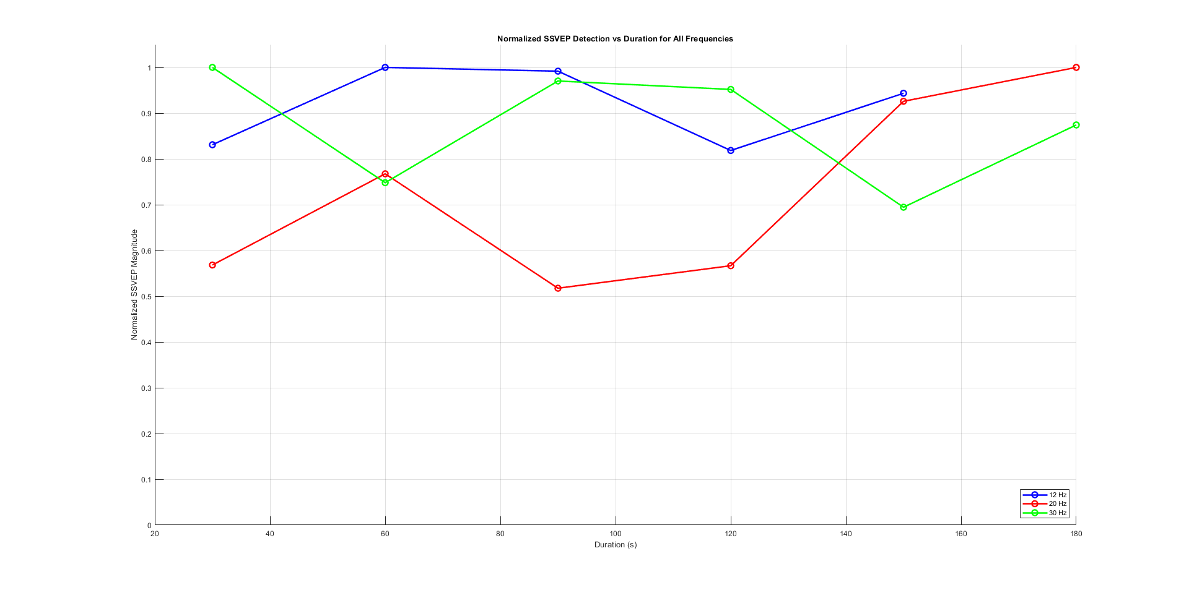
Figure 6. normalized SSVEP detection vs duration for all frequencies
Figure 6 shows the result of normalized SSVEP responses with gradually increased duration. For datasets of 12Hz and 30Hz stimulus, reliable SSVEP is detected when the duration is approximately 60s and for datasets of 20Hz stimulus, it requires 180s of the signal duration.

Task 5: Evaluate the results
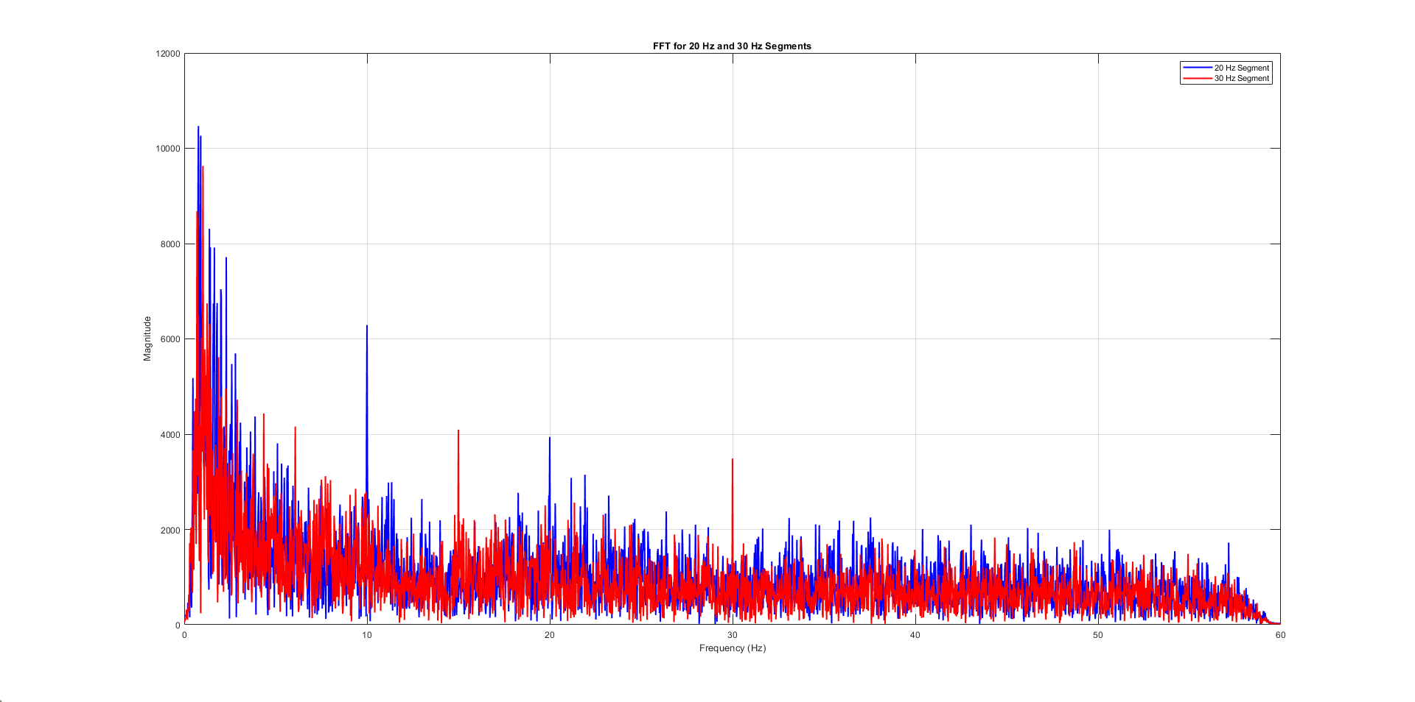
Figure 7. FFT showing the SSVEP peaks of different attention conditions

Figure 7 exhibits the FFT results showing the SSVEP peaks for two different conditions (blue: attend 20Hz and distractor 30Hz and red: attend 30Hz and distractor at 20Hz). It is obvious that when the subject focused on the 20Hz stimulus the 10Hz and 20Hz components remarkably increased while when it concentrated on the 30 Hz stimulus, 15Hz and 30Hz components increased.

