Homework 8

Information

Name | UNI
Zhewen Guo | zg2567

Goals
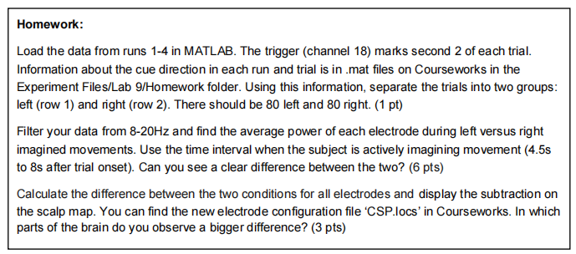
Figure 1. screenshot of requirements

Task 1: Load dataset
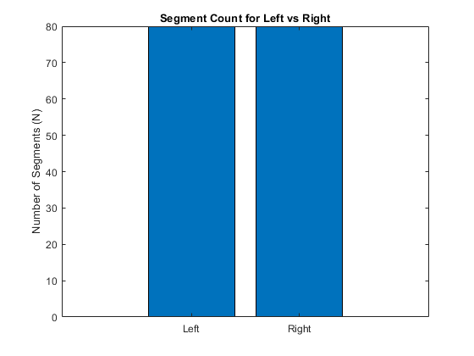
Figure 2. trials separated into 2 parts

Task 2: Average power

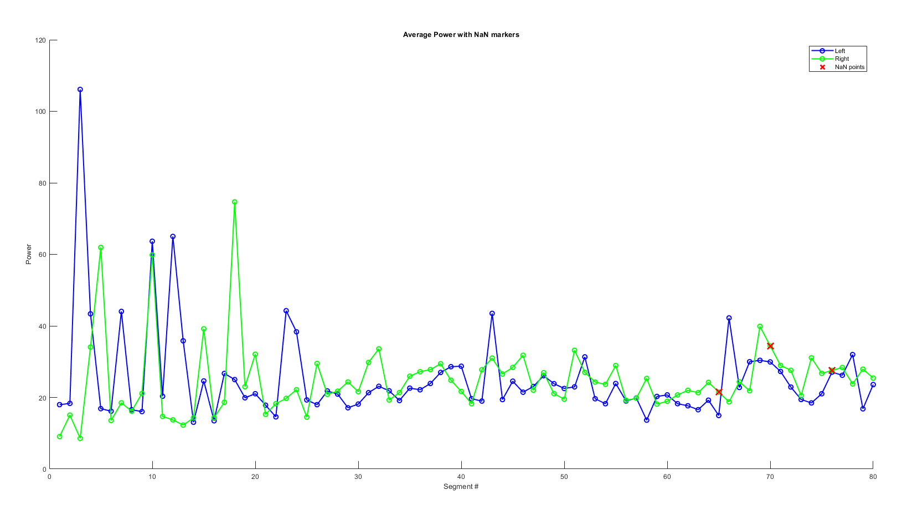
Figure 3. mean power of each electrode
Figure 3 shows the average power of each electrode during left (blue) versus right (green) imagined movement. Since there are multiple abnormal values, I filtered the result with a threshold, removing values greater than 1000 and replacing them with NaN (shown as red cross in the figure). Apparently, there is no clear gap between the two, the mean power of these two categories fluctuate around 20 for most of the trials.

Task 3: Separate the EEG response and calculate FFT
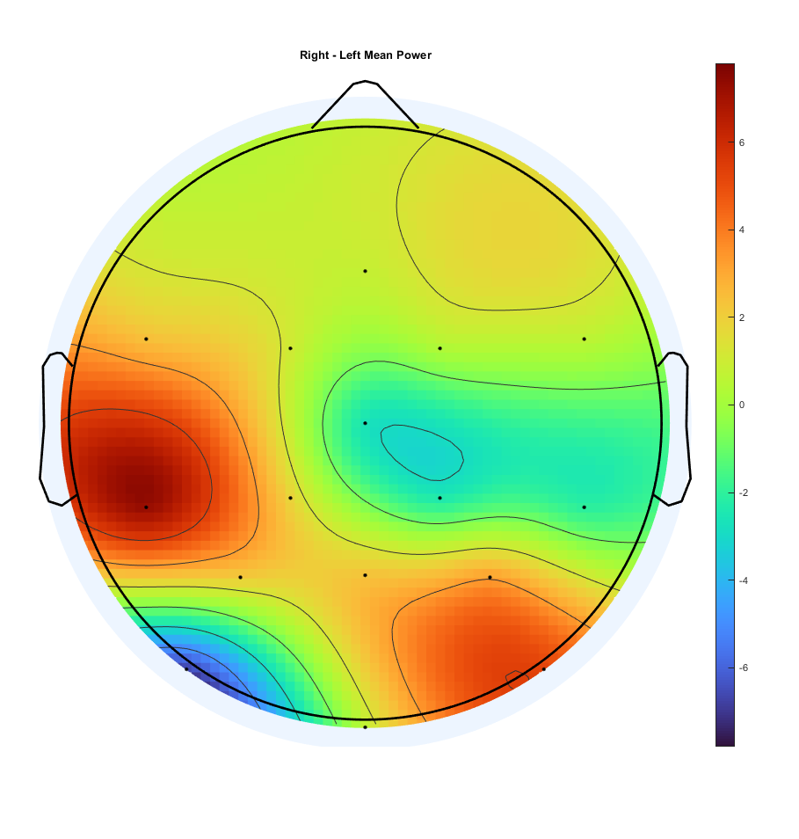
Figure 4. scalp maps of relative power (right - left)

According to Figures 4, relative power (right - left) is greater at the left part of the brain. This pattern occurs because right-hand motor imagery primarily activates the contralateral (left) sensorimotor cortex. As a result, power modulation is stronger over the left hemisphere, leading to higher relative power values (right − left) in that region.

