Mini Project

Information

Name | UNI
Zhewen Guo | zg2567

Introduction
Event related potential (ERP) is a specific pattern of brain responses which reflects how the brain processes a particular stimulus or task. To measure ERP, researchers use scalp electrodes to record the electrical activity of the brain during specific tasks (e.g. counting oddballs). The event or stimulus is time-stamped in the electroencephalography (EEG) data.There are multiple stages of ERP components. In sequence: pre-stimulus preparatory processes (-100 - 0ms), stimulus onset (0ms), C1 (0 -100ms), P1 (approximately 100ms), N1 (100 -200ms), P2 (200 -300ms), N2 (approximately 300ms), P3 (300 -600ms).

P300 is a positive ERP component that occurs approximately 300ms after stimulus onset. It indicates the brain’s evaluation of significant or target events.MMN (N2a) is an ERP component that appears when a deviant stimulus appears among sequence of frequent regular events. The key difference is that a distinct P300 occurs only when the subject is fully attentive, while MMN is a passive and automatic process reflecting pre-attentive detection of unexpected changes.
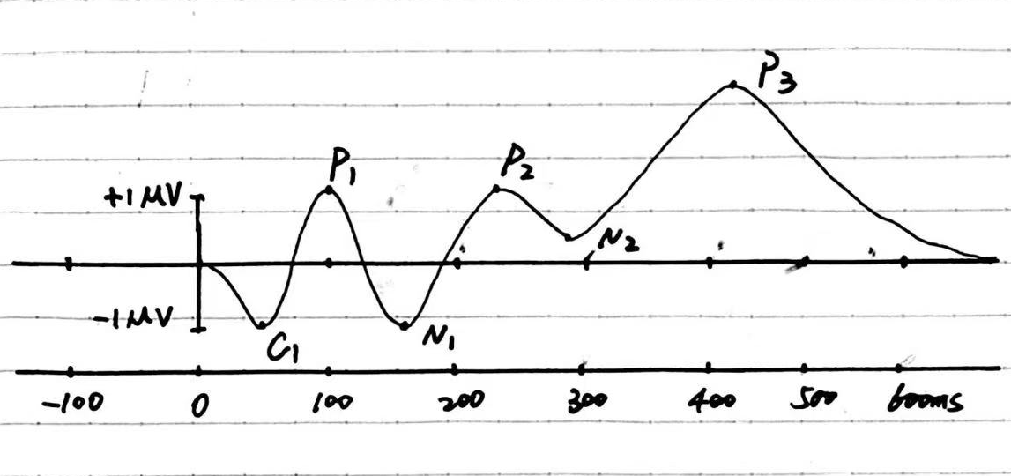
Figure 1. ERP characteristics from Brain Products

Stimuli and Procedure
- To capture target components of EEG data, a band pass filter (0.5-60Hz) is utilized to remove low-frequency (lower than 0.5Hz) and high-frequency (higher than 60Hz) noise. Additionally, a notch filter is used to reduce power line noise caused by alternating current (AC). The cutoff frequency depends on the frequency of AC (60Hz in the United States and 50Hz for nations like China).
- The sampling frequency is 256Hz in this experiment. According to the Nyquist sampling theorem, as long as the sampling frequency is more than twice the highest frequency of the signal (more than 120Hz in this experiment), the original analog signal can be reconstructed without distortion.
- Our experiment includes two trials: the first involves data collected from a subject spelling the 10-letter word ‘Apple Juice’, and the second involves data from the subject spelling the 14-letter word ‘photooxidation’. Each trail contains a training data and a testing data. Besides, for cross-subject analysis, datasets from all groups are collected to train the model.
- After processing the EEG signals, we can manually check each channel and remove periods with wired waveforms. Additionally, if the average ERP signals differ significantly from the standard ERP waveforms, ICA can be applied to remove artifacts and improve the quality of the datasets.
- In this experiment, when a sequence of letters is highlighted on the screen, it is called a "flash". When the sequence includes the target letter, it is called a "target". Channel 10 outputs a non-zero value when there is a ‘flash’. While, channel 11outputs 1 when the interested flash appears.

Part 1. Within-Subject, Cross-Session Analysis
1.1. ERP Response to Target and Non-Target Flashes
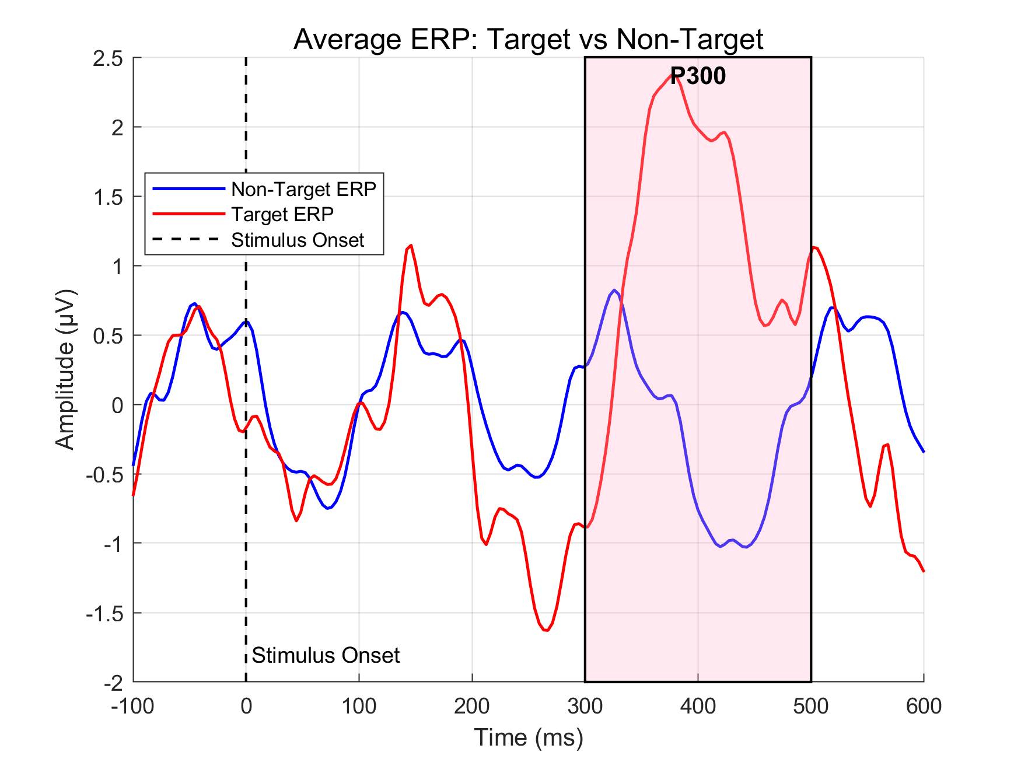
Figure 2. Average ERP over all electrodes from train1.m
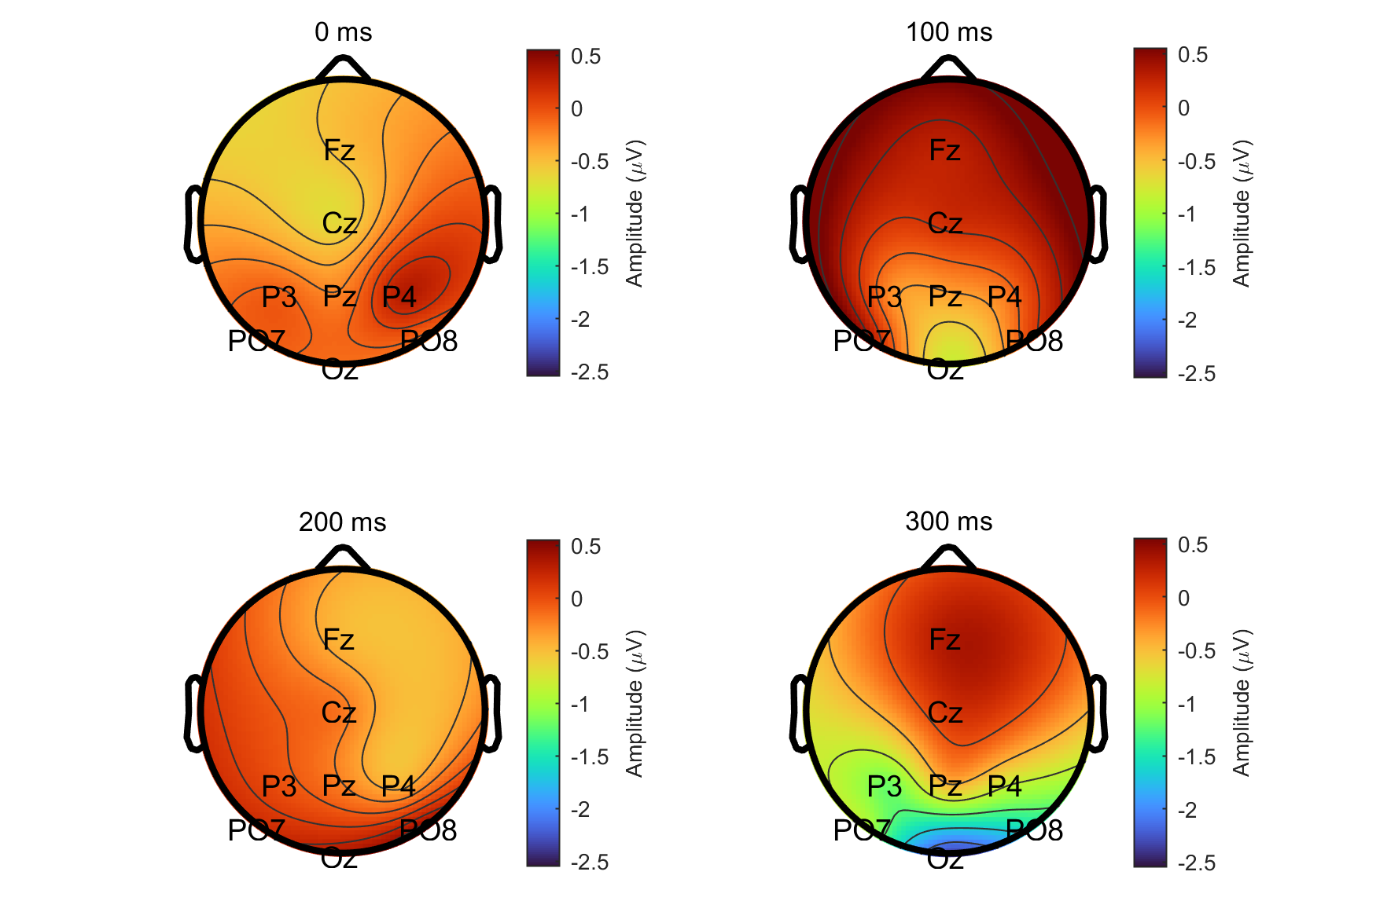
Figure 3. The scalp map of target flash from train1.m
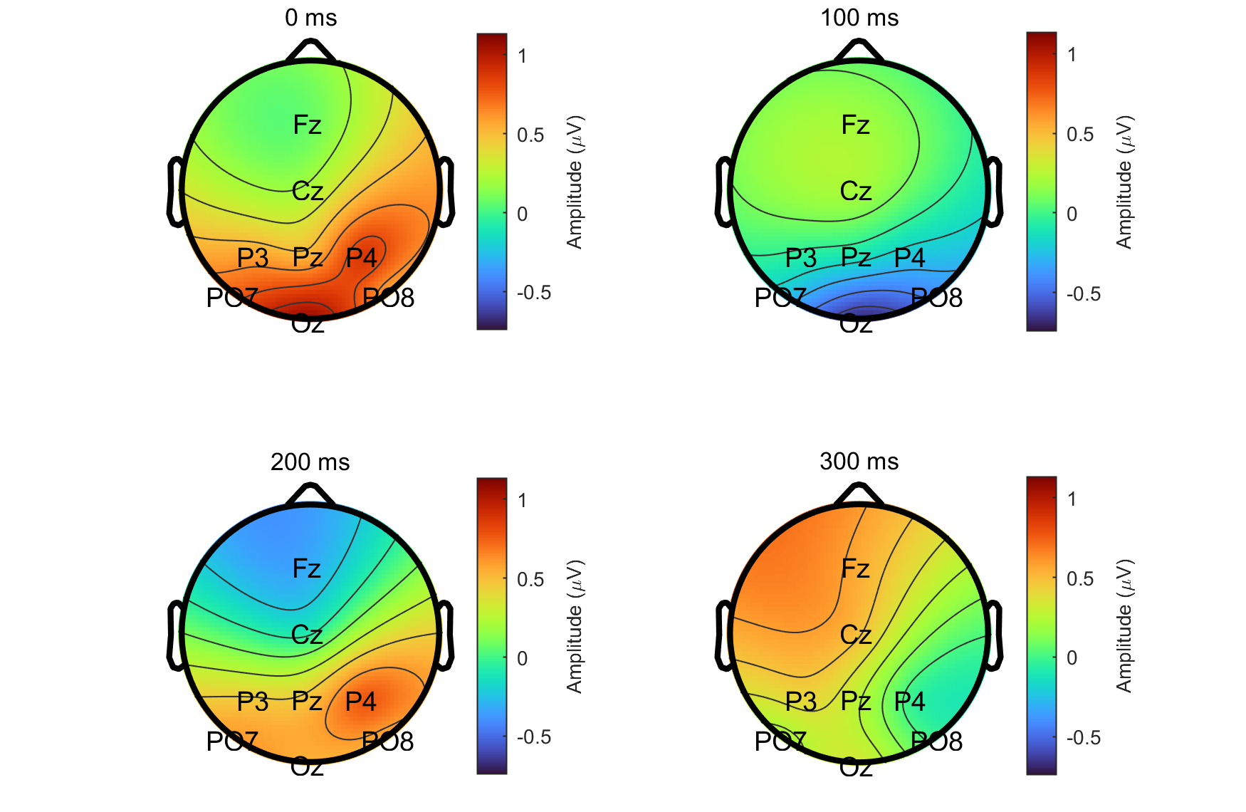
Figure 4. The scalp map of non-target flash from train1.m
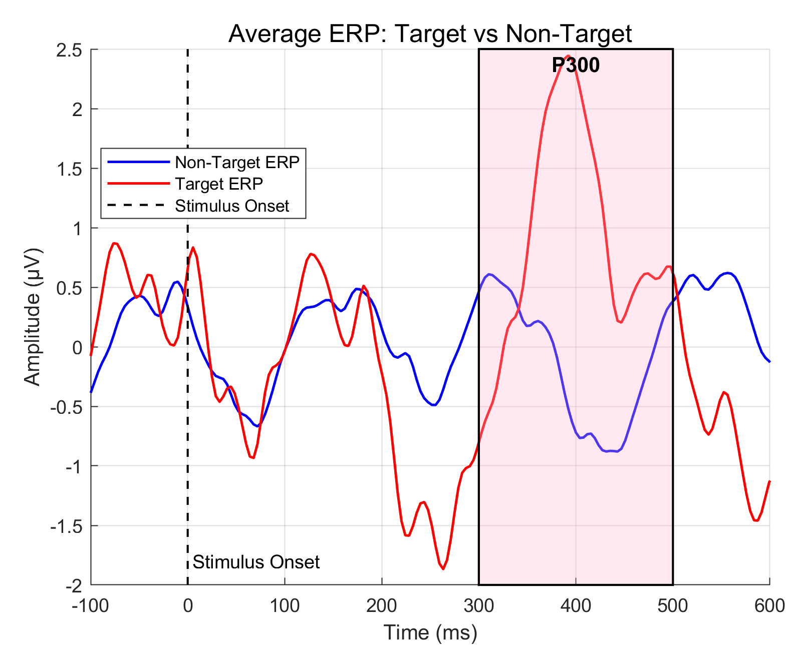
Figure 5. Average ERP over all electrodes from train2.m
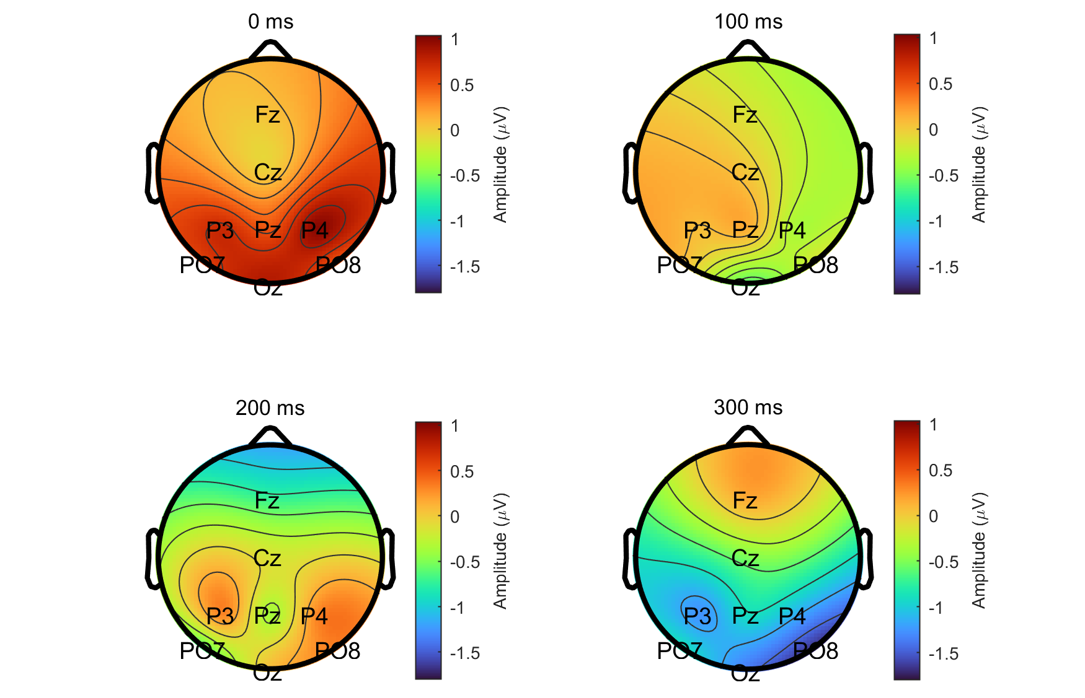
Figure 6. The scalp map of target flash from train2.m
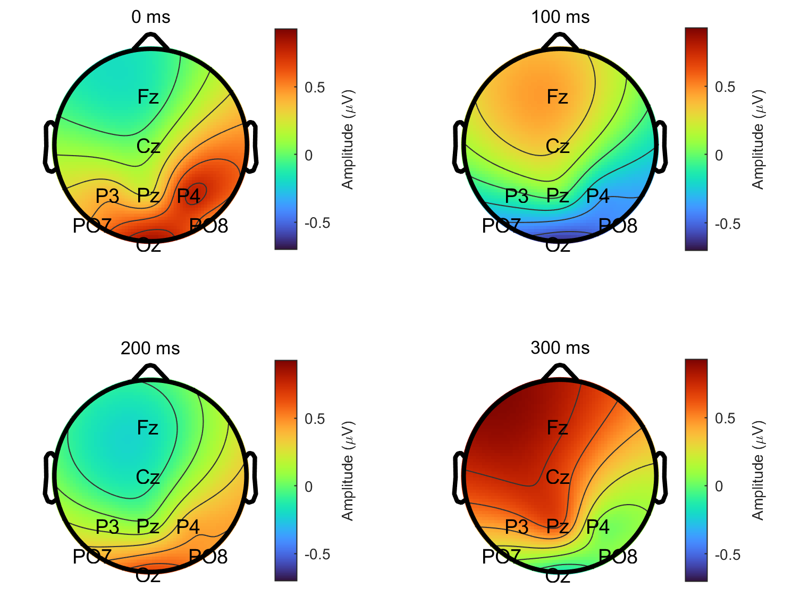
Figure 7. The scalp map of non-target flash from train2.m

Figure 2 (train1.mat) and 5 (train2.mat) display the average ERP waveforms over all electrodes exhibiting how brain react to non-target flashes (blue) and target flashes (red). It is evident that clear P300 components appear approximately 300ms after stimulus onset in both datasest. The two figures look similar since the two datasets differ only in the length of the words, while the experimental paradigm remains unchanged. The ERP still appears when the subject fully attends to and detects the deviant stimulus which is not affected by variations in word length.

Figure 3, 4, 6 and 7 show the scalp map of the signal at 0, 100, 200, and 300ms after the onset of the flash. For ease of comparison, all subplots within each figure were plotted using the same value scale (colorbar). There are slight differences between each pair of the scalp maps, since we plot images of exact time stamp instead of an average value of a time window. Nevertheless, consistent spatial patterns and regularities can be observed across these maps:

Table 1. Main ERP Components, Time Windows, and Associated Brain Regions
ERP Component | Time (ms) | Main Peak Electrodes
- | 0 | -
P1 | 100 | Oz, PO7, PO8
N1/P2 | 200 | P3, P4
P3 | 300 | Pz, Cz, P3, P4

Two sets of graphs are basically the same since the two experiential conditions differ only in the date of acquisition and in the length of the spelled words. Because the ERP reflects the brain’s response to infrequent stimuli and is largely insensitive to these factors. Hence, similar results of two sets are to be expected.

1.2. Training and Testing Within-Subject Decoding Models
$$Number of Features =\left( \left\lceil \left|t_{min}\right|×f_{s}\right\rceil + \left\lceil \left|t_{max}\right|×f_{s}\right\rceil +1\right)×N_{ch}$$
Based on the formula above, the number of features in my project is 1448. Evaluations of model accuracy are shown in Table2:

Table 2. Accuracy of each model
Accuracy | Test Set 1 | Test Set 2 | Test Set 1+2
Model₁ | 74.26% | 75.61% | 75.13%
Model₂ | 69.14% | 80.67% | 76.61%
Model₁₊₂ | 77.04% | 83.50% | 81.23%

Since P300 mainly appears between 300ms to 600ms and there is a huge gap between target and non-target ERP waveforms, so I choose to set the new time range from 300ms to 600ms. And evaluations of new model accuracy are shown in Table3:

Table 3. Accuracy of each model (new time range)
Accuracy | Test Set 1 | Test Set 2 | Test Set 1+2
Model1 | 79.46% (↑) | 77.78% (↑) | 78.37% (↑)
Model₂ | 70.63%(↑) | 83.00% (↑) | 78.64% (↑)
Model₁₊₂ | 80.76% (↑) | 83.91% (↑) | 82.80% (↑)

By comparing Table 1 and Table 2, it is evident that the performance improved remarkably in all cases. Therefore, we can conclude that focusing on a narrow time window of 300–600 ms after stimulus onset, corresponding to the P300 component, helps the model achieve significantly better performance.

According to Table 2, the combination of Model₁₊₂ and Test Set 2 achieve the highest accuracy. This can be explained by the fact that Model₁₊₂ was trained on the largest dataset (train1.mat + train2.mat), which helps the model avoid underfitting and learn more robust features. Moreover, it was tested on Test Set 2, which represents only a subset of the entire testing dataset (test1.mat + test2.mat). As a result, the testing data are relatively less complex and contain fewer variations, making it easier for the model to achieve higher accuracy.

As for generalizing ability, we should examine models trained and tested with data from totally different trials. Model₁ tested on Test Set 2 achieves a higher accuracy (77.78%) than Model₂ tested on Test Set 1 (70.63%). So the conclusion is that Model₁ has a better generalization.

As for the comparison between cross-session model and within-session model, we should check models trained on data from multiple sessions versus models trained on data from only a single session (Model₁₊₂ vs Model₁ and Model2). There is no doubt that Model₁₊₂ , a cross-session model, achieves a higher average accuracy than the other two within-session models

Besides, following methods could be utilized for model evaluation. The ROC curve (Figure 8) evaluates the model’s overall discriminative ability by illustrating the trade-off between true positive and false positive rates. The confusion matrix (Figure 9) provides detailed insight into prediction outcomes, enabling the calculation of accuracy, precision, recall, and F1-score.
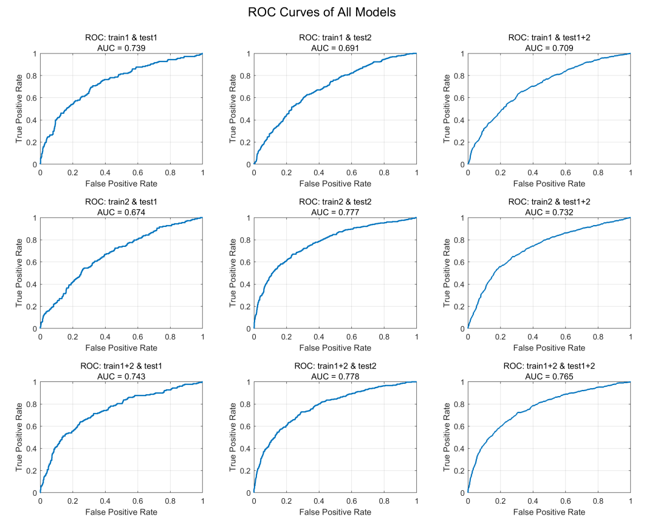
Figure 8. All ROC curves
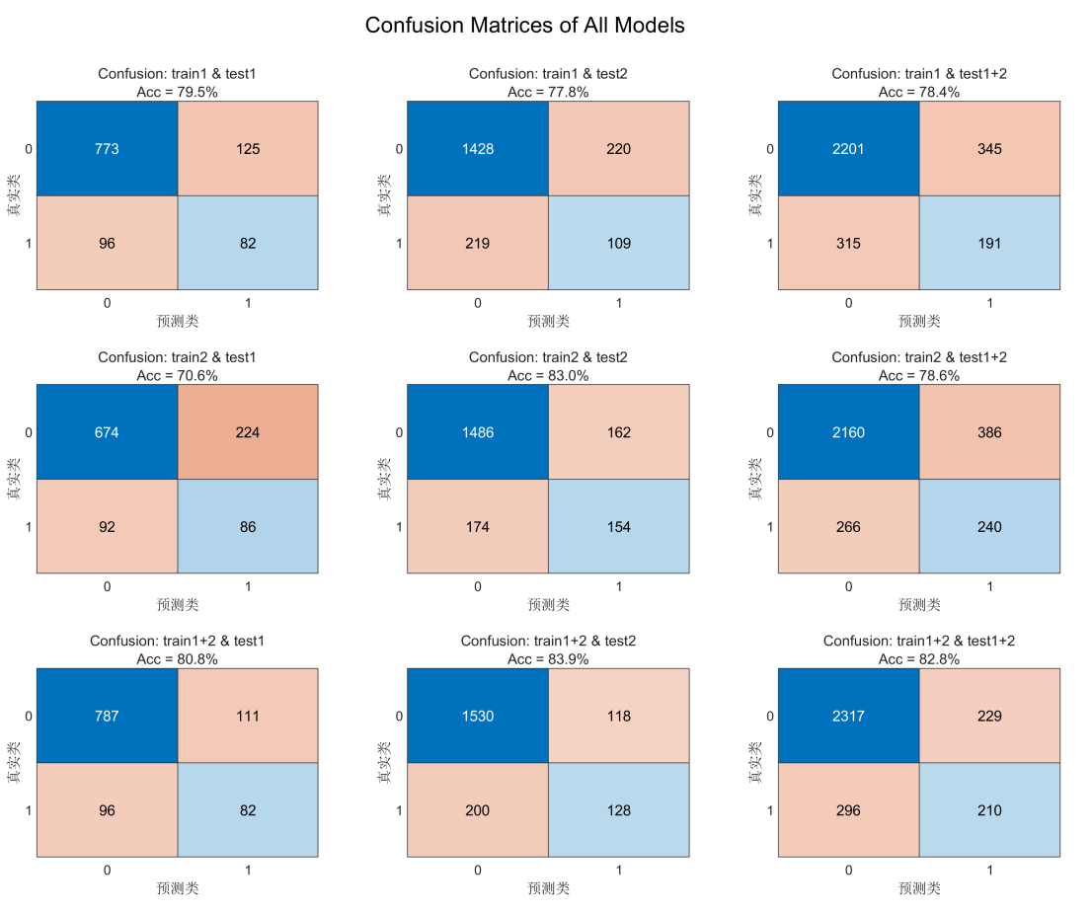
Figure 9. All confusion matrices
1.3. Analyze Within-Subject Decoding Models
According to Figure 9, the image is similar to Figure 3 and Figure 6, representing that the model is focus on P300 component and assigns more weights to electrodes P3, and P4, which is consistent with the conclusions obtained in Table 1.
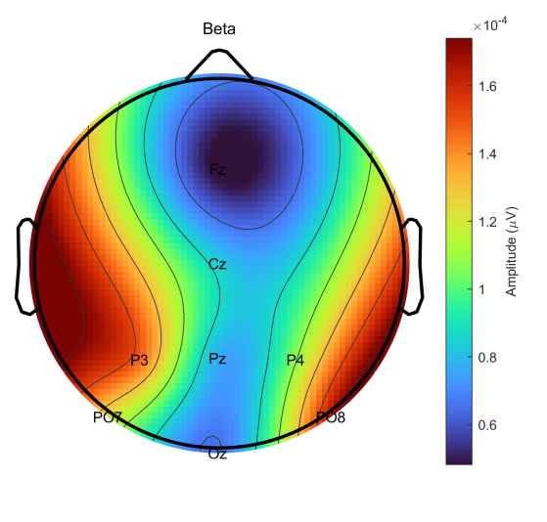
Figure 9. Topoplot of the average squared weights at each electrode

The average squared weights over electrodes are shown in Figure 10, along with the mean ERP waveform from 300 ms to 600 ms. To examine their temporal relationship, a sliding-window correlation was performed between the average squared weights and the mean ERP waveform (averaged across train1 and train2). Both signals contained 181 time points covering 300–600 ms after stimulus onset. Using a 20-sample moving window, the Pearson correlation was computed at each step to obtain a time-resolved correlation curve, from which the maximum correlation and its corresponding time point were determined. The results are shown in Figure 11.
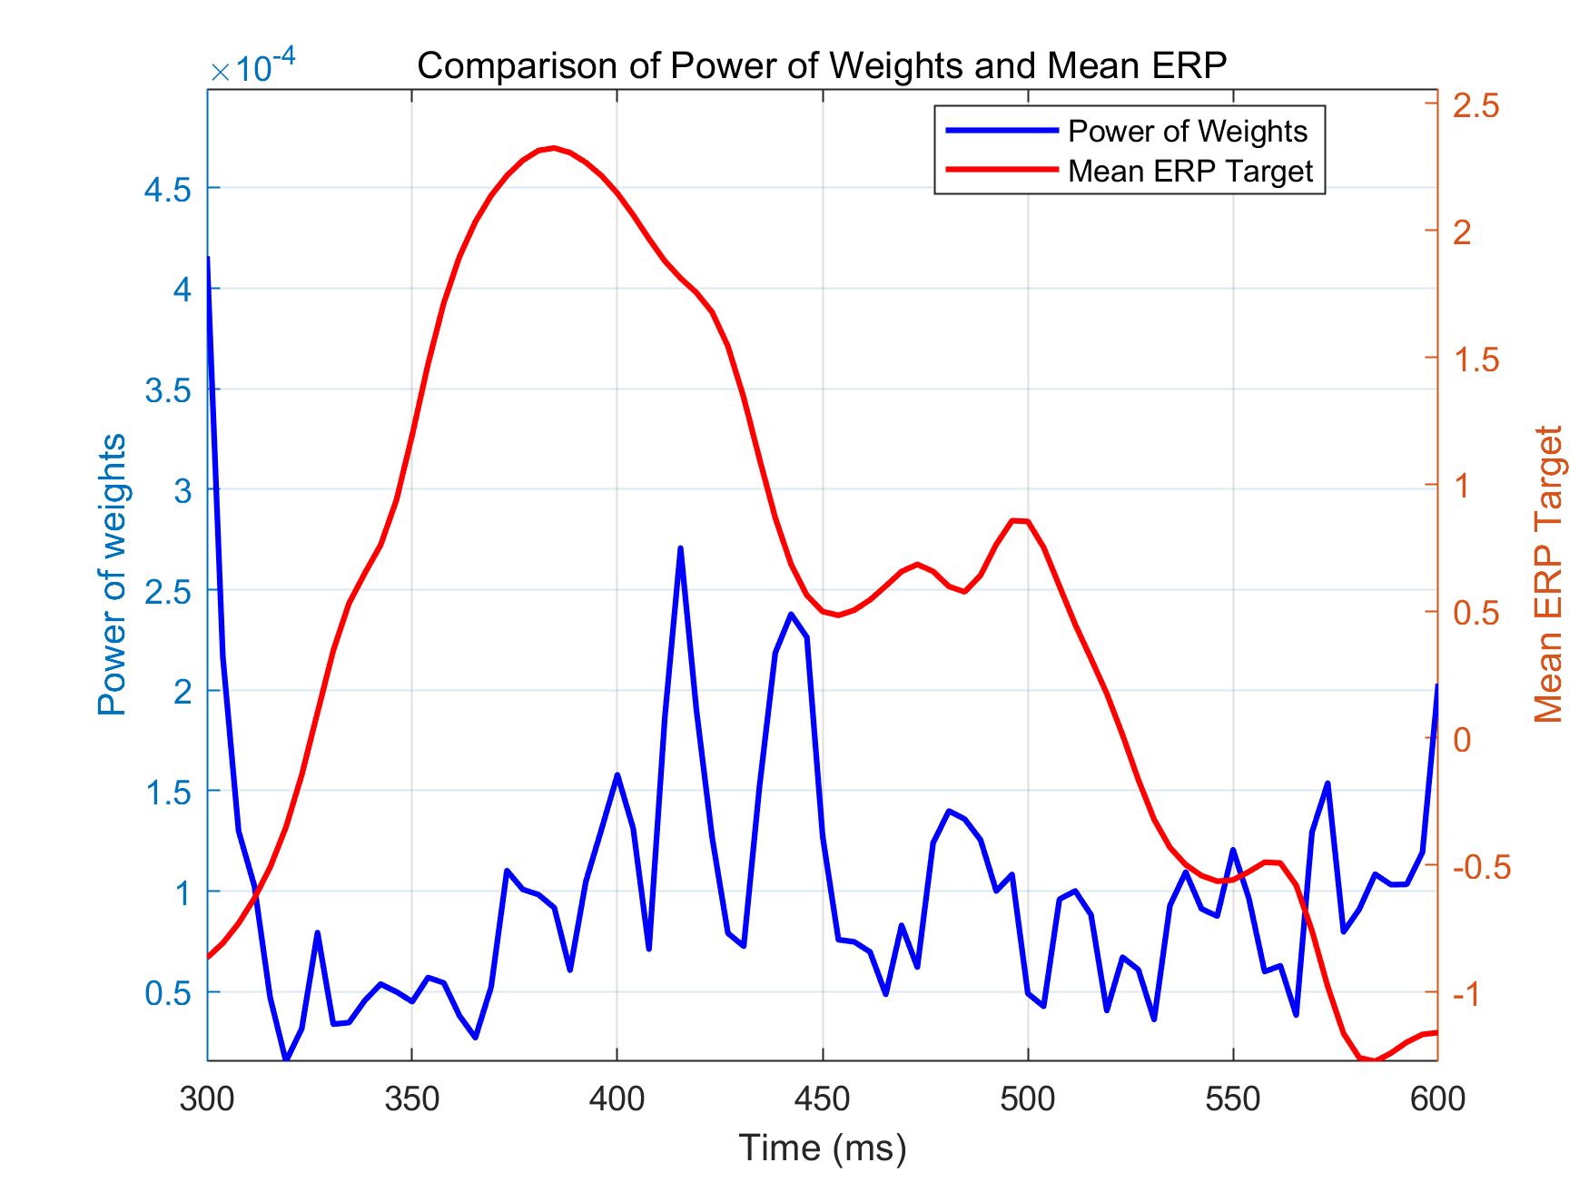
Figure10. Comparison of Power of Weights and Mean ERP
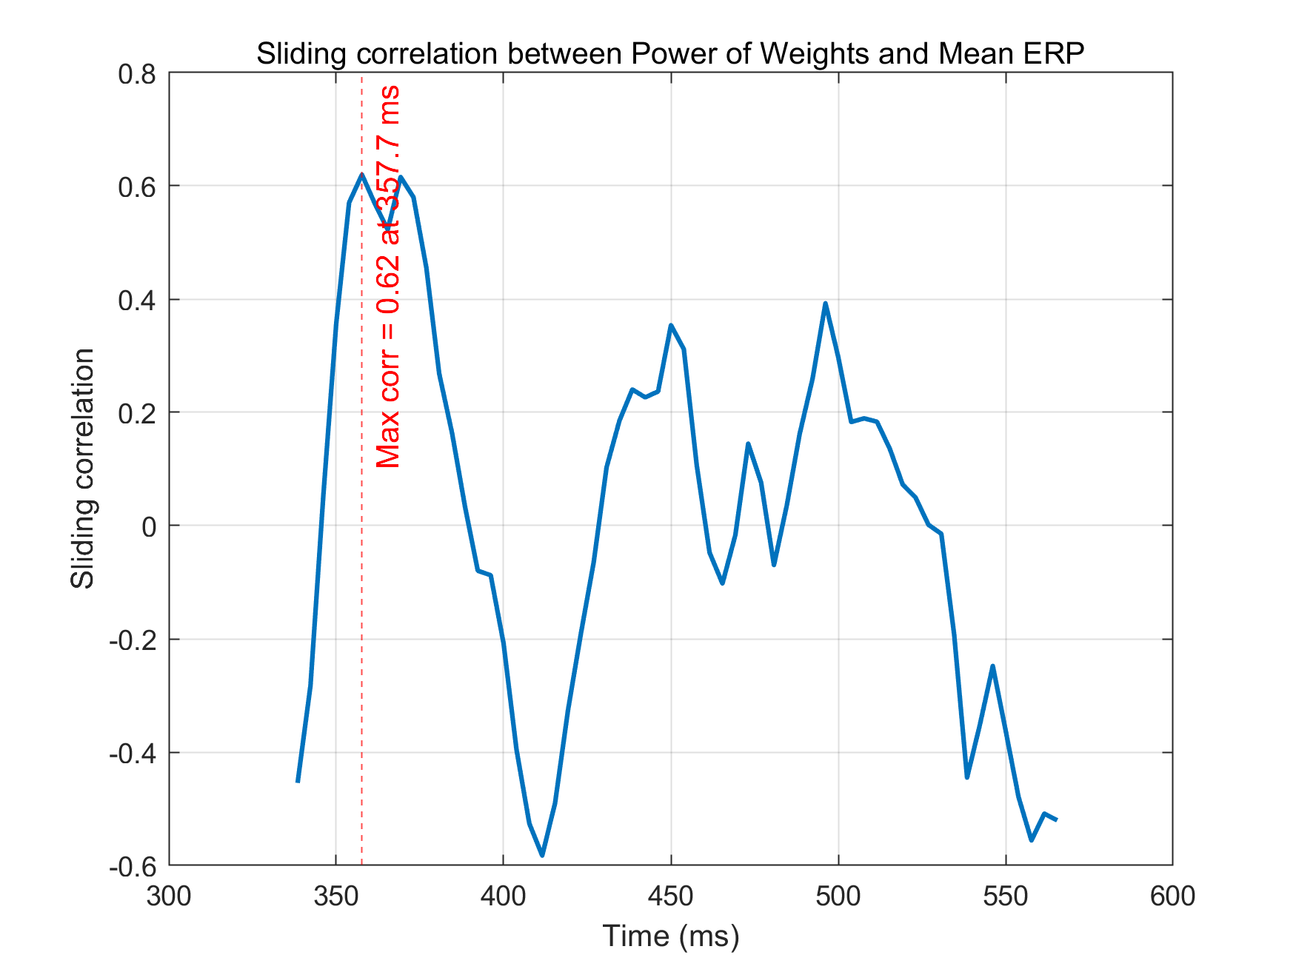
.Figure11. Sliding correlation between power of weights and mean ERP

Part 2. Cross-Subject Analysis
2.1. ERP Response to Target and Non-Target Flashes
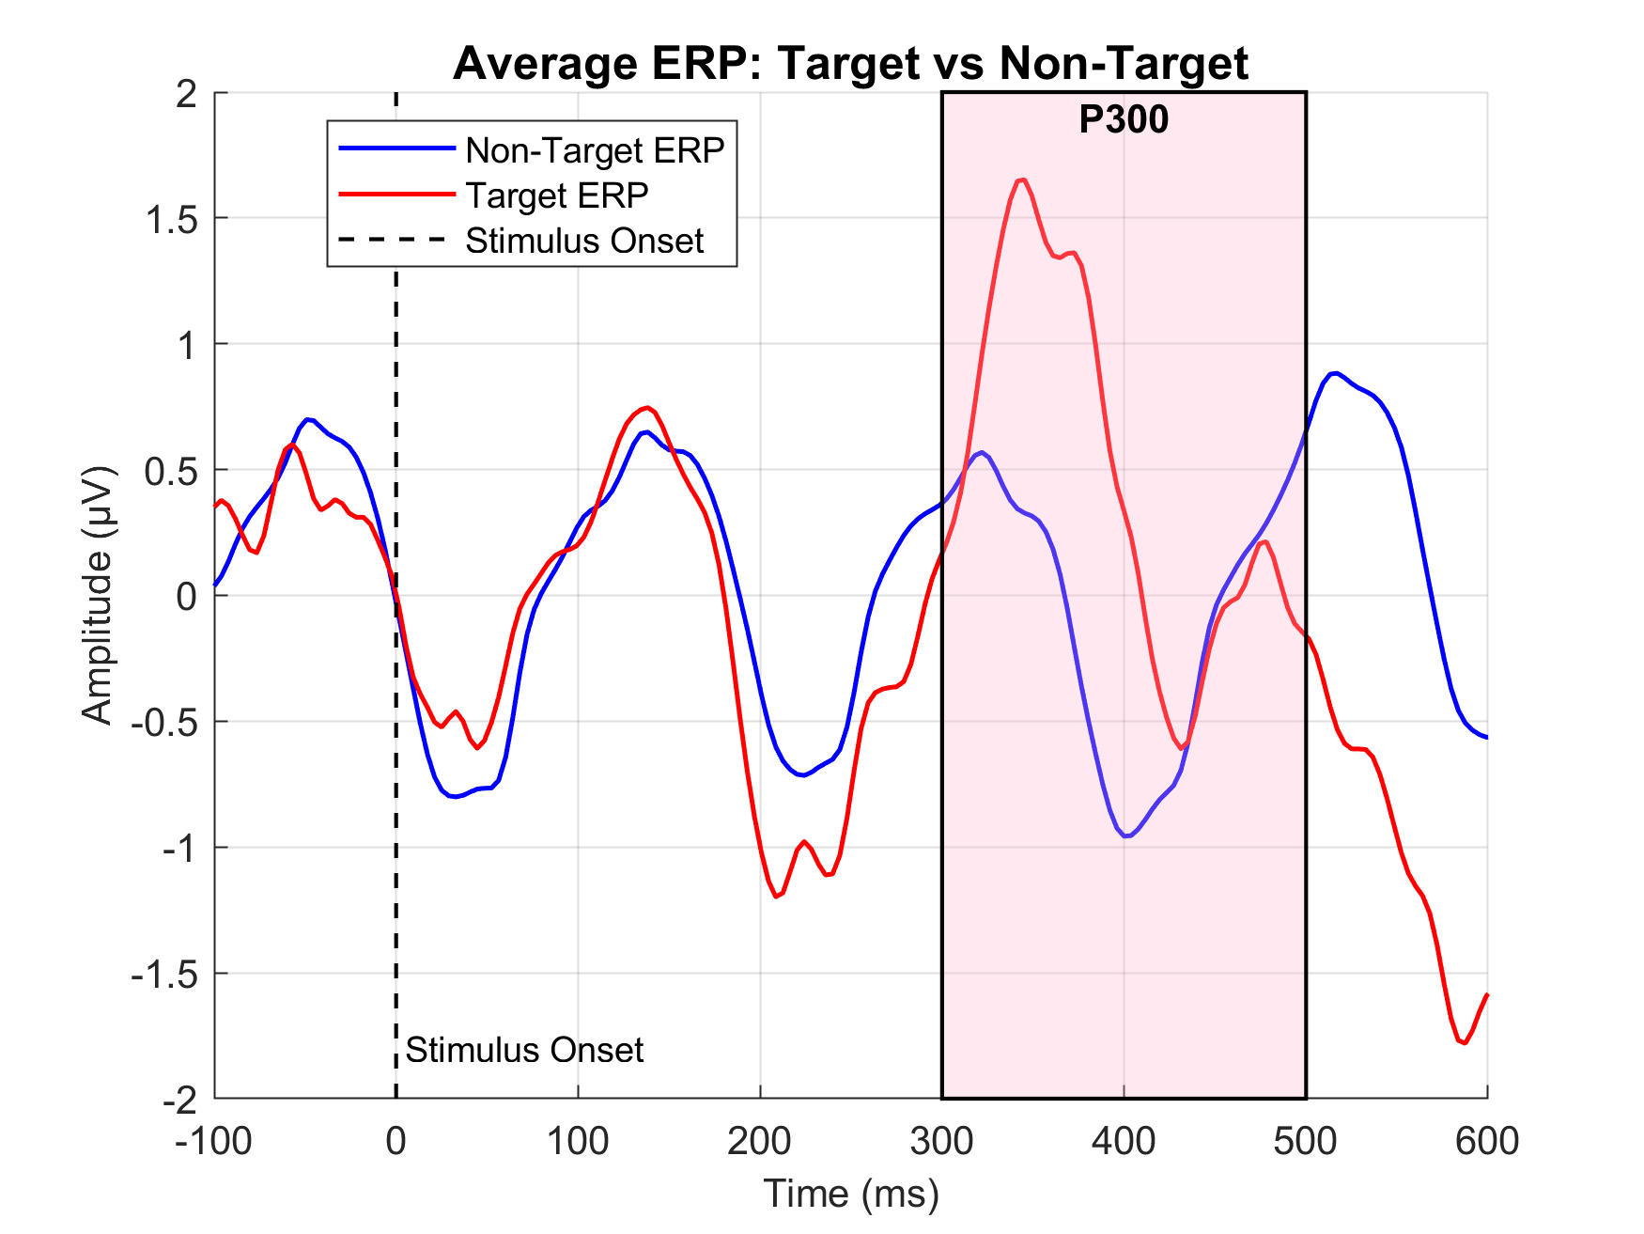
Figure 12. Average ERP over all datasets from train1.m
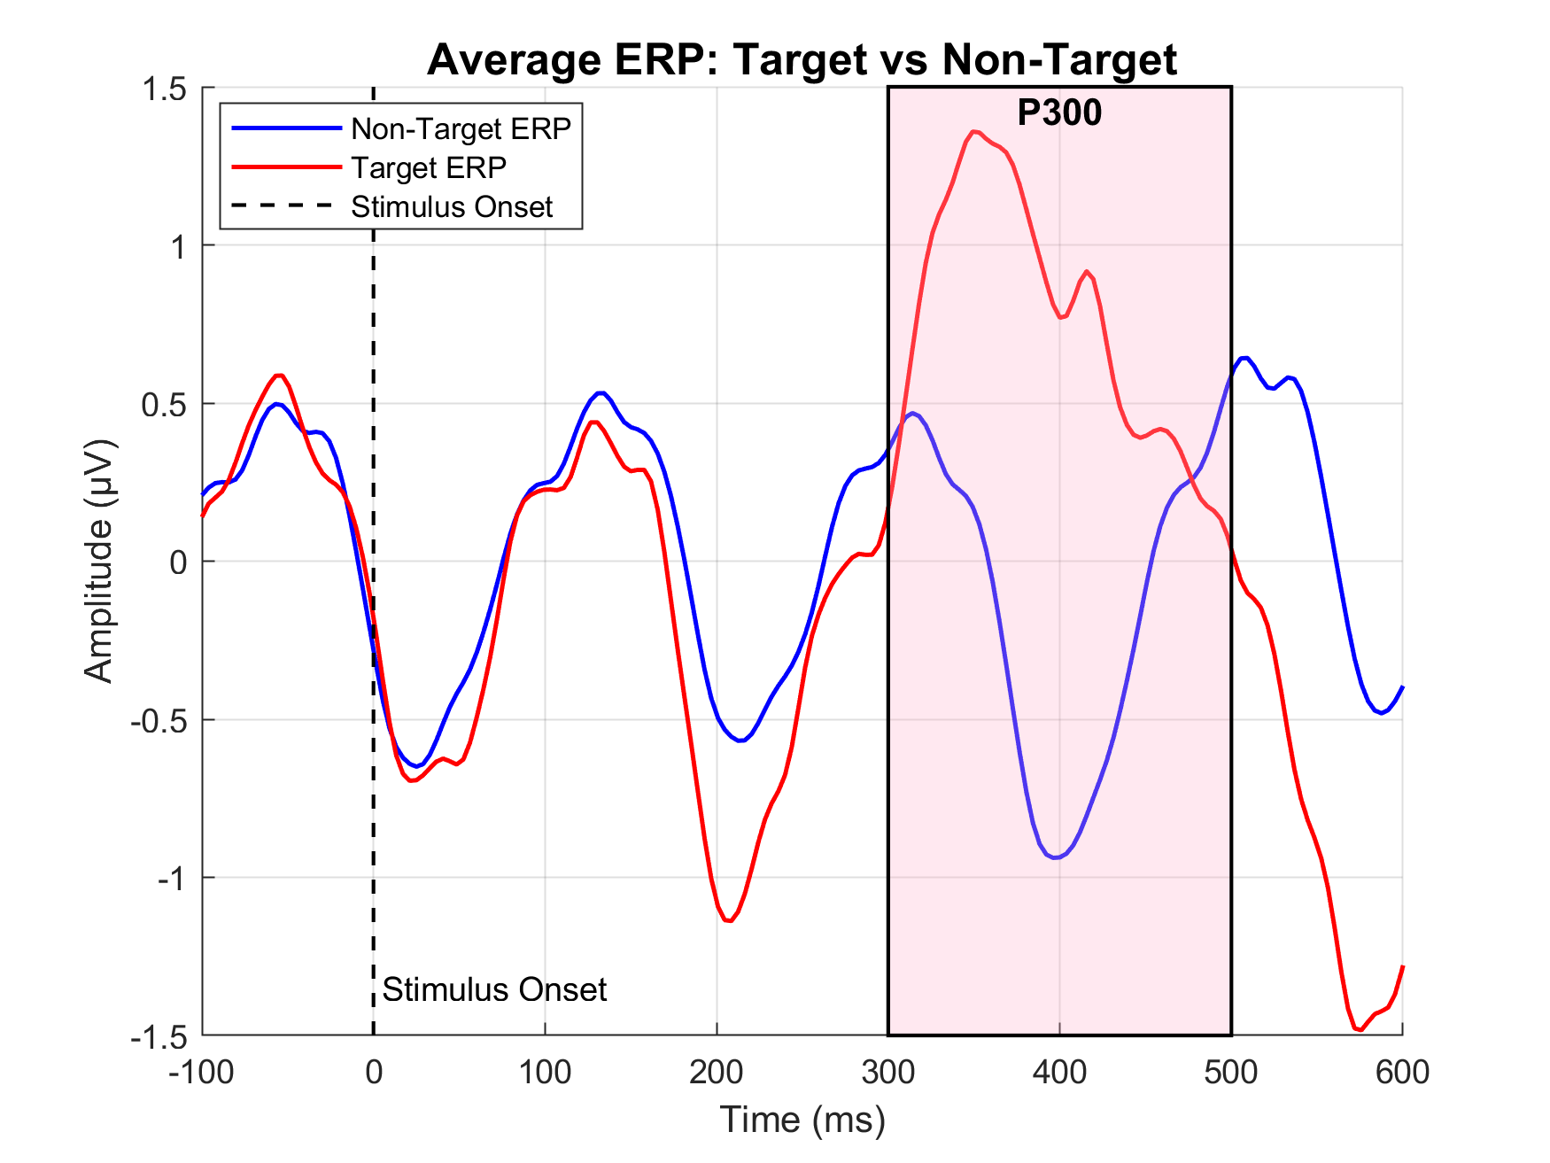
Figure 13. Average ERP over all datasets from train2.m
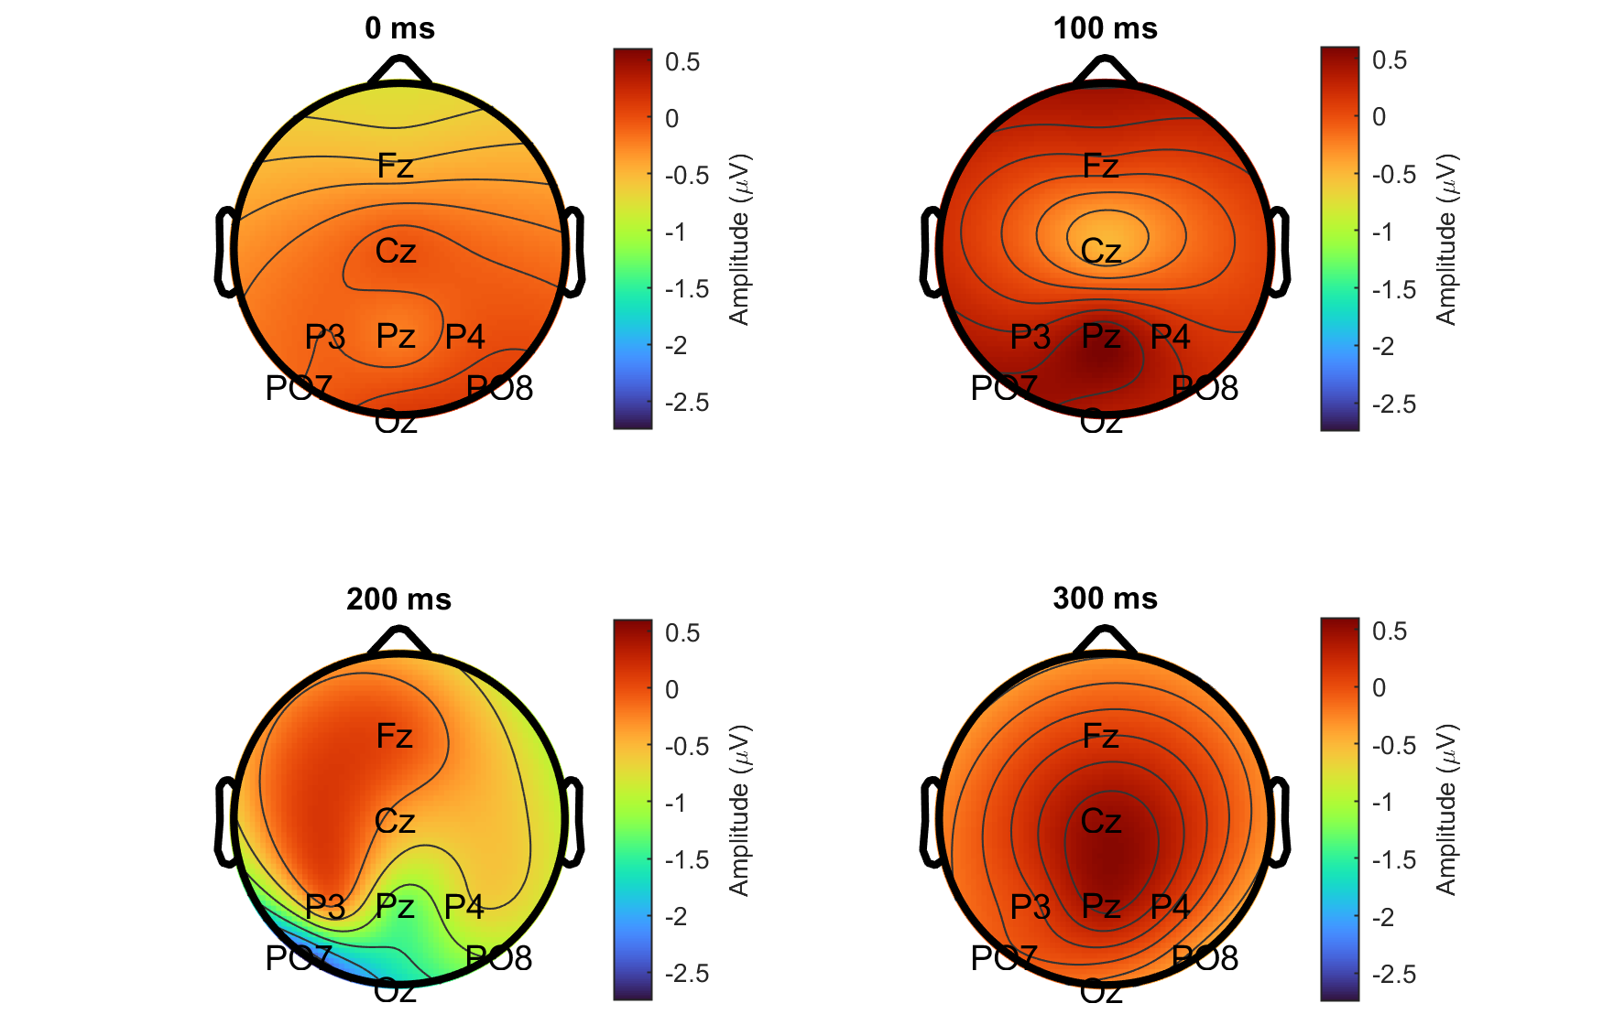
Figure 14. The scalp map of non-target flash from train1.m
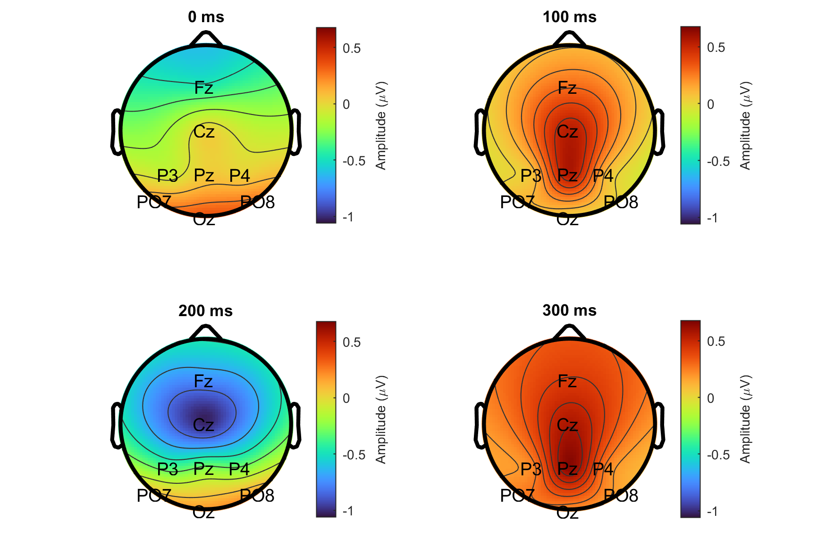
Figure 15. The scalp map of target flash from train1.m

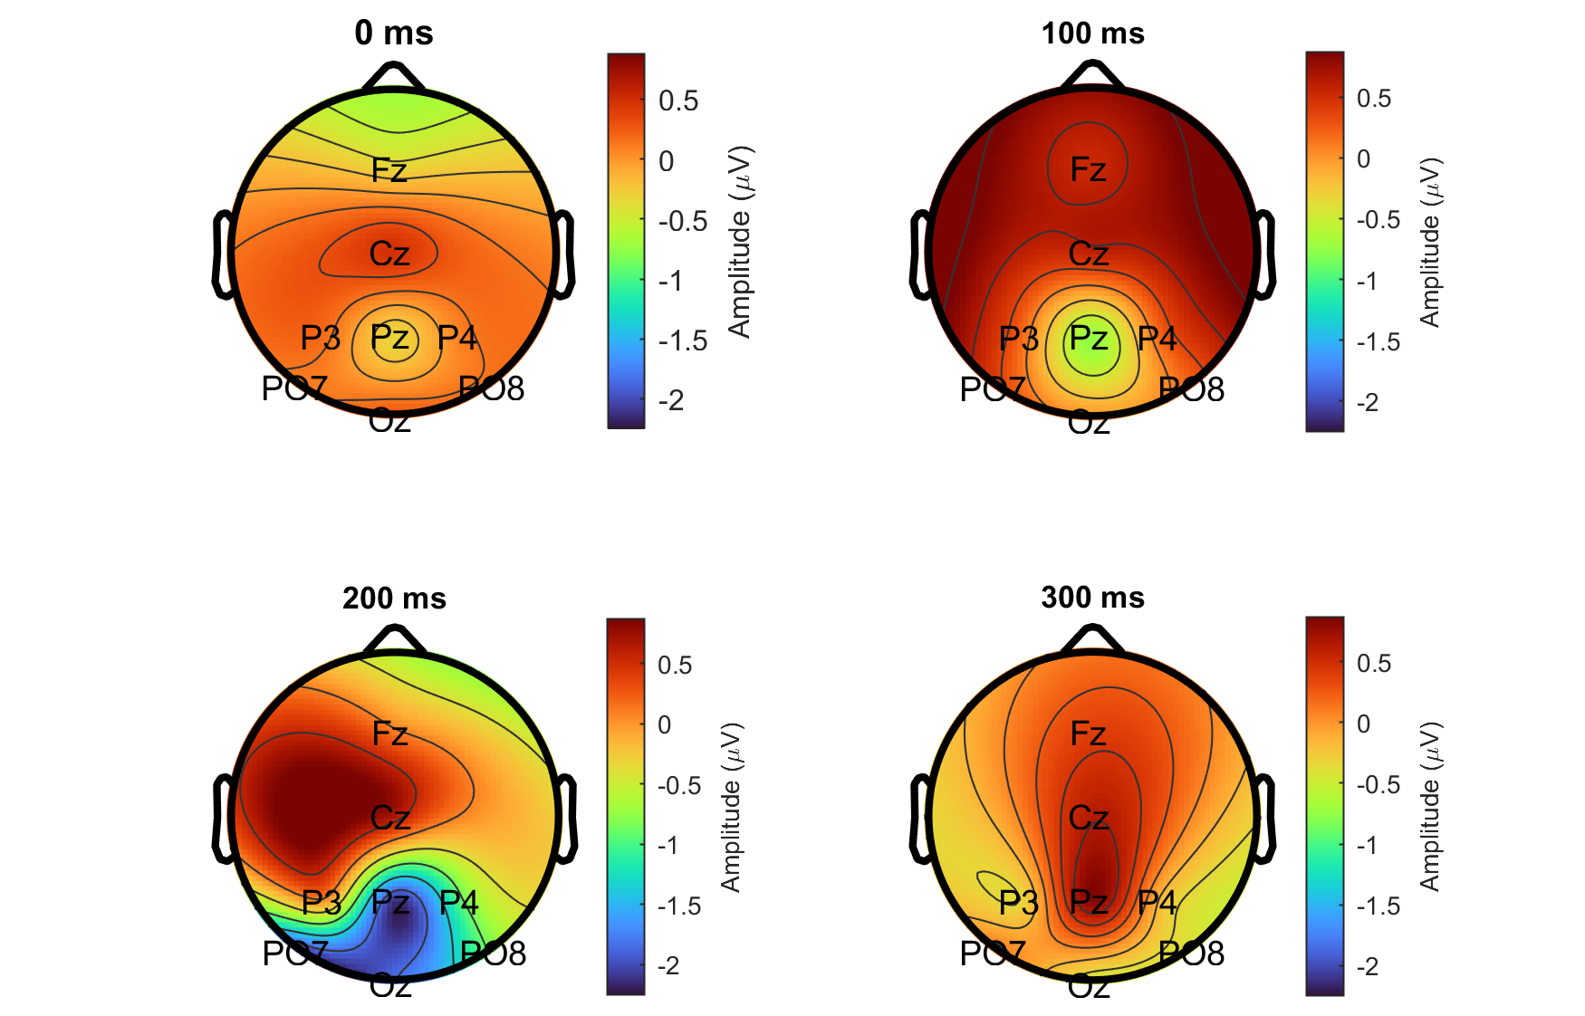
Figure 16. The scalp map of non-target flash from train2.m
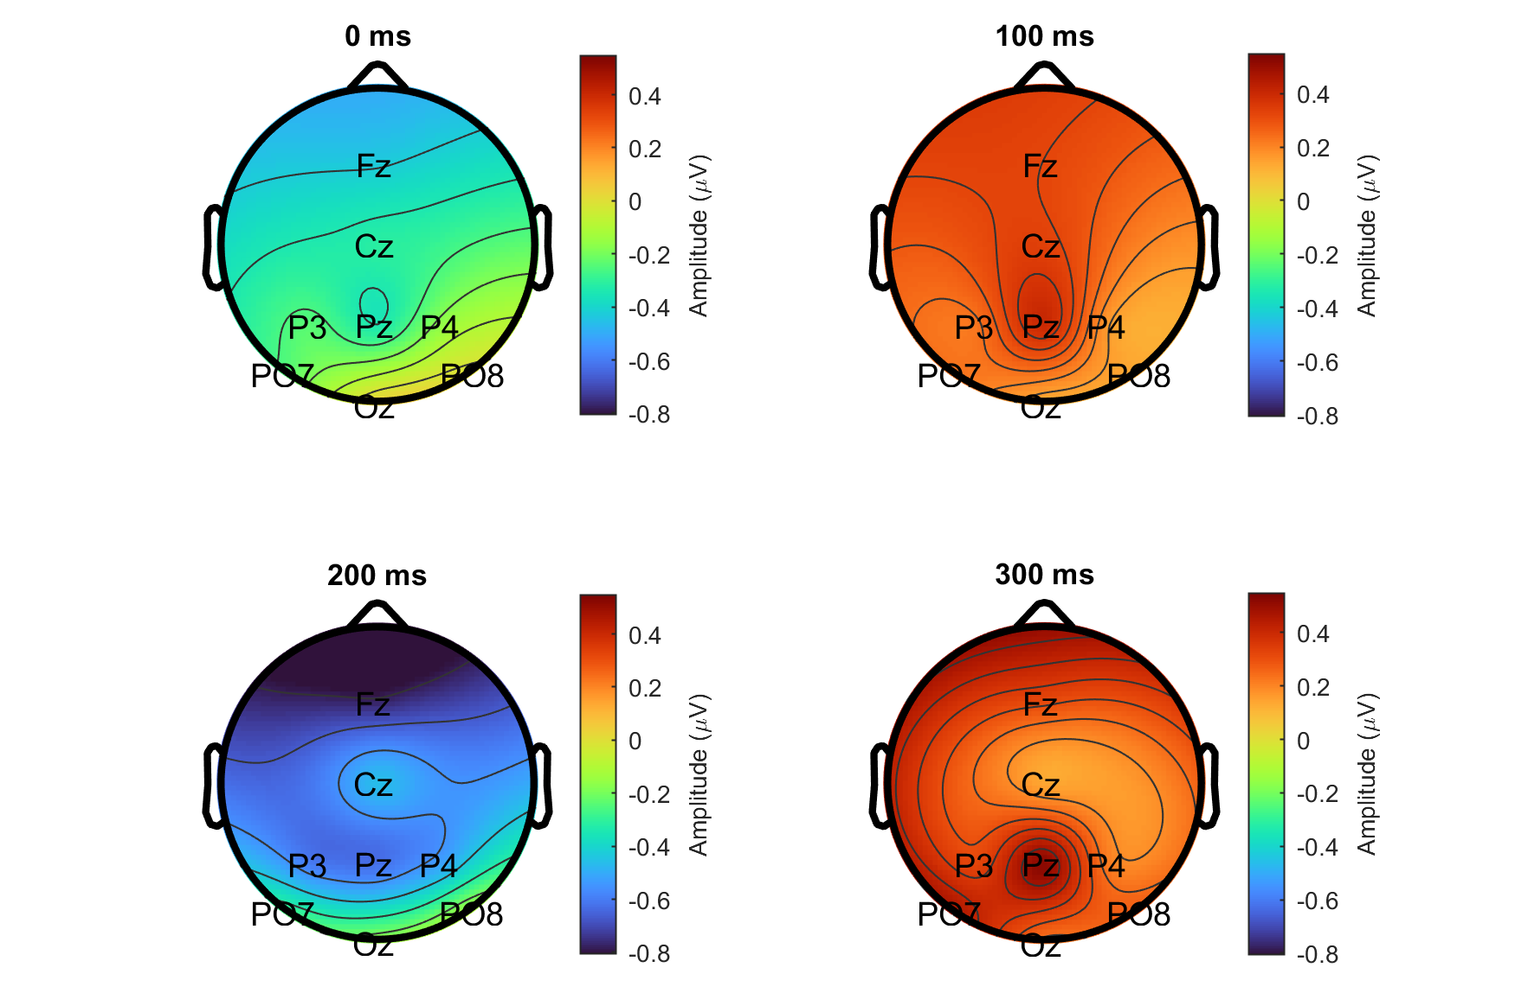
Figure 17. The scalp map of target flash from train2.m
The average ERP waveforms are similar between Figure2&5 (my group) and Figure 12&13 (all datasets). Although the overall waveform pattern shows no difference, the P300 component in the ERP computed from the entire dataset appears earlier in time. This may be related to variations in reaction speed across different participants.
Similarly, though the specific values differ, the topoplots show consistent patterns in terms of overall trends. Mainly because ERP components correspond to activity in specific brain regions, and this pattern is relatively stable across individuals.

2.2. Training and Testing Cross-Subject Decoding Models
According to the Figure 12 and 13, I choose to set the time range from 300 to 450, due to the variations in reaction speed across different subjects. Here is the result:

Table 4. Evaluation of cross-subjects model
Setting | Accuracy | Precision | Recall | F1
Cross-Subject Model + Group1 Test | 64.71% | 0.23 | 0.47 | 0.31
Cross-Subject Model + All Other Groups Test | 69.70% | 0.24 | 0.44 | 0.31
Within-Subject Model + Group1 Test | 82.96% | 0.48 | 0.29 | 0.36
Within-Subject Model + All Other Groups Test | 75.91% | 0.24 | 0.24 | 0.24

The results show that the Within-Subject model performs best when evaluated on the same subject (Accuracy is 82.96%), indicating strong within-subject ERP consistency. However, its performance drops substantially when applied to other subjects (F1 is only 0.24), highlighting pronounced cross-subject variability and domain shift, indicating lower generalization ability. In contrast, the Cross-Subject model achieves moderate but stable performance across testing conditions (Accuracy range from 65% to 70%), suggesting that it captures generalizable P300 characteristics but lacks subject-specific adaptation. Therefore, cross-subject models are suitable for calibration-free usage, while within-subject models are preferable for personalized BCI scenarios.

2.3. Analyze Cross-Subject Decoding Models
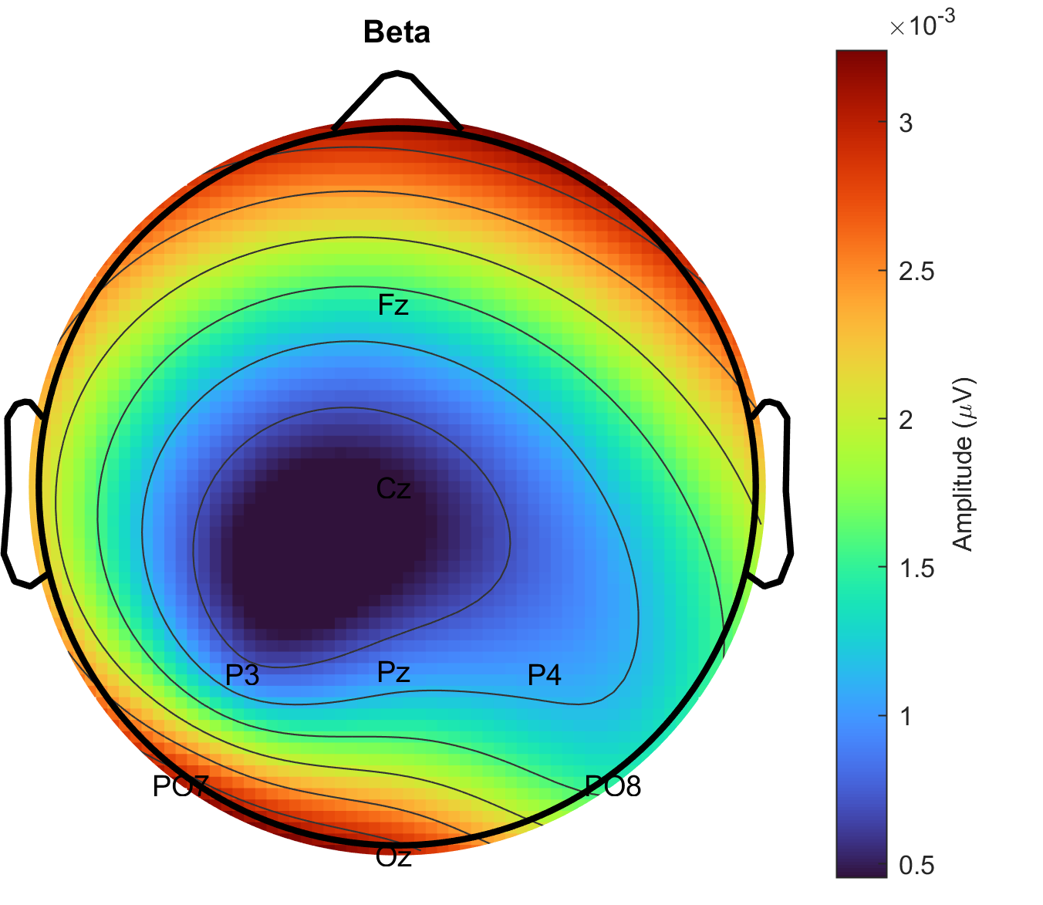
Figure 18. Topoplot of the average squared weights at each electrode
Figure 18 is different to Figure 9, showing that the cross-subject model assigns more weights to electrodes PO7 PO8 and Oz more than P3, P4 and Pz.
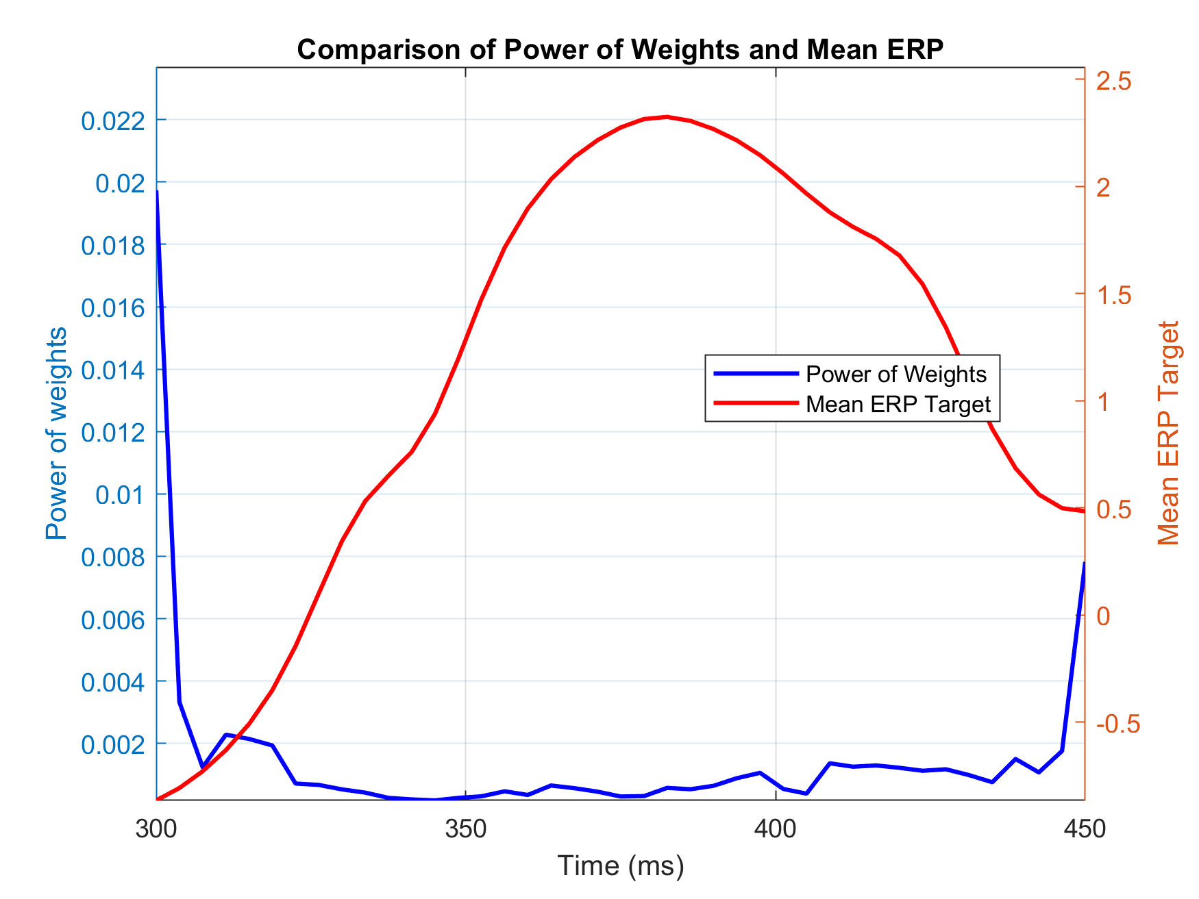
Figure19. Comparison of Power of Weights and Mean ERP
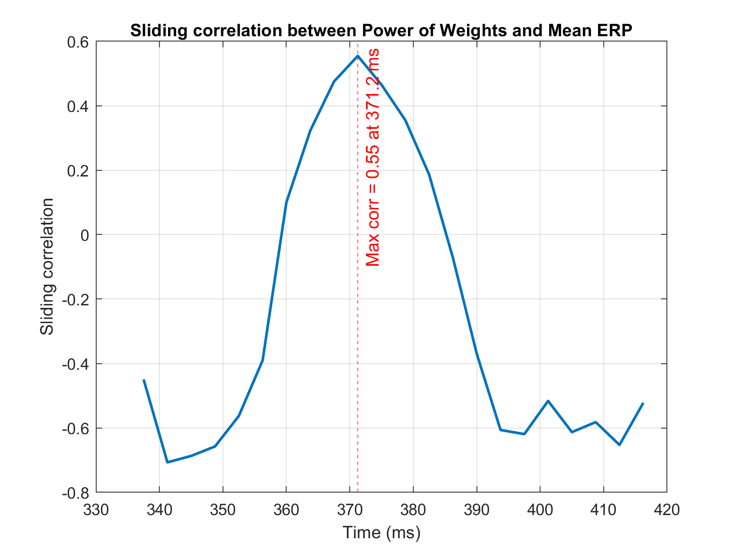
Figure20. Sliding correlation between power of weights and mean ERP
Figure 19 shows the relationship between power of weights over time and mean ERP waveforms between 300 to 450ms. Figure 20 use a sliding window to calculate the correlation between power of weights and ERP, showing that the model's highest attention occurs at 371.2 ms, which is very close to the P300 peak at 357 ms shown in Figure 11.

Discussion
Within-session models provide the highest accuracy because the data distribution remains stable, but they require retraining every time and are thus inconvenient for real use. Within-subject models retain personalization across sessions and generally achieve higher performance, though they still need occasional calibration due to physiological variability. In contrast, cross-subject models offer the best convenience and generalization by enabling plug-and-play usage, but their accuracy is typically lower due to large inter-subject differences in EEG patterns (That’s why z-score normalization is important in pre-processing stage).

Table 5. Comparison between 3 kinds of models
Model Type | Calibration  Needed | Personalization | Accuracy | Suitable Scenario
Within-Session | High | Very High | Highest | Short-term lab experiments
Within-Subject | Moderate | High | Higher | Personalized BCI use
Cross-Subject | Minimal | Low | Moderate | Practical deployment

