Mini Project 2

Information

Name | UNI
Zhewen Guo | zg2567

Introduction
In this experiment, the participant sits still and looks at a screen while EEG is recorded. Each trial starts with a fixation cross. Then a beep and an arrow appear. The arrow points left or right and tells the participant which hand to imagine moving. The participant does not move their hand but only imagines the movement while the arrow is on the screen. Brain signals related to this imagined movement are recorded for later usage to separate left-hand and right-hand imagined movements using CSP filter and a LDA classifier.
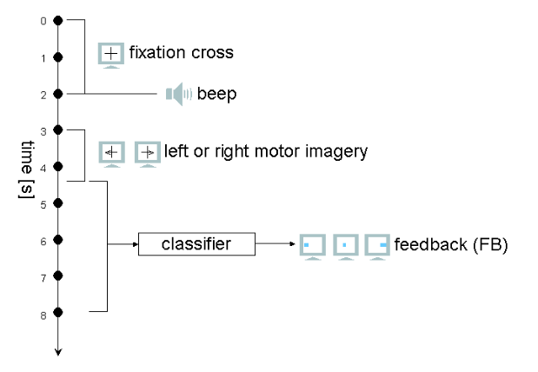
Figure 1. experimental paradigm

Stimuli and Procedure
To filter the artifacts and improve the data quality a band-pass (0.5–30 Hz) and a 60 Hz notch were used during recording. As for offline analysis filtering, I applied a band-pass FIR filter from 8–20 Hz, and used filtfilt to make it zero-phase (no phase delay). The sampling rate in this experiment was Fs = 256 Hz.

The experiment used 4 runs each week, with 40 trials per run. And the entire experiment last for two weeks, hence there are 8 runs in total. To separate the data, aach trial onset was detected using the trigger channel (channel 18) by identifying a negative edge in the trigger signal. The trial labels were obtained from the provided class label files (classrun 1-4.mat), where the first row indicates left-hand motor imagery trials and the second row indicates right-hand motor imagery trials. Using the EEG time vector data.y(1,:), EEG segments were then extracted for each trial within a fixed analysis window of 2.0 to 5.5 seconds after the trigger, which corresponds to the motor imagery period since the trigger marks second 2 of each trial.

To check the data quality, I manually plot all the original EEG data and check if there is any obvious outlier. The result shows that the quality is good enough for the following data analysis.

Training Imagined Movement
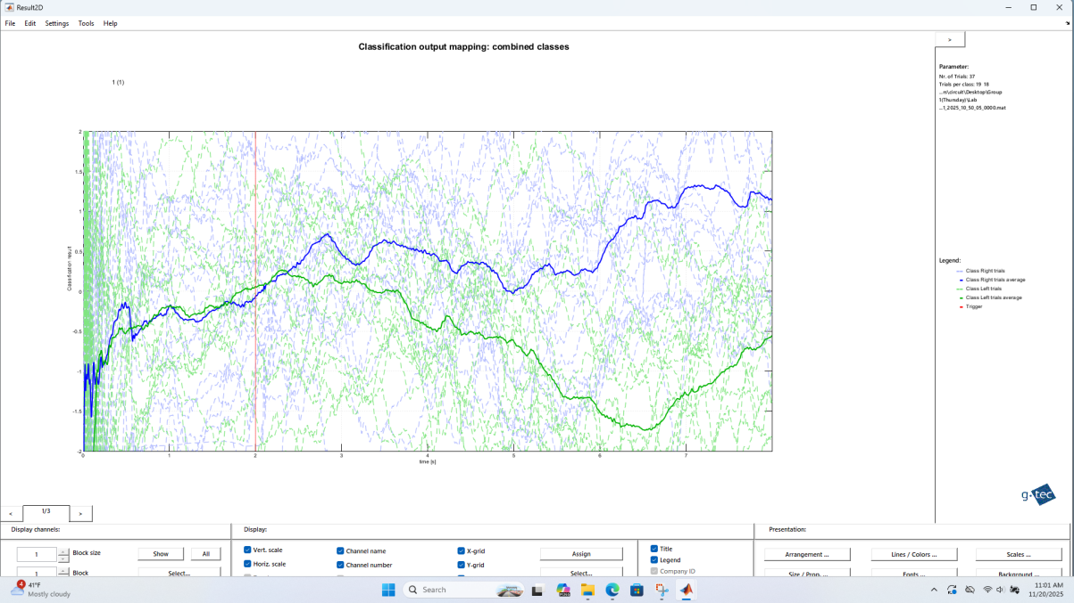
Figure 2. classification result of the first trial
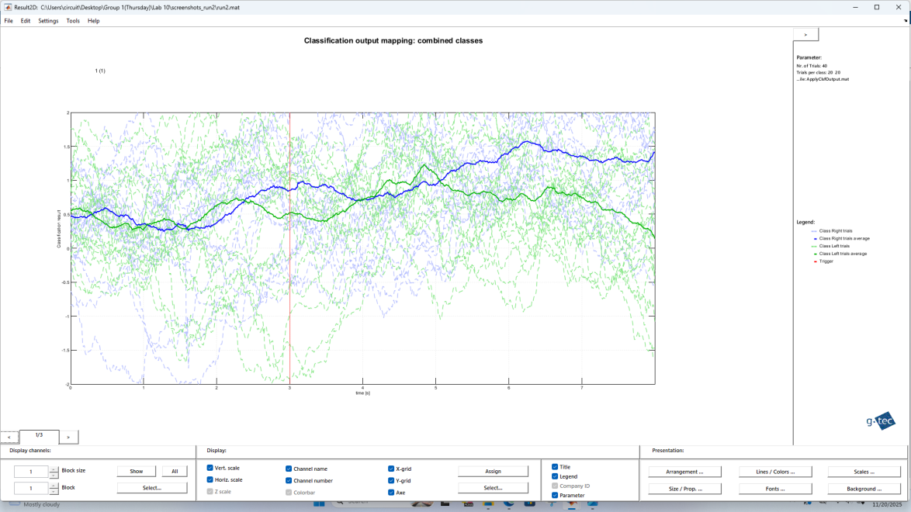
Figure 3. classification result of the second trial
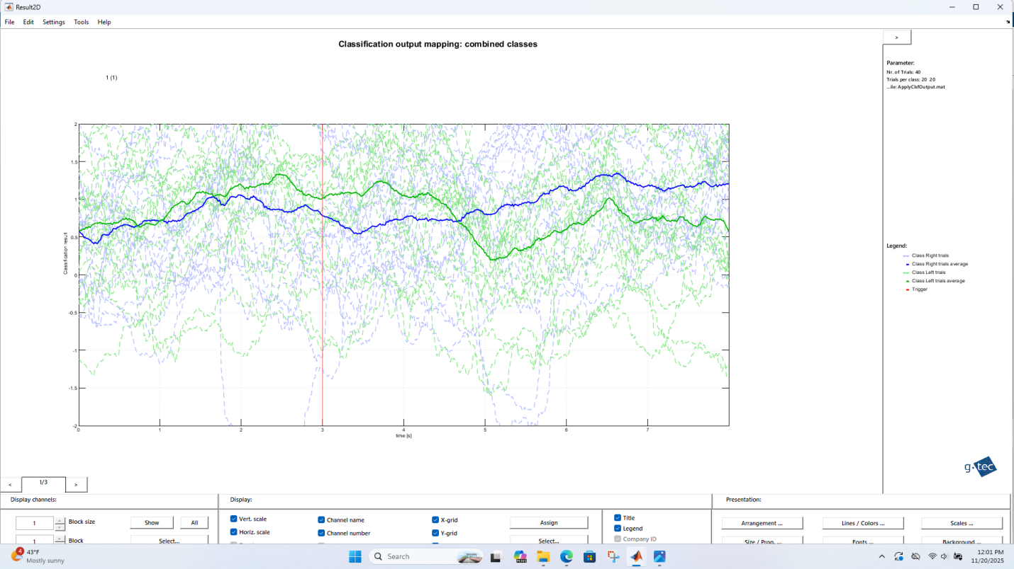
Figure 4. classification result of the third trial
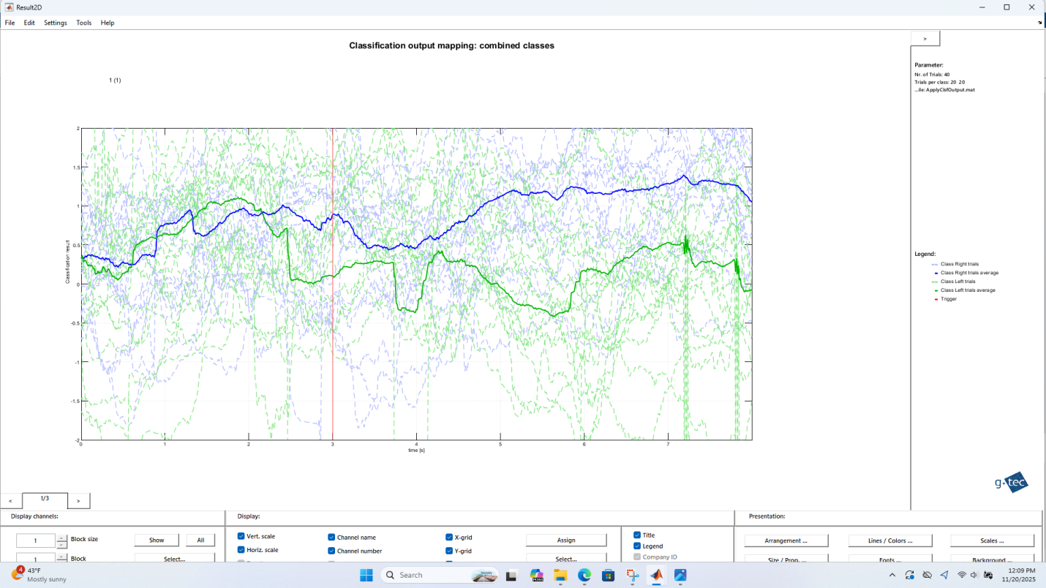
Figure 5. classification result of the fourth trial
The behavioral results suggest a mild learning effect across training sessions. During the early runs, the subject was still becoming familiar with the motor imagery task, and performance showed larger variability. But according to Figures 3-5, it is apparent that the gap between the two categories increases slightly across training sessions, indicating behavioral improvement in the subject and an increase in accuracy over time.
Applying Common Spatial Pattern Filters
CSP filters were computed by first separating EEG trials into left and right motor imagery classes and forming class-wise mean covariance matrices, where each trial covariance was normalized by its trace. A generalized eigenvalue problem was then solved between the left and right covariance matrices, and the resulting eigenvalues and eigenvectors were sorted. The first three and last three eigenvectors, corresponding to the smallest and largest eigenvalues, were selected as the most discriminative CSP filters. These filters were projected onto the EEG data to obtain CSP components, and for each projected dimension, the average time-course response was computed separately for left and right trials and plotted, allowing visualization of how the two classes differ across the selected CSP components.
$$X_{csp}=W^{T}X\left(t\right)$$
$$var\left(x_{csp}\right)={WCW}^{T}$$
$$C_{−,+}=\frac{1}{\left|X_{i}\right|}\sum_{i=−,+}{X_{i}X_{i}^{T}}$$
$$W={argmax}_{w}\frac{var\left(W^{T}X_{+}\right)}{var\left(W^{T}X_{−}\right)}={argmax}_{w}\frac{{WC_{+}W}^{T}}{{WC_{−}W}^{T}}$$
$$Take derivative and set to zero{ C}_{+}W={ ℷC}_{−}W$$
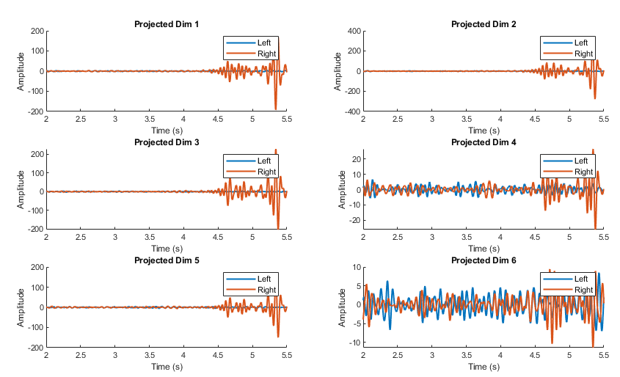
Figure 6. The scalp map of non-target flash from train2.m
This figure 6 shows the average CSP-projected time-domain responses for left and right motor imagery across the selected CSP dimensions, illustrating how CSP enhances class-specific differences in the EEG signals.
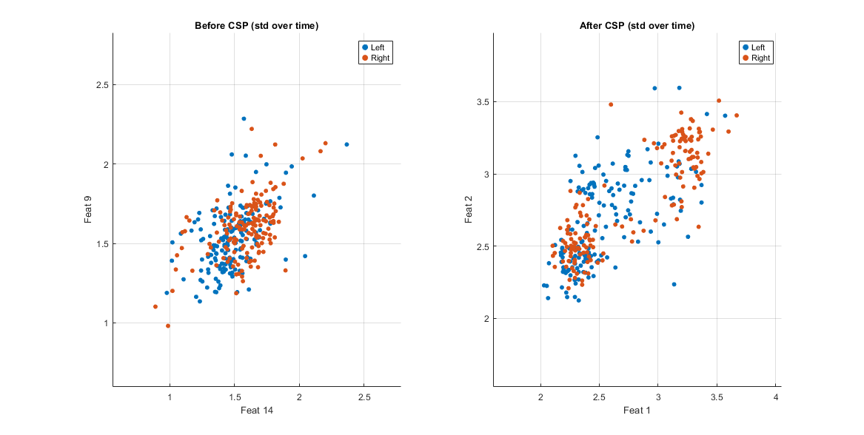
Figure 7. Data before and after CSP filter
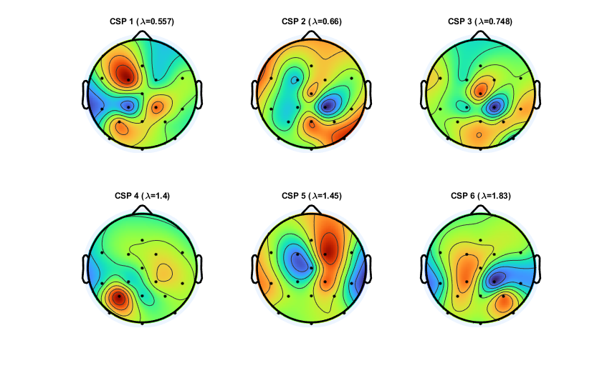
Figure 8. Display the CSP filter on the scalp
This figure 7 compares the feature distributions before and after CSP. In the left plot (Before CSP), left-hand and right-hand trials are highly overlapping. This shows that the original EEG features do not separate the two classes well.In the right plot (After CSP), the left-hand and right-hand trials are more clearly separated. After CSP, the features show different patterns for the two classes, with less overlap. Hence, CSP improves the separability of left and right imagined movements, making the data easier to classify.
The standard deviation of the projected data in each trial is utilized to remove the time dimension. Because the standard deviation measures the signal power of each CSP component during a trial. Motor imagery mainly changes the variance of EEG rhythms rather than the exact waveform shape. Using standard deviation captures this discriminative information while producing a fixed-length feature vector, which is suitable for classification.

Classification in CSP-Projected Space
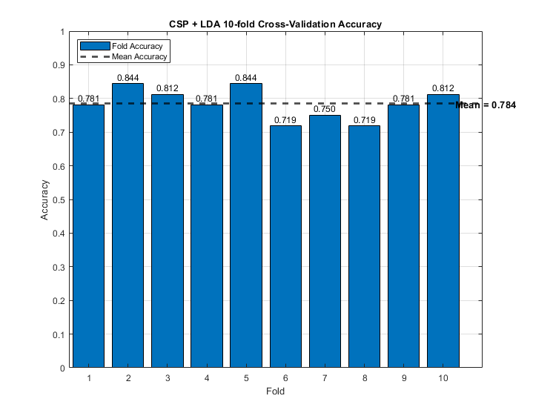
Figure 8. Display the 10-fold accuracy
The CSP + LDA classifier shows good and stable performance. Across the 10 non-overlapping folds, accuracies range from about 72% to 84%, with a mean accuracy of 78.4%, which is clearly above random choice (50%). The small standard error (0.0143) indicates that performance is consistent across folds, with little variation between training and testing splits. Overall, these results suggest that CSP successfully extracts discriminative features for left vs. right motor imagery, and LDA provides reliable classification result.

