**Effects of Human Resource Management on Project Effectiveness and Success**

**3.Introduction**

Human Resource Management (HRM) plays very important role in the overall success of projects within organizations. This report focuses on exploring various effects of HRM on project effectiveness and success.

**3.1 Definition of Human Resource Management (HRM):**

Human Resource Management is nothing but employee management with an emphasis on employees as assets of the business. It is a strategic approach to the effective management of people within an organisation so that they help the business gain a competitive advantage. HRM is largely concerned with hiring, managing and giving employees right direction within the organisation.

**3.2 Definition of Project Effectiveness and Success:**

Project effectiveness can be explained as how well a project achieves its objectives while optimizing the use of resources, such as time, cost, and manpower. Project success, on the other hand, is mostly defined by completing a project on time, within budget, and according to quality specifications. Additionally, successful projects always achieve long-term goals such as stakeholder satisfaction and sustainable growth.

**3.3 Importance of topic:**

Human Resource Management is often simply referred to as Human Resources (HR). The main purpose of the HRM practice is to manage the people within a workplace to achieve organisations mission. The effective management of human resources impacts the timely execution of tasks, team morale, conflict resolution, and the overall project outcome. In this advancing era where the ability to adapt to rapid changes is crucial, the influence of HRM in project management is more significant than ever.

Human Resources contribute their best in every layer of an organization, from recruiting to data management.

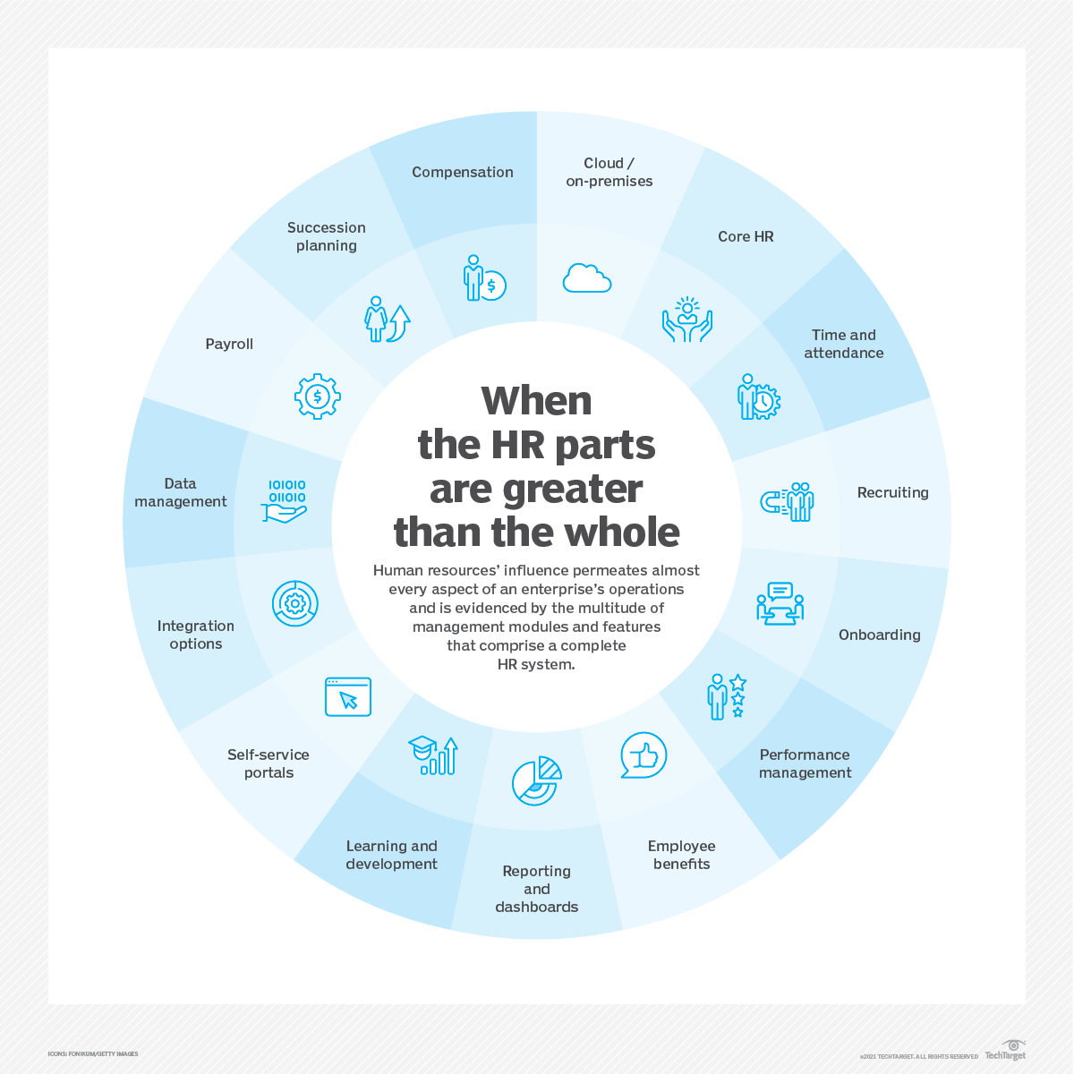

**4. Literature Review**

**4.1 Overview of existing research on HRM and project outcomes:**

The amount of research on the connection between project outcomes and human resource management (HRM) has increased dramatically. The existing research presents several prominent themes including:  
**Diversity and Team Composition:**

* Teams with complementary skills outperform one another on challenging projects.
* Diverse teams can solve problems more creatively and are better equipped to adjust to project needs.

**Styles of Leadership:**

* Project success has been found to be favourably connected with good leadership.
* It has been identified that leaders who foster open communication and guide their teams achieve better project outcomes.

**Training and Development:**

* It’s identified that the major contribution to the project effectiveness is through continuous skill enhancement programs.
* Smart training initiatives help in improving team performance and their adaptability in dynamic project environments.

**Communication:**

* Over years effective communication among team members and stakeholders has been crucial for project success.
* The clearer and more effective the communication is the more it helps in managing expectations, resolve conflicts and maintain project momentum.

**4.2 Key theories and models related to HRM and project success:**

There were several frameworks that provide insights into how HRM practices influence project success.

**Resource-Based View (RBA):**

* The critical source who aid to competitive advantage for organizations were human resources.
* Projects those utilize human capital effectively tend to outperform those neglecting the resource.

**Social Capital Theory:**

* This theory helps us in understanding the importance of social relationships within teams for achieving project goals.
* Overall success of the projects mainly depends on the strong social bonds among team members who contribute to better collaboration and knowledge sharing during projects.

**Self-Determination Theory:**

* This theory states that human behaviour is mainly motivated by three innate psychological needs which are autonomy, competence and relatedness. The projects which address these needs are said to be achieving better outcomes by engaging employees more effectively.

**Vroom’s Expectancy Theory:**

* It suggests that the effort of an employee is influenced by relationship between effort and outcome. So, the clear communication of the project goals may increase employee motivation which further increases the productivity.

**10. Conclusion**

**10.1 Summary of findings**

The study has highlighted the significant impact of Human Resource Management (HRM) on project effectiveness and success.

**The literature review has also revealed that:**

* HRM plays very important role in determining project outcomes by considering factors such as team composition, leadership styles, training and development initiatives, and effective communication.
* Various theoretical frameworks, including the Resource-Based View, Social Capital Theory, Self-Determination Theory, and Vroom's Expectancy Theory, have provided valuable insights into how HRM practices influence project success.

**10.2 Final thoughts**

In conclusion, both the theoretical frameworks which we have discussed above, and our practical experiences suggest that HRM is a key determinant of project success. Effective management of human resources leads to better team performance, which further leads to successful project outcomes. Future research could further explore how we can integrate the advanced HRM practices with project management tools to enhance project delivery in various industries.

**11. References**

**11.1 List of sources and literature cited in the report**

1. Armstrong, M., 2018. *Armstrong's Handbook of Human Resource Management Practice.* 14th ed. London: Kogan Page.

2. Barney, J.B., 1991. Firm Resources and Sustained Competitive Advantage. *Journal of Management,* 17(1), pp.99-120.

3. Jiang, J., Klein, G., and Chen, H.G., 2001. The Relative Influence of IS Project Implementation Policies on Project Performance. *Information & Management,* 38(1), pp.1-9.

4. Müller, R. and Turner, R., 2007. The Influence of Project Managers on Project Success Criteria and Project Success by Type of Project. *European Management Journal,* 25(4), pp.298-309.

5. Deci, E.L. and Ryan, R.M., 2000. The "What" and "Why" of Goal Pursuits: Human Needs and the Self-Determination of Behavior. *Psychological Inquiry,* 11(4), pp.227-268.

6. Putnam, R.D., 2000. *Bowling Alone: The Collapse and Revival of American Community.* New York: Simon & Schuster.

7. Herzberg, F., Mausner, B., and Snyderman, B.B., 1959. *The Motivation to Work.* New York: John Wiley & Sons.

8. Vroom, V.H., 1964. *Work and Motivation.* New York: Wiley.

9. Turner, J.R., 2009. *The Handbook of Project-Based Management: Leading Strategic Change in Organizations.* 3rd ed. New York: McGraw-Hill.

10. Ulrich, D. and Brockbank, W., 2005. *The HR Value Proposition.* Boston: Harvard Business School Press.