LITTLE LEMON
Database Management & Sales Analytics Project
Implementation documentation and data analysis report

1. Executive overview
This project delivers a normalized operational database for restaurant bookings and a dimensional analytics model for the supplied Little Lemon orders dataset. It includes MySQL DDL and stored procedures, Python clients and ETL, cleaned analysis data, Tableau setup materials, diagrams and a data analysis report.
The supplied spreadsheet contains 21,000 order-line records, not booking records. The booking system is modelled separately according to the project brief; the spreadsheet populates the sales analytics star schema.

2. Data model
Operational model: Customers, Employees, RestaurantTables, Bookings, MenuItems, RestaurantOrders and OrderItems. Bookings connect a customer to a restaurant table and optionally an employee. Restaurant order headers link to customers and optionally bookings; order lines connect orders to menu items.
Analytics model: DimCustomer, DimGeography, DimMenu and DimDate dimensions surround FactSales. Each fact row represents one row in the source spreadsheet.
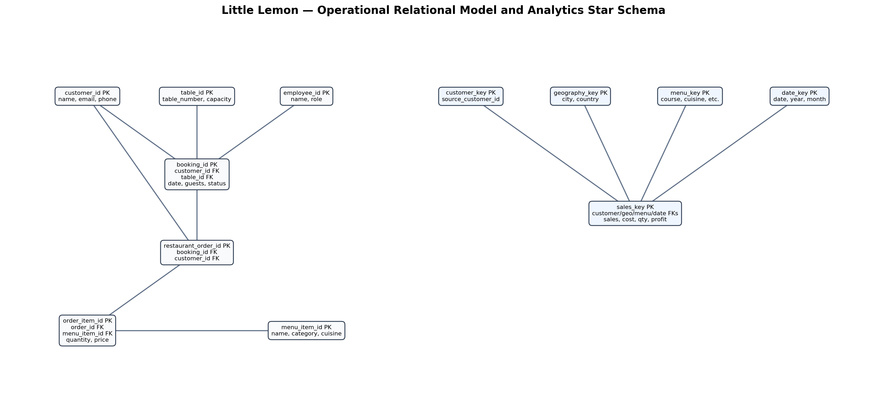

3. Dataset profile
Rows: 21000
Unique Orders: 1000
Unique Customers: 1000
Countries: 123
Sales Total: 4,631,847.03
Cost Total: 3,087,898.02
Delivery Cost Total: 1,070,484.66
Gross Profit Total: 473,464.35
Avg Order Sales: 220.56
Avg Quantity: 2.12
Missing Country Codes: 42
Order Date Min: 2019-06-14
Order Date Max: 2023-01-06
Delivery Before Order: 9366
Duplicate Order Id Rows: 21000

4. Data preparation and quality
The source data was loaded and column names normalized for analysis. Forty-two missing country codes were replaced with UNK in the cleaned extract. The original workbook remains unchanged. A major anomaly was identified: 9,366 rows have a delivery date earlier than the order date. These values were retained and flagged for validation rather than being automatically corrected.
There are 21,000 rows and 1,000 distinct Order IDs, so order IDs repeat across detail lines. Monetary values are shown in source currency units because no currency is specified. Gross Profit is calculated as Sales minus Cost minus Delivery Cost.

5. Database and stored procedures
Run sql/little_lemon.sql in MySQL Workbench. It creates the operational and analytical tables, foreign keys, indexes, reference rows and the required procedures:
- GetMaxQuantity() — returns the maximum guest count among bookings.
- ManageBooking(booking_id) — checks whether a booking exists and reports its status.
- AddBooking(customer_id, booking_date, table_id, guests) — validates and inserts a booking.
- UpdateBooking(booking_id, booking_date, table_id, guests) — updates a confirmed booking.
- CancelBooking(booking_id) — changes a confirmed booking to CANCELLED.

6. Python implementation
python/booking_client.py connects to MySQL and demonstrates calling each stored procedure. python/load_analytics.py reads the source Excel workbook and loads its rows into the dimensional model. Install dependencies from python/requirements.txt and configure connection settings using python/.env.example. Never commit actual passwords.

7. Tableau reporting
The cleaned CSV is Tableau-ready. Recommended worksheets are monthly sales trend, sales by cuisine, top 10 countries, quantity by course, discount versus sales and executive KPI tiles. Assemble these into the Little Lemon Sales Performance dashboard and apply Order Year, Country, Cuisine and Course filters. See tableau/TABLEAU_BUILD_GUIDE.md. The included TWB is a starter workbook intended for relinking and validation in Tableau Desktop; save the final dashboard as a packaged TWBX from Tableau.

8. Key analytical findings
Total sales are 4,631,847.03 source currency units. Total cost is 3,087,898.02; delivery cost is 1,070,484.66; derived gross profit is 473,464.35. The workbook spans 2019-06-14 to 2023-01-06 and includes customers across 123 countries.

9. Deployment checklist
- Execute SQL script in MySQL Workbench.
- Reverse-engineer the schema to create the editable Workbench EER model.
- Configure Python environment variables and install requirements.
- Run the Excel-to-MySQL ETL script.
- Test all five stored procedures using the Python client or CALL statements.
- Connect Tableau to the cleaned CSV or MySQL FactSales star schema.
- Build and save the final dashboard as .twbx.
- Commit the project folder to GitHub; exclude credentials and local environment folders.

10. Assumptions and limitations
The brief does not define detailed booking attributes or reservation conflict rules. The implementation uses a 120-minute same-table conflict window, requires a table capacity at least equal to guest count, and restricts updates/cancellations to confirmed bookings. The provided spreadsheet contains order data rather than booking data. The TWB starter should be opened, relinked and validated in Tableau Desktop; Tableau Desktop was not available in this build environment to certify a packaged workbook.

