Nav

Header aside

main

article

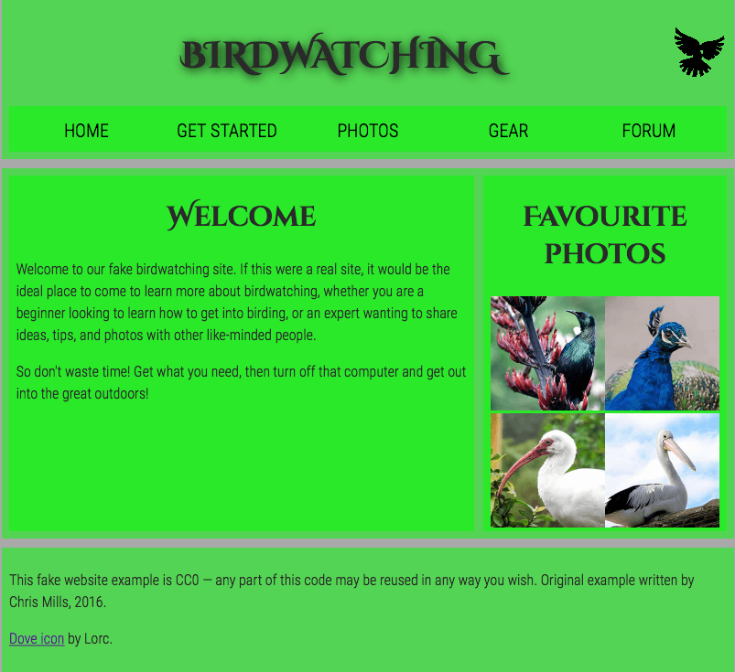

Footer