**Abstract:**

Internet of things is an idea of making devices and objects smarter by linking them to internet. Using Raspberry Pi computer, DHT sensor and an electronic device that transmit or receive information about temperature and humidity data over the internet is employed. Program the system in such a way that whenever the temperature exceeds a certain limit the device will automatically sends an notification to the mobile through SMS. A readily available IOT app from play store is installed in a mobile for performing switch on/off actions to the electronic devices present in the same room. Hence the temperature of the room can be controlled. Raspberry Pi is a mini-computer which performs multiple tasks at a time than Microcontroller which is a application specific i.e., one program can be run at a time. Internet connectivity is not easy in microcontroller but it is fairly easy to connect Raspberry Pi to internet.

1. **INTRODUCTION:**

Main aim of the project is to measure temperature and relative humidity by using appropriate sensors which is very beneficial for industrial purpose and also for house hold purpose. Recording the information is also necessary which can be done by incorporating devices. Raspberry PI is the latest and efficient wireless temperature control technique.

1. **EXISTING METHODS:**

Arduino works as a microcontroller for controlling the temperature but the disadvantages of it are:

* Power requirement
* Network connectivity
* Sensor connectivity
* Development languages

These are overcome by using **Raspberry PI**.

**Raspberry PI** is a mini-computer which performs multiple tasks at a time than Microcontroller which is a application specific i.e., one program can be run at a time. Internet connectivity is not easy in microcontroller but it is fairly easy to connect Raspberry Pi to internet.

1. **MODIFIED METHOD:**

Raspberry pi is the latest technology. Proposed system visualize and store temperature parameters with the help of sensors interfaced to Raspberry Pi will get all data and stored in a memory card. Python is the recommended language. A mobile app is used for temperature recording.

1. **COMPONENTS REQUIREMENT:**

Hardware requirement:

* Raspberry Pi
* DHT11 Sensor
* Devices (Fan and Electrical bulb)
* Micro SD card
* Mobile
* VGN to HDMI cable
* Power bank

Software requirement:

* Install OS
* Python programming
* Internet connection
* Mobile app

**4.1.RASPBERRY PI:**

The Raspberry Pi is a wonderful micro computer that brims with potential. With a Raspberry Pi can build robots, learn to code, and create all kinds of weird and wonderful projects. Raspberry Pi with a small green board of chips and sockets. Before building the basics sorted: keyboard, mouse, display, and operating system.

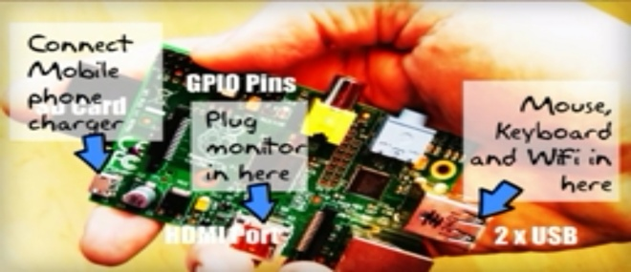

Fig 4.1: Raspberry Pi

**4.2.DHT11 SENSOR:**

DHT11 digital temperature and humidity sensor is a composite Sensor contains a calibrated digital signal output of the temperature and humidity.

**Features:**

Low cost, long-term stability, relative humidity and temperature measurement, excellent quality, fast response, long distance signal transmission, digital signal output, and precise calibration.

**Applications:**

HVAC, dehumidifier, testing and inspection equipment, consumer goods, automotive, automatic control, data loggers, weather stations, home appliances, humidity regulator, medical and other humidity measurement and control.

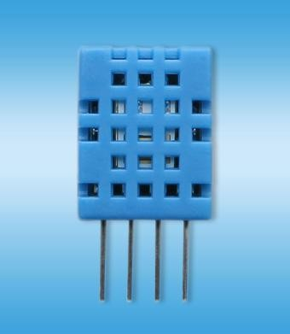

Fig 4.2:DHT11 sensor

**4.3.MICRO SD CARD:**

The micro SD card acts as the hard drive for Raspberry Pi.Install the Raspbian operating system onto the card, then all documents, files, and projects are saved to it.Samsung Evo+ and SanDisk Extreme are two popular brands worth looking out for, and both are fairly cheap.

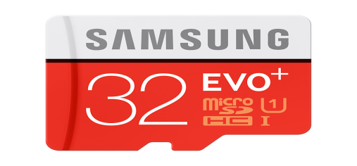

Fig 4.3:Micro SD Card

**4.4.HDMI cable:**

An HDMI cable is the easiest way to connect Raspberry Pi to a computer monitor or television. Don’t need an expensive one, and most people recycle one from an old games console or DVD player.

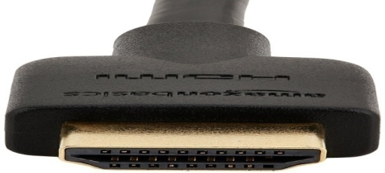

Fig 4.4: HDMI Cable

**4.5.USB power:**

A good 2A or 2.5A power supply provide with enough power to run a Raspberry Pi with all kinds of peripherals connected.

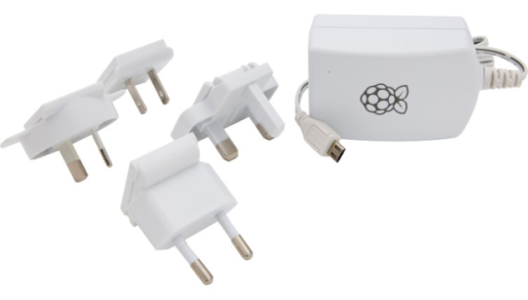

Fig 4.5: USB Power Cable

1. **INSTALLING OS:**

**5.1.Start with NOOBS :**

There are two approaches to installing Raspbian and other operating systems. Beginners should start with NOOBS .More advanced users may copy an image file containing a whole operating system directly to the SD card. Connect your micro SD card to a Mac or Windows PC, typically using a micro SD-to-SD card adapter or a USB card reader, and use **SD Card Formatter** to erase the card. Next, download the NOOBS ZIP file. Extract the contents of the file and open the NOOBS folder. Copy the contents across to the root of the SD card.

1. **AVAILABLE OS:**

**6.1.Raspbian :**

The official operating system is the easiest to use, and the one beginners should start with. It works a lot like other popular operating systems.

**6.2.Windows 10 IOT Core :**

Not the full version of Windows, but Windows 10 IOT Core enables programmers to run Internet of Things and embedded projects

**6.3.Ubuntu MATE:**

Ubuntu is one of the world’s most popular Linux operating systems, lightweight version that runs just fine on the Raspberry Pi.

1. **SETTING UP THE INTERNET:**

Get online wirelessly and quickly, setting up wireless LAN on Raspberry Pi

**7.1.Check for networks:**

Click on the Wireless Networks icon in the Panel. Raspbian will display a list of all the wireless networks available in local area. Click on the one that's ours.

**7.2.Enter your password**:

Enter your Wi-Fi password in the Pre Shared Key field and click on OK. The network symbol will switch to a wireless symbol and connected.

**7.3.Test connection:**

Test internet connection by opening a webpage. Click on Web Browser in the Launch Bar and enter www.raspberrypi.org in the URL field. Press RETURN to load the page.

1. **BLOCK DIAGRAM:**

Fig 8: Block Diagram

1. **CONCLUSION:**

Based on current situation of the development, a new scheme of house hold temperature and humidity monitoring system composed of Raspberry Pi, DHT11 sensor and android mobile phone is used. Proposed method has good flexibility. Cheaper in cost compared to the existing techniques.

1. **REFERENCES:**

[1] Basil Ahammed, Design & Implementation of Smart House Control Using LabVIEW, International Journal of Soft Computing and Engineering (IJSCE), 1 (6), 2012.

[2] Dingrong Yuan, Shenglong Fang, Yaqiong Liu, The design of smart home monitoring system based on WiFi electronic trash, Journal of Software, 9 (2), 2014, 425-428.

[3] Jiansheng PENG W.L, Qiwen HE, Design of smart home system based on the wireless MCU CC2510, Journal of Hechi University, 10, 2008.

[4] Patricio G, Gomes L, Smart house monitoring and actuating system development using automatic code generation, Industrial Informatics, 7th IEEE International Conference, 256-261, 2009, 23-26.

[5] Vinay Sagar K.N, Kusuma S.M, Home Automation using Internet of Things, IRJET, 02, 2015.