Invention Disclosure Form (IDF)
Academic Intellectual Property Documentation — Research Methodology (RM)
RV University, Bengaluru, Karnataka, India
Date of Submission: [TO BE PROVIDED BY INVENTORS]
Internal Reference ID: RVU-RM-IDF-2026-VEERA-01
Academic Context: Research Methodology (RM) Coursework Evaluation, School of Computer Science and Engineering
Introductory Statutory Criteria:
A patent application must meet the following criteria in order to apply for patent (under the Indian Patents Act, 1970 and Patent Rules):
Statutory Criterion | Statutory Definition & Requirement under The Patents Act, 1970
1. Novelty  [Section 2(1)(j)] | The subject matter of the invention must be new, meaning it has not been published anywhere in the world in any document, nor publicly used or known prior to the filing date (priority date) of the patent application. It must not fall into the public domain.
2. Inventive Step  [Section 2(1)(ja)] | A feature of an invention that involves technical advance as compared to existing knowledge, or having economic significance, or both, making the invention not obvious to a person skilled in the art (PSITA) in the relevant technical domain.
3. Industrial Applicability  [Section 2(1)(ac)] | The invention must possess utility and be capable of being made or used in an industry, automated inspection, quality assessment, or practical computing environment.
4. Non-Patentability Filter  [Section 3(k) / CRIs] | Under Section 3(k), a mathematical method, a business method, a computer programme per se, or algorithms are not patentable. For Computer-Related Inventions (CRIs) involving Artificial Intelligence (AI) and Machine Learning (ML), the application must demonstrate: (i) a technical effect, (ii) solving a specific technical problem in digital image processing / multimodal inference, (iii) practical hardware-software interaction (e.g., processor, memory, display), and (iv) avoid claiming an abstract algorithmic calculation in isolation.

Following details must be provided by the inventor(s) who wishes to apply for patent:
1. Title of Invention:
Full Statutory Title: FAILURE-AWARE MULTIMODAL EVIDENCE ACQUISITION SYSTEM AND ADAPTIVE COMPUTE ALLOCATION METHOD FOR RELIABLE VISION-LANGUAGE INFERENCE
Short Working / Project Title: VEERA (Visual Evidence Evaluation and Reliability Assessment)
2. List All Inventors:
Note: Under Indian Patent Law, an inventor must be an actual natural person who contributed directly to the inventive concept, technical architecture, or experimental formulation. Separate fields are provided below for each contributor:
Inventor 1 (Lead Student Researcher / Core Architecture):
Full Legal Name | [INFORMATION REQUIRED FROM INVENTORS]
Designation & Academic Roll No. | [INFORMATION REQUIRED FROM INVENTORS]
Department & School | [INFORMATION REQUIRED FROM INVENTORS]
College / Institute / University | [INFORMATION REQUIRED FROM INVENTORS]
Contact Number & Email ID | [INFORMATION REQUIRED FROM INVENTORS]
Nationality & Country of Residence | [INFORMATION REQUIRED FROM INVENTORS]
Permanent Residential Address | [INFORMATION REQUIRED FROM INVENTORS]
Signature & Date | Signature: _______________________ Date: ______________
Inventor 2 (Co-Student Researcher / Teammate):
Full Legal Name | [INFORMATION REQUIRED FROM INVENTORS]
Designation & Academic Roll No. | [INFORMATION REQUIRED FROM INVENTORS]
Department & School | [INFORMATION REQUIRED FROM INVENTORS]
College / Institute / University | [INFORMATION REQUIRED FROM INVENTORS]
Contact Number & Email ID | [INFORMATION REQUIRED FROM INVENTORS]
Nationality & Country of Residence | [INFORMATION REQUIRED FROM INVENTORS]
Permanent Residential Address | [INFORMATION REQUIRED FROM INVENTORS]
Signature & Date | Signature: _______________________ Date: ______________
Inventor 3 (Faculty Guide / Academic Supervisor):
Full Legal Name | [INFORMATION REQUIRED FROM INVENTORS]
Designation & Academic Roll No. | [INFORMATION REQUIRED FROM INVENTORS]
Department & School | [INFORMATION REQUIRED FROM INVENTORS]
College / Institute / University | [INFORMATION REQUIRED FROM INVENTORS]
Contact Number & Email ID | [INFORMATION REQUIRED FROM INVENTORS]
Nationality & Country of Residence | [INFORMATION REQUIRED FROM INVENTORS]
Permanent Residential Address | [INFORMATION REQUIRED FROM INVENTORS]
Signature & Date | Signature: _______________________ Date: ______________
Additional Inventors (if applicable): [INFORMATION REQUIRED FROM INVENTORS — If additional faculty or students contributed to the inventive step, replicate the inventor table structure above before formal submission.]

Project and Invention Description:
3. Is this a funded project? If yes, provide details:
[INFORMATION REQUIRED FROM INVENTORS — To be confirmed]:
- Coursework Context: Project was undertaken as part of the academic curriculum for the Research Methodology (RM) course in the School of Computer Science and Engineering, RV University.
- Funding Verification: [INVENTORS MUST CONFIRM — Whether this work was self-funded academic coursework, or received internal university seed funding or an external research grant. If funded, supply: Grant Agency, Sanction Order No., Project Code, and Sanction Date].
4. Is this work bounded by any contractual agreement?
[INFORMATION REQUIRED FROM INVENTORS — To be confirmed]:
- Institutional IP Policy: Subject to the Intellectual Property Policy of RV University, Bengaluru, governing student coursework, laboratory infrastructure usage, and faculty guidance.
- Third-Party / Industry Agreements: [INVENTORS MUST CONFIRM — Confirm whether any non-disclosure agreements (NDAs), third-party industry sponsor agreements, or dataset access restrictions apply].
5. Is the invention a product or a process?
Classification: Both Product and Process (System and Computer-Implemented Method).
- A. Product Aspect: Product Aspect (System / Apparatus): A computer-based multimodal inspection apparatus comprising: an image ingestion interface; a memory storing base vision-language weights and a domain-adapted LoRA adapter; a hardware processor (CPU / GPU accelerator); an empirical reliability evaluation unit; an adaptive multi-crop spatial evidence acquisition controller; and a graphical inspection interface.
- B. Process Aspect: Process Aspect (Computer-Implemented Method): A sequential, failure-aware evidence acquisition and inference method comprising: capturing an image and question; generating next-token logits; computing a probability gap G(x,q) = |p_Yes - p_No|; evaluating G(x,q) against a validation-calibrated sufficiency threshold tau = 0.7853; autonomously emitting an answer if sufficient; conditionally generating overlapping spatial crops (400x400 with 50% stride) if ambiguous; conducting multi-crop voting; and selectively emitting a verified consensus verdict or an explicit abstention decision.
6. Has this work been disclosed to the public before? Yes / No / Details required:
[INFORMATION REQUIRED FROM INVENTORS — Exact public disclosure history must be audited prior to filing]:
- Kaggle Platform Disclosure: Dataset 'gaganakp/veera-finetuned-release' and notebook 'veera-kaggle-gpu-deployment' exist on Kaggle. [INVENTORS MUST VERIFY: Check whether dataset and notebook access settings are set to 'Private' or 'Public'. Public visibility prior to filing date may constitute prior publication under Section 29–34 of The Patents Act, 1970].
- Academic / Coursework Presentations: Project demonstrations and presentations conducted internally for RV University faculty and peers as part of continuous internal evaluation (CIE). [INVENTORS MUST CONFIRM whether any external individuals attended without an NDA].
- Preprints / Repositories: [INVENTORS MUST CONFIRM whether any paper, preprint, or GitHub repository has been made publicly accessible].
7. Proposed Abstract of the Invention:
A failure-aware multimodal evidence acquisition system and computer-implemented method for reliable vision-language inference are disclosed. The system includes an input interface, memory storing a base vision-language model and a fine-tuned low-rank adaptation (LoRA) adapter, and a processor executing a reliability evaluation unit and an evidence controller. In response to an input image and query, the system executes an initial forward pass and extracts softmax probabilities for binary answer tokens to compute an empirical reliability gap G(x,q) = |p_Yes - p_No|. A sufficiency gating mechanism compares G(x,q) against a validation-calibrated threshold tau (0.7853). When G(x,q) >= tau, a confident direct answer is output autonomously without secondary visual inspection. When G(x,q) < tau, the evidence controller dynamically extracts multiple localized spatial crops (400x400 pixels at 50% stride) across cardinal regions of the image, conducts local crop inference, and aggregates multi-crop votes. If crop consensus reaches a defined quorum (>= 75%), a verified verdict is emitted; if evidence remains contradictory, the system triggers failure-aware abstention, thereby mitigating overconfident errors while selectively allocating compute.
8. Key Words:
Vision-Language Models (VLM); Failure-Aware Multimodal AI; Reliability Estimation; Softmax Probability Gap; Visual Evidence Acquisition; Adaptive Compute Allocation; Selective Abstention; Low-Rank Adaptation (LoRA); Computer-Related Inventions (CRI).
9. Background of the Invention:
Vision-Language Models (VLMs), such as Qwen2.5-VL, LLaVA, and related architectures, have shown strong capabilities in multimodal scene understanding and question answering. However, in automated inspection and reliability-critical applications, standard VLMs exhibit three significant technical limitations:
- 1. Overconfident Generation: Absence of Direct Reliability Calibration: Standard VLMs generate responses autoregressively without estimating the empirical certainty of their visual grounding. Consequently, they can assert incorrect binary claims with high text generation probabilities, misleading downstream automated systems.
- 2. Uniform Computational Expenditure: Uniform Multi-Billion Parameter Inference Cost: In conventional pipelines, every input query triggers the exact same computational forward pass through multi-billion parameter transformer layers, regardless of whether the image presents an obvious feature or an ambiguous, fine-grained visual region.
- 3. Inability to Abstain Gracefully: Forced Decision-Making: Standard classifiers are forced to output a binary decision (e.g., 'Yes' or 'No') even when visual evidence is corrupted, blurred, occluded, or inconclusive. In safety-critical or quality-assurance contexts, an uncalibrated forced guess can be problematic, whereas a failure-aware 'abstain / request review' decision provides operational safety.
Prior art techniques rely on static test-time augmentation (TTA), uniform ensemble voting, or external calibration networks. However, these techniques multiply inference latency across all inputs and do not selectively acquire localized visual evidence based on real-time uncertainty gating. There is a need for an architecture that couples logit-level reliability extraction with selective multi-crop evidence acquisition and formal abstention.
10. What problems does the invention address and how is your invention able to overcome the limitations/problems of the existing technologies?
The invention provides specific procedural and architectural approaches to address the limitations identified above:
- A. Addressing Overconfident Generation: Logit-Level Probability Gap: Rather than relying on heuristic text generation confidence, VEERA isolates raw logit outputs at the first answer token position for the binary token pair ('Yes', Token ID 9454; 'No', Token ID 2753 in Qwen2.5-VL), normalizes them via softmax, and computes the absolute probability gap G(x,q) = |p_Yes - p_No|. This provides a mathematically bounded [0.0, 1.0] uncertainty metric.
- B. Reducing Unnecessary Compute: Validation-Selected Sufficiency Gating: The system interposes a decision threshold tau (nominally 0.7853, selected on validation data). High-certainty inputs (G >= tau) exit immediately after a single forward pass (~0.503 seconds mean latency on GPU), spending zero additional compute on unambiguous scenes.
- C. Mitigating Fine-Grained Blindness: Targeted Multi-Crop Evidence Acquisition: When an initial inspection is flagged as uncertain (G < tau), the system conditionally triggers an experimental evidence controller to extract four 400x400 overlapping crops at 50% stride covering cardinal and central regions, inspecting localized sub-regions without human intervention.
- D. Preventing Forced Guesses: Consensus Quorum and Failure-Aware Abstention: Multi-crop predictions are evaluated using a consensus quorum (>= 75% agreement). If the evidence remains split (e.g., 2 Yes vs. 2 No) or mean confidence remains substandard, VEERA abstains and outputs an explicit 'review / uncertain' status with a structured decision trace.
11. Provide a detailed explanation of the invention along with working examples. Provide an elaborated description of each aspect of the invention (product and/or process):
The VEERA architecture comprises five cooperating hardware-software subsystems configured to execute global reasoning and failure-aware evidence acquisition:
- 11.1 Subsystem Architecture: Subsystem 1: Client Graphical User Interface (React 19 + Vite): An interactive user interface providing drag-and-drop image upload, natural language query input, and a structured results display exposing reliability metrics, crop thumbnail cards with positional bounding boxes, and an inspection rationale.
- Subsystem 2: API Gateway & Marshaling Layer (FastAPI): An asynchronous server exposing /health and /api/v1/inspect endpoints, featuring image format validation (JPEG, PNG, WebP <= 10MB), non-blocking execution, and JSON schema serialization.
- Subsystem 3: Neural Vision-Language Model Core: A pre-trained Qwen2.5-VL-3B-Instruct base model coupled with a domain-adapted LoRA adapter (Rank=8, Alpha=16, Dropout=0.05, targeting attention projection layers q_proj, k_proj, v_proj, o_proj). The adapter footprint is approximately 14.1 MB, allowing dynamic loading onto the base model.
- Subsystem 4: Reliability Evaluation & Sufficiency Gating Engine: Executes next-token logit extraction, softmax normalization over primary binary token IDs, calculation of the probability gap G(x,q), and comparison against validation threshold tau = 0.7853.
- Subsystem 5: Multi-Crop Acquisition & Consensus Engine: Dynamically partitions the input image into 4 cardinal/center overlapping 400x400 crops at 50% stride, executes secondary inference passes, computes vote consensus, and outputs final disposition (answered vs. abstain).
Illustrative Working Examples (Simulated Walkthroughs for Disclosure Purposes — Not Measured Experiments):
The three walkthrough scenarios below are simulated illustrative examples designed to explain the procedural logic of the pipeline. They do not represent individual measured experimental rows.
Illustrative Example 1 — Confident Direct Resolution (Simulated High-Certainty Pass):
• Input: Image of an indoor room; Query: 'Is there a chair in the image?'
• Simulated Execution: Global forward pass yields raw logit for 'Yes' = 14.28 and 'No' = 9.12. Softmax normalization produces p(Yes) = 0.994, p(No) = 0.006. The empirical gap is G = |0.994 - 0.006| = 0.988.
• Gating Decision: Since G (0.988) >= tau (0.7853), the sufficiency condition is satisfied. The evidence controller bypasses crop generation entirely.
• Simulated Output: Status='answered', Answer='yes', Reliability Score=0.988, Evidence Inspections=0, Latency=~0.50s. Direct answer delivered with zero additional crop compute.
Illustrative Example 2 — Ambiguous Pass Resolved by Multi-Crop Acquisition (Simulated Quorum Resolution):
• Input: Cluttered scene where a small targeted object is located near an edge; Query: 'Is there a backpack in the image?'
• Simulated Execution: Global forward pass yields p(Yes) = 0.62, p(No) = 0.38. Empirical gap G = 0.24.
• Gating Decision: G (0.24) < tau (0.7853). Global evidence is deemed insufficient.
• Multi-Crop Acquisition: The controller extracts 4 overlapping 400x400 crops (Top-Left, Top-Right, Center ROI, Bottom-Right).
• Simulated Crop Inference: Crop 1: Vote='no' (G=0.88); Crop 2: Vote='no' (G=0.91); Crop 3: Vote='no' (G=0.84); Crop 4: Vote='yes' (G=0.94). Consensus: 3 'No' vs. 1 'Yes' (75% agreement).
• Simulated Output: Status='answered', Answer='no', Mean Reliability=0.893, Evidence Inspections=4. Resolved via 75% consensus quorum.
Illustrative Example 3 — Contradictory Evidence Triggering Failure-Aware Abstention (Simulated Tied Vote):
• Input: Occluded or low-quality image; Query: 'Is there a person in the image?'
• Simulated Execution: Global pass yields G = 0.31 (< 0.7853). Crop engine evaluates 4 crops. Two crops predict 'Yes' (G=0.61), while two crops predict 'No' (G=0.59).
• Aggregation: Consensus ratio is 50% (Tied vote: 2 Yes vs. 2 No). No quorum is reached.
• Simulated Output: Status='review', Answer='uncertain', Assessment='inconclusive', Evidence Inspections=4. The system abstains and flags the sample for human review.
12. Kindly attach drawings, reports, papers, charts, or other materials that may aid in your description:
The following technical figures and verified experimental charts are incorporated to substantiate the technical disclosure. Note: Performance figures reflect evaluation on the RePOPE binary object-presence benchmark (natural images from MS-COCO) and do not represent physical crack or industrial defect detection:
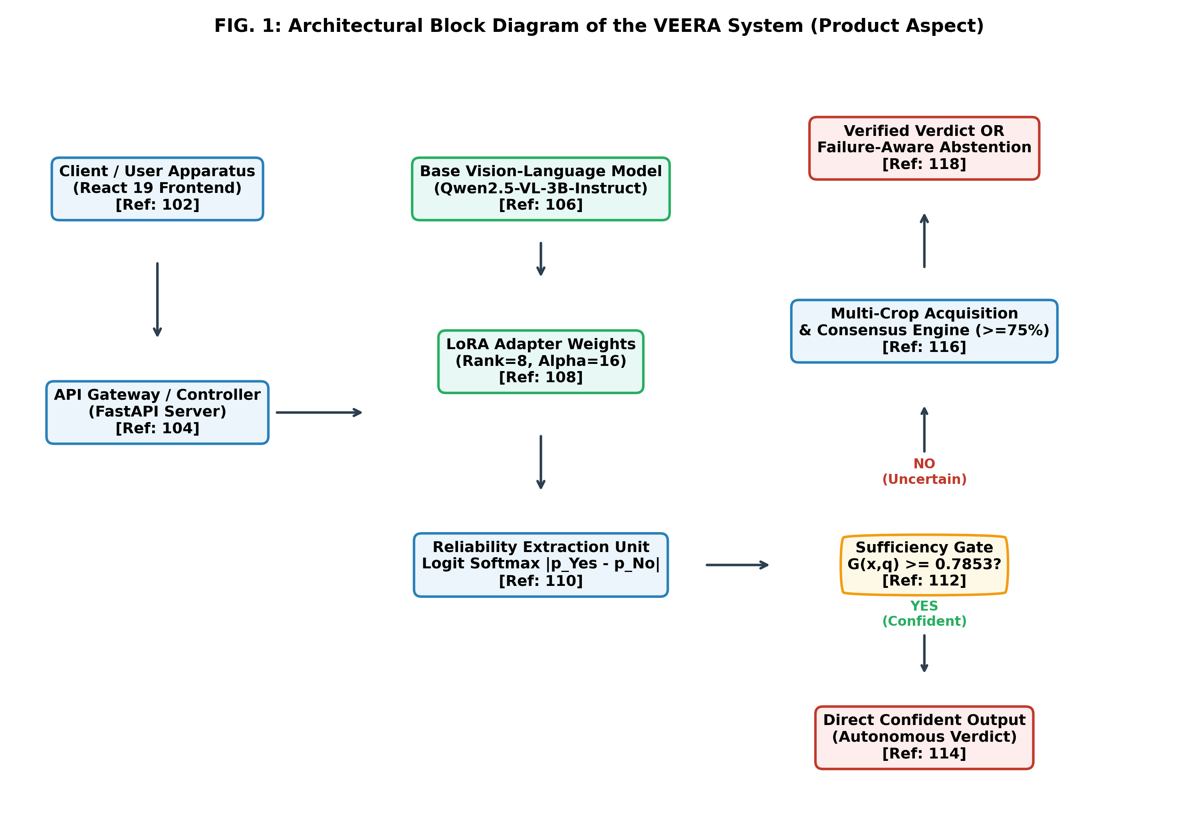
FIG. 1: Functional Block Diagram of the VEERA System Architecture (Product Aspect).
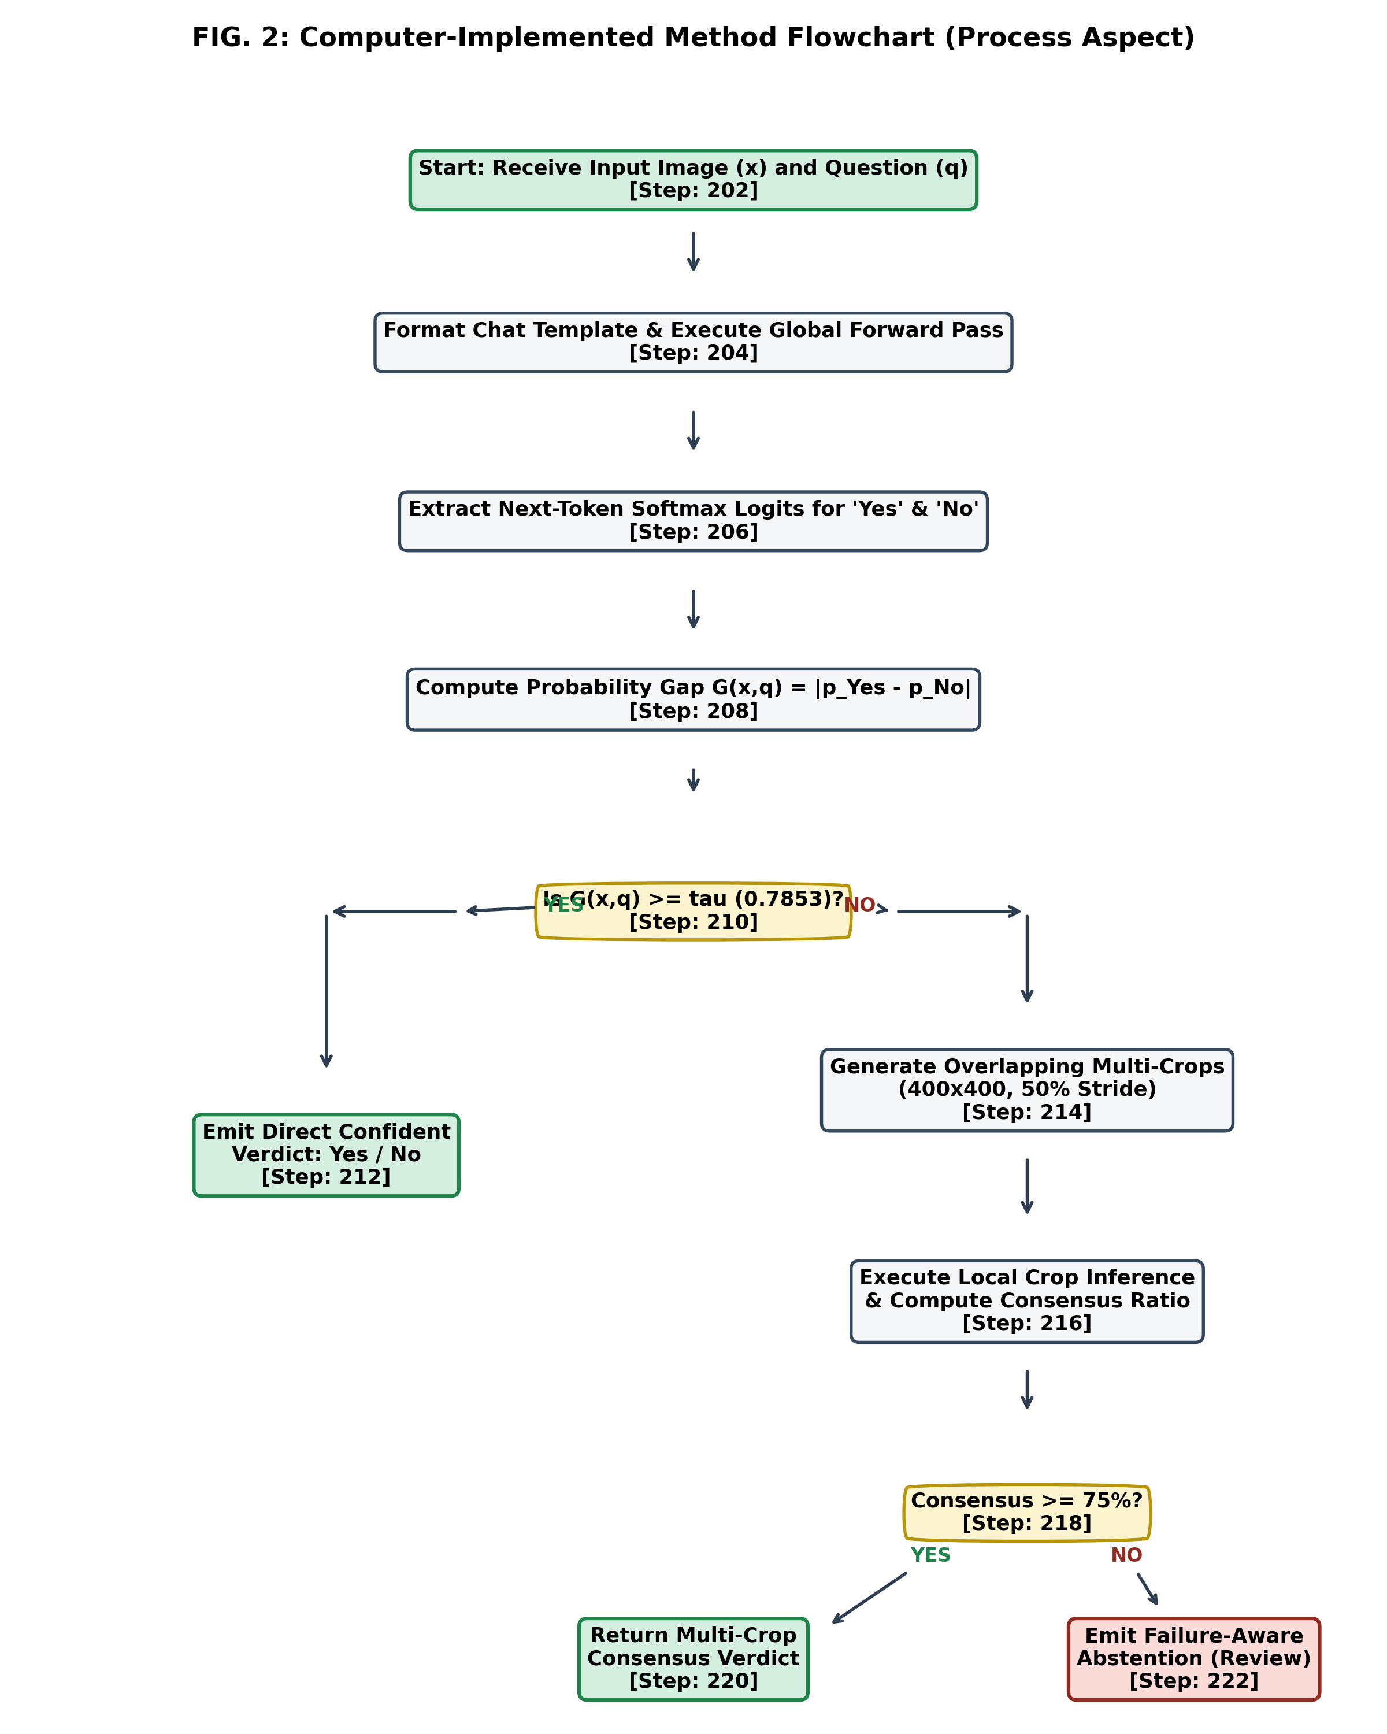
FIG. 2: Flowchart of the Dual-Stage Failure-Aware Inference Process (Method Aspect).
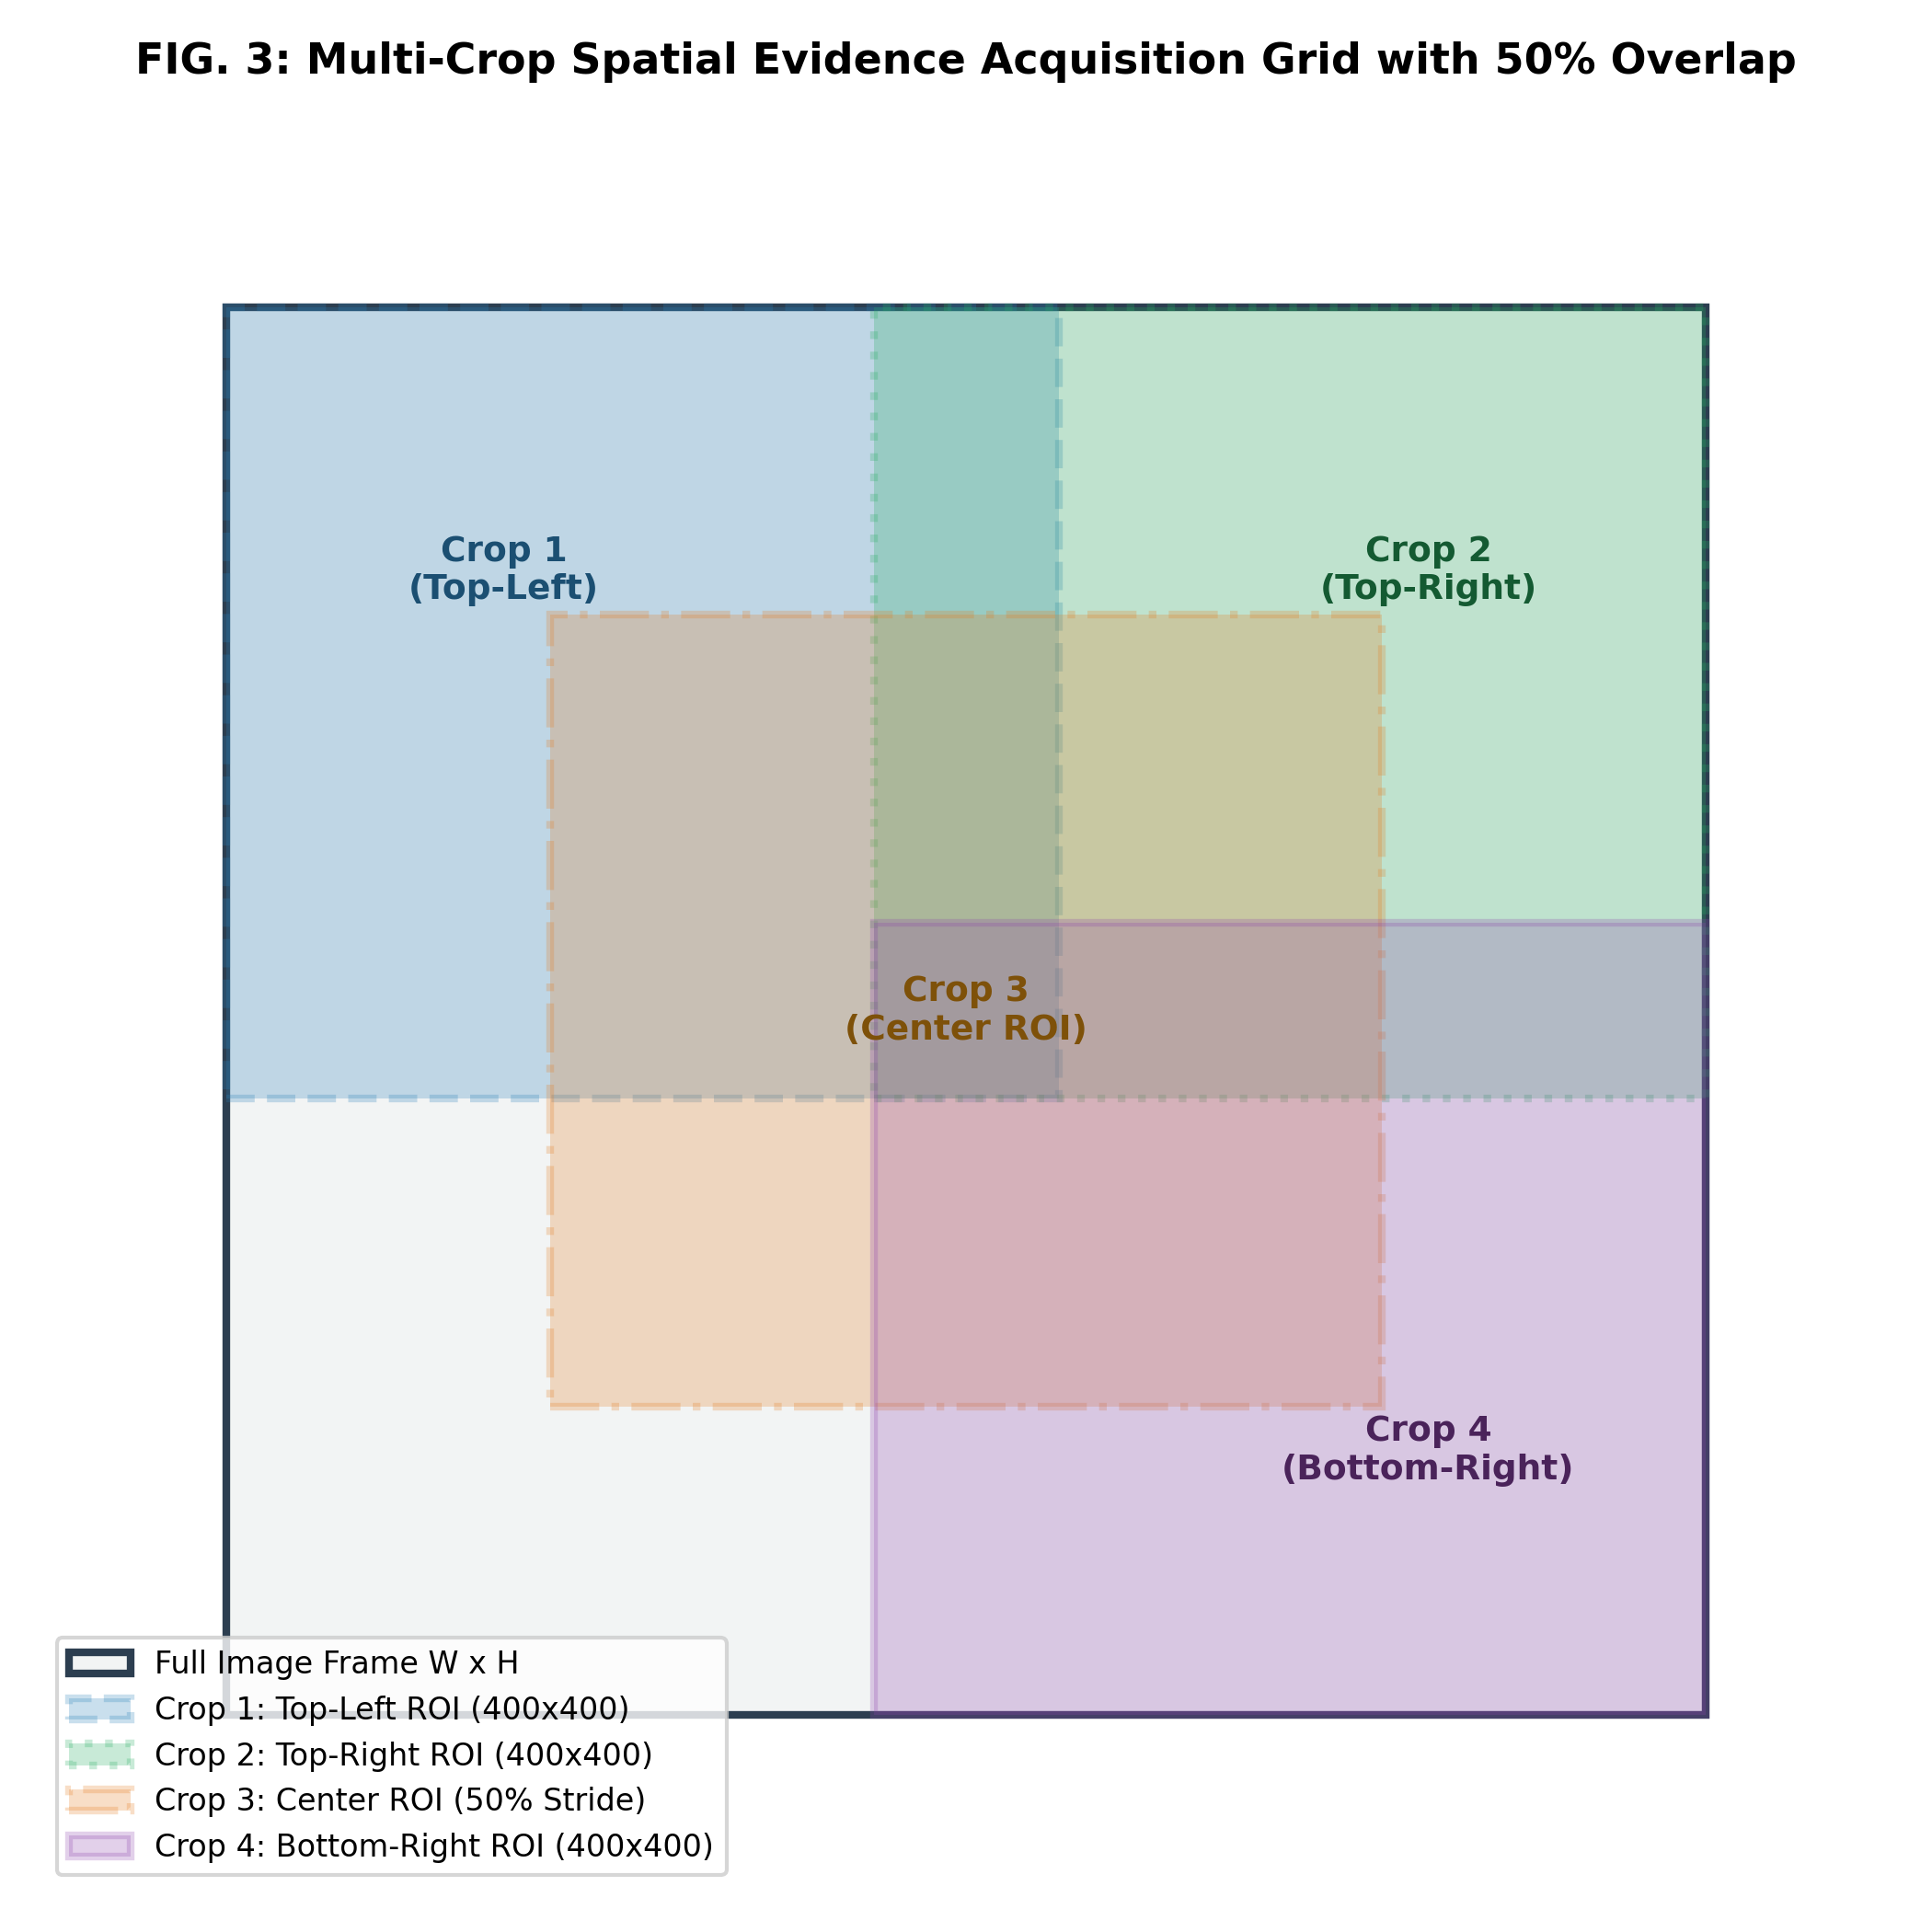
FIG. 3: Multi-Crop Spatial Evidence Acquisition Grid with 50% Overlap Stride.
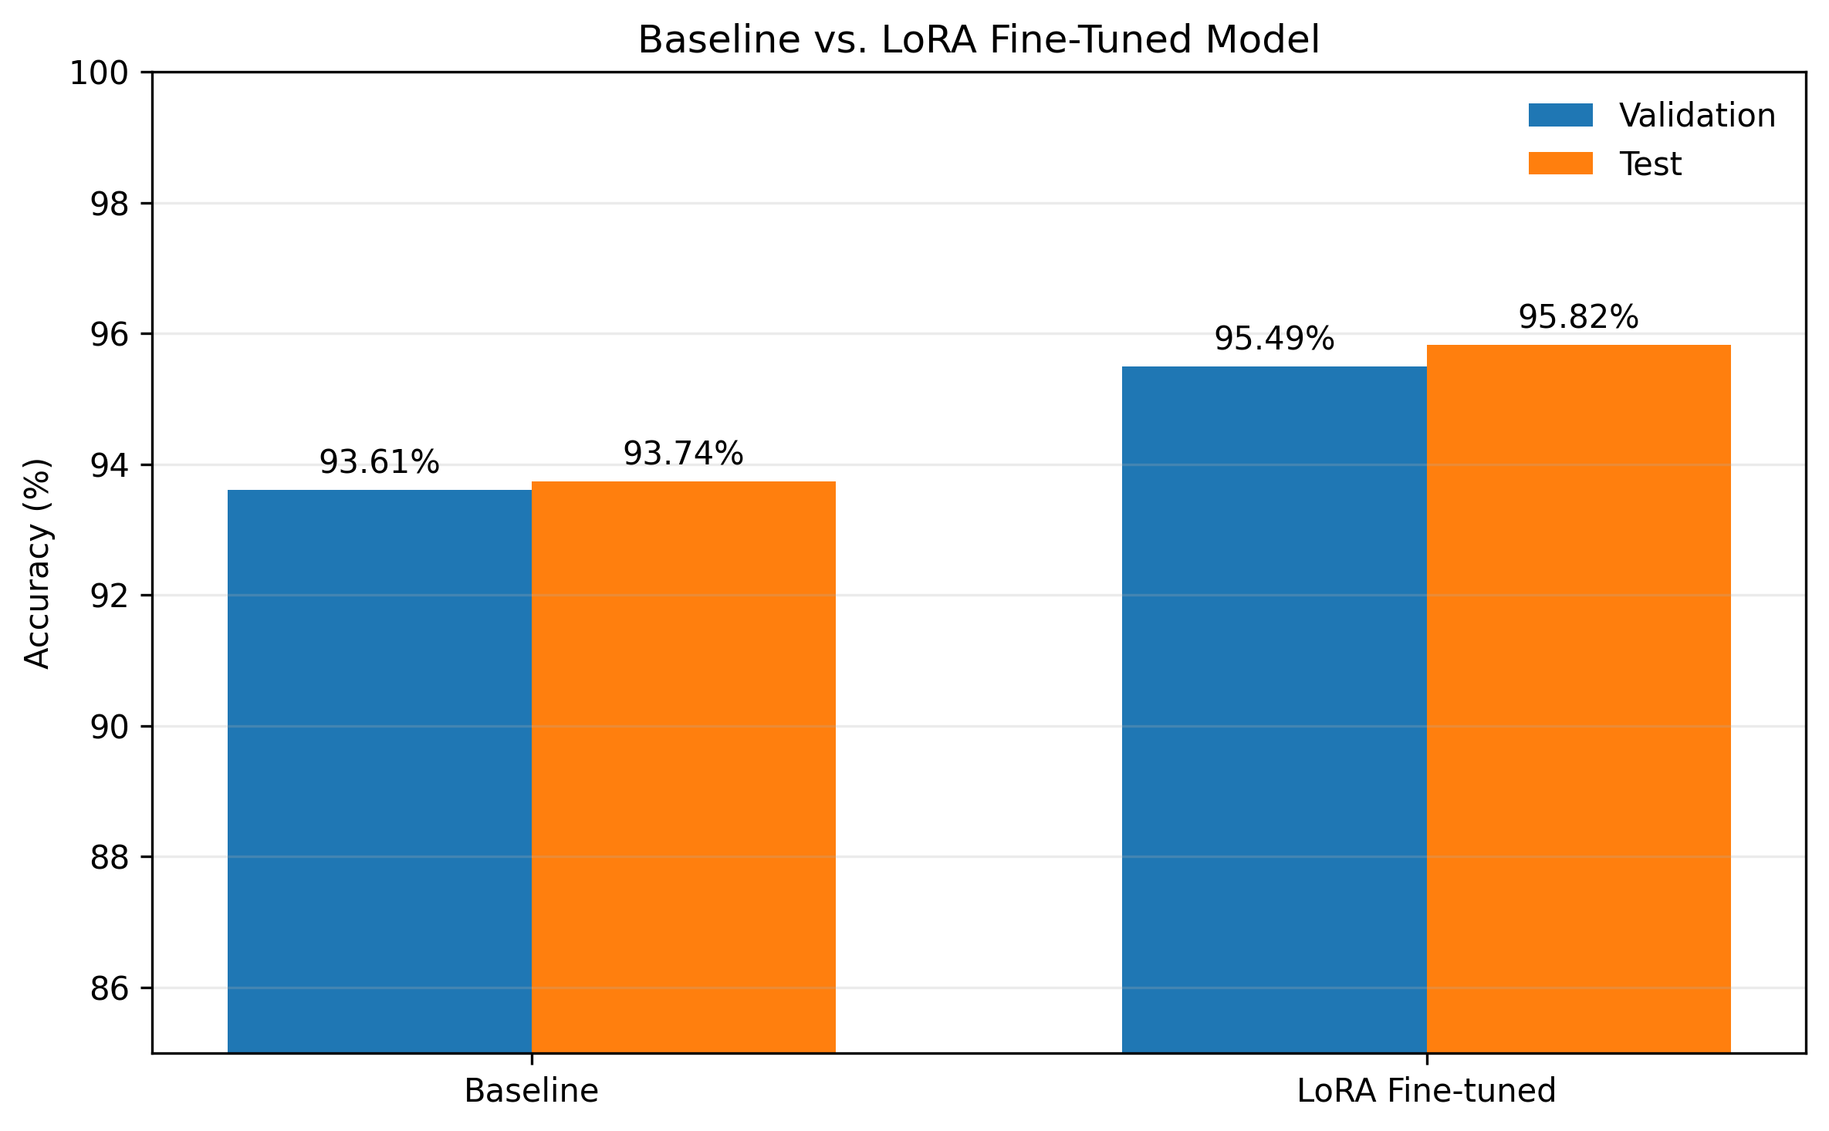
FIG. 4: Measured Accuracy: Baseline Qwen2.5-VL-3B vs. Fine-Tuned VEERA across RePOPE Splits (Natural Images).
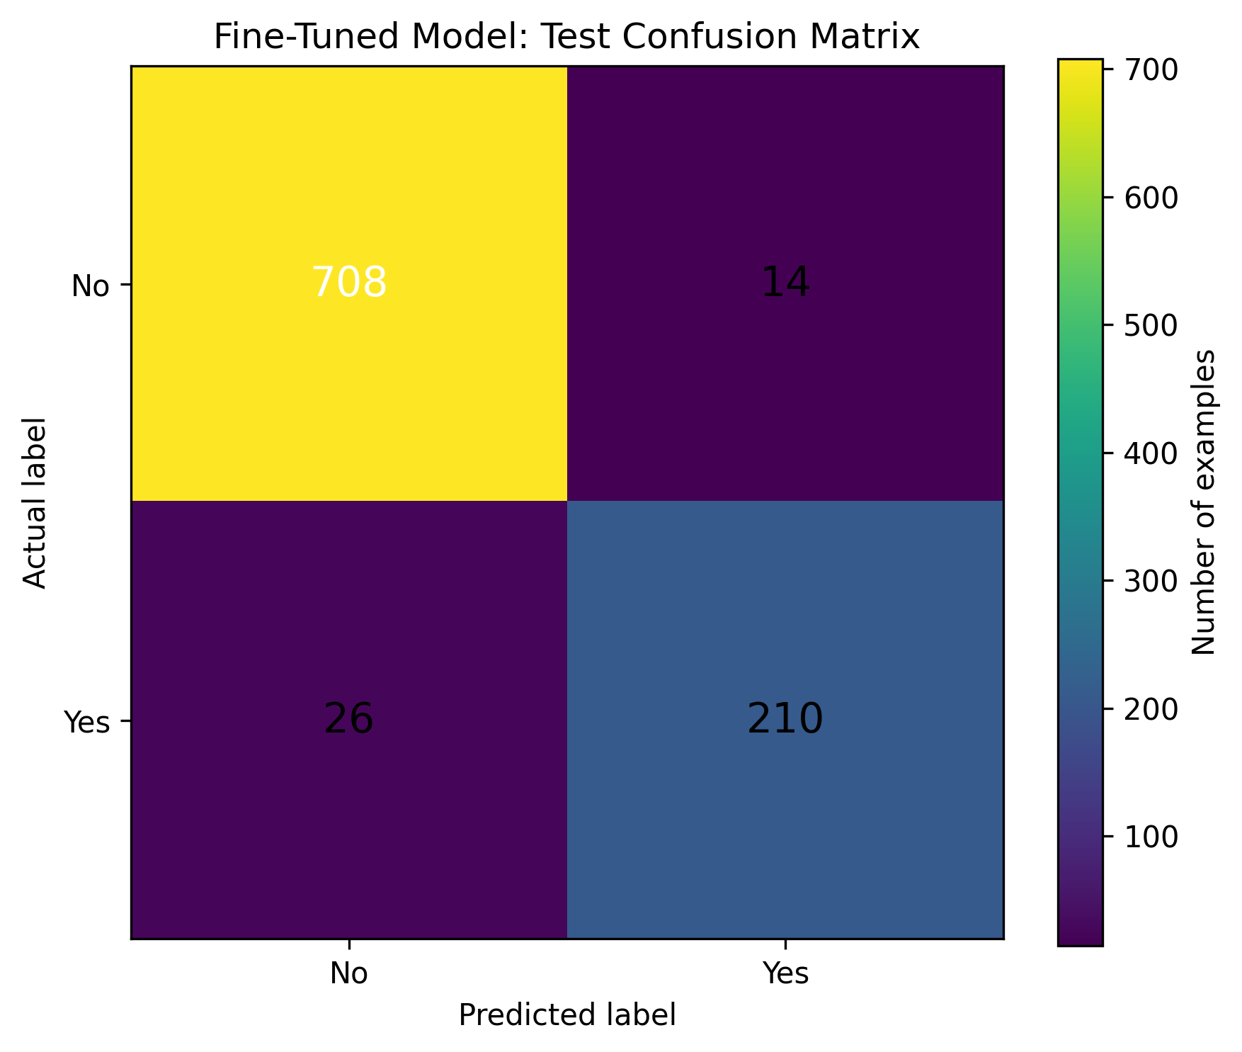
FIG. 5: Test Confusion Matrix across 958 RePOPE Benchmark Test Instances (Object Presence).
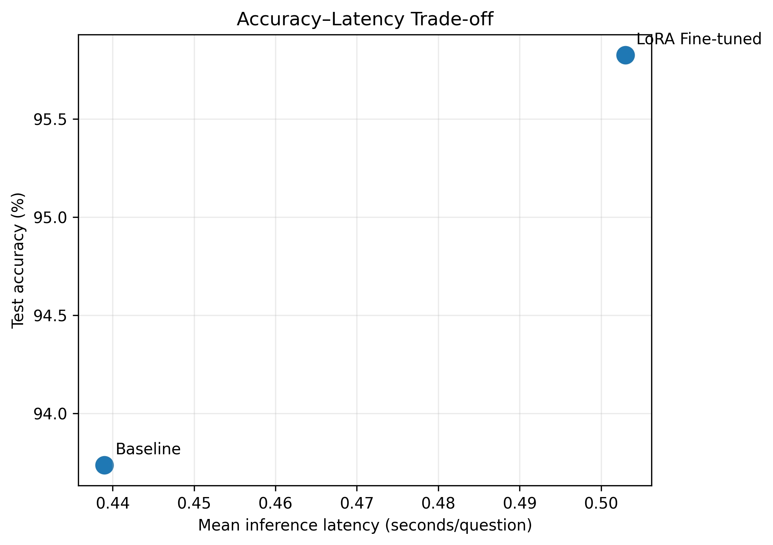
FIG. 6: Accuracy-Latency Tradeoff Curve between Baseline and LoRA Fine-Tuned Pipeline.
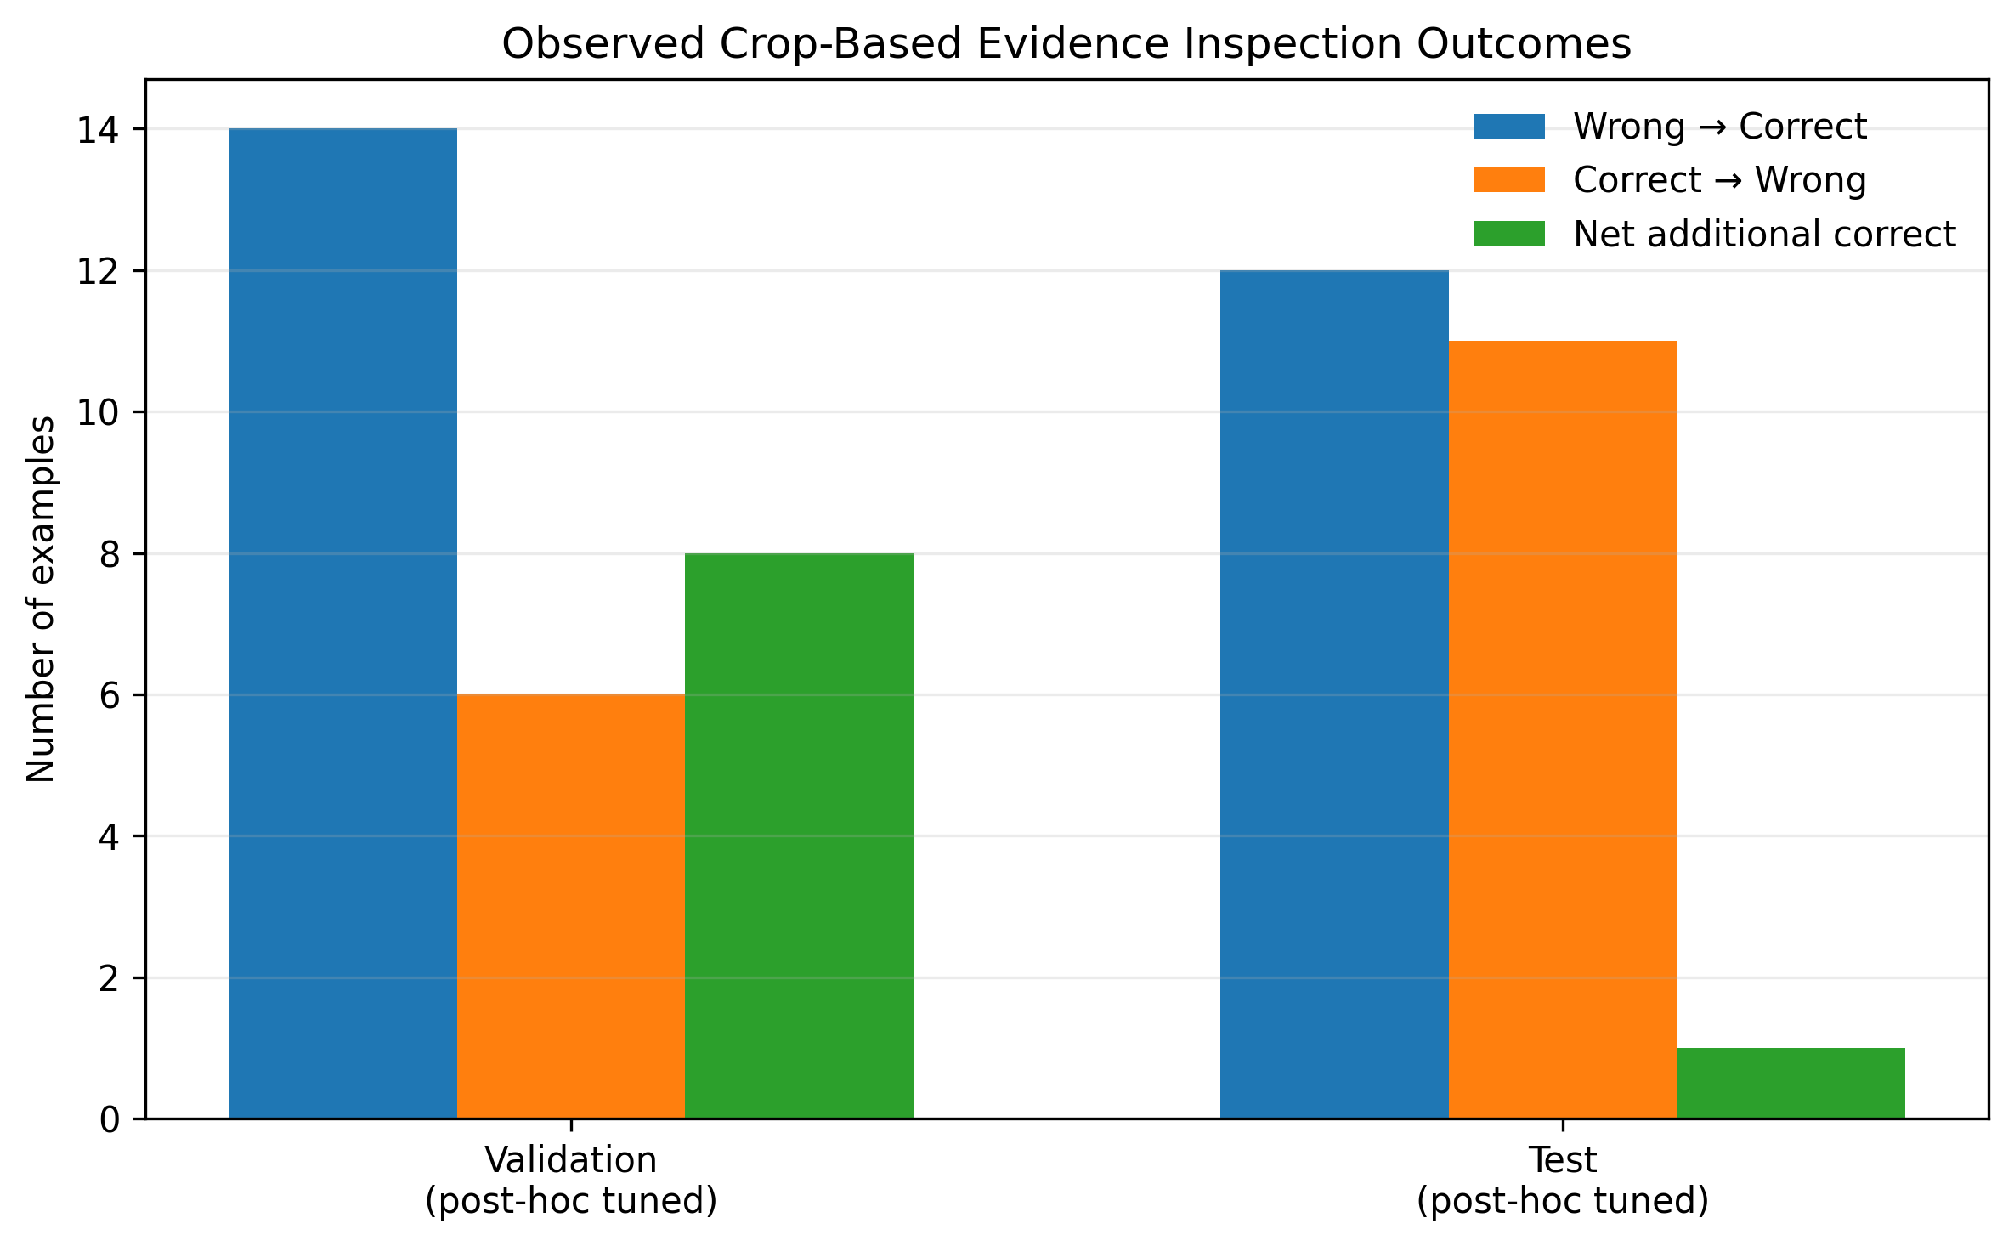
FIG. 7: Exploratory Multi-Crop Evidence Outcomes on Validation (Net +8) and Test (Net +1) Splits.
13. What are the aspects of your disclosure that you want to claim/monopolize?
Subsection: Proposed Draft Claims (Prepared for Academic Invention Disclosure; Not Legally Granted or Certified Patent Claims):
Note: The claims below represent the technical architecture of VEERA. Example claim statements from generic templates (e.g., eye/facial landmark detection) have been excluded. Features such as specialized sensor pipelines or dedicated hardware registers have been omitted as standard general-purpose computing hardware is utilized.
Claim 1 (Proposed Independent System Claim):
A multimodal computing system for failure-aware visual evidence acquisition, comprising:
a memory configured to store a pre-trained base vision-language model and a fine-tuned low-rank adaptation (LoRA) adapter;
at least one hardware processor operatively coupled to said memory and configured to execute:
an input interface configured to receive a multimodal query comprising a digital image and a natural-language question;
a global inference engine configured to execute an initial forward pass through said base vision-language model with said LoRA adapter to generate next-token logits;
a reliability evaluation unit configured to isolate logits corresponding to predefined binary response tokens, compute normalized softmax probabilities, and derive an empirical reliability gap G(x, q) = |p_Yes - p_No|;
a sufficiency gating mechanism configured to evaluate whether said reliability gap G(x, q) meets or exceeds a predetermined sufficiency threshold tau selected from validation data;
an adaptive evidence controller configured to output an answer when G(x, q) >= tau, and, when G(x, q) < tau, generate a plurality of localized spatial crops of said digital image and execute secondary localized inference across said crops; and
an evidence aggregation and abstention unit configured to compute a consensus across said secondary localized inference and selectively emit either a consensus verdict or an explicit failure-aware abstention signal.
Claim 2 (Proposed Dependent System Claim):
The system as claimed in claim 1, wherein said base vision-language model is Qwen2.5-VL-3B-Instruct, and wherein said LoRA adapter comprises trainable rank r=8, scaling alpha=16, and dropout 0.05 applied to query (q_proj), key (k_proj), value (v_proj), and output (o_proj) attention projections.
Claim 3 (Proposed Dependent System Claim):
The system as claimed in claim 1, wherein said predefined binary response tokens consist of token identifier 9454 corresponding to 'Yes' and token identifier 2753 corresponding to 'No' under the vocabulary tokenizer of the vision-language model.
Claim 4 (Proposed Dependent System Claim):
The system as claimed in claim 1, wherein said sufficiency threshold tau is set to 0.7853, selected on a 954-sample validation split to achieve a target coverage level.
Claim 5 (Proposed Dependent System Claim):
The system as claimed in claim 1, wherein said adaptive evidence controller generates four overlapping crops of size 400x400 pixels with a 50% stride ratio positioned respectively at top-left, top-right, center region-of-interest, and bottom-right of the digital image.
Claim 6 (Proposed Dependent System Claim):
The system as claimed in claim 1, wherein said evidence aggregation and abstention unit requires a consensus quorum of at least 75% agreeing votes across said localized crops to emit an answered verdict, and transitions to an abstention state when said consensus quorum is unsatisfied.
Claim 7 (Proposed Dependent System Claim):
The system as claimed in claim 1, further comprising an asynchronous RESTful API gateway exposing /health and /api/v1/inspect endpoints, and a graphical client dashboard configured to render bounding box coordinates and thumbnail representations of said localized spatial crops alongside said reliability score.
Claim 8 (Proposed Independent Computer-Implemented Method Claim):
A computer-implemented method for failure-aware multimodal evidence acquisition in vision-language processing, the method comprising:
receiving, by a processor, an input image and a natural-language query;
executing an initial global forward pass of said input image and query through a vision-language model augmented with a low-rank adaptation adapter;
extracting next-token logit values corresponding to opposing binary answer tokens;
computing normalized probabilities for said binary answer tokens via softmax normalization and calculating an empirical reliability gap G(x, q) as the absolute difference between said normalized probabilities;
comparing said empirical reliability gap G(x, q) against a sufficiency threshold tau selected on validation data;
in response to G(x, q) >= tau, returning an answer without triggering secondary visual inspection;
in response to G(x, q) < tau, generating a plurality of localized overlapping image crops from said input image;
executing localized inference on each of said image crops to obtain a set of crop-level votes and reliability scores;
calculating a consensus ratio across said crop-level votes; and
emitting a verified answer when said consensus ratio satisfies a predetermined quorum, and emitting a failure-aware abstention signal when said consensus ratio fails to satisfy said predetermined quorum.
Claim 9 (Proposed Dependent Method Claim):
The method as claimed in claim 8, wherein said opposing binary answer tokens are selected as vocabulary tokens 'Yes' and 'No' following a formatted conversational chat template requiring binary response.
Claim 10 (Proposed Dependent Method Claim):
The method as claimed in claim 8, wherein said sufficiency threshold tau is selected on a validation dataset by evaluating selective prediction coverage prior to test evaluation.
Claim 11 (Proposed Dependent Method Claim):
The method as claimed in claim 8, wherein generating said localized image crops comprises extracting four square sub-regions of 400x400 pixels at a 50% spatial stride ratio.
Claim 12 (Proposed Dependent Method Claim):
The method as claimed in claim 8, wherein said failure-aware abstention signal designates an inconclusive assessment status and returns a structured diagnostic trace indicating contradictory evidence.
Claim 13 (Proposed Independent Non-Transitory Storage Medium Claim):
A non-transitory computer-readable storage medium storing instructions that, when executed by one or more processors, cause the one or more processors to perform operations comprising the method of claim 8.

Novelty, Inventive Step, and Parameters:
14. Have you conducted a novelty/inventiveness search for your invention? If yes, what databases/references were used by you? What are the search results?
Search Status: Novelty/inventiveness search status: Not established from the available project materials.
Explanation & Recommendations for Inventors:
No formal patentability search report or documented prior-art clearance is recorded in the existing project repository. Prior to formal filing with the Indian Patent Office (IPO), the inventors should conduct and document a comprehensive patent search across patent databases (InPASS, WIPO PATENTSCOPE, Espacenet, USPTO) and non-patent literature (Google Scholar, IEEE Xplore, ACM Digital Library).
Suggested Search Keywords: ('vision-language model' OR 'VLM') AND ('reliability' OR 'uncertainty' OR 'probability gap') AND ('crop' OR 'active perception' OR 'evidence acquisition') AND ('abstention' OR 'selective prediction').
15. Do you feel that a person of average skill (not extraordinary skill) in your area of technology would have arrived at your invention with existing knowledge in the public domain? If no, what could be the reasons for the same?
Assessment Status: Preliminary Technical Assessment (Subject to Formal Patent Professional Review):
Based on an initial review of the academic literature available in the project materials, a person skilled in the art (PSITA) would recognize individual elements (e.g., vision-language inference, token logit extraction, image cropping). However, the specific combination and workflow of VEERA present notable technical differences from conventional practice:
1. Technical Distinction from Standard VLM Pipelines: Standard multimodal systems execute uniform single-pass inference across all queries, with no empirical gating mechanism to decide whether additional visual evidence should be acquired.
2. Direct Gating via Token-Probability Gap: In VEERA, the absolute difference between binary answer token probabilities G(x,q) = |p_Yes - p_No| is directly coupled to a validation-selected threshold tau = 0.7853 to dynamically trigger localized spatial crop extraction.
3. Explicit Multi-Crop Abstention Quorum: Rather than forcing a binary decision or taking a simple average, the evidence controller applies a 75% consensus quorum and explicitly outputs an abstention status when evidence is contradictory.
Important Note on Legal Patentability:
This assessment represents a preliminary technical comparison. It does NOT constitute a legal opinion on patentability, non-obviousness, or compliance with Section 3(k) of the Indian Patents Act, 1970. Formal patentability can only be evaluated after a comprehensive prior-art search conducted by a registered patent agent or attorney.
16. Kindly provide workable ranges for all the parameters involved in your invention:
Audit of Parameters: The table below distinguishes experimentally verified nominal settings from proposed, unvalidated ranges. Parameters that were tested at only a single configuration are explicitly identified:
Parameter Description | Verified Nominal Setting | Status of Workable Range | Technical Source / Evidence
Reliability Threshold (tau) | 0.7853 | Proposed range (0.65–0.88)  [Not experimentally validated] | Selected on 954-sample validation split for coverage analysis; reliability.py:18
LoRA Rank (r) | 8 | Proposed range (4–32)  [Only r=8 evaluated] | experiment_summary.json; adapter_config.json
LoRA Alpha (alpha) | 16 | Proposed range (8–64)  [Only alpha=16 evaluated] | adapter_config.json (Scaling alpha/r = 2.0)
LoRA Dropout Rate | 0.05 | Proposed range (0.0–0.20)  [Only 0.05 evaluated] | adapter_config.json
Crop Dimensions (Square) | 400 x 400 px | Proposed range (224–512 px)  [Only 400px implemented] | crops.py:19; adapts to min(crop_size, image_dim)
Crop Overlap Stride Ratio | 0.50 (50%) | Proposed range (0.25–0.75)  [Only 0.50 implemented] | crops.py:20; stride = crop_size * stride_ratio
Max Crop Evidence Count | 4 crops | Proposed range (2–8 crops)  [Only 4 crops implemented] | crops.py:21; Cardinal (TL, TR, BR) + Center ROI
Consensus Quorum Ratio | 0.75 (75%) | Proposed range (0.50–1.00)  [Only 0.75 implemented] | reliability.py:98; 3/4 agreeing crops
Max Upload File Size | 10 MB | Configured server limit  (1 MB to 50 MB workable) | app.py:22; ALLOWED_CONTENT_TYPES: JPEG, PNG, WebP
17. References (if any):
The technical disclosure references the following peer-reviewed literature and project documentation:
- [1] Li, Y., Du, Y., Zhou, K., Wang, J., Zhao, W. X., & Wen, J. R. (2023). Evaluating Object Hallucination in Large Vision-Language Models (POPE Benchmark). Proceedings of EMNLP 2023. [Foundation for the RePOPE binary presence evaluation dataset].
- [2] Qwen Team, Alibaba Cloud. (2024). Qwen2.5-VL Technical Report: Enhancing Vision-Language Foundation Models. arXiv:2409.12191. [Base vision-language foundation model].
- [3] Hu, E. J., Shen, Y., Wallis, P., Allen-Zhu, Z., Li, Y., Wang, S., Wang, L., & Chen, W. (2022). LoRA: Low-Rank Adaptation of Large Language Models. Proceedings of ICLR 2022. [Parameter-efficient adapter framework].
- [4] VEERA Project Technical Report & Research Pipeline Notebook (2026). 'Failure-Aware Visual Evidence Acquisition and Adaptive Compute Allocation for Reliable Vision-Language Reasoning'. Academic Project Documentation, RV University. [Primary implementation record].

Applicant Details and Additional Notes:
1. Applicant Details (Full Names, Nationality and Addresses):
Note: Under the Indian Patents Act, 1970, the 'Applicant' is the legal entity or person(s) who holds the right to apply for and own the patent. Ownership arrangements (institutional ownership vs. joint ownership vs. student ownership) must be formally confirmed under university policies prior to filing:
Applicant 1 (Primary Institutional Applicant Option — RV University):
Full Legal Name of Entity/Person | [INFORMATION REQUIRED FROM INVENTORS / APPLICANT]
Legal Entity Type | [INFORMATION REQUIRED FROM INVENTORS / APPLICANT]
Authorized Signatory & Designation | [INFORMATION REQUIRED FROM INVENTORS / APPLICANT]
Nationality / Country of Incorporation | [INFORMATION REQUIRED FROM INVENTORS / APPLICANT]
Official Registered Postal Address | [INFORMATION REQUIRED FROM INVENTORS / APPLICANT]
Official Email & Contact Number | [INFORMATION REQUIRED FROM INVENTORS / APPLICANT]
Applicant 2 (Joint Individual Applicant Option (Subject to Institutional IPR Policy)):
Full Legal Name of Entity/Person | [INFORMATION REQUIRED FROM INVENTORS / APPLICANT]
Legal Entity Type | [INFORMATION REQUIRED FROM INVENTORS / APPLICANT]
Authorized Signatory & Designation | [INFORMATION REQUIRED FROM INVENTORS / APPLICANT]
Nationality / Country of Incorporation | [INFORMATION REQUIRED FROM INVENTORS / APPLICANT]
Official Registered Postal Address | [INFORMATION REQUIRED FROM INVENTORS / APPLICANT]
Official Email & Contact Number | [INFORMATION REQUIRED FROM INVENTORS / APPLICANT]
2. Any additional notes or remarks:
The inventors and reviewing faculty should note the following technical and operational boundaries established in the project records:
- A. Domain Scope Boundary: Benchmark Domain Scope: The fine-tuned LoRA model was trained and evaluated on the RePOPE binary object-presence benchmark (natural images from MS-COCO). The reported test accuracy of 95.82% applies exclusively to binary object-presence questions on this dataset. It does not evaluate physical crack detection, structural surface fracture, or industrial defect inspection.
- B. Exploratory Prototype Status: Evidence Controller Status: The multi-crop evidence acquisition policy and abstention logic represent a functional software prototype (implemented in backend/evidence_controller.py). In exploratory test split comparisons, cropping corrected 12 errors but altered 11 previously correct answers (net gain of 1). Cropping is not yet proven to deliver generalizable accuracy improvements.
- C. Deployment Environment: Inference Environment & Unit Tests: Backend unit tests verify procedural logic and math (9/9 tests pass). Real model inference requires loading the 6.2 GB Qwen2.5-VL-3B-Instruct model with the 14.1 MB LoRA adapter on an accelerator (e.g., Kaggle GPU session). Local CPU execution operates in an offline diagnostic mode when model weights are not loaded.
- D. Academic Disclaimer: Academic Disclosure Disclaimer: This document is an academic Invention Disclosure Form (IDF) prepared for coursework evaluation in Research Methodology (RM). It does not constitute a filed patent application with the Indian Patent Office, and patentability has not been legally certified.

