Chapter 1
1.1 Introduction [Font Size-14 , Times New Roman]
Brief introduction about the mini project topic—two paragraphs. [Font Size 12]
  - State of the Art [Font Size-14]

[The state of art development often refers to the most advanced and innovative techniques, tools, and practices available in a specific field at a given time.] [font size-12]

  - Motivation
  - Problem Statement
  - Objectives
  - Methodology
The methodologies used to build the project were:
- Pre-Processing
- Text Extraction
- Application
  - Innovation
  - Organization of the report
This report is organized into the following seven chapters: (Include each chapter explanation with 2 to 3 lines.)
Chapter 1
Chapter 2
Chapter 3
Chapter 4
Chapter 5
Chapter 6
Chapter 7

Chapter 2
2.1 Literature Review
Cite all the literature in IEEE format
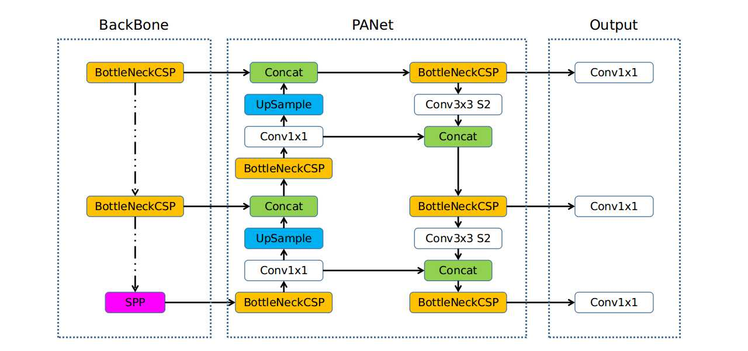
Fig. 2.1: Overview of Yolov5 Architecture
Note: All the text mentioned in the flowchart/figure should maintain a font size of 18 [Times New Roman] before taking the snapshot

Table 2.1: Summary of selected papers
Authors | Objectives | Strength and Weaknesses | Tool Used | Limitations

Chapter 3

Preamble Description about topics of chapter-3
3.1 Functional Requirements [if any]
3.2 Non Functional Requirements [if any]
3.3 Hardware Requirements [if any]
[The hardware requirements formulated for the project were:]
Fig. 3.1: Overview of Yolov5 Architecture
3.4 Software requirements [if any]
Fig. 3.2: Overview of Yolov5 Architecture
[The software requirements formulated for this project were:]

3.5 Summary

Chapter 4
Preamble description about chapter-4
4.1 Design of Mini Project
Preamble description about chapter-4
A High level design specification aims to illustrate the overall system architecture of the software while designing it. The high level diagrams are used to present a wider picture on what is the aim or functionality of different modules of the system.

4.1 High Level Design

4.1.1 System Architecture
Fig. 4.1: System Architecture of Your project
4.2 Detailed Design
The Design of the System involved the following considerations:

4.2.1 Structure Chart
A structure chart is a top-down, hierarchical diagram used in software engineering to visualize a system's architecture by breaking it into modules, representing their dependencies, and detailing data/control passing.

Fig. 4.2: Structure Chart
[Explanation of your project structure chart]

4.2.2 Functional Description of the Modules
- Training Module
Annotation Module:
Input: Images
Output: Annotated Images
Model Training:
Input: Annotated Images
Output: Weights Of Trained Yolov5 Model
Model Storage:
Input: Weight File Of A Yolov5 Model
Stores It In A Specified File
- Inference Module
Preprocessing Module:
Input: Pdf File Or Image File
Output: Processed Image Or List Of Images In A Directory
Model Loader:
Input: Path To The Weights File
Output: Yolov5 Object Detection Model
Detection Model:
Input: Yolov5 Model And Input Image
Output: Labels Of Each Class, Cropped Images In A Directory
Data Extraction:
Input: Image, Table Flag
Output: Folder Containing The Extracted Text In A Json And Csv File Format

Chapter 5
5.1 Implementation
Preamble about your chapter-5

5.2 Programming Language Selection

5.3 Platform Selection

The Libraries used are:
Tools used are:

5.3 Code Conventions

5.4 Summary

Chapter 6

6.1 Experimental Results and Testing
Preamble description about your chapter-6 one paragraph

6.2 Evaluation Metrics

6.3 Experimental Dataset

6.4 Performance Analysis
Table 1 shows the precision, recall, intersection over union metric and cells matched metric for both the models used in the implementation.
Table 6.1: Performance Parameters for Yolo model and Deep Learning model
Model | Precision | Recall | IOU | Cells Matched
Yolov5 | 89% | 90% | 87% | –
Deep Learning mode for tabular data extraction | 83% | 85% | – | Average percentage of cells matched - 84%

6.5 Unit Testing
Unit Testing comprises testing individual units/modules that make up the system. Unit testing offers a way to identify and eliminate bugs at a very early stage of development, reducing any chances of the bug impacting the whole system.
Table 6.2: Unit testing modules, input for the test, expected output, received output.
No | Module Tested | Input | Expected Output | Output | Testing Environment
1 | Training Module | Image of Invoice | Annotated Image | Annotated Image | Manual Testing
2 | OCR Engine | Image of Invoice | Extracted Text | Accurately Extracted Text | Manual Testing
3 | Detection Module | Image/PDF | Various fields of the invoice and associated value | Various fields of the invoice and associated value | Manual Testing
4 | Table Extraction Module | Extracted table from detection module | Tabular contents of the table | Tabular contents of the table | Manual Testing

6.6 Integration Testing
Integration testing is performed to inspect how individual modules work together in tandem whether there is any loss of information, whether any breakage occurs, are the input/output in suitable format.
Table 6.3: Integration testing modules, input for the test, expected output, received output.
No | Module Tested | Input | Expected Output | Output | Testing Environment
4 | Integration: OCR with Detection Module | Images/PDF of the invoice | The areas of the invoice extracted by the Yolov5 model’s text are properly extracted | The areas of the invoice extracted by the Yolov5 model’s text are properly extracted | Manual Testing
5 | Integration: Detection Module to Table Detection | Extracted tables from the detection module | Tabular content of the extracted table. | Tabular content of the extracted table. | Manual Testing
6 | System Testing | Complete usage - Blackbox test | System working smoothly | System working smoothly | –

6.7 System Testing
System Tests is the process in which a team evaluates how the various components of an application interact together in the full, integrated system or application.
Table 6.4: System testing modules, input for the test, expected output, received output.
SL.No. | Module Tested | Input | Expected Output | Output | Testing Environment
6 | System Testing | Complete usage - Blackbox test | System working smoothly | System working smoothly | –

6.8 Summary

Chapter 7
7.1 Discussion
One paragraph concludes about the project and future enhancement.
7.2 Conclusion
7.3 Future Enhancement

References
- G. Eason, B. Noble, and I. N. Sneddon, “On certain integrals of Lipschitz-Hankel type involving products of Bessel functions,” Phil. Trans. Roy. Soc. London, vol. A247, pp. 529–551, April 1955. (references)
- J. Clerk Maxwell, A Treatise on Electricity and Magnetism, 3rd ed., vol. 2. Oxford: Clarendon, 1892, pp.68–73.
- I. S. Jacobs and C. P. Bean, “Fine particles, thin films and exchange anisotropy,” in Magnetism, vol. III, G. T. Rado and H. Suhl, Eds. New York: Academic, 1963, pp. 271–350.
- K. Elissa, “Title of paper if known,” unpublished.
- R. Nicole, “Title of paper with only first word capitalized,” J. Name Stand. Abbrev., in press.
- Y. Yorozu, M. Hirano, K. Oka, and Y. Tagawa, “Electron spectroscopy studies on magneto-optical media and plastic substrate interface,” IEEE Transl. J. Magn. Japan, vol. 2, pp. 740–741, August 1987 [Digests 9th Annual Conf. Magnetics Japan, p. 301, 1982].
- M. Young, The Technical Writer’s Handbook. Mill Valley, CA: University Science, 1989.

Instructions to be followed:
Plagiarism Report should be attached at the end of the report (to be submitted during SEE).
- Add a minimum 15 reference papers as per IEEE citations.
- Chapter font size-16 and Times new roman
- Sub heading-Font Size 14 and Times New Roman
- Content-Font size 12 and Times New Roman
- Table Name: font size-11, bold, Times New Roman
- Figure name (caption): font size-11, bold, Times New Roman
- Table name should be written first followed by the Table
- Figure should be followed by figure name (caption).
- Content text must be aligned in justify mode.
- Table caption and Figure caption must be centre- aligned.
- Add appropriate screenshots of your project in the result section.

Appendices

Publication Details (if any)

