**Fast Style Transfer**

**I: Abstract**

In fine art, especially painting, humans have mastered the skill to create unique visual experiences through composing a complex interplay between the content and style of an image, but for computers, it is difficult to understand the meaning of style and make a painting with artistic features. In this project, we implemented an artificial system based on the generative deep neural network, which can transform the pictures taken in real scenes into a special artistic style.

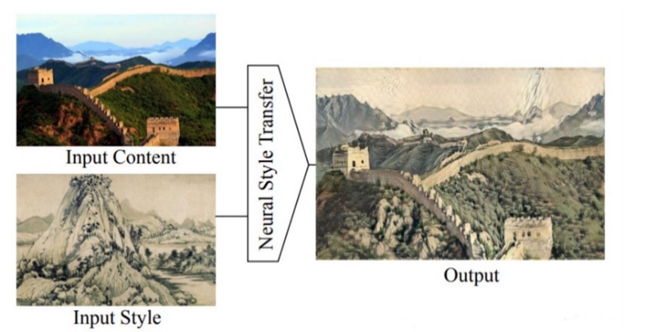**II: Definition**

Neural style transfer refers to combining the content of one image with the style of another image and then generate a new image with both characteristics.

**III: Principle**

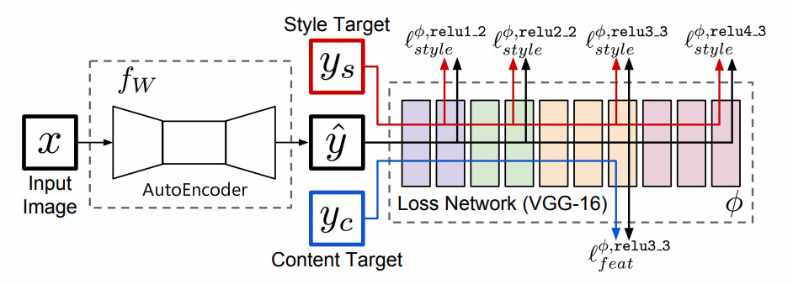

Generative neural networks are widely used in semantic segmentation, protein structure prediction and other generative tasks because of their strong creative ability. We plan to use a special generative neural network—autoencoder to achieve the image style transformation task. A pretrained neural network for image classification can be used to define perceptual loss functions that measure perceptual differences in content and style between images. By minimizing the perceptual loss between output and input images, the autoencoder can generate an image with artistic style and input image content.

**IV: Improvement direction**

**Autoencoder**

1. Use instance normalization to adjust data distribution before each activation function.
2. Replace some convolution network layers with the capsule network layers for better performance.
3. Introduce deep-wise mechanism to reduce network computation.

**Loss Network**

1. Replace the VGG net with a network that performs better on ImageNet to extract higher-quality feature maps to calculate the perceptual loss.

**Opetimizer**

1. Use adamW instead of SGD for super convergence.

**V: Scope**

Due to the limited computing resources, we chose the style transfer algorithm that requires less training data, but this also causes some limitations. For different styles, individual training is required, it means only arbitrary content transform of fixed style can be achieved.

**V: Evaluation Metric**

As an unsupervised learning task, we cannot measure the performance of the network by drawing roc curve and some other methods, we can only judge the convergence degree of the network by the size of the loss value, and prevent the network from over-fitting by monitoring the difference of the network performances between the test set and the training set. When the total loss on the test set is lower than a certain threshold, the network training can be considered to be successful.