PacketQuest
Stop-and-Wait ARQ Simulation
Output Screens and Step-by-Step Working

1. Project Overview
PacketQuest is a Flask web application that teaches the Stop-and-Wait ARQ (Automatic Repeat reQuest) protocol using an online-order analogy: the customer is the sender, the Amazon server is the receiver, and the order confirmation is the ACK. This document walks through running the project and shows the actual output at every step.
File | Purpose
app.py | Flask server: serves the web page at / and exposes /api/health and /api/simulate.
arq_simulation.py | Protocol engine: simulate_order() with packet loss, ACK loss, and duplicate detection.
packet_quest_arq.html | Main interactive browser interface (landing, theory, simulation pages).
AmazonOrder.html, StopAndWait.html | Earlier standalone versions of the same interface.
test_app.py, test_arq_simulation.py | 8 unit tests for the API and the protocol engine.
requirements.txt | Dependency list: Flask 3.x.

How Stop-and-Wait ARQ works
- Send: the sender transmits one frame carrying sequence number 0 or 1, and starts a timer.
- Wait: the sender does nothing else until an ACK arrives.
- ACK received in time: the sender flips its sequence number (0 to 1 or 1 to 0) and sends the next frame.
- Timeout: if the frame or its ACK is lost, the sender retransmits the same frame with the same sequence number.
- Duplicate detection: if the receiver sees a sequence number it was not expecting, it discards the frame but still sends an ACK.

2. Backend Output (Terminal)

Step 1: Install dependencies
Open a terminal in the project folder and install Flask:
pip install -r requirements.txt

Step 2: Run the unit tests
Run all tests with the standard library runner. All 8 tests pass: 4 for the Flask API and 4 for the ARQ engine (clean delivery, lost ACK creating a duplicate, invalid input rejected, and the max-attempts safety limit).
python -m unittest -v
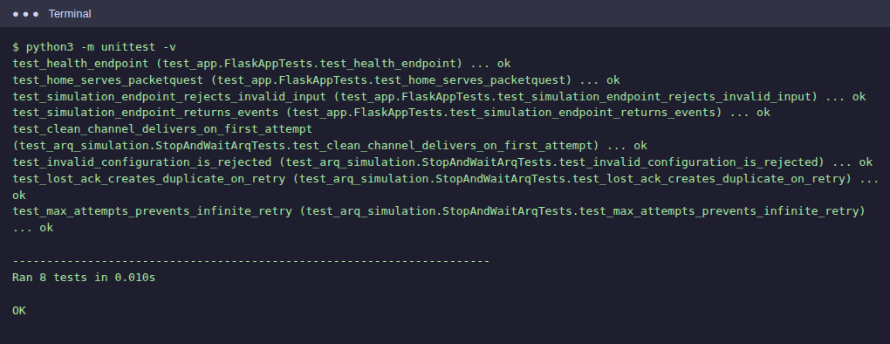
Figure 1: Unit test results, 8 tests, OK

Step 3: Start the server and call the API
Start the Flask server, then test the endpoints. The health check returns a status object. A valid /api/simulate request on a loss-free channel returns one delivery attempt with five events (send, receive, accepted, ack_send, ack_received). Invalid input such as loss_probability 2 returns an error.
python app.py
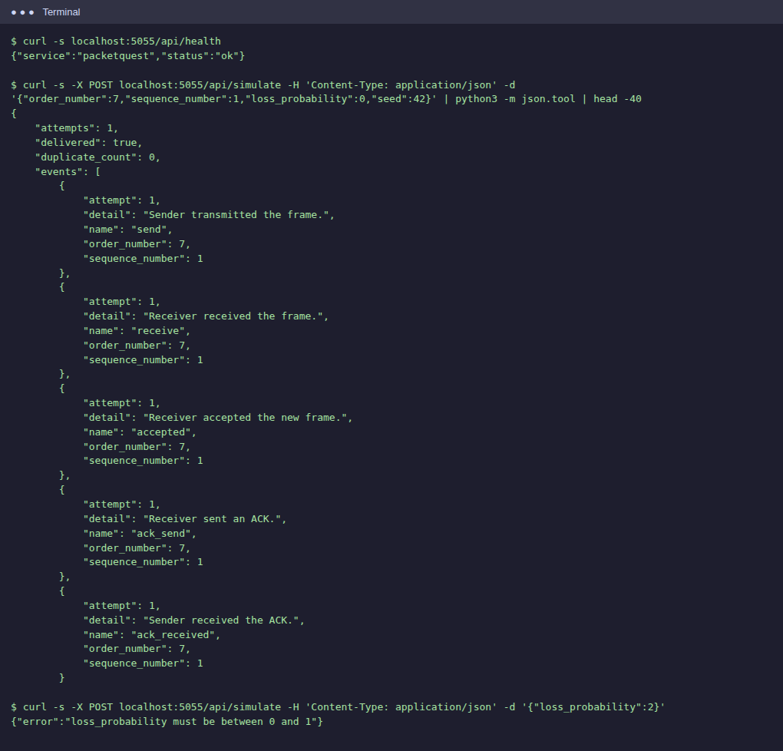
Figure 2: /api/health, /api/simulate (clean channel) and error response

Step 4: Run the ARQ engine directly with a lossy channel
With 40% loss and a fixed random seed, attempt 1 is delivered and accepted, but its ACK is lost. The sender times out and retransmits (attempt 2). The receiver recognises the repeated sequence number as a duplicate, discards it, and re-sends the ACK, which now arrives. Result: 2 attempts, 1 duplicate.
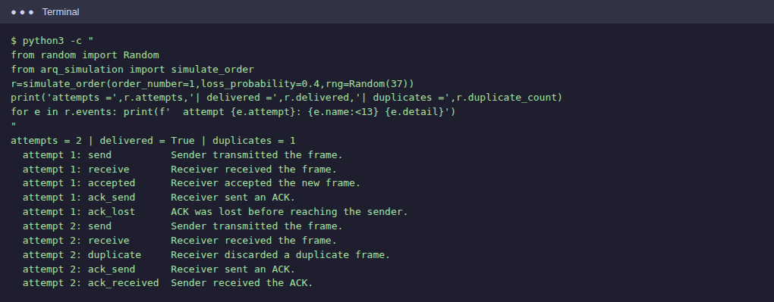
Figure 3: Event log from simulate_order() showing ACK loss then duplicate discard

3. Browser Interface Output
Open http://127.0.0.1:5000/ in a browser. The screens below were captured from the running application.

Step 5: Landing page
The home screen offers two paths: Explore the theory, or Open simulation.
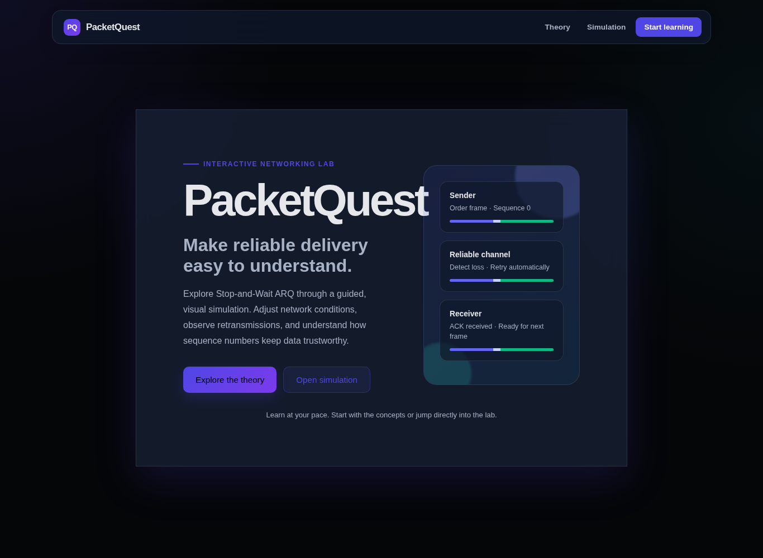
Figure 4: Landing page

Step 6: Theory page
Explains the four actors (Sender, Receiver, ACK, Noisy Channel), the six protocol steps, and the key concepts: timeout, 1-bit sequence numbers, duplicate detection, reliability, and the efficiency trade-off.
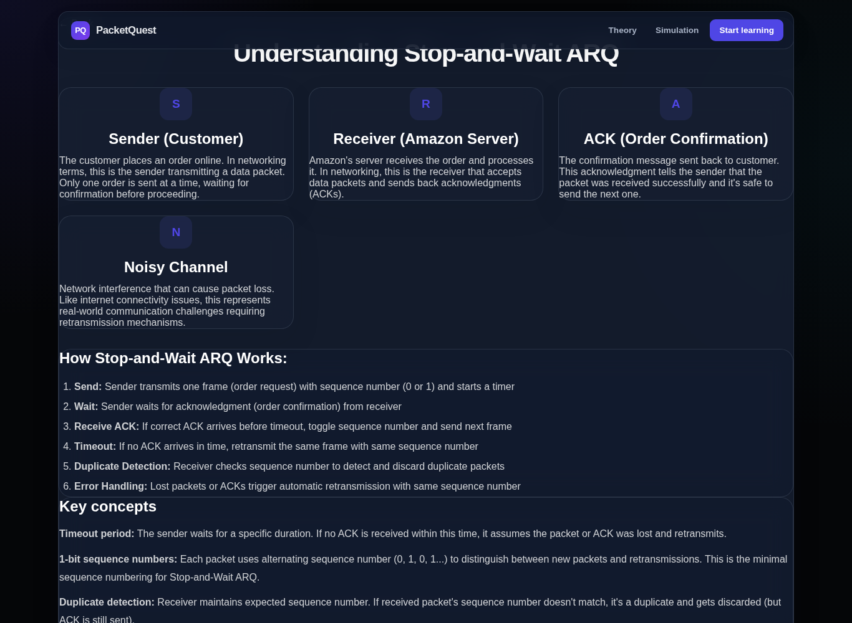
Figure 5: Theory page

Step 7: Simulation page, initial state
The control panel has a Noisy Channel switch, a Packet Loss Probability slider, Send order and Reset buttons, and five counters (successful deliveries, lost frames, retransmissions, duplicates detected, average delivery time). Sender and Receiver sequence numbers both start at 0.
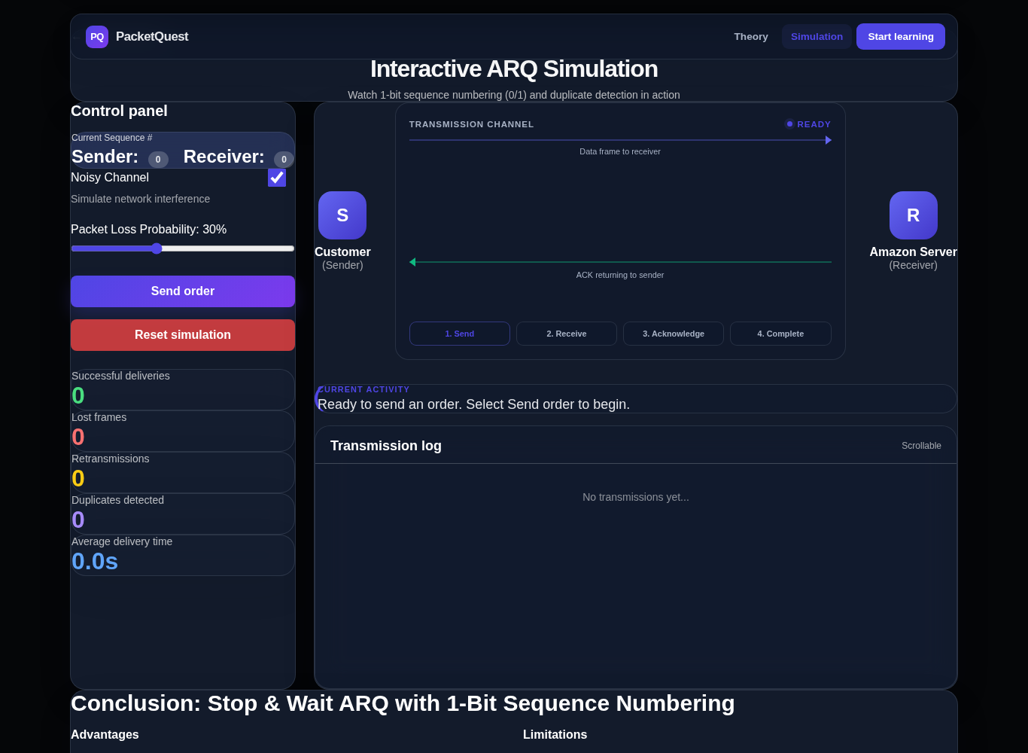
Figure 6: Simulation page before any order is sent

Step 8: Scenario A: clean channel (0% loss)
Set the loss slider to 0% and click Send order. The packet travels to the server, the ACK returns, and the order completes on the first attempt. Sequence numbers flip from 0 to 1. Counters: 1 successful delivery, 0 lost, 0 retransmissions.
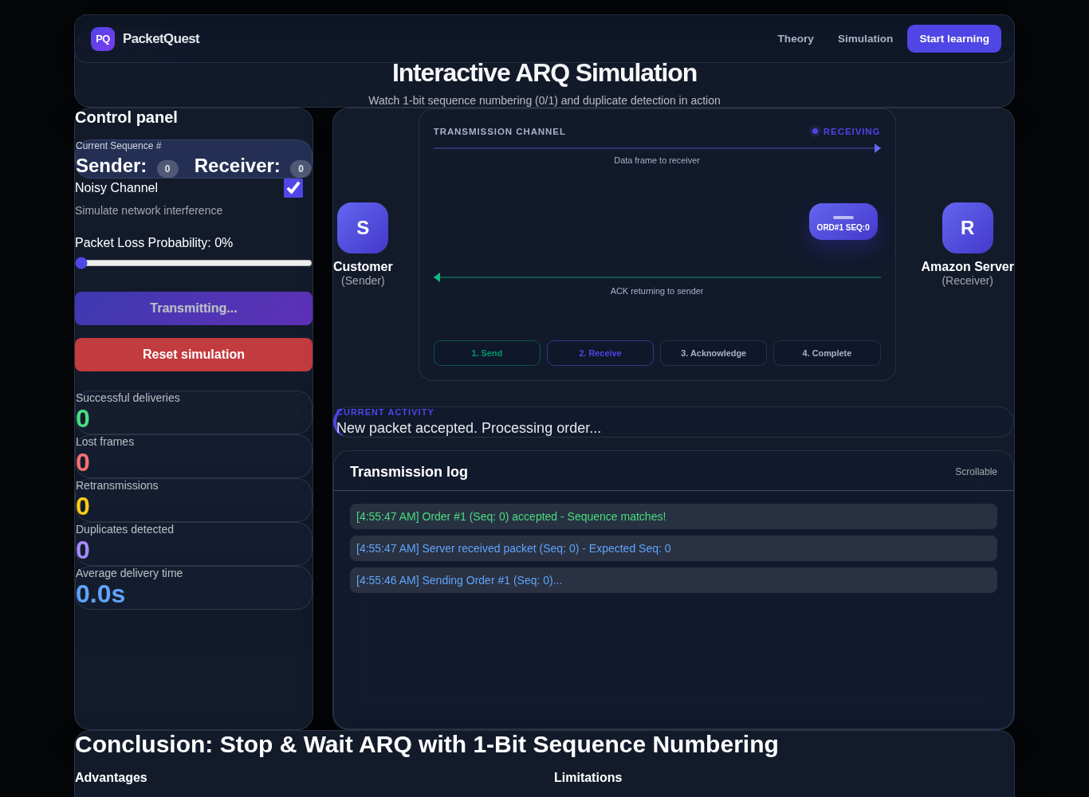
Figure 7: Order #1 in transit
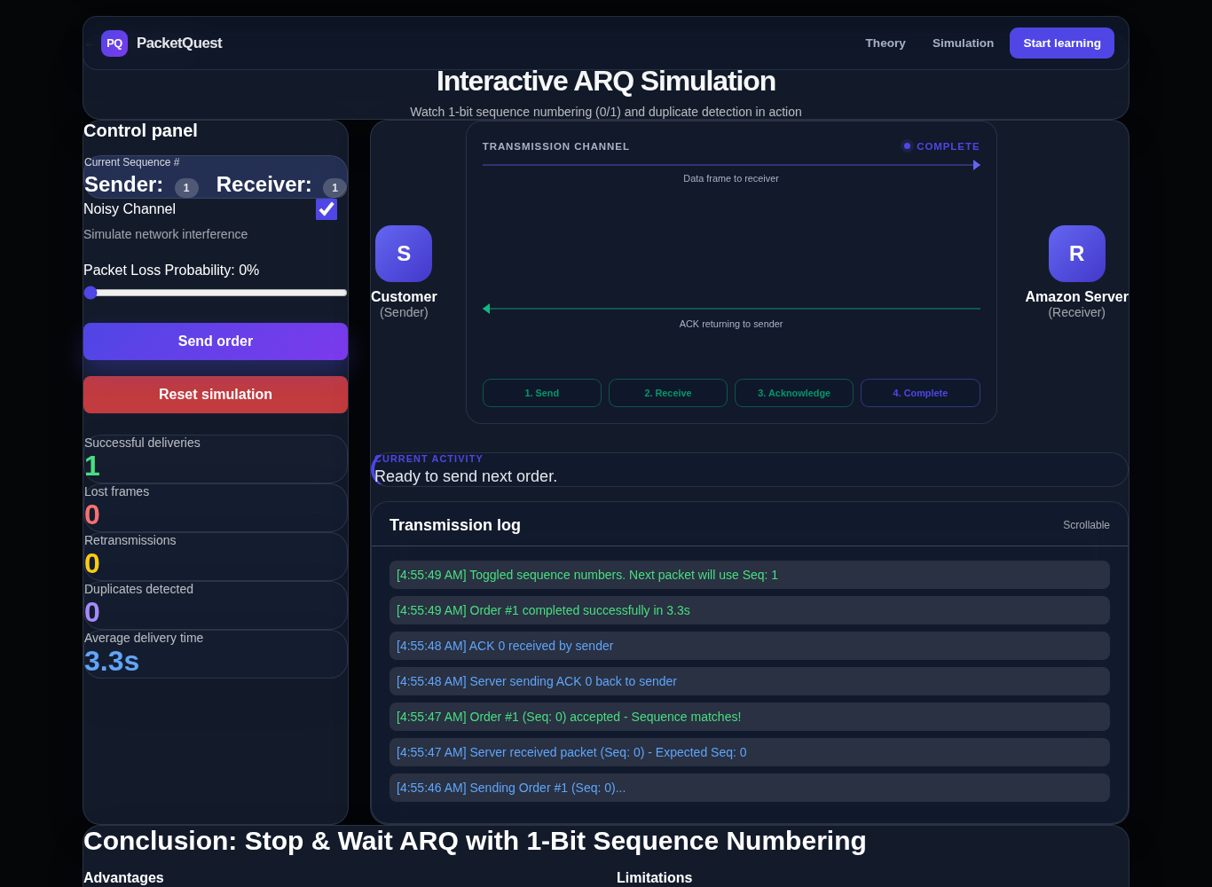
Figure 8: Order #1 completed, sequence numbers toggled

Step 9: Scenario B: data packet lost
With loss set to 50%, the first transmission of Order #2 is lost. The timeout bar fills, the status reads "Timeout. Retransmitting with the same sequence number", and the retransmission (same Seq 1) succeeds. Counters: 1 lost frame, 1 retransmission.
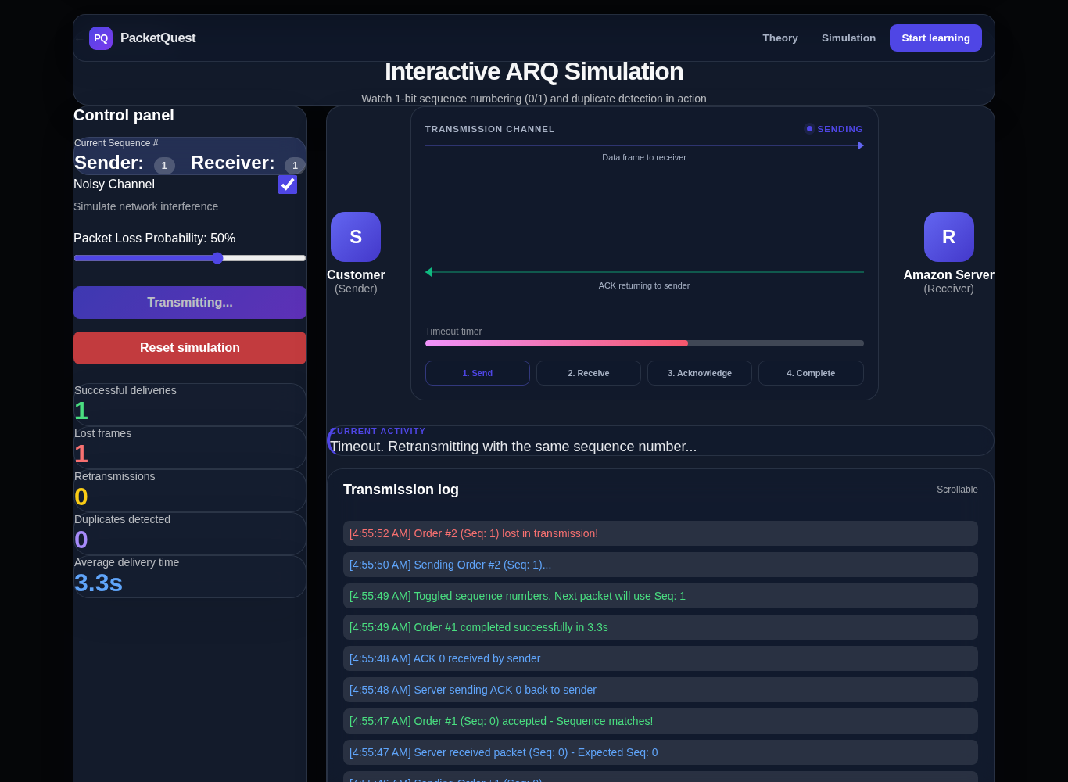
Figure 9: Packet lost, timeout and retransmit
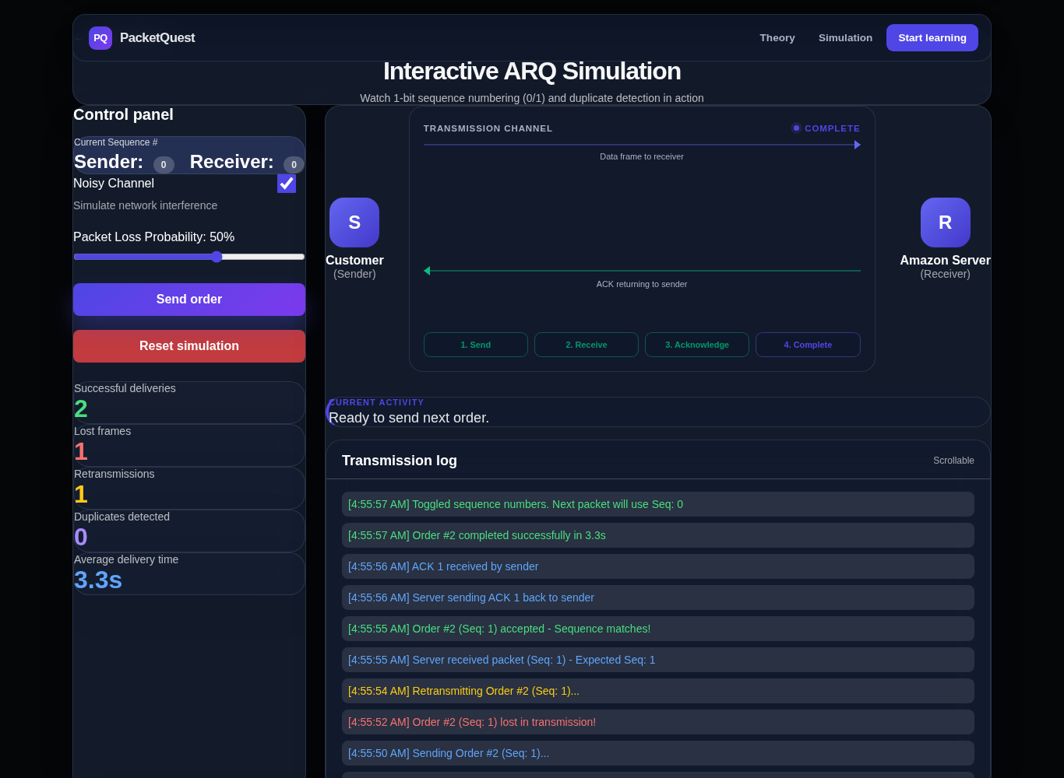
Figure 10: Order #2 completed after one retransmission

Step 10: Scenario C: ACK lost
For Order #3 the packet reaches the server but the ACK is lost. The sender times out and retransmits the same frame (Seq 0). The log below shows the order completing after the retransmission.
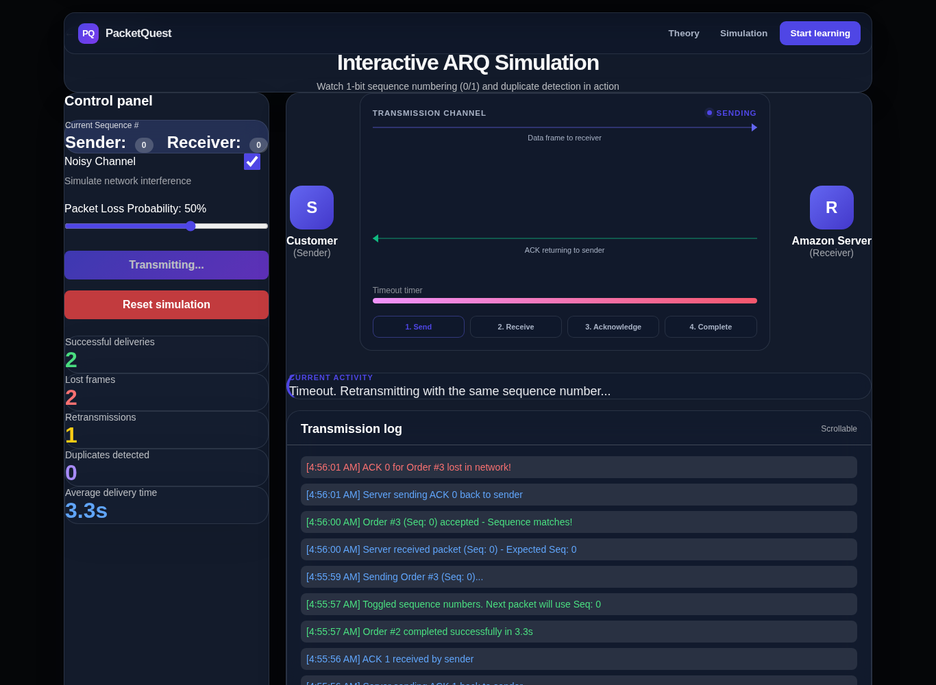
Figure 11: ACK lost, sender times out
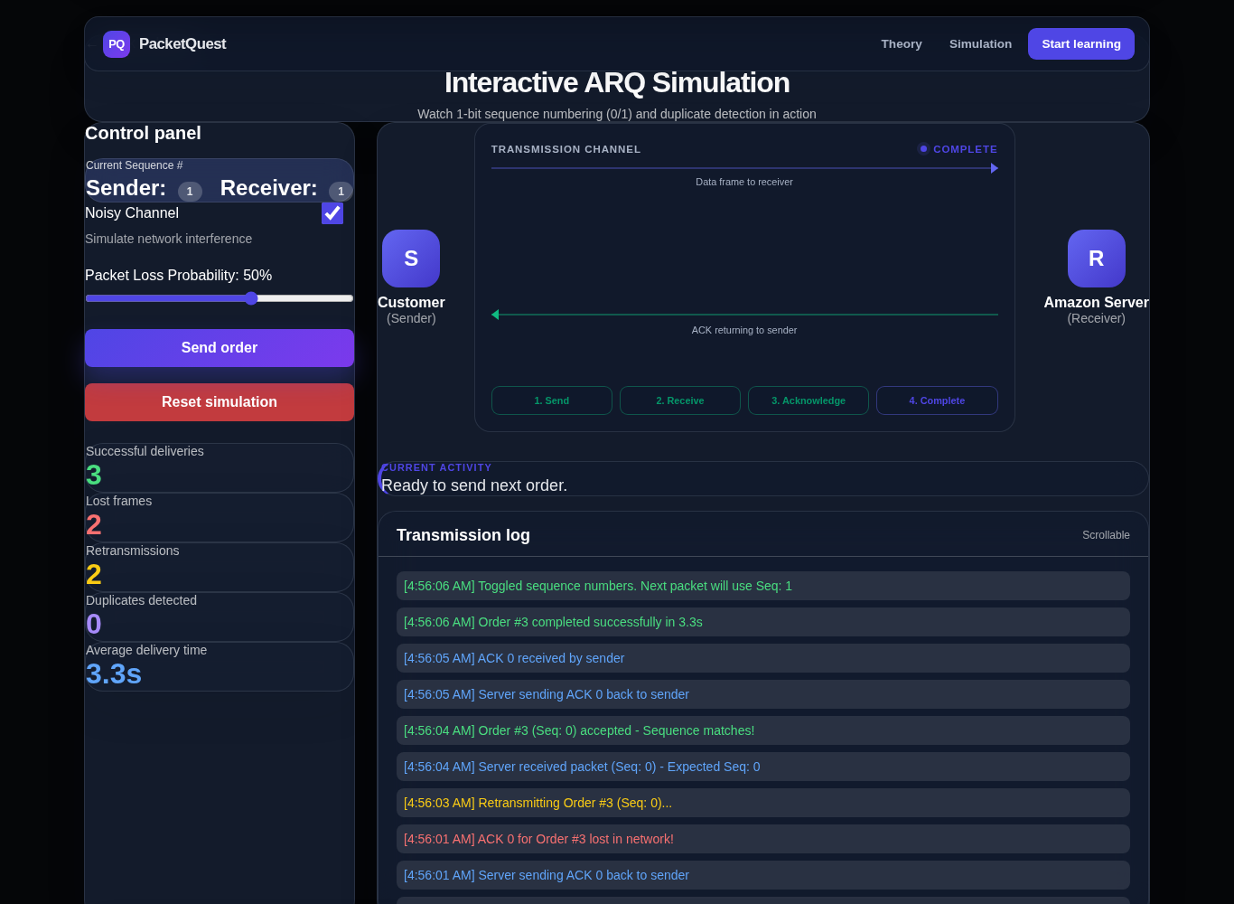
Figure 12: Order #3 completed after retransmission

4. Final Results
Test | Result | Notes
Unit tests (8) | 8 passed | API and ARQ engine
GET /api/health | 200 OK | {"status":"ok","service":"packetquest"}
POST /api/simulate (clean) | delivered, 1 attempt | 5 events, last is ack_received
POST /api/simulate (invalid) | 400 error | loss_probability must be between 0 and 1
UI scenario A: clean | Pass | 1 attempt, sequence toggled
UI scenario B: packet lost | Pass | Retransmitted with same Seq
UI scenario C: ACK lost | Completes, see note | Retransmission not flagged as duplicate

Observations worth fixing
- Duplicate detection differs between the two implementations. In scenario C the browser page logged "Order #3 (Seq: 0) accepted - Sequence matches!" twice and the Duplicates counter stayed at 0. The Python engine (Figure 3) correctly reports the duplicate. Cause: in packet_quest_arq.html the receiver's expected sequence number is flipped only after the sender receives the ACK. It should flip as soon as the receiver accepts a new frame, as arq_simulation.py does.
- The browser page runs its own JavaScript simulation and does not call /api/simulate, so the Flask API and the page are not yet connected.
- The page loads Tailwind from a CDN. The screenshots were taken in an environment without internet access, so spacing may look slightly different on your machine with network access.
- Scenarios B and C used a fixed sequence of loss outcomes so the results are repeatable. In normal use the loss events are random.

