Name: Văn Nhật Thành

Student Id: 24mse23212

1. Objective

The goals and the purposes of this exercise are helping students to have a better understanding of OOP programing in Python, especially Inheritance characteristic.

1. Algorithm

* Inheritance principles

1. Program Output
   1. 1-1

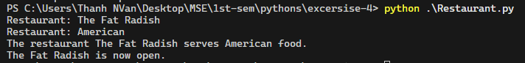

* 1. 1-2



* 1. 1-3

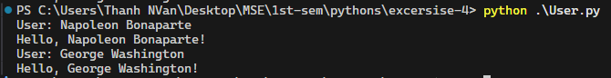

* 1. 1-4

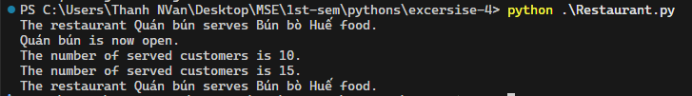

* 1. 1-5

