算法设计与分析作业答案

第三周作业

1. 矩阵连乘问题

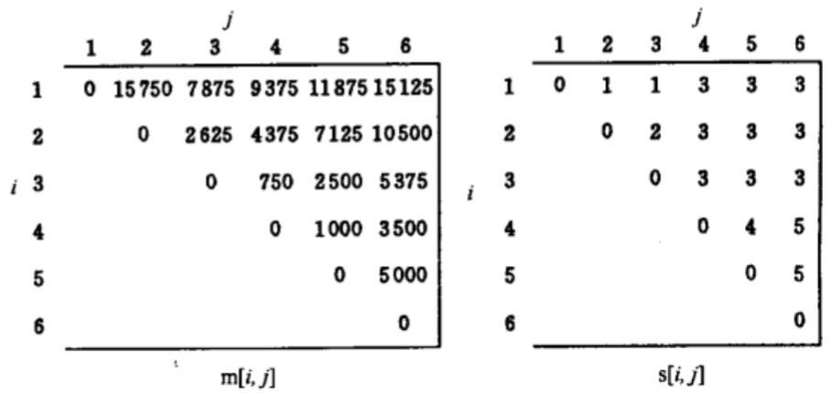

1. 最长公共子序列

|  |  |  |  |  |  |  |  |
| --- | --- | --- | --- | --- | --- | --- | --- |
| c | 0 | 1 | 2 | 3 | 4 | 5 | 6 |
| 0 | 0 | 0 | 0 | 0 | 0 | 0 | 0 |
| 1 | 0 | 0 | 0 | 1 | 1 | 1 | 1 |
| 2 | 0 | 0 | 1 | 1 | 1 | 1 | 1 |
| 3 | 0 | 0 | 1 | 2 | 2 | 2 | 2 |
| 4 | 0 | 1 | 1 | 2 | 2 | 2 | 2 |
| 5 | 0 | 1 | 1 | 2 | 3 | 3 | 3 |
| 6 | 0 | 1 | 1 | 2 | 3 | 3 | 4 |

|  |  |  |  |  |  |  |  |
| --- | --- | --- | --- | --- | --- | --- | --- |
| b | 0 | 1 | 2 | 3 | 4 | 5 | 6 |
| 0 | 0 | 0 | 0 | 0 | 0 | 0 | 0 |
| 1 | 0 | 2 | 2 | 1 | 3 | 3 | 3 |
| 2 | 0 | 2 | 1 | 2 | 2 | 2 | 2 |
| 3 | 0 | 2 | 2 | 1 | 3 | 3 | 3 |
| 4 | 0 | 1 | 2 | 2 | 2 | 2 | 2 |
| 5 | 0 | 2 | 2 | 2 | 1 | 3 | 3 |
| 6 | 0 | 2 | 2 | 2 | 2 | 2 | 1 |

b[6][6]➡b[5][5]➡b[5][4]➡b[4][3]➡b[3][3]➡b[2][2]➡b[1][1]➡b[0][1]

反向输出 F D A C

第四周作业

1. 图像压缩问题

|  |  |  |  |
| --- | --- | --- | --- |
|  | l[n] | b[n] | s[n] |
| 1 | 1 | 4 | 15 |
| 2 | 2 | 4 | 19 |
| 3 | 3 | 4 | 23 |
| 4 | 4 | 6 | 35 |
| 5 | 5 | 6 | 41 |
| 6 | 6 | 6 | 47 |
| 7 | 7 | 4 | 53 |
| 8 | 8 | 4 | 59 |
| 9 | 9 | 4 | 65 |
| 10 | 10 | 4 | 71 |
| 11 | 11 | 4 | 77 |
| 12 | 6 | 4 | 82 |
| 13 | 7 | 4 | 86 |
| 14 | 1 | 8 | 105 |
| 15 | 2 | 8 | 113 |
| 16 | 3 | 8 | 121 |

S={0,6,13,16}

分段: 第一段:6个; 第二段:7个; 第三段3个

1. 最小生成树

Prim和Kruskal一样

A

C

B

D

A

C

B

A

C

A

C

B

D

E

第六周作业

1. 0-1背包问题

答案见ppt

1. 流水作业调度问题

N1 124

N2 0356

加工顺序1245630

花费时间43