|  |  |  |  |
| --- | --- | --- | --- |
| **Game name** | **Bug list** | **Priority** | **Detail** |
| Project Cars 2  (2017) | * Physics - flying | **High** | While Player’s car is Rolling start, Sometimes The car flied away by wrong physics. |
| * Z-fighting | Low | Picture (1-1) sometimes wheel texture show us Z-fighting at night time environment |
| * Physics – Careless touch | **High** | While crash car to car,  Each car is fly away. |
| * Logitech Controller doesn’t work | **Critical** | Specific brand Wheel controller stuff does not work on Project cars 2 environment. |
| * Physics – Often Over-steer | **High** | Even Font wheel driving car also often make an over-steer like a Rear wheel driving car. |

BUG Report Sheet

April 9th 2019 to April 16th 2019

**Non-Confidential**

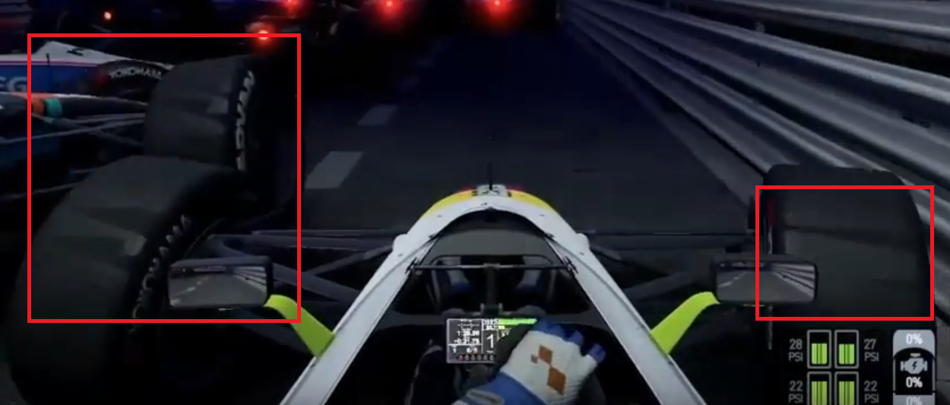

**1-1 Z-fighting**