‘Project Cars 2’ Bug Report Document

|  |  |  |
| --- | --- | --- |
| **No** | **Lists** | **Descriptions** |
| 1 | **Title** | Z-fighting on car tire surface with shadow at night time. |
| 2 | **Description Detail** | Especially, tire wheel showed us annoying Z-fighting under the road lamp with shadow during playing night time environment. |
| 3 | **Severity** | Low, It doesn’t make players focused. |
| 4 | **Bug priority** | Medium, Annoying visual problem. |
| 5 | **Version** | 7.00, also under versions. |
| 6 | **Repeatability** | Every time During night environment. |
| 7 | **Steps** | 1. Set the environment to Night time (23:00).  2. Rolling start the car  3. Passed under road lamps and drawn the shadow.  4. Car wheels surface will be showed us Z-fighting what shape of triangle like a mesh polygons. |

**Screen Shot**

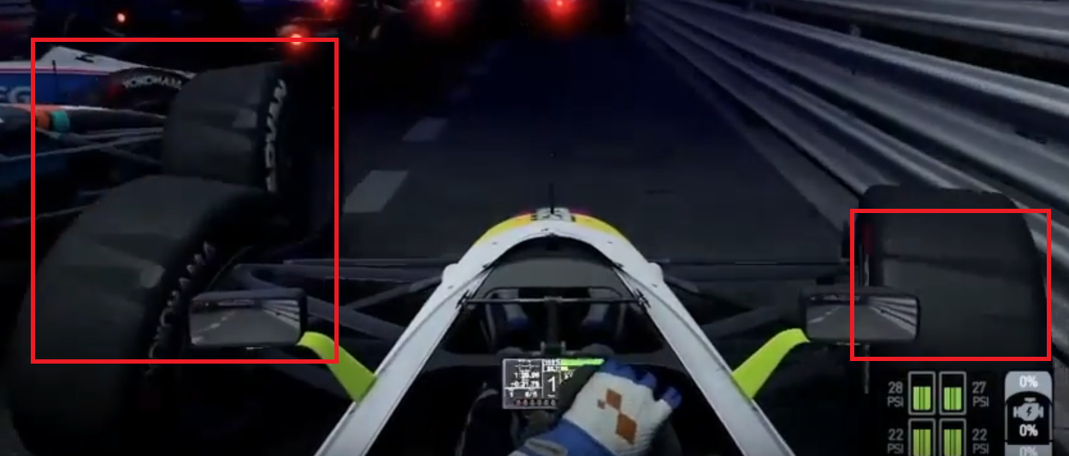

**DX log (Test Environment)**

|  |  |
| --- | --- |
| **Lists** | **Description** |
| **Devices** | Play-Station 4 |
| **Hardware** | Logitech g29 wheel, shift bar, pedals |
| **O.S** | Unix-like |
| **Etc** | PC connecting for recording video. |

|  |  |  |
| --- | --- | --- |
| **No** | **Lists** | **Descriptions** |
| 1 | **Title** | Bouncing and flying car moment of crash and kissing each other. |
| 2 | **Description Detail** | If you crash with other cars over run to 70MPH and 200 KPH, your car will be flew over the racing track by An unexpected Physics bug. |
| 3 | **Severity** | High, It will be make bad playing-experience to player. |
| 4 | **Bug priority** | Critical, Unexpected moment. |
| 5 | **Version** | 4.00, also under versions. |
| 6 | **Repeatability** | Rarely repeat. |
| 7 | **Steps** | 1. Run and speed up to 70MPH and 200KPH 2. Crash other A.I Car to purpose. 3. You can watch your car and A.l’s are flew. |

**Screen Shot**

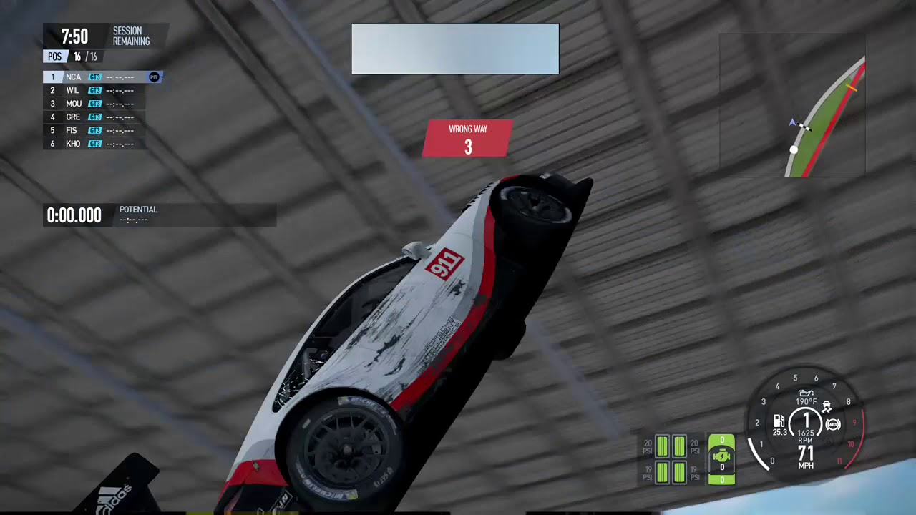

**DX log (Test Environment)**

|  |  |
| --- | --- |
| **Lists** | **Description** |
| **Devices** | PC (Geforce 1080Ti, RAM 16GB, I7-8series) |
| **Hardware** | Logitech g29 wheel, shift bar, pedals PC Mode |
| **O.S** | Windows 10 Redstone 5 |
| **Etc** | Network connection for Steam playing. |