‘Sound Voltex IV’ Bug Report Document

|  |  |  |
| --- | --- | --- |
| **No** | **Lists** | **Descriptions** |
| 1 | **Title** | Suddenly invisible beat-notes process While playing game |
| 2 | **Description Detail** | During Play on letter half of the song name ‘Doppelganger’.  Suddenly notes are invisible. |
| 3 | **Severity** | High, It is a little bit hard to approaching this bug. But, if already approached, I will be critical to play. |
| 4 | **Bug priority** | Critical |
| 5 | **Version** | Series ‘4’, Oldest one, Not detailed. |
| 6 | **Repeatability** | It’s not bug therefore, you can approach on purpose like Easter egg. However, It has possible to be like to bug. |
| 7 | **Steps** | 1. Select song named ‘Doppelganger’.  2. Play on letter half of game, especially, the time that change game speed by force and no notes dropped.  3. Let’s put a ‘Start’ button and spin a ‘nov’s. You can watch same bug. |

**Screen Shot**

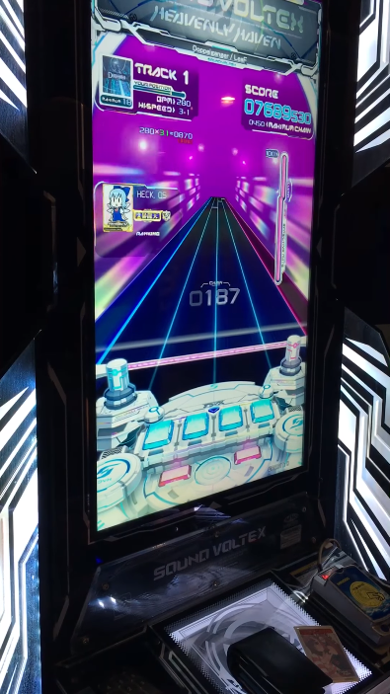

<https://www.youtube.com/watch?v=qif9wzEePz4>

**DX log (Test Environment)**

|  |  |
| --- | --- |
| **Lists** | **Description** |
| **Devices** | Window based Arcade Device |
| **Hardware** | Company doesn’t mention regarding device spec. |
| **O.S** | Windows 7 |
| **Etc** |  |

|  |  |  |
| --- | --- | --- |
| **No** | **Lists** | **Descriptions** |
| 1 | **Title** | Initializing and resetting process doesn’t work after start the game. |
| 2 | **Description Detail** | Graphic and sound already show even before finished game.  It is one of the serious broken processes |
| 3 | **Severity** | Medium, One of the annoying sound and programing bugs. |
| 4 | **Bug priority** | Medium |
| 5 | **Version** | Series ‘4’, Oldest one, Not detailed. |
| 6 | **Repeatability** | Probably usually but It was solved at June 22nd 2017. |
| 7 | **Steps** | 1. Select very hard one. 2. Play. Probably it shows again. |

**Screen Shot**

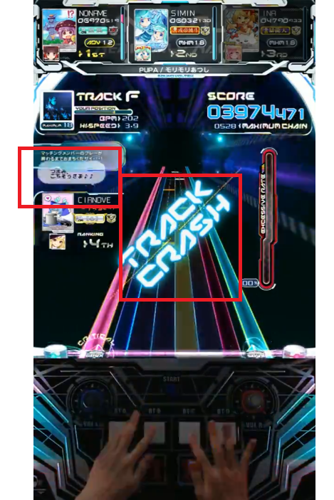

**DX log (Test Environment)**

|  |  |
| --- | --- |
| **Lists** | **Description** |
| **Devices** | Window based Arcade Device |
| **Hardware** | Company doesn’t mention regarding device spec. |
| **O.S** | Windows 7 |
| **Etc** |  |