‘Punk – O –Matic 2’ Bug Report Document

|  |  |  |
| --- | --- | --- |
| **No** | **Lists** | **Descriptions** |
| 1 | **Title** | Frequent audio skipping during playing music time-line. |
| 2 | **Description Detail** | ‘punk-o-matic2’ is music simulation game. Therefore, audio is very important object. However, this game performed frequent audio skipping problem during playing music time line that is made by player. |
| 3 | **Severity** | Critical, Sound problem is very serious bug on the music genre.  It will make critical to play. |
| 4 | **Bug priority** | Critical |
| 5 | **Version** | Version : **NG.2.13** |
| 6 | **Repeatability** | Frequently. |
| 7 | **Steps** | 1. Make a music with given samples.  2. Play your music  3. When main rhythm changed. You can feel an annoying audio skipping. |

**Screen Shot**

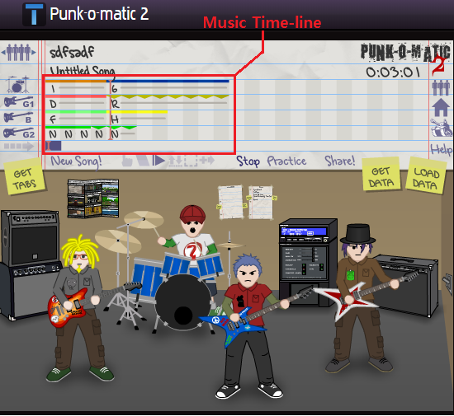

**DX log (Test Environment)**

|  |  |
| --- | --- |
| **Lists** | **Description** |
| **Devices** | SAMSUNG DB400T3a Desktop-PC |
| **Hardware** | Inter core i5-4460, Quad-cores 3.20GHz, 100Mbps Network environment. |
| **O.S** | Windows 7 |
| **Etc** |  |