‘Initial D Arcade stage 8’ Bug Report Document

|  |  |  |
| --- | --- | --- |
| **No** | **Lists** | **Descriptions** |
| 1 | **Title** | Device Accel-pedal doesn’t work whole play-time. |
| 2 | **Description Detail** | Sometimes, device doesn’t work Accel-pedal during playing.  I try to push Accel-pedal but it didn’t work.  I try to push Accel and break pedal at the same time.  It was worked a little. But my car couldn’t go fast. |
| 3 | **Severity** | **High**, It is critical thing of playing game. |
| 4 | **Bug priority** | Medium, It is old device problem. |
| 5 | **Version** | Unknown, Latest version. |
| 6 | **Repeatability** | **Rare** |
| 7 | **Steps** | 1. Play with oldest device model. |

**Screen Shot**

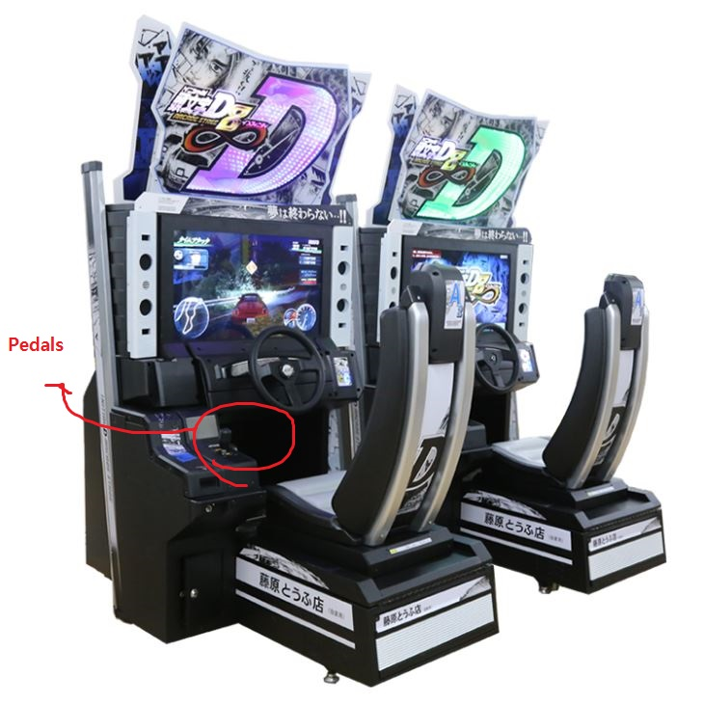

**DX log (Test Environment)**

|  |  |
| --- | --- |
| **Lists** | **Description** |
| **Devices** | RINGEDGE |
| **Hardware** | CPU Intel Pentium E2160 1.8GHz, RAM DDR2 SDRAM PC-26400 1GB,  Geforce 8800GS(GDDR3 SDRAM 384 MB), enable ‘ALL Net’ service. |
| **O.S** | Microsoft Windows embedded standard 2009. |
| **Etc** | Oldest and too many impacted arcade device. |