LUDO

Project by the students of Vocational School for Computer Programming and Innovation.

2020

# **CONTENT**

## Team:

## History of the game:

Pachisi was created in India in the 6th century. The earliest evidence of this game evolution in India is the depiction of boards on the caves of Ellora. The original version is also described in Mahabharata, where Draupadi was put on stake by Pandavas. It was also known as "Chopad". The contemporary version was played by the Mughal emperors of India; a notable example is Akbar.

Pachisi was modified to use a cubic die with dice cup and patented as "Ludo" in England in 1896. The Royal Navy took Ludo and converted it into the board game Uckers.

## Elements of the game:

Ludo consists of a square board with four different colored bases in each corner. The first colored space outside of each base is the start position. A path leads clockwise around the board returning to a path with the same color as the base, then to the home column, which leads to the center home triangle.

## Instruments of the game:

There are four different colored sets of playing pieces that start off in their matching bases. Each set consists of 4 playing pieces. The included die is used to govern the movement of the pieces.

## Rules of the game:

2 to 4 players begin by placing their respective pieces in their bases. Each takes turns throwing the die, and the player with the highest roll plays first. The players to the left follow in turn going clockwise. On each player’s turn, the player rolls the die to determine a move. The goal of the game is to move all four of the player’s pieces clockwise once around the board, up the home column, and into the home triangle.

*Movement*

To begin, a player must roll a six to move a piece out of the base and onto the start position. That piece is then in play. The player cannot make any other moves until at least one piece is in play.

If a player has a piece or pieces in play, they can move any one of their pieces 1 to 6 spaces along the path according to the number they roll.

Rules of the 6’s.

If a six is rolled, the player can choose to either move a piece out of his base onto the start position or move a piece that is in play.

Anytime a six is rolled, the player gets an extra roll after his move.

If a six is rolled three times in a row, the player loses his turn. Landing on a shared space.

Landing on a shared square

If a player’s piece lands on an opponent’s piece, the opponent’s piece is sent back to their base where he must roll a six again in order move it out onto the starting square.

If a player lands on a space occupied by one of his own pieces, that space becomes blocked. A blocked space cannot be passed or landed on by an opponent’s piece.

## Win conditions:

When a player’s piece has reached the home column of its own color, the piece continues its moves toward the center to its home triangle. When a player’s die roll lands its piece on the home triangle, that piece has completed its journey. A piece can only be moved to the home triangle with an exact roll.

The first player to have all four of his pieces finish their journeys wins. The remaining players continue the game to determine the runnerups. Each team has a different letter for their pawn. "B", "R", "U" and "H".

If the players manage to spell the word 'BRUH' anywhere on the board, a deathmatch starts.

During this deathmatch if you remove someone’s pawn from the table, the whole team will not be able to continue playing the game.

## Plot of the game:

Bella, Robert, Ursule and Harry met a wizard who cast a spell on them. He first cloned them three times, so now there are four of each person. They are all now pawns in his maze. Only the real ones can escape and reach the marked spaces in the middle. Once all four of them reach the spots, the curse will be broken. The clones will all disappear and Bella, Robert, Ursule and Harry will finally be able to go back to their homes.

## Used Technologies:

### For the game and the site:

* Java script
* HTML 5
* CSS 3

### Communication:

* Teams
* Messenger
* GitHub

## Aims of the project:

The aim of the project is to turn the old ordinary game “LUDO” into something more interesting, by adding a plot and entertaining elements. Our idea is to remind people the classic game but also to make it more innovative and different.

## Algorithm of the game:

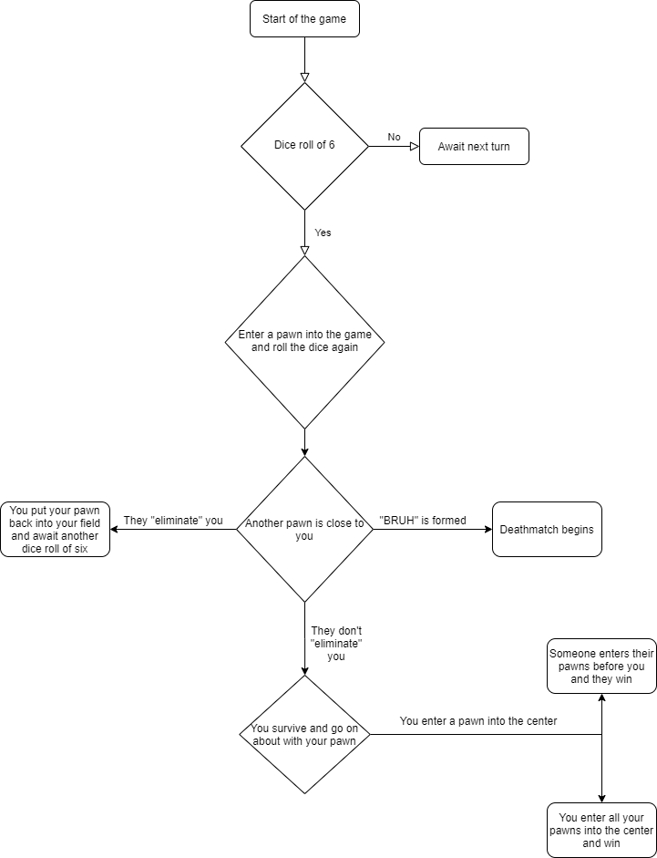

## Code description:

## The first function of the code has the purpose of hiding loaded items. The second generates a random number, just like a normal dice roll. The third is used to check which team’s turn it is so we can be sure none of them have two, or more, turns in a roll. The fourth is the dice roll itself, it displays a random number and from there you can choose between multiple options that will determine your play in the game. The fifth function’s purpose is to load the “spawn-points” of the pawns, hence have them appear and become available for use. The sixth is to reset the game, either for when it’s over or because of an occurred error. The seventh is used for moving the pawns around the board, the dice in decision of how much you can move them. And finally, the eighth function checks if you’ve rolled a six. This is essential because as we’ve said before in the documentation, you can play a dice roll of six in two ways: either move an already used pawn or have a pawn on your team enter the game.